1月检查申请单质控
住院号 | 检查单类型 | 开单日期 | 开单医师 |  |  | 检查项目
 |  |  |  | 主诉 | 病情摘要 |  | 既往史 | 体格检查 | 辅助检查 | 诊断 | 内容申请单不一致
02212186 | CT | 2022-1-2 | 严雪港 | √ | √ |  | √ | √ | √ | √ | √
02112127 | CT | 2022-1-3 | 林武 | √ | √ |  | √ | √ | √ | √ | √
02112137 | MR | 2021-12-31 | 孙莉 | √ | √ |  | √ | √ | √ | √ | √
02112143 | MR | 2022-1-1 | 罗桢敏 | √ | √ |  | √ | √ | √ | √ | √
02212192 | MR | 2022-1-3 | 朱海波 | √ | √ |  | √ | √ | √ | √ | √
02212172 | MR | 2022-1-4 | 何易 | √ | √ |  | √ | √ | √ | √ | √
02212172 | MR | 2022-1-6 | 何薇 | √ | √ |  | √ | √ | √ | √ | √
02111997 | CT | 2022-1-4 | 李慧娇 | √ | √ |  | √ | √ | √ | √ | √
02112094 | MR | 2021-12-31 | 夏炳江 | √ | √ |  | √ | √ | √ | √ | √
02108081 | MR | 2022-1-4 | 边俊 | √ | √ |  | √ | √ | √ | √ | √
01714613 | MR | 2022-1-4 | 孙莉 | √ | √ |  | √ | √ | √ | √ | √
02212326 | MR | 2022-1-6 | 张华良 | √ | √ |  | √ | √ | √ | √ | √
02212285 | CT | 2022-1-5 | 许杨 | √ | √ |  | √ | √ | √ | √ | √
02212312 | CT | 2022-1-5/6 | 谢立江 | √ | √ |  | √ | √ | √ | √ | √
01902353 | MR | 2022-1-6 | 金少威 | √ | √ |  | √ | √ | √ | √ | √
02212350 | MR | 2022-1-6 | 金少威 | √ | √ |  | √ | √ | √ | √ | √
02212327 | CT | 2022-1-7 | 孙莉 | √ | √ |  | √ | √ | √ | √ | √
02212303 | CT | 2022-1-5 | 谢立江 | √ | √ |  | √ | √ | √ | √ | √
01311898 | MR | 2022-1-8 | 何薇 | √ | √ |  | √ | √ | √ | √ | √
02212399 | MR | 2022-1-8 | 马军华 | √ | √ |  | √ | √ | √ | √ | √
02212406 | CT | 2022-1-9 | 许伟攀 | √ | √ |  | √ | √ | √ | √ | √
01809158 | MR | 2022-1-7 | 孙莉 | √ | √ |  | √ | √ | √ | √ | √
02212384 | CT/MR | 2022-1-7 | 凌一鸣 | √ | √ |  | √ | √ | √ | √ | √
02212379 | MR | 2022-1-7 | 王立刚 | √ | √ |  | √ | √ | √ | √ | ×
02212393 | CT | 2022-1-10 | 李国华 | √ | √ |  | √ | √ | √ | √ | √
01903121 | MR | 2022-1-9 | 边佳萍 | √ | √ |  | √ | √ | √ | √ | √
02110286 | CT | 2022-1-11 | 陈俊杰 | √ | √ |  | √ | √ | √ | √ | √
02212423 | CT | 2022-1-11 | 陈俊杰 | √ | √ |  | √ | √ | √ | √ | √
02112101 | MR | 2022-1-8 | 凌一鸣 | √ | √ |  | √ | √ | √ | √ | √
02000679 | MR | 2022-1-8 | 王立刚 | √ | √ |  | √ | √ | √ | √ | √
02212204 | MR | 2022-1-9 | 许伟攀 | √ | √ |  | √ | √ | √ | √ | √
02212440 | MR | 2022-1-9 | 朱海波 | √ | √ |  | √ | √ | √ | √ | √
02212441 | MR | 2022-1-9 | 孙莉 | √ | √ |  | √ | √ | √ | √ | √
02212441 | CT | 2022-1-14 | 冯梦雪 | √ | √ |  | √ | √ | √ | √ | √
01505694 | CT | 2022-1-9 | 葛剑洪 | √ | √ |  | √ | √ | √ | √ | √
02212488 | MR | 2022-1-10 | 谢峰 | √ | √ |  | √ | √ | √ | √ | √
02212327 | CT | 2022-1-12 | 冯梦雪 | √ | √ |  | √ | √ | √ | √ | √
02112126 | CT | 2022-1-12 | 尤志新 | √ | √ |  | √ | √ | √ | √ | √
02212416 | MR | 2022-1-8 | 张桢阳 | √ | √ |  | √ | √ | √ | √ | √
02102706 | MR | 2022-1-10 | 管仕强 | √ | √ |  | √ | √ | √ | √ | √
02212348 | MR | 2022-1-10 | 魏平洋 | √ | √ |  | √ | √ | √ | √ | √
01505694 | MR | 2022-1-10 | 葛剑洪 | √ | √ |  | √ | √ | √ | √ | √
02212244 | MR | 2022-1-12 | 罗桢敏 | √ | √ |  | √ | √ | √ | √ | √
02212512 | CT | 2022-1-12 | 沈兴潮 | √ | √ |  | √ | √ | √ | √ | √
02212498 | MR | 2022-1-12 | 张新凡 | √ | √ |  | √ | √ | √ | √ | √
02212574 | CT | 2022-1-15 | 孙莉 | √ | √ |  | √ | √ | √ | √ | √
01805112 | MR | 2022-1-12 | 王立刚 | √ | √ |  | √ | √ | √ | √ | √
01909267 | CT/MR | 2022-1-15 | 孙莉 | √ | √ |  | √ | √ | √ | √ | √
02111892 | MR | 2022-1-13 | 王风永 | √ | √ |  | √ | √ | √ | √ | √
02212489 | MR | 2022-1-14 | 许杨 | √ | √ |  | √ | √ | √ | √ | √
02212279 | CT | 2022-1-14 | 周怡 | √ | √ |  | √ | √ | √ | √ | √
02212551 | MR | 2022-1-13 | 金少威 | √ | √ |  | √ | √ | √ | √ | √
02005070 | CT | 2022-1-17 | 马黎丽 | √ | √ |  | √ | √ | √ | √ | √
02212639 | CT | 2022-1-16 | 王风永 | √ | √ |  | √ | √ | √ | √ | √
02212583 | CT | 2022-1-16 | 张澍漾 | √ | √ |  | √ | √ | √ | √ | √
01508699 | MR | 2022-1-15 | 张华良 | √ | √ |  | √ | √ | √ | √ | √
02212622 | MR | 2022-1-15 | 陈剑磨 | √ | √ |  | √ | √ | √ | √ | √
02106263 | MR | 2022-1-15 | 孙莉 | √ | √ |  | √ | √ | √ | √ | √
01908814 | MR | 2022-1-18 | 王亚平 | √ | √ |  | √ | √ | √ | √ | √
01902495 | MR | 2022-1-18 | 刘磊 | √ | √ |  | √ | √ | √ | √ | ×
02212693 | MR | 2022-1-18 | 孙莉 | √ | √ |  | √ | √ | √ | √ | √
02237614 | CT | 2022-1-19 | 丁雪艳 | √ | √ |  | √ | √ | √ | √ | √
02212310 | CT | 2022-1-21 | 谢铭 | √ | √ |  | √ | √ | √ | √ | √
02237617 | MR | 2022-1-21 | 罗桢敏 | √ | √ |  | √ | √ | √ | √ | √
01609370 | MR | 2022-1-20 | 边佳萍 | √ | √ |  | √ | √ | √ | √ | √
02237709 | MR | 2022-1-23 | 何易 | √ | √ |  | √ | √ | √ | √ | √
01508613 | MR | 2022-1-20 | 孙莉 | √ | √ |  | √ | √ | √ | √ | √
01909049 | CT | 2022-1-23 | 鲁剑梅 | √ | √ |  | √ | √ | √ | √ | √
02237766 | MR | 2022-1-24 | 管仕强 | √ | √ |  | √ | √ | √ | √ | √
02237730 | CT | 2022-1-24 | 凌一鸣 | √ | √ |  | √ | √ | √ | √ | √
02237708 | MR | 2022-1-22 | 边俊 | √ | √ |  | √ | √ | √ | √ | √
02237783 | MR | 2022-1-26 | 孙莉 | √ | √ |  | √ | √ | √ | √ | √
02007675 | MR | 2022-1-26 | 刘兆龙 | √ | √ |  | √ | √ | √ | √ | √
02007675 | MR | 2022-1-26 | 边佳萍 | √ | √ |  | √ | √ | √ | √ | √
01815727 | CT | 2022-1-25 | 何薇 | √ | √ |  | √ | √ | √ | √ | √
02100768 | MR | 2022-1-24 | 陶铁瑛 | √ | √ |  | √ | √ | √ | √ | √
02237825 | MR | 2022-1-25 | 陶铁瑛 | √ | √ |  | √ | √ | √ | √ | √
02237808 | CT | 2022-1-26 | 罗桢敏 | √ | √ |  | √ | √ | √ | √ | √
02237814 | MR | 2022-1-27 | 丁雪艳 | √ | √ |  | √ | √ | √ | √ | √
02237662 | MR | 2022-1-26 | 李慧娇 | √ | √ |  | √ | √ | √ | √ | √
02237698 | CT | 2022-1-25 | 何薇 | √ | √ |  | √ | √ | √ | √ | √
01700845 | MR | 2022-1-26 | 孙莉 | √ | √ |  | √ | √ | √ | √ | √
02237887 | CT | 2022-1-28 | 柴绍军 | √ | √ |  | √ | √ | √ | √ | √
02237851 | MR | 2022-1-28 | 尤志新 | √ | √ |  | √ | √ | √ | √ | √
02237890 | CT | 2022-1-28 | 樊晓琦 | √ | √ |  | √ | √ | √ | √ | √
02006585 | MR | 2022-1-28 | 谢峰 | √ | √ |  | √ | √ | √ | √ | ×
01916044 | MR | 2022-1-29 | 何薇 | √ | √ |  | √ | √ | √ | √ | √
02237909 | CT | 2022-1-28 | 王风永 | √ | √ |  | √ | √ | √ | √ | √
02111811 | MR | 2022-1-30 | 王风永 | √ | √ |  | √ | √ | √ | √ | ×
02237931 | MR | 2022-1-31 | 陶铁瑛 | √ | √ |  | √ | √ | √ | √ | √
02237895 | CT | 2022-1-30 | 何易 | √ | √ |  | √ | √ | √ | √ | √
注：对住院患者检查申请单进行专项检查，其中主诉、体格检查或诊断任缺一项者视为不合格申请单；非入院常规检查，如申请单内容与检查部位及要求不一致，亦视为不合格申请单。
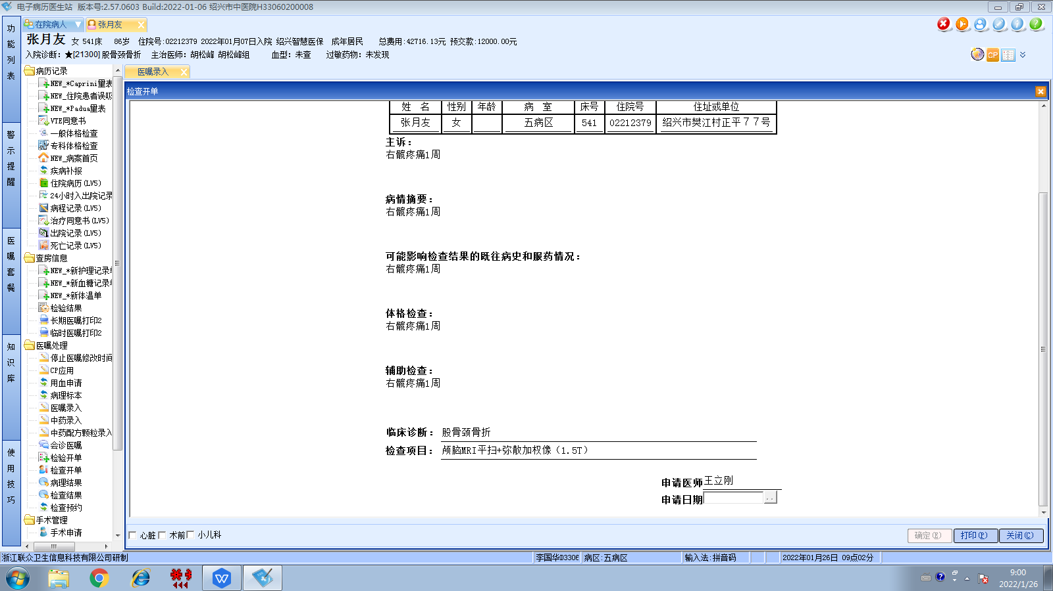
1-7胡松峰组
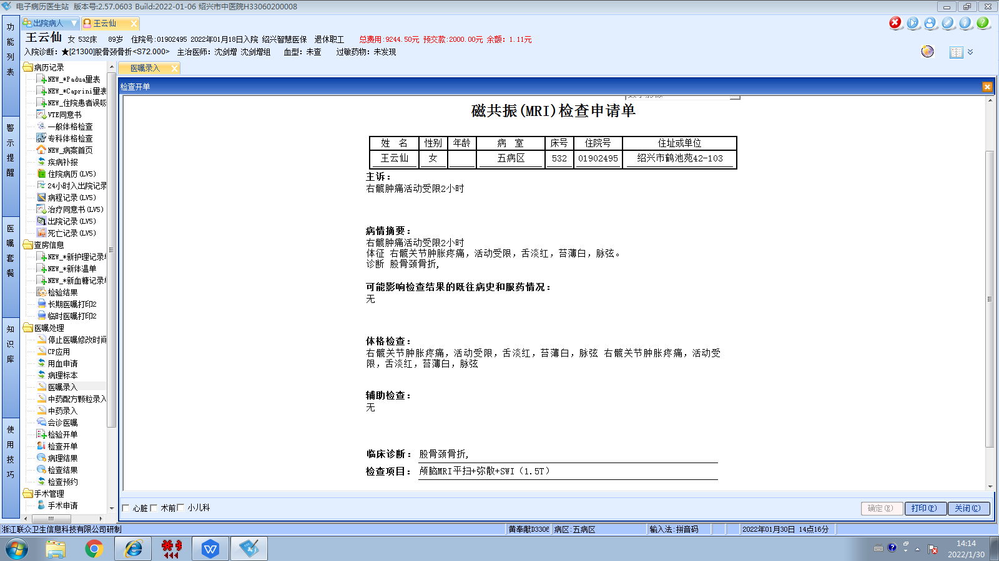
1-18沈剑增组
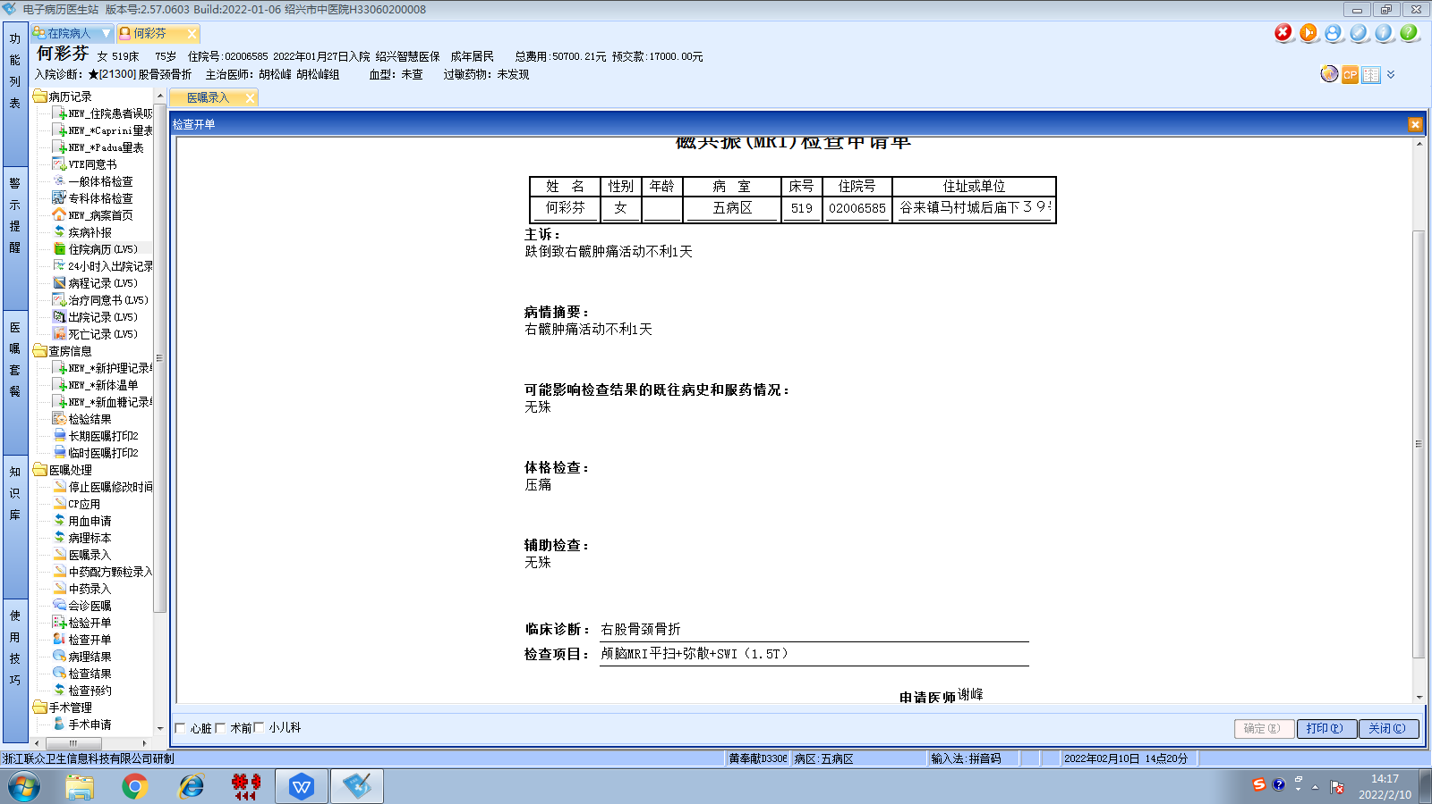
1-28胡松峰组
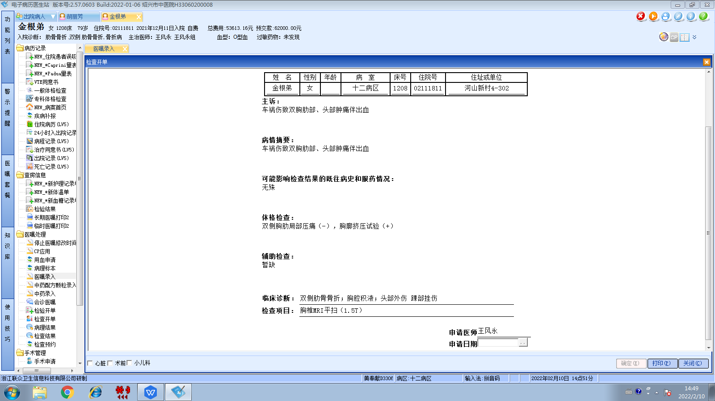
1-30王风永组

