3月检查申请单质控
住院号 | 检查单类型 | 开单日期 | 开单医师 |  |  | 检查项目
 |  |  |  | 主诉 | 病情摘要 |  | 既往史 | 体格检查 | 辅助检查 | 诊断 | 内容申请单不一致
01508688 | CT | 2022-2-25 | 王冰清 | √ | √ |  | √ | √ | √ | √ | √
02005724 | CT/MR | 2022-2-28 | 凌一鸣 | √ | √ |  | √ | √ | √ | √ | √
02005724 | MR | 2022-3-2 | 凌一鸣 | √ | √ |  | √ | √ | √ | √ | √
01814090 | MR | 2022-2-27 | 谢峰 | √ | √ |  | √ | √ | √ | √ | ×
01715011 | MR | 2022-2-27 | 何易 | √ | √ |  | √ | √ | √ | √ | √
02238936 | MR | 2022-2-27 | 肖功 | √ | √ |  | √ | √ | √ | √ | √
02238961 | CT | 2022-3-1 | 孙莉 | √ | √ |  | √ | √ | √ | √ | √
02238963 | MR | 2022-2-28 | 钟承隽 | √ | √ |  | √ | √ | √ | √ | √
02238819 | CT | 2022-2-26 | 叶玲玲 | √ | √ |  | √ | √ | √ | √ | √
02239034 | CT | 2022-3-2 | 裘鸿飞 | √ | √ |  | √ | √ | √ | √ | √
02238777 | CT | 2022-3-3 | 龚彬 | √ | √ |  | √ | √ | √ | √ | √
01914756 | CT | 2022-3-3 | 何薇 | √ | √ |  | √ | √ | √ | √ | √
01815010 | MR | 2022-3-2 | 王冰清 | √ | √ |  | √ | √ | √ | √ | √
01915433 | MR | 2022-2-28 | 李慧娇 | √ | √ |  | √ | √ | √ | √ | √
02239022 | MR | 2022-3-2 | 丁雪艳 | √ | √ |  | √ | √ | √ | √ | ×
02238947 | MR | 2022-3-2 | 刘兆龙 | √ | √ |  | √ | √ | √ | √ | √
02238945 | MR | 2022-3-1 | 魏平洋 | √ | √ |  | √ | √ | √ | √ | √
02238944 | MR | 2022-3-1 | 魏平洋 | √ | √ |  | √ | √ | √ | √ | √
01606707 | CT | 2022-3-4 | 许杨 | √ | √ |  | √ | √ | √ | √ | √
01903812 | MR | 2022-3-4 | 王轶辉 | √ | √ |  | √ | √ | √ | √ | √
02007000 | MR | 2022-3-3 | 许伟攀 | √ | √ |  | √ | √ | √ | √ | √
02239076 | CT | 2022-3-4 | 周怡 | √ | √ |  | √ | √ | √ | √ | √
01903820 | CT | 2022-3-5 | 凌一鸣 | √ | √ |  | √ | √ | √ | √ | √
01412574 | MR | 2022-2-28 | 王冰清 | √ | √ |  | √ | √ | √ | √ | √
02239128 | CT | 2022-3-5 | 魏平洋 | √ | √ |  | √ | √ | √ | √ | √
02239089 | MR | 2022-3-4 | 凌一鸣 | √ | √ |  | √ | √ | √ | √ | √
02239002 | CT | 2022-3-5 | 吕宇航 | √ | √ |  | √ | √ | √ | √ | √
01804921 | CT/MR | 2022-3-3 | 王一萍 | √ | √ |  | √ | √ | √ | √ | √
01804921 | MR | 2022-3-6 | 王一萍 | √ | √ |  | √ | √ | √ | √ | √
02239123 | MR | 2022-3-5 | 张华良 | √ | √ |  | √ | √ | √ | √ | ×
01607681 | MR | 2022-3-4 | 龙平 | √ | √ |  | √ | √ | √ | √ | √
02239177 | MR | 2022-3-8 | 葛剑洪 | √ | × |  | × | √ | × | √ | ×
02239177 | CT | 2022-3-9 | 陶铁瑛 | √ | √ |  | √ | √ | √ | √ | ×
01814113 | MR | 2022-3-4 | 许杨 | √ | × |  | × | √ | × | √ | √
02239143 | CT | 2022-3-8 | 王风永 | √ | √ |  | √ | √ | √ | √ | ×
02239099 | MR | 2022-3-4 | 周怡 | √ | √ |  | √ | √ | √ | √ | √
02239206 | CT | 2022-3-9 | 王冰清 | √ | √ |  | √ | √ | √ | √ | √
01603950 | MR | 2022-3-9 | 王冰清 | √ | √ |  | √ | √ | √ | √ | √
02239303 | CT/MR | 2022-3-10 | 陶铁瑛 | √ | √ |  | √ | √ | √ | √ | √
01309567 | MR | 2022-3-9 | 陶铁瑛 | √ | √ |  | √ | √ | √ | √ | √
02239217 | MR | 2022-3-8 | 周怡 | √ | √ |  | √ | √ | √ | √ | ×
02239163 | MR | 2022-3-9 | 谢峰 | √ | √ |  | √ | √ | √ | √ | √
01911810 | CT | 2022-3-11 | 何银银 | √ | √ |  | √ | √ | √ | √ | √
02239154 | CT | 2022-3-10 | 樊晓琦 | √ | √ |  | √ | √ | √ | √ | √
02239332 | CT | 2022-3-12 | 葛剑洪 | √ | √ |  | √ | √ | √ | √ | √
02239128 | CT | 2022-3-12 | 何薇 | √ | √ |  | √ | √ | √ | √ | √
02101445 | CT | 2022-3-12 | 葛剑洪 | √ | √ |  | √ | √ | √ | √ | √
02239146 | MR | 2022-3-6 | 王冰清 | √ | √ |  | √ | √ | √ | √ | √
02239175 | CT | 2022-3-10 | 张梦娇 | √ | √ |  | √ | √ | √ | √ | √
01714048 | MR | 2022-3-10 | 尤志新 | √ | √ |  | √ | √ | √ | √ | √
02100039 | MR | 2022-3-10 | 陈剑磨 | √ | √ |  | √ | √ | √ | √ | √
01803677 | MR | 2022-3-10 | 周怡 | √ | √ |  | √ | √ | √ | √ | √
02239272 | MR | 2022-3-9 | 许伟攀 | √ | √ |  | √ | √ | √ | √ | √
02239258 | CT | 2022-3-13 | 柴绍军 | √ | √ |  | √ | √ | √ | √ | √
01202747 | MR | 2022-3-10 | 孙玲玲 | √ | √ |  | √ | √ | √ | √ | √
02239275 | MR | 2022-3-9 | 王风永 | √ | √ |  | √ | √ | √ | √ | √
02239292 | MR | 2022-3-10 | 许杨 | √ | √ |  | √ | √ | √ | √ | √
02239315 | CT | 2022-3-13 | 陈琦军 | √ | √ |  | √ | √ | √ | √ | √
02105561 | MR | 2022-3-13 | 谢峰 | √ | √ |  | √ | √ | √ | √ | √
02239187 | MR | 2022-3-10 | 王立刚 | √ | √ |  | √ | √ | √ | √ | √
01805112 | MR | 2022-3-12 | 谢峰 | √ | √ |  | √ | √ | √ | √ | √
20092251 | MR | 2022-3-10 | 王冰清 | √ | √ |  | √ | √ | √ | √ | √
02104135 | MR | 2022-3-12 | 龙平 | √ | √ |  | √ | √ | √ | √ | √
02104860 | CT | 2022-3-15 | 谢立江 | √ | √ |  | √ | √ | √ | √ | √
02239197 | MR | 2022-3-12 | 冯水娟 | √ | √ |  | √ | √ | √ | √ | √
02102613 | MR | 2022-3-14 | 陈琦军 | √ | √ |  | √ | √ | √ | √ | √
02002143 | MR | 2022-3-12 | 王风永 | √ | √ |  | √ | √ | √ | √ | √
01915156 | MR | 2022-3-14 | 孟闯闯 | √ | √ |  | √ | √ | √ | √ | √
02239143 | CT | 2022-3-17 | 王风永 | √ | √ |  | √ | √ | √ | √ | √
02239447 | MR | 2022-3-14 | 何薇 | √ | √ |  | √ | √ | √ | √ | √
02239447 | CT | 2022-3-16 | 何薇 | √ | √ |  | √ | √ | √ | √ | √
02002320 | MR | 2022-3-15 | 许杨 | √ | √ |  | √ | √ | √ | √ | √
02239595 | CT | 2022-3-18 | 葛剑洪 | √ | √ |  | √ | √ | √ | √ | √
02239507 | CT | 2022-3-18 | 王冰清 | √ | √ |  | √ | √ | √ | √ | √
02104372 | MR | 2022-3-15 | 盛苏红 | √ | √ |  | √ | √ | √ | √ | √
02111769 | MR | 2022-3-16 | 张华良 | √ | √ |  | √ | √ | √ | √ | √
02239510 | MR | 2022-3-16 | 林武 | √ | √ |  | √ | √ | √ | √ | √
02239500 | MR | 2022-3-15 | 葛剑洪 | √ | √ |  | √ | √ | √ | √ | √
02239380 | MR | 2022-3-16 | 张华良 | √ | √ |  | √ | √ | √ | √ | √
02238580 | CT | 2022-3-19 | 何薇 | √ | √ |  | √ | √ | √ | √ | √
01408681 | MR | 2022-3-17 | 施俊峰 | √ | √ |  | √ | √ | √ | √ | √
02239210 | MR | 2022-3-16 | 刘兆龙 | √ | √ |  | √ | √ | √ | √ | √
02239300 | CT | 2022-3-19 | 林武 | √ | √ |  | √ | √ | √ | √ | √
02239133 | MR | 2022-3-17 | 边俊 | √ | √ |  | √ | √ | √ | √ | √
02239502 | MR | 2022-3-16 | 刘运海 | √ | √ |  | √ | √ | √ | √ | √
01916466 | CT | 2022-3-17 | 何薇 | √ | √ |  | √ | √ | √ | √ | √
02239485 | MR | 2022-3-16 | 许杨 | √ | √ |  | √ | √ | √ | √ | √
02239024 | CT | 2022-3-19 | 许伟攀 | √ | √ |  | √ | √ | √ | √ | √
02239536 | MR | 2022-3-18 | 柴绍军 | √ | √ |  | √ | √ | √ | √ | √
01607853 | MR | 2022-3-18 | 朱大明 | √ | √ |  | √ | √ | √ | √ | √
02239507 | MR | 2022-3-18 | 王冰清 | √ | √ |  | √ | √ | √ | √ | √
02239598 | CT | 2022-3-21 | 王一萍 | √ | √ |  | √ | √ | √ | √ | √
02239605 | MR | 2022-3-22 | 龚彬 | √ | √ |  | √ | √ | √ | √ | √
01903970 | MR | 2022-3-19 | 何薇 | √ | √ |  | √ | √ | √ | √ | √
02239611 | MR | 2022-3-19 | 赵雄碧 | √ | √ |  | √ | √ | √ | √ | √
02239611 | MR | 2022-3-24 | 张建宇 | √ | √ |  | √ | √ | √ | √ | √
01508953 | CT | 2022-3-22 | 施俊峰 | √ | √ |  | √ | √ | √ | √ | √
02239657 | CT | 2022-3-22 | 王冰清 | √ | √ |  | √ | √ | √ | √ | √
02107798 | MR | 2022-3-22 | 施俊峰 | √ | √ |  | √ | √ | √ | √ | √
01704422 | CT | 2022-3-23 | 罗桢敏 | √ | √ |  | √ | √ | √ | √ | √
02239678 | CT | 2022-3-22 | 王冰清 | √ | √ |  | √ | √ | √ | √ | √
02239650 | MR | 2022-3-20 | 刘运海 | √ | √ |  | √ | √ | √ | √ | √
02239766 | CT | 2022-3-23 | 谢立江 | √ | √ |  | √ | √ | √ | √ | √
02001612 | MR | 2022-3-24 | 李国华 | √ | √ |  | √ | √ | √ | √ | √
02239751 | MR | 2022-3-23 | 施俊峰 | √ | √ |  | √ | √ | √ | √ | √
01806459 | MR | 2022-3-22 | 许杨 | √ | √ |  | √ | √ | √ | √ | √
01914922 | MR | 2022-3-22 | 何薇 | √ | √ |  | √ | √ | √ | √ | √
02239794 | MR | 2022-3-24 | 凌一鸣 | √ | √ |  | √ | √ | √ | √ | √
02239656 | MR | 2022-3-23 | 沈剑增 | √ | √ |  | √ | √ | √ | √ | √
02239620 | CT | 2022-3-25 | 尤志新 | √ | √ |  | √ | √ | √ | √ | √
02239812 | CT/MR | 2022-3-25 | 凌一鸣 | √ | √ |  | √ | √ | √ | √ | √
02239760 | CT | 2022-3-23 | 陆超锋 | √ | √ |  | √ | √ | √ | √ | √
02239628 | MR | 2022-3-23 | 沈剑增 | √ | √ |  | √ | √ | √ | √ | √
02239696 | CT | 2022-3-26 | 许伟攀 | √ | √ |  | √ | √ | √ | √ | √
02239728 | MR | 2022-3-24 | 吴明 | √ | √ |  | √ | √ | √ | √ | √
02239813 | CT | 2022-3-25 | 凌一鸣 | √ | √ |  | √ | √ | √ | √ | √
02239828 | CT | 2022-3-28 | 钟承隽 | √ | √ |  | √ | √ | √ | √ | √
02239828 | CT | 2022-3-30 | 樊晓琦 | √ | √ |  | √ | √ | √ | √ | √
01916057 | MR | 2022-3-26 | 沈兴潮 | √ | √ |  | √ | √ | √ | √ | √
02239944 | CT | 2022-3-29 | 赵雄碧 | √ | √ |  | √ | √ | √ | √ | √
02007764 | CT/MR | 2022-3-30 | 肖功 | √ | √ |  | √ | √ | √ | √ | √
01401144 | MR | 2022-3-28 | 金少威 | √ | √ |  | √ | √ | √ | √ | √
02240025 | CT | 2022-3-31 | 刘浩飞 | √ | √ |  | √ | √ | √ | √ | √
02239540 | CT | 2022-3-29 | 王敏龙 | √ | √ |  | √ | √ | √ | √ | √
02239763 | MR | 2022-3-29 | 罗桢敏 | √ | √ |  | √ | √ | √ | √ | √
20102007 | CT | 2022-3-30 | 尤志新 | √ | √ |  | √ | √ | √ | √ | √
02239992 | CT | 2022-3-30 | 许杨 | √ | √ |  | √ | √ | √ | √ | √
02239876 | MR | 2022-3-28 | 裘鸿飞 | √ | √ |  | √ | √ | √ | √ | √
注：对住院患者检查申请单进行专项检查，其中主诉、体格检查或诊断任缺一项者视为不合格申请单；非入院常规检查，如申请单内容与检查部位及要求不一致，亦视为不合格申请单。
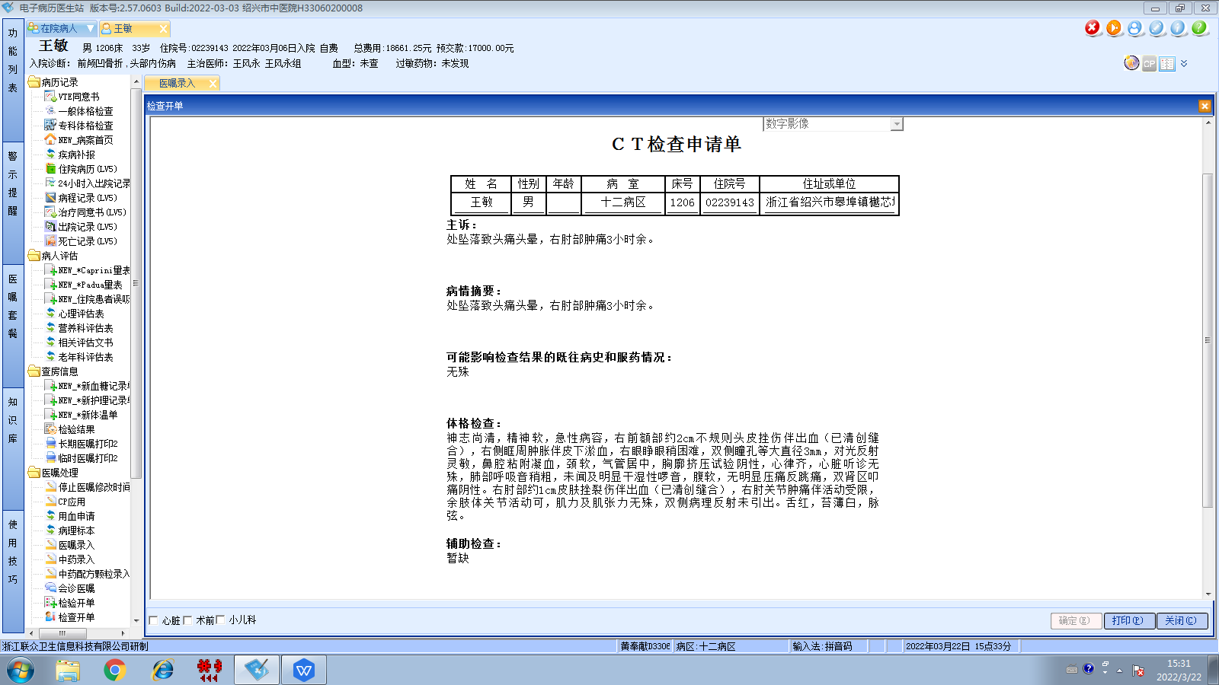
王风永组
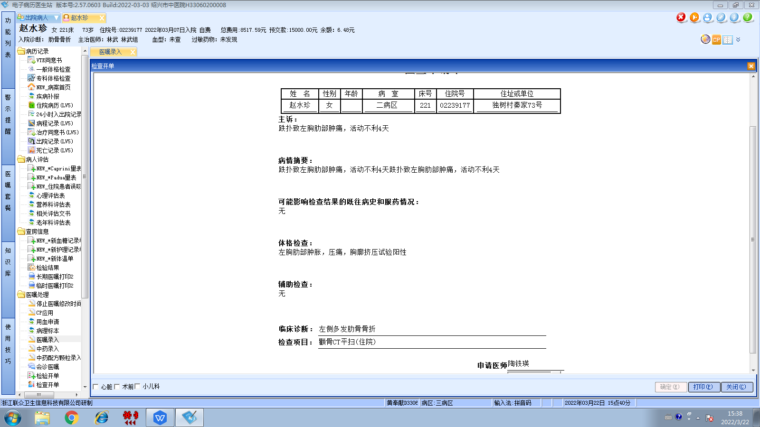
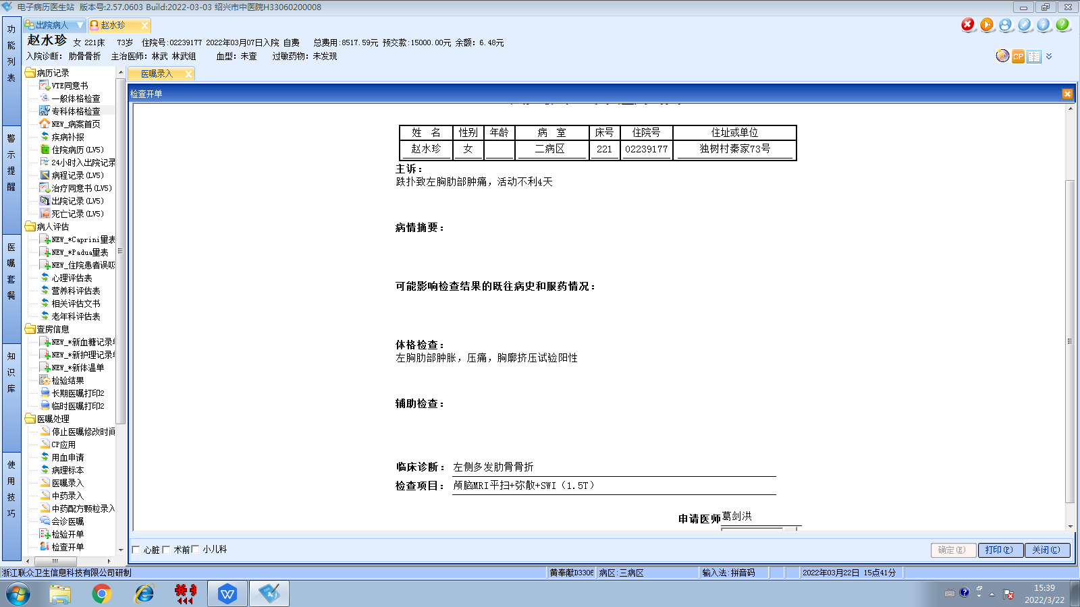
林武组
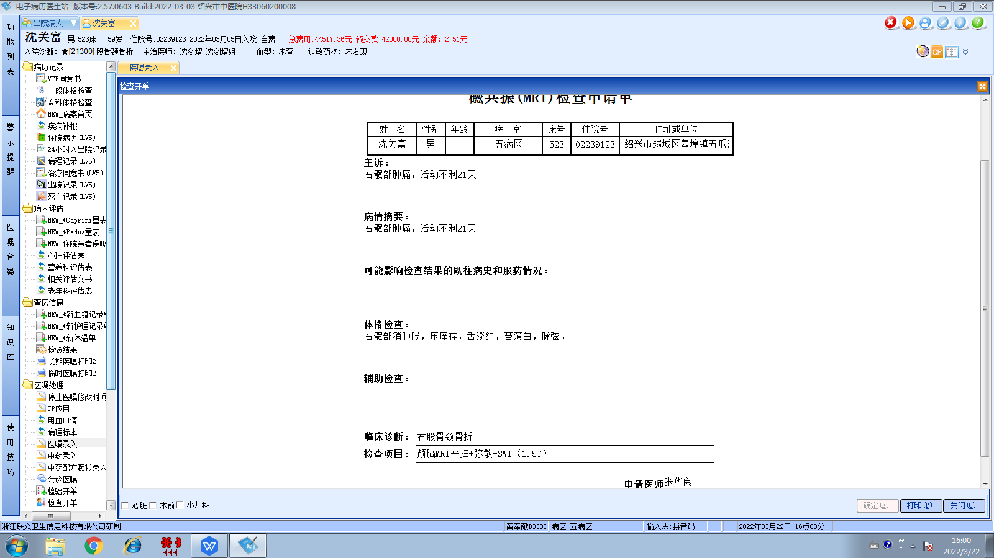
沈剑增组
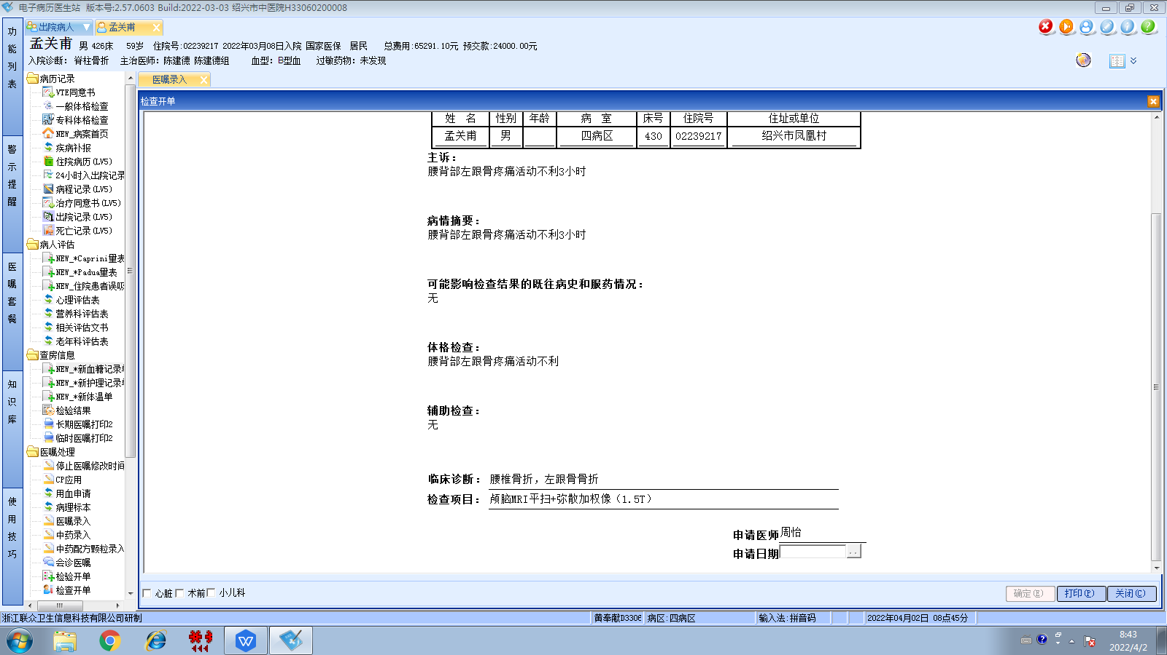
陈建德组

