4月检查申请单质控
住院号 | 检查单类型 | 开单日期 | 开单医师 |  |  | 检查项目
 |  |  |  | 主诉 | 病情摘要 |  | 既往史 | 体格检查 | 辅助检查 | 诊断 | 内容申请单不一致
02240013 | CT/MR | 2022-3-31 | 刘运海 | √ | √ |  | √ | √ | √ | √ | √
02240066 | CT/MR | 2022-4-1 | 王春春 | √ | √ |  | √ | √ | √ | √ | √
02239829 | CT | 2022-4-2 | 柴绍军 | √ | √ |  | √ | √ | √ | √ | √
02239620 | MR | 2022-4-1 | 尤志新 | √ | √ |  | √ | √ | √ | √ | √
20102007 | MR | 2022-3-30 | 尤志新 | √ | √ |  | √ | √ | √ | √ | √
02239766 | MR | 2022-3-30 | 谢立江 | √ | √ |  | √ | √ | √ | √ | √
02239903 | CT | 2022-3-31 | 吴明 | √ | √ |  | √ | √ | √ | √ | √
01606734 | MR | 2022-4-1 | 陶铁瑛 | √ | √ |  | √ | √ | √ | √ | √
02239999 | MR | 2022-3-31 | 陶铁瑛 | √ | √ |  | √ | √ | √ | √ | √
02240017 | MR | 2022-3-31 | 孙利荣 | √ | √ |  | √ | √ | √ | √ | √
02239988 | CT | 2022-4-2 | 孟闯闯 | √ | √ |  | √ | √ | √ | √ | √
02240024 | MR | 2022-3-31 | 夏炳江 | √ | √ |  | √ | √ | √ | √ | √
01804499 | MR | 2022-3-31 | 王冰清 | √ | √ |  | √ | √ | √ | √ | √
02240090 | CT | 2022-4-3 | 王风永 | √ | √ |  | √ | √ | √ | √ | √
02240164 | CT | 2022-4-3 | 肖功 | √ | √ |  | √ | √ | √ | √ | √
02238907 | MR | 2022-4-1 | 王风永 | √ | √ |  | √ | √ | √ | √ | √
02240080 | MR | 2022-4-3 | 凌一鸣 | √ | √ |  | √ | √ | √ | √ | √
02239941 | MR | 2022-4-1 | 周怡 | √ | √ |  | √ | √ | √ | √ | √
02240058 | MR | 2022-4-1 | 胡松峰 | √ | √ |  | √ | √ | √ | √ | √
01916043 | CT | 2022-4-6 | 王亚平 | √ | √ |  | √ | √ | √ | √ | √
01909751 | MR | 2022-4-1 | 魏平洋 | √ | √ |  | √ | √ | √ | √ | √
01404183 | MR | 2022-4-5 | 何薇 | √ | √ |  | √ | √ | √ | √ | √
02239661 | CT | 2022-4-7 | 黎村丰 | √ | √ |  | √ | √ | √ | √ | ×
01508568 | MR | 2022-4-3 | 陈剑磨 | √ | √ |  | √ | √ | √ | √ | √
01812135 | CT | 2022-4-7 | 尤志新 | √ | √ |  | √ | √ | √ | √ | √
02240146 | MR | 2022-4-5 | 陶铁瑛 | √ | √ |  | √ | √ | √ | √ | √
02240154 | MR | 2022-4-3 | 孙利荣 | √ | √ |  | √ | √ | √ | √ | √
02240183 | MR | 2022-4-4 | 罗桢敏 | √ | √ |  | √ | √ | √ | √ | √
02240187 | MR | 2022-4-4 | 许杨 | √ | √ |  | √ | √ | √ | √ | √
01907959 | MR | 2022-4-4 | 马军华 | √ | √ |  | √ | √ | √ | √ | √
02240210 | MR | 2022-4-6 | 支飞虎 | √ | √ |  | √ | √ | √ | √ | ×
01700316 | CT | 2022-4-10 | 葛剑洪 | √ | √ |  | √ | √ | √ | √ | √
02240128 | MR | 2022-4-6 | 张华良 | √ | √ |  | √ | √ | √ | √ | √
02240136 | MR | 2022-4-3 | 周怡 | √ | √ |  | √ | √ | √ | √ | ×
02240072 | MR | 2022-4-6 | 周怡 | √ | √ |  | √ | √ | √ | √ | √
02240608 | CT | 2022-4-21 | 何薇 | √ | √ |  | √ | √ | √ | √ | √
01408745 | MR | 2022-4-17 | 谢立江 | √ | √ |  | √ | √ | √ | √ | √
02240594 | MR | 2022-4-16 | 何薇 | √ | √ |  | √ | √ | √ | √ | √
02240643 | MR | 2022-4-20 | 张建宇 | √ | √ |  | √ | √ | √ | √ | √
02240643 | MR | 2022-4-18 | 赵雄碧 | √ | √ |  | √ | √ | √ | √ | √
02240799 | MR | 2022-4-22 | 王一萍 | √ | √ |  | √ | √ | √ | √ | √
02240799 | MR | 2022-4-21 | 何薇 | √ | √ |  | √ | √ | √ | √ | √
02240799 | MR | 2022-4-23 | 何薇 | √ | √ |  | √ | √ | √ | √ | √
01916615 | MR | 2022-4-21 | 刘兆龙 | √ | √ |  | √ | √ | √ | √ | √
02240710 | MR | 2022-4-18 | 章联欢 | √ | √ |  | √ | √ | √ | √ | ×
02240710 | CT | 2022-4-22 | 孙莉 | √ | √ |  | √ | √ | √ | √ | √
02240641 | CT | 2022-4-23 | 凌一鸣 | √ | √ |  | √ | √ | √ | √ | √
02240735 | CT | 2022-4-21 | 魏平洋 | √ | √ |  | √ | √ | √ | √ | ×
02240614 | CT | 2022-4-24 | 陆超锋 | √ | √ |  | √ | √ | √ | √ | √
02240871 | CT | 2022-4-23 | 柴绍军 | √ | √ |  | √ | √ | √ | √ | ×
02240870 | CT | 2022-4-25 | 朱海波 | √ | √ |  | √ | √ | √ | √ | √
01907829 | MR | 2022-4-19 | 张华良 | √ | √ |  | √ | √ | √ | √ | √
02109232 | CT | 2022-4-25 | 吕宇航 | √ | √ |  | √ | √ | √ | √ | √
01900924 | MR | 2022-4-22 | 张梦娇 | √ | √ |  | √ | √ | √ | √ | √
01402771 | MR | 2022-4-22 | 张华良 | √ | √ |  | √ | √ | √ | √ | √
02240894 | MR | 2022-4-23 | 胡烨琛 | √ | √ |  | √ | √ | √ | √ | √
01914307 | MR | 2022-4-21 | 冯梦雪 | √ | √ |  | √ | √ | √ | √ | √
02240730 | MR | 2022-4-19 | 张建宇 | √ | √ |  | √ | √ | √ | √ | √
02240785 | MR | 2022-4-20 | 赵艳明 | √ | √ |  | √ | √ | √ | √ | √
02240984 | CT | 2022-4-27 | 孙莉 | √ | √ |  | √ | √ | √ | √ | √
02240303 | CT | 2022-4-27 | 李慧娇 | √ | √ |  | √ | √ | √ | √ | √
02240980 | CT | 2022-4-28 | 冯水娟 | √ | √ |  | √ | √ | √ | √ | √
01806495 | CT | 2022-4-27 | 何薇 | √ | √ |  | √ | √ | √ | √ | √
01609077 | CT | 2022-4-27 | 王风永 | √ | √ |  | √ | √ | √ | √ | √
02240973 | MR | 2022-4-25 | 王立刚 | √ | √ |  | √ | √ | √ | √ | ×
02241109 | CT | 2022-4-30 | 刘运海 | √ | √ |  | √ | √ | √ | √ | ×
02241014 | CT | 2022-4-27 | 王志刚 | √ | √ |  | √ | √ | √ | √ | √
注：对住院患者检查申请单进行专项检查，其中主诉、体格检查或诊断任缺一项者视为不合格申请单；非入院常规检查，如申请单内容与检查部位及要求不一致，亦视为不合格申请单。
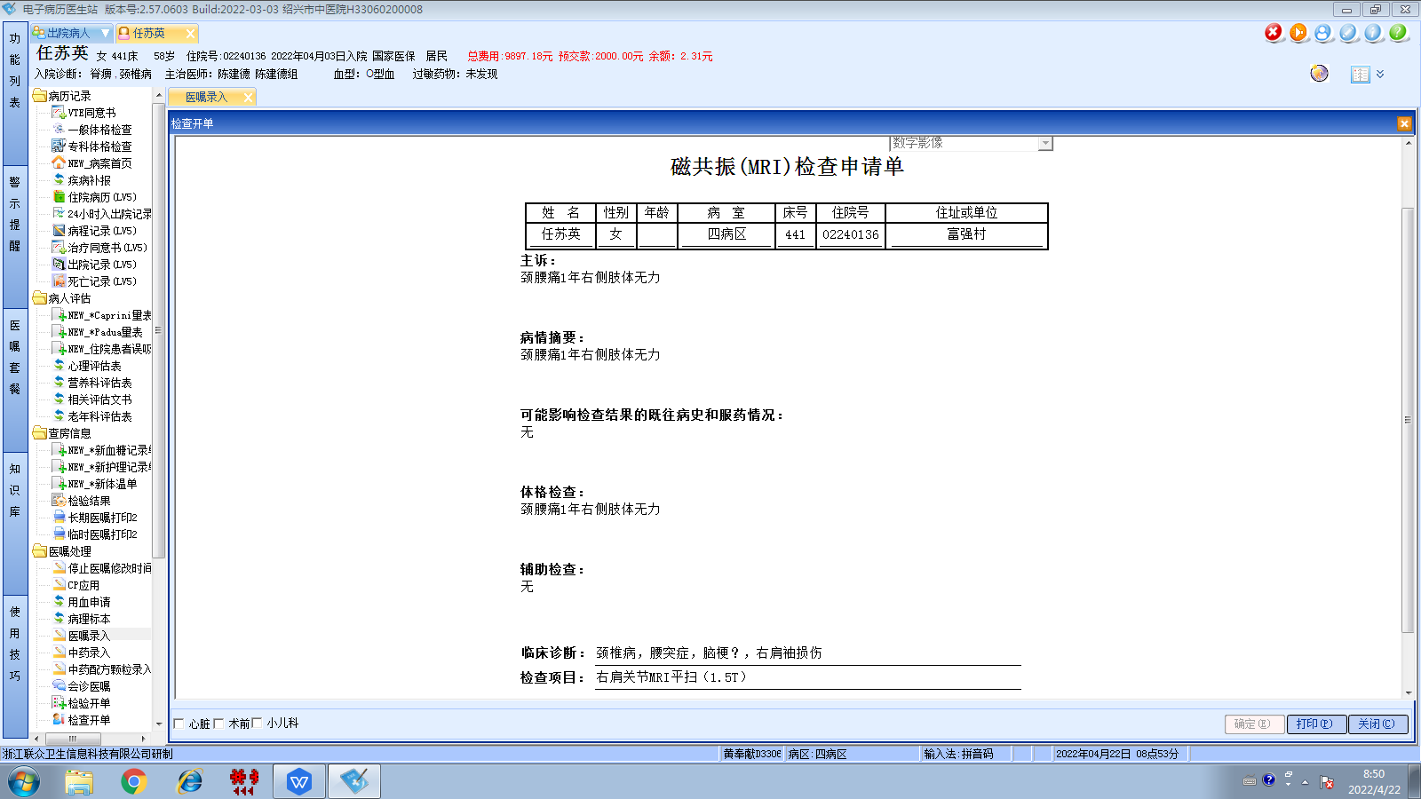
陈建德组
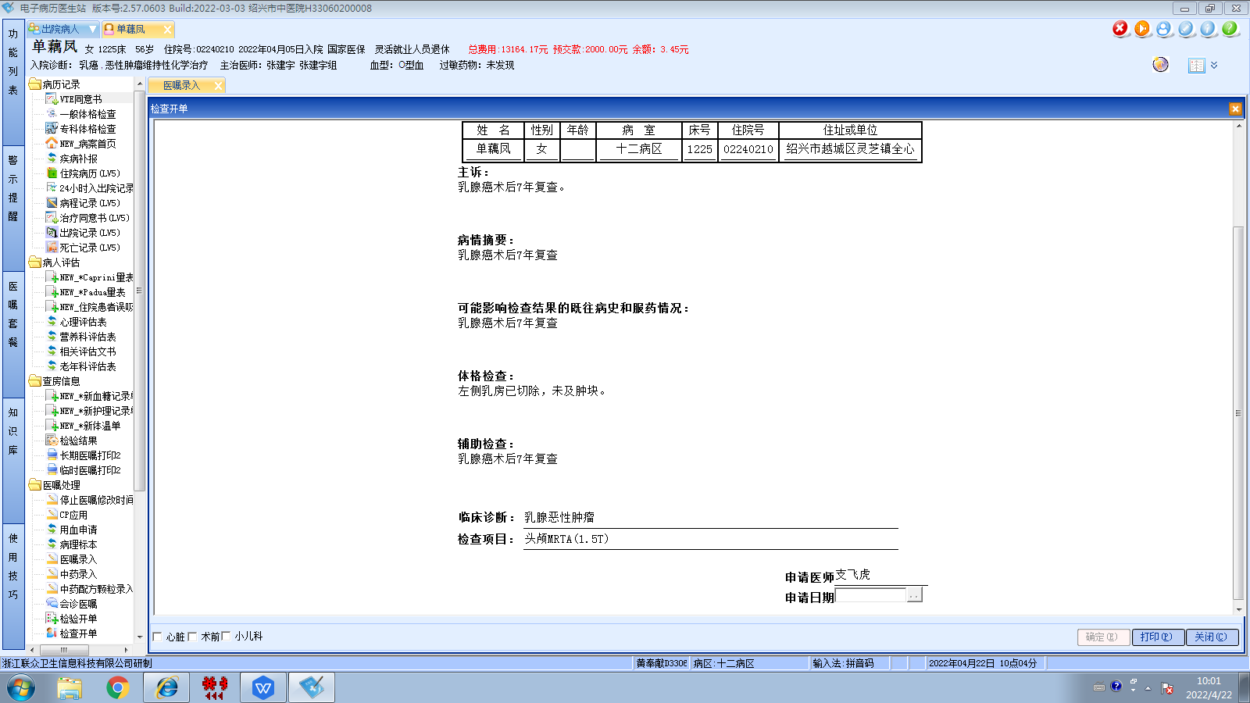
张建宇组
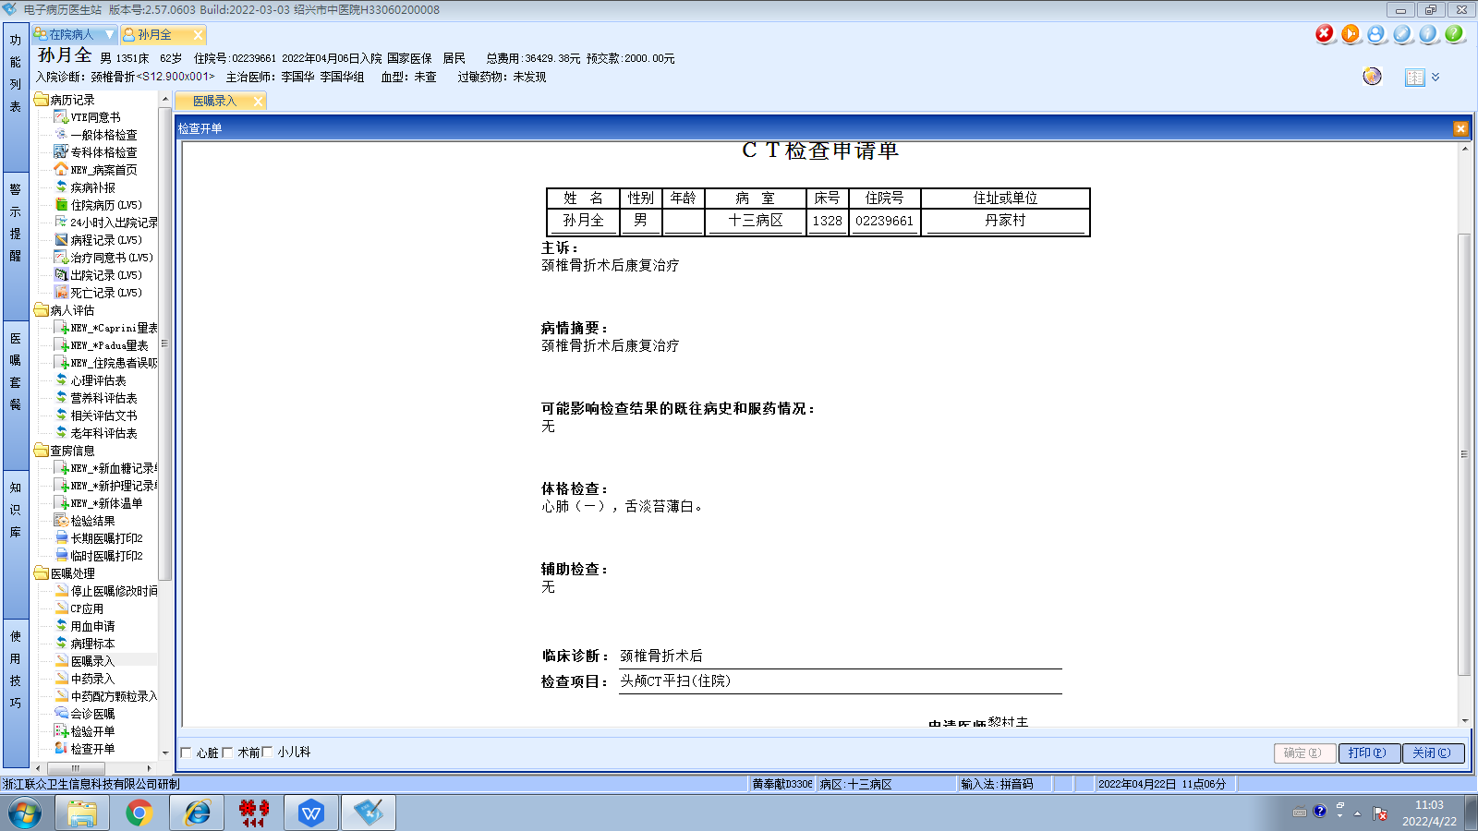李国华组
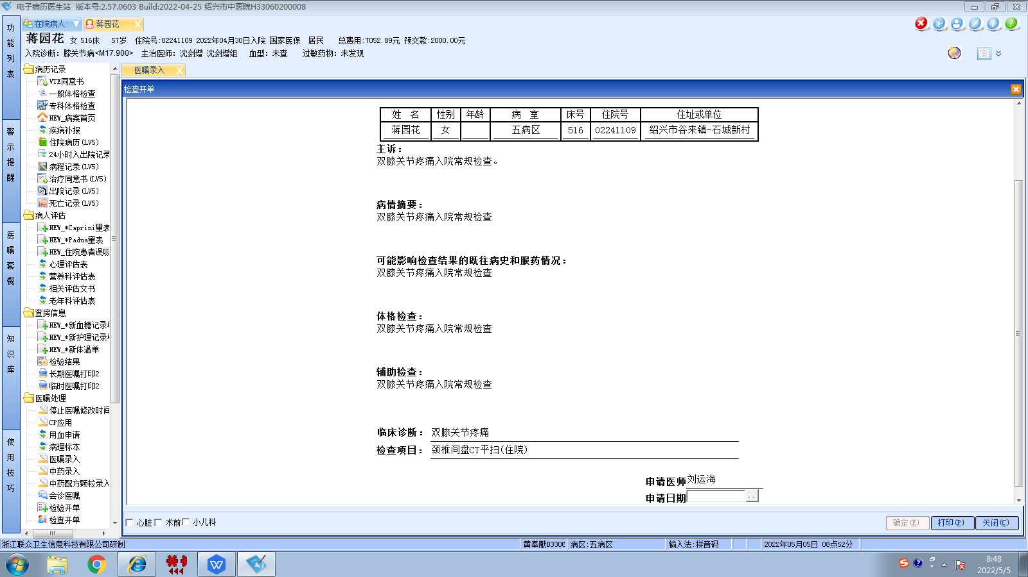
沈剑增组
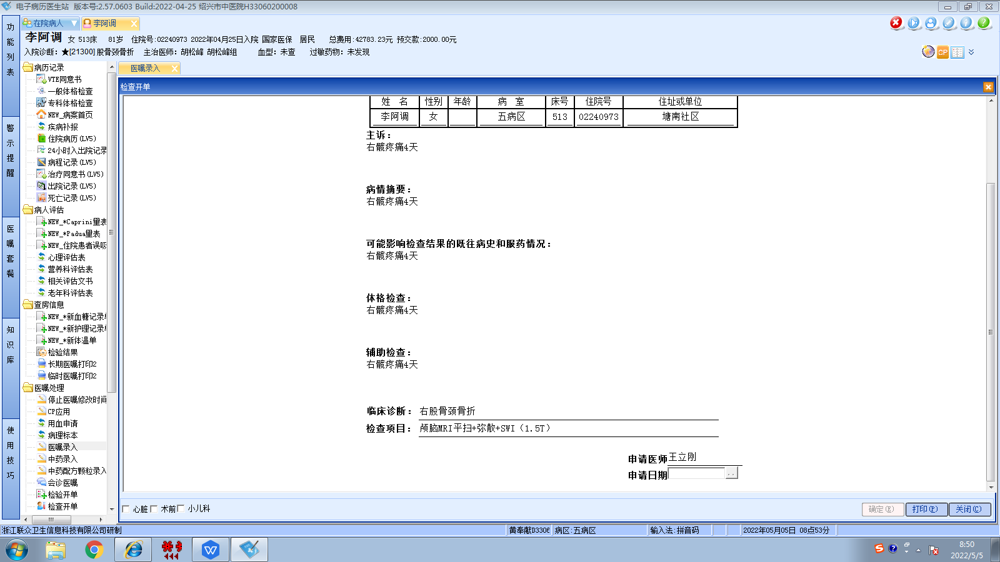胡松峰组
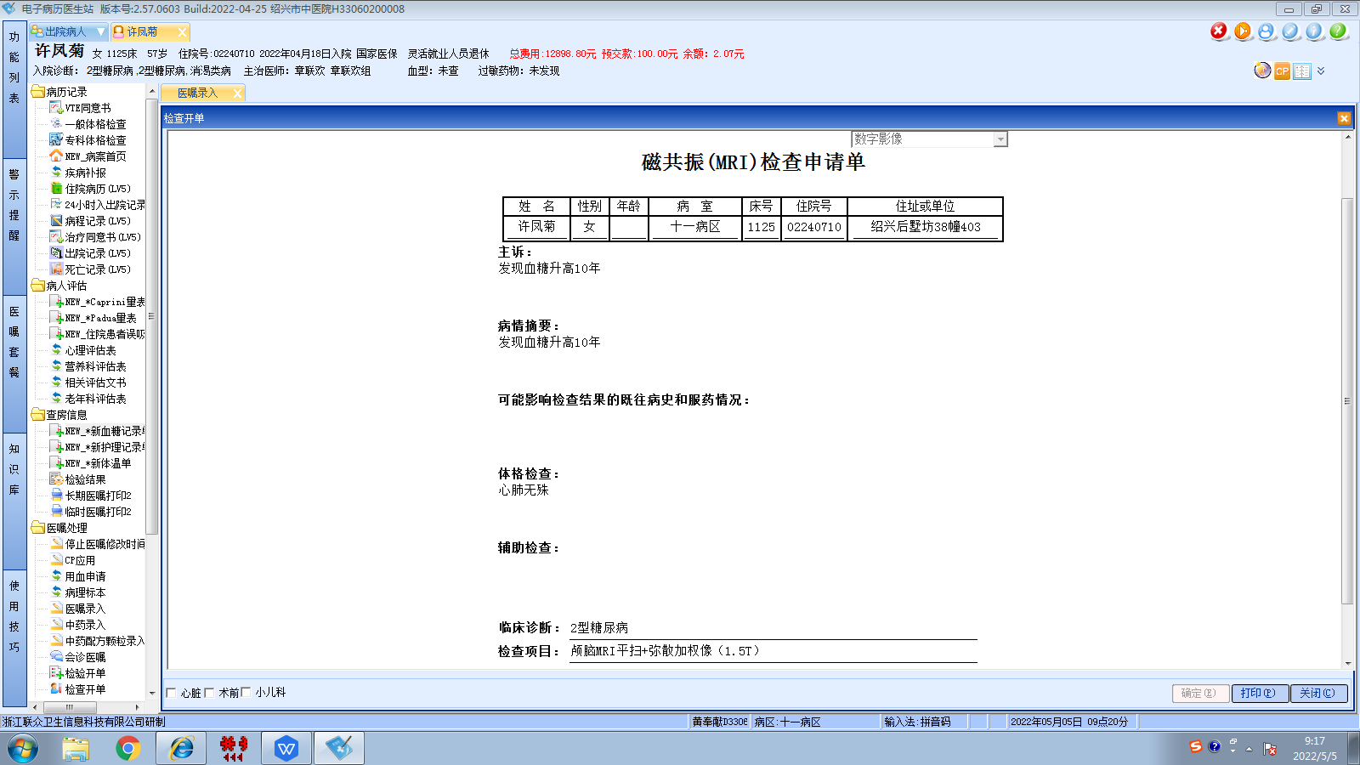章联欢组
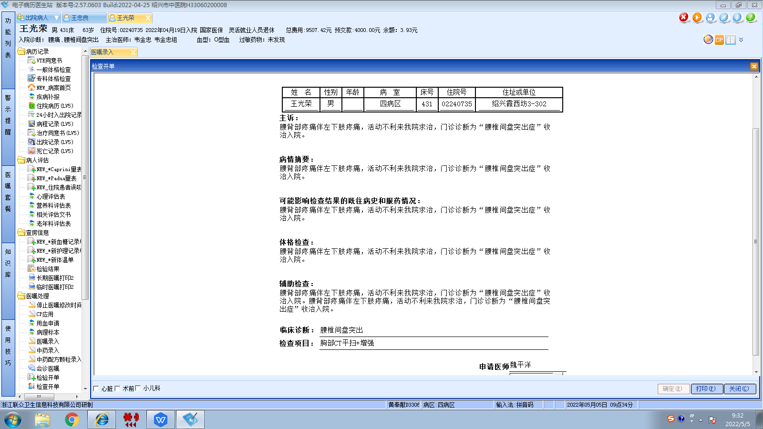韦金忠组
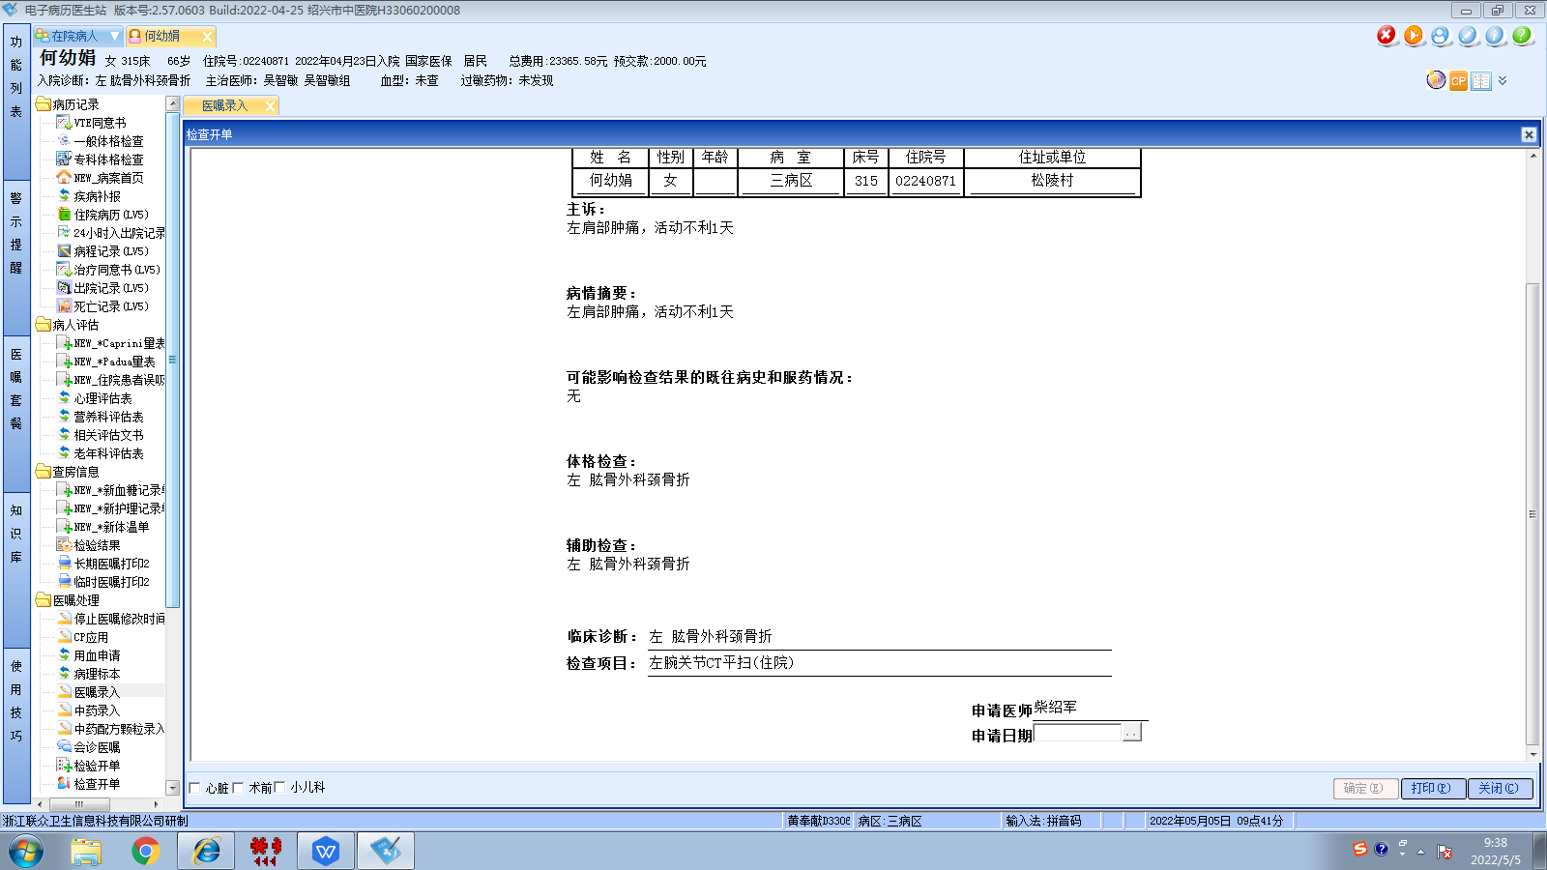吴智敏组

