5月检查申请单质控
住院号 | 检查单类型 | 开单日期 | 开单医师 |  |  | 检查项目
 |  |  |  | 主诉 | 病情摘要 |  | 既往史 | 体格检查 | 辅助检查 | 诊断 | 内容申请单不一致
02241046 | MR | 2022-4-28 | 许海锋 | √ | √ |  | √ | √ | √ | √ | √
01806495 | MR | 2022-4-27 | 何薇 | √ | √ |  | √ | √ | √ | √ | √
01708611 | MR | 2022-4-27 | 孙莉 | √ | √ |  | √ | √ | √ | √ | √
02241069 | MR | 2022-4-29 | 张梦娇 | √ | √ |  | √ | √ | √ | √ | √
01500771 | MR | 2022-4-29 | 陶铁瑛 | √ | √ |  | √ | √ | √ | √ | ×
02241085 | CT/MR | 2022-5-3 | 何薇 | √ | √ |  | √ | √ | √ | √ | √
02241159 | CT/MR | 2022-5-3 | 何薇 | √ | √ |  | √ | √ | √ | √ | √
02241138 | MR | 2022-5-1 | 王敏龙 | √ | √ |  | √ | √ | √ | √ | √
02241162 | CT | 2022-5-3 | 张梦娇 | √ | √ |  | √ | √ | √ | √ | √
02240928 | MR | 2022-5-1 | 李慧娇 | √ | √ |  | √ | √ | √ | √ | √
02240928 | MR | 2022-5-8 | 孙莉 | √ | √ |  | √ | √ | √ | √ | √
01806155 | MR | 2022-5-5 | 李慧娇 | √ | √ |  | √ | √ | √ | √ | √
02001877 | MR | 2022-5-7 | 何薇 | √ | √ |  | √ | √ | √ | √ | √
02241194 | MR | 2022-5-4 | 谢立江 | √ | √ |  | √ | √ | √ | √ | √
02241286 | MR | 2022-5-4 | 王立刚 | √ | √ |  | √ | √ | √ | √ | √
02108238 | MR | 2022-5-5 | 李国华 | √ | √ |  | √ | √ | √ | √ | √
02107652 | MR | 2022-5-7 | 裘鸿飞 | √ | √ |  | √ | √ | √ | √ | √
02241361 | MR | 2022-5-6 | 沈兴潮 | √ | √ |  | √ | √ | √ | √ | √
02241337 | MR | 2022-5-6 | 刘依兰 | √ | √ |  | √ | √ | √ | √ | √
02239343 | MR | 2022-3-21 | 王立刚 | √ | √ |  | √ | √ | √ | √ | √
01911771 | MR | 2022-5-6 | 盛苏红 | √ | √ |  | √ | √ | √ | √ | √
01911739 | MR | 2022-5-6 | 章联欢 | √ | √ |  | √ | √ | √ | √ | ×
01508613 | MR | 2022-5-10 | 冯梦雪 | √ | √ |  | √ | √ | √ | √ | √
02103684 | MR | 2022-5-7 | 马军华 | √ | √ |  | √ | √ | √ | √ | √
02241400 | MR | 2022-5-7 | 秦培芝 | √ | √ |  | √ | √ | √ | √ | √
02241305 | CT | 2022-5-9 | 王一萍 | √ | √ |  | √ | √ | √ | √ | √
02241195 | MR | 2022-5-7 | 凌一鸣 | √ | √ |  | √ | √ | √ | √ | √
02241443 | MR | 2022-5-9 | 孙莉 | √ | √ |  | √ | √ | √ | √ | √
02241444 | MR | 2022-5-11 | 周怡 | √ | √ |  | √ | √ | √ | √ | √
01802193 | CT | 2022-5-10 | 刘兆龙 | √ | √ |  | √ | √ | √ | √ | √
02241508 | CT | 2022-5-10 | 凌一鸣 | √ | √ |  | √ | √ | √ | √ | √
02240928 | MR | 2022-5-9 | 章联欢 | √ | √ |  | √ | √ | √ | √ | √
02241374 | CT/MR | 2022-5-10 | 谢立江 | √ | √ |  | √ | √ | √ | √ | √
01812774 | MR | 2022-5-9 | 孙莉 | √ | √ |  | √ | √ | √ | √ | √
01915447 | MR | 2022-5-10 | 裘鸿飞 | √ | √ |  | √ | √ | √ | √ | √
02241460 | MR | 2022-5-11 | 孙利荣 | √ | √ |  | √ | √ | √ | √ | √
02241165 | MR | 2022-5-11 | 王立刚 | √ | √ |  | √ | √ | √ | √ | √
02241314 | MR | 2022-5-13 | 周怡 | √ | √ |  | √ | √ | √ | √ | √
02241485 | MR | 2022-5-11 | 陆超锋 | √ | √ |  | √ | √ | √ | √ | √
02241647 | CT/MR | 2022-5-14 | 张澍漾 | √ | √ |  | √ | √ | √ | √ | √
01809232 | MR | 2022-5-11 | 裘鸿飞 | √ | √ |  | √ | √ | √ | √ | √
02241687 | CT | 2022-5-15 | 罗桢敏 | √ | √ |  | √ | √ | √ | √ | √
01913321 | MR | 2022-5-16 | 裘鸿飞 | √ | √ |  | √ | √ | √ | √ | √
02241625 | CT | 2022-5-15 | 管仕强 | √ | √ |  | √ | √ | √ | √ | √
02241784 | CT | 2022-5-18 | 王风永 | √ | √ |  | √ | √ | √ | √ | ×
02241503 | MR | 2022-5-12 | 孙莉 | √ | √ |  | √ | √ | √ | √ | √
02111488 | CT | 2022-5-18 | 孙利荣 | √ | √ |  | √ | √ | √ | √ | ×
02239901 | CT | 2022-5-17 | 赵艳明 | √ | √ |  | √ | √ | √ | √ | √
02241772 | CT | 2022-5-18 | 凌一鸣 | √ | √ |  | √ | √ | √ | √ | √
02111815 | CT | 2022-5-19 | 李国华 | √ | √ |  | √ | √ | √ | √ | √
01608619 | MR | 2022-5-18 | 林武 | √ | √ |  | √ | √ | √ | √ | √
02241705 | MR | 2022-5-16 | 王冰清 | √ | √ |  | √ | √ | √ | √ | √
01605297 | CT | 2022-5-19 | 沈兴潮 | √ | √ |  | √ | √ | √ | √ | √
02241681 | CT/MR | 2022-5-18 | 吕宇航 | √ | √ |  | √ | √ | √ | √ | √
02005197 | CT | 2022-5-21 | 柯娟 | √ | √ |  | √ | √ | √ | √ | √
02241622 | MR | 2022-5-19 | 裘鸿飞 | √ | √ |  | √ | √ | √ | √ | √
02241814 | CT | 2022-5-19 | 许伟攀 | √ | √ |  | √ | √ | √ | √ | √
01809513 | CT | 2022-5-20 | 孙利荣 | √ | √ |  | √ | √ | √ | √ | √
02241819 | MR | 2022-5-19 | 边佳萍 | √ | √ |  | √ | √ | √ | √ | √
01913395 | MR | 2022-5-18 | 孟闯闯 | √ | √ |  | √ | √ | √ | √ | √
02241786 | CT | 2022-5-21 | 刘浩飞 | √ | √ |  | √ | √ | √ | √ | √
02241873 | MR | 2022-5-20 | 孙利荣 | √ | √ |  | √ | √ | √ | √ | √
02241874 | MR | 2022-5-20 | 何易 | √ | √ |  | √ | √ | √ | √ | √
02241858 | MR | 2022-5-20 | 王志刚 | √ | √ |  | √ | √ | √ | √ | √
01909478 | MR | 2022-5-20 | 徐芳 | √ | √ |  | √ | √ | √ | √ | √
02109956 | MR | 2022-5-20 | 孙莉 | √ | √ |  | √ | √ | √ | √ | √
01510536 | MR | 2022-5-19 | 朱海波 | √ | √ |  | √ | √ | √ | √ | √
02241834 | CT | 2022-5-24 | 许杨 | √ | √ |  | √ | √ | √ | √ | √
02241609 | CT | 2022-5-22 | 张建宇 | √ | √ |  | √ | √ | √ | √ | √
02241977 | CT | 2022-5-23 | 张澍漾 | √ | √ |  | √ | √ | √ | √ | √
02241975 | CT | 2022-5-25 | 尤志新 | √ | √ |  | √ | √ | √ | √ | √
01509915 | CT/MR | 2022-5-26 | 许杨 | √ | √ |  | √ | √ | √ | √ | √
02106810 | MR | 2022-5-23 | 周怡 | √ | × |  | × | √ | × | √ | ×
02242070 | MR | 2022-5-25 | 章联欢 | √ | √ |  | √ | √ | √ | √ | √
01912600 | MR | 2022-5-23 | 王立刚 | √ | √ |  | √ | √ | √ | √ | √
02241867 | MR | 2022-5-20 | 孙莉 | √ | √ |  | √ | √ | √ | √ | √
02241993 | MR | 2022-5-24 | 朱大明 | √ | √ |  | √ | √ | √ | √ | √
02238359 | MR | 2022-5-24 | 龚彬 | √ | √ |  | √ | √ | √ | √ | √
01916615 | MR | 2022-5-25 | 边佳萍 | √ | √ |  | √ | √ | √ | √ | √
02242029 | MR | 2022-5-24 | 沈家峰 | √ | √ |  | √ | √ | √ | √ | √
02242117 | CT | 2022-5-27 | 王磊 | √ | √ |  | √ | √ | √ | √ | √
02242065 | MR | 2022-5-27 | 罗桢敏 | √ | √ |  | √ | √ | √ | √ | √
02241647 | CT | 2022-5-28 | 张华良 | √ | √ |  | √ | √ | √ | √ | ×
01508876 | MR | 2022-5-27 | 谢峰 | √ | √ |  | √ | √ | √ | √ | √
02242083 | MR | 2022-5-25 | 周怡 | √ | √ |  | √ | √ | √ | √ | √
02242104 | MR | 2022-5-26 | 王冰清 | √ | √ |  | √ | √ | √ | √ | √
01909109 | MR | 2022-5-31 | 孙玲玲 | √ | √ |  | √ | √ | √ | √ | √
02242053 | MR | 2022-5-29 | 孙莉 | √ | √ |  | √ | √ | √ | √ | √
02242185 | MR | 2022-5-28 | 边俊 | √ | √ |  | √ | √ | √ | √ | ×
02242165 | MR | 2022-5-28 | 边俊 | √ | √ |  | √ | √ | √ | √ | ×
01907893 | MR | 2022-5-31 | 肖功 | √ | √ |  | √ | √ | √ | √ | ×
注：对住院患者检查申请单进行专项检查，其中主诉、体格检查或诊断任缺一项者视为不合格申请单；非入院常规检查，如申请单内容与检查部位及要求不一致，亦视为不合格申请单。
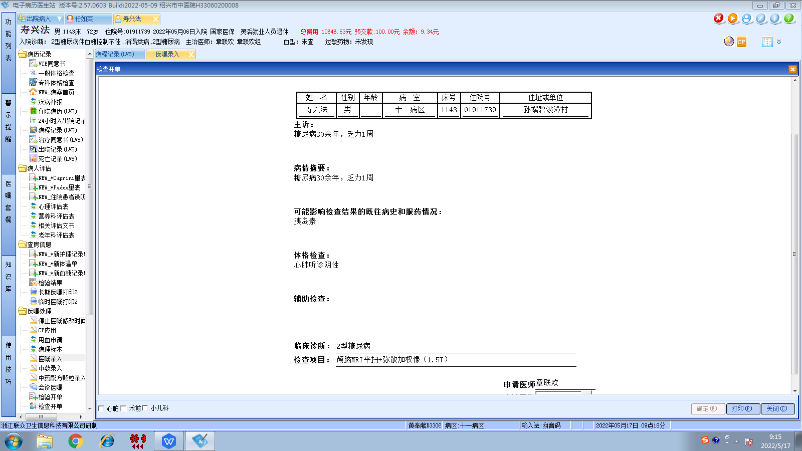章联欢组
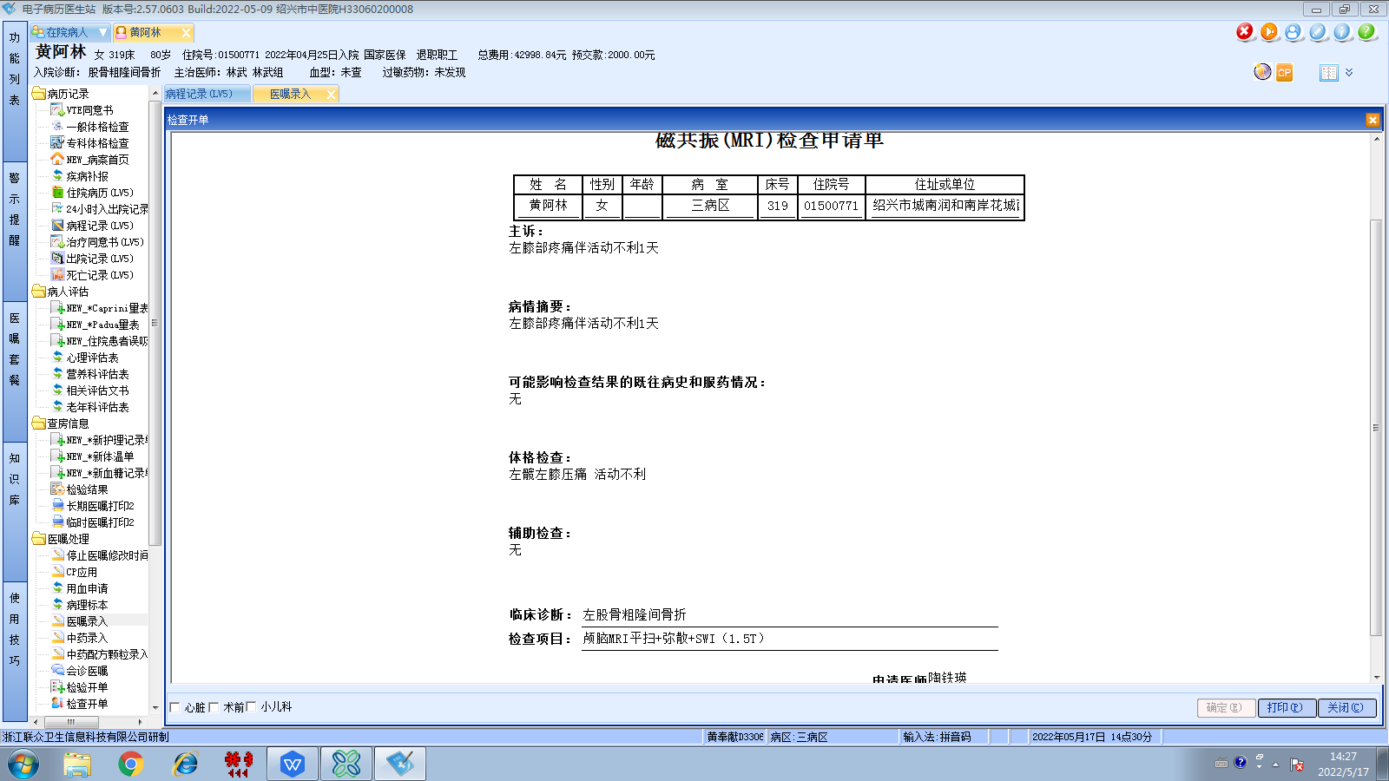林武组
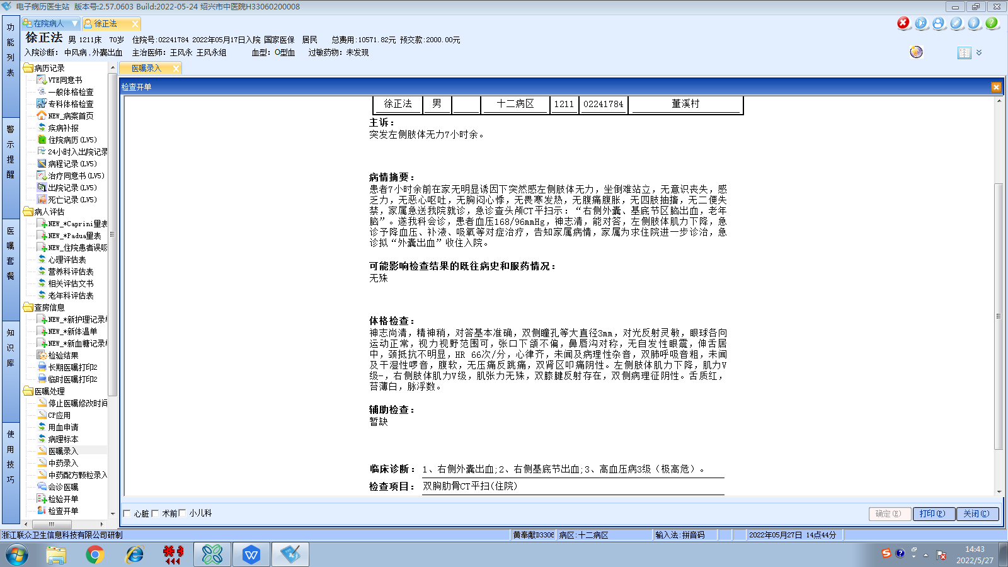王风永组
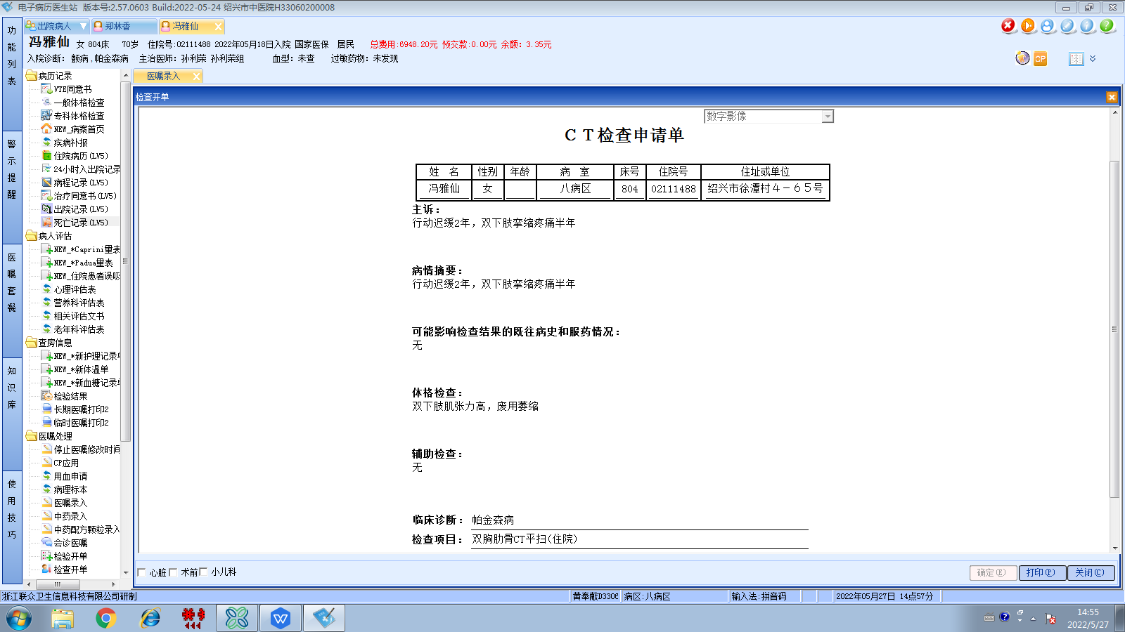孙利荣组
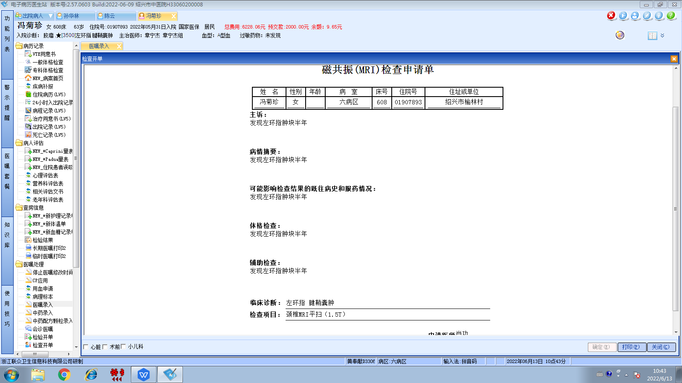章宁杰组
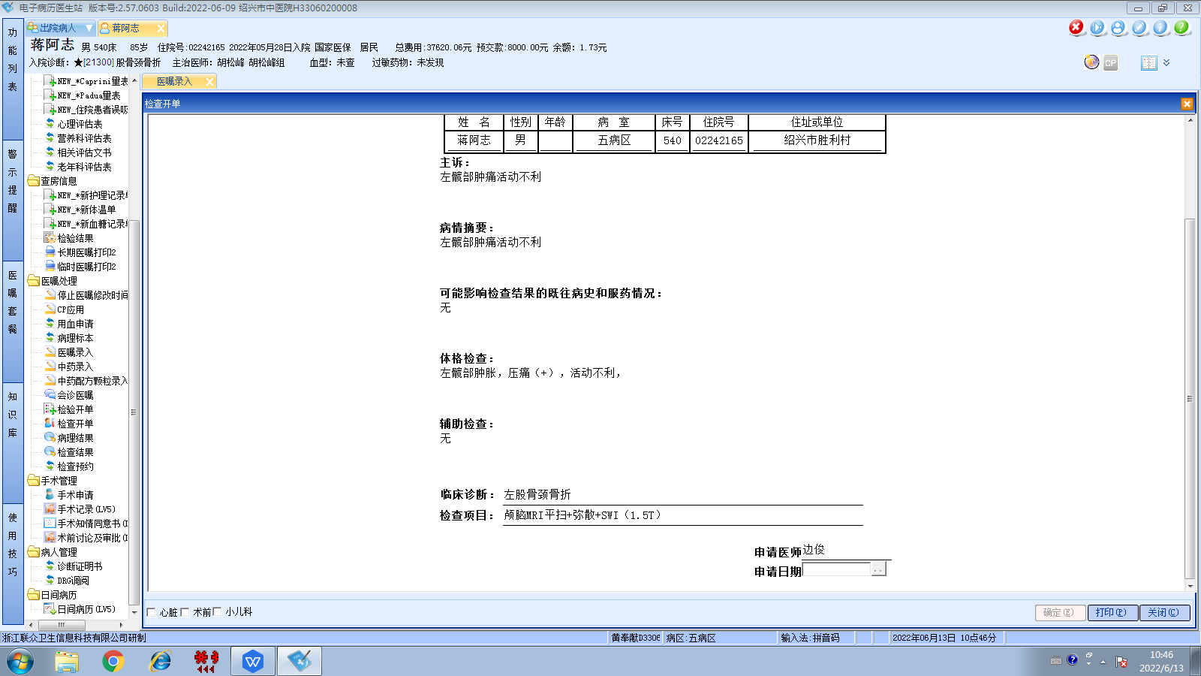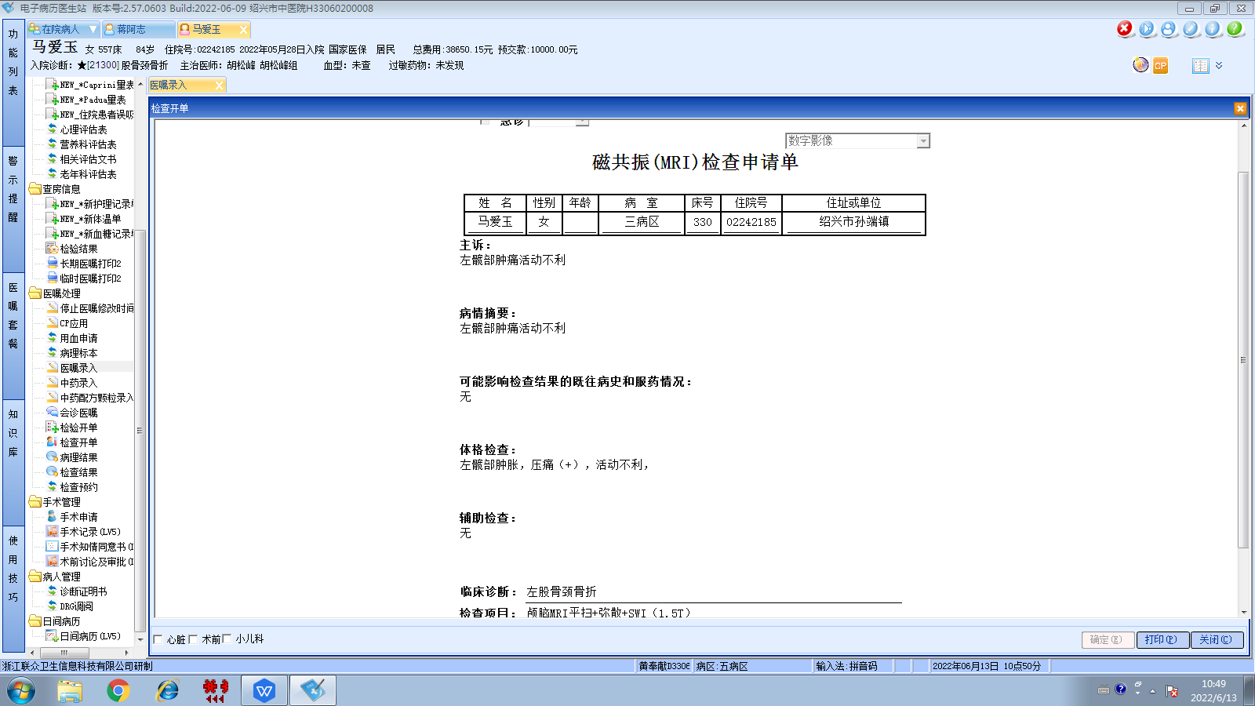胡松峰组
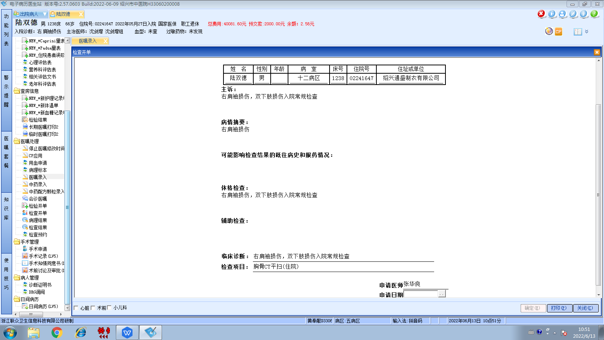沈剑增组
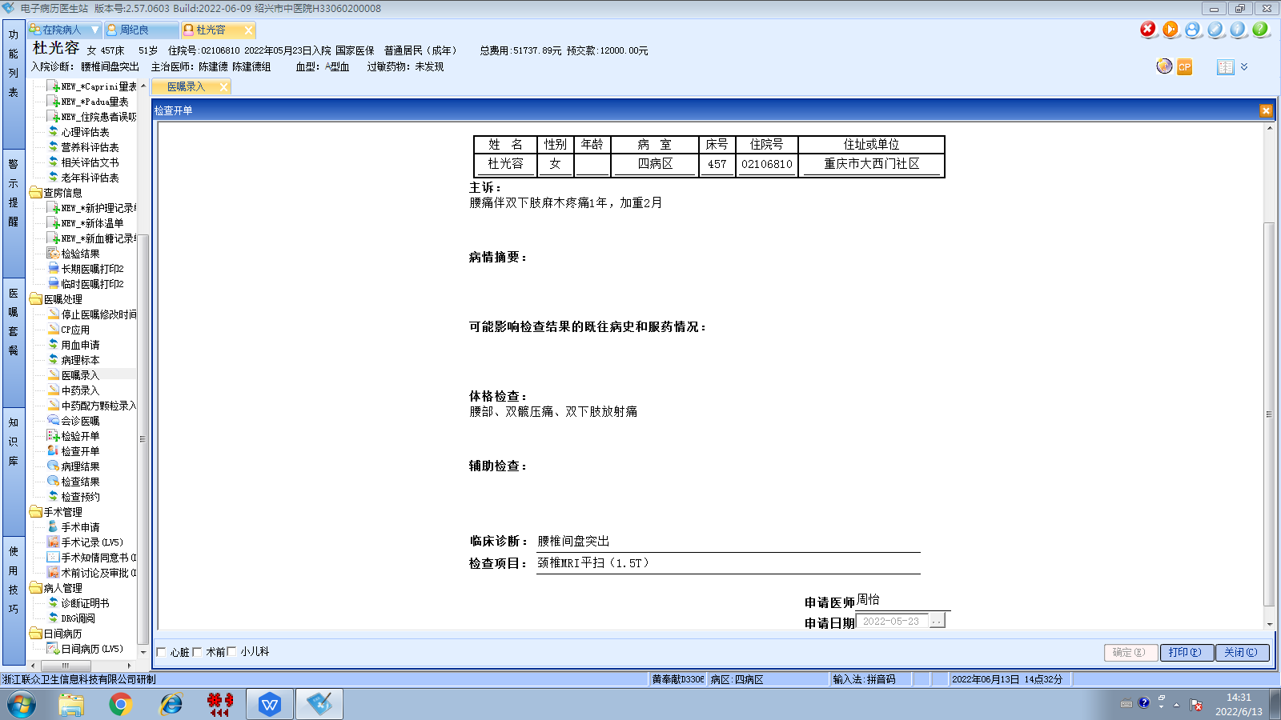陈建德组

