6月检查申请单质控
住院号 | 检查单类型 | 开单日期 | 开单医师 | 检查项目
 |  |  |  | 主诉 | 病情摘要 | 既往史 | 体格检查 | 辅助检查 | 诊断 | 内容申请单不一致
01512831 | MR | 2022-5-29 | 章联欢 | √ | √ | √ | √ | √ | √ | √
01512831 | MR | 2022-6-3 | 孙莉 | √ | √ | √ | √ | √ | √ | √
02242146 | MR | 2022-5-29 | 朱观祥 | √ | √ | √ | √ | √ | √ | √
02242269 | MR | 2022-5-31 | 徐芳 | √ | √ | √ | √ | √ | √ | √
02242318 | CT | 2022-6-1 | 王风永 | √ | √ | √ | √ | √ | √ | √
01905782 | MR | 2022-6-1 | 尤志新 | √ | √ | √ | √ | √ | √ | √
02111077 | CT | 2022-6-2 | 夏炳江 | √ | √ | √ | √ | √ | √ | √
01900415 | MR | 2022-6-1 | 沈剑增 | √ | √ | √ | √ | √ | √ | √
02242336 | CT/MR | 2022-6-2 | 陈剑磨 | √ | √ | √ | √ | √ | √ | √
02242228 | CT | 2022-6-4 | 王冰清 | √ | √ | √ | √ | √ | √ | √
02242071 | CT | 2022-6-4 | 赵雄碧 | √ | √ | √ | √ | √ | √ | √
02242230 | MR | 2022-6-3 | 朱海波 | √ | √ | √ | √ | √ | √ | √
01915521 | MR | 2022-6-3 | 孙莉 | √ | √ | √ | √ | √ | √ | √
01907873 | MR | 2022-6-6 | 沈兴潮 | √ | √ | √ | √ | √ | √ | √
01901464 | MR | 2022-6-6 | 王磊 | √ | √ | √ | √ | √ | √ | √
02242182 | CT | 2022-6-6 | 马军华 | √ | √ | √ | √ | √ | √ | √
02242327 | MR | 2022-6-3 | 朱海波 | √ | √ | √ | √ | √ | √ | √
02242455 | MR | 2022-6-5 | 王立刚 | √ | √ | √ | √ | √ | √ | √
02242404 | MR | 2022-6-3 | 陈剑磨 | √ | √ | √ | √ | √ | √ | ×
02242569 | MR | 2022-6-7 | 陈剑磨 | √ | √ | √ | √ | √ | √ | ×
02242487 | MR | 2022-6-6 | 谢立江 | √ | √ | √ | √ | √ | √ | √
01902421 | MR | 2022-6-5 | 孙莉 | √ | √ | √ | √ | √ | √ | √
01609458 | CT | 2022-6-5 | 刘潇 | √ | √ | √ | √ | √ | √ | √
02242542 | CT | 2022-6-7 | 管仕强 | √ | √ | √ | √ | √ | √ | √
02242332 | MR | 2022-6-3 | 孙莉 | √ | √ | √ | √ | √ | √ | √
02242504 | MR | 2022-6-6 | 周怡 | √ | √ | √ | √ | √ | √ | √
02238463 | MR | 2022-6-7 | 刘兆龙 | √ | √ | √ | √ | √ | √ | √
01916420 | MR | 2022-6-6 | 刘运海 | √ | √ | √ | √ | √ | √ | √
02242462 | MR | 2022-6-6 | 罗桢敏 | √ | √ | √ | √ | √ | √ | √
02242430 | MR | 2022-6-8 | 罗桢敏 | √ | √ | √ | √ | √ | √ | √
02242391 | MR | 2022-6-7 | 魏平洋 | √ | √ | √ | √ | √ | √ | ×
02106760 | MR | 2022-6-10 | 孙莉 | √ | √ | √ | √ | √ | √ | √
02105925 | CT | 2022-6-9 | 孙莉 | √ | √ | √ | √ | √ | √ | √
02102759 | MR | 2022-6-8 | 张建宇 | √ | √ | √ | √ | √ | √ | √
02242668 | CT | 2022-6-10 | 黄加鑫 | √ | √ | √ | √ | √ | √ | √
02242589 | MR | 2022-6-11 | 沈剑增 | √ | √ | √ | √ | √ | √ | √
02242474 | CT | 2022-6-7 | 刘依兰 | √ | √ | √ | √ | √ | √ | √
02242580 | MR | 2022-6-9 | 许杨 | √ | √ | √ | √ | √ | √ | √
01514082 | CT | 2022-6-13 | 刘浩飞 | √ | √ | √ | √ | √ | √ | √
02003529 | CT | 2022-6-14 | 何薇 | √ | √ | √ | √ | √ | √ | √
01502664 | MR | 2022-6-9 | 葛剑洪 | √ | √ | √ | √ | √ | √ | √
02242750 | MR | 2022-6-12 | 钟承隽 | √ | √ | √ | √ | √ | √ | ×
01809757 | CT | 2022-6-14 | 谢睿 | √ | √ | √ | √ | √ | √ | √
02242612 | MR | 2022-6-10 | 陈剑磨 | √ | √ | √ | √ | √ | √ | √
02242626 | MR | 2022-6-9 | 黄加鑫 | √ | √ | √ | √ | √ | √ | √
02242638 | MR | 2022-6-11 | 龙平 | √ | √ | √ | √ | √ | √ | √
02242569 | CT | 2022-6-15 | 谢峰 | √ | √ | √ | √ | √ | √ | √
02242756 | MR | 2022-6-13 | 田悦越 | √ | √ | √ | √ | √ | √ | √
02242757 | MR | 2022-6-12 | 沈家峰 | √ | √ | √ | √ | √ | √ | √
01410625 | MR | 2022-6-11 | 许伟攀 | √ | √ | √ | √ | √ | √ | √
01410625 | CT | 2022-6-17 | 黄加鑫 | √ | √ | √ | √ | √ | √ | √
02242798 | CT | 2022-6-16 | 刘俊琼 | √ | √ | √ | √ | √ | √ | √
02242798 | CT | 2022-6-16 | 孙利荣 | √ | √ | √ | √ | √ | √ | √
02108851 | MR | 2022-6-13 | 沈剑增 | √ | √ | √ | √ | √ | √ | √
02242850 | CT | 2022-6-16 | 张澍漾 | √ | √ | √ | √ | √ | √ | √
01804112 | MR | 2022-6-14 | 边俊 | √ | √ | √ | √ | √ | √ | √
01903490 | CT | 2022-6-17 | 谢睿 | √ | √ | √ | √ | √ | √ | √
02242792 | MR | 2022-6-14 | 裘鸿飞 | √ | √ | √ | √ | √ | √ | √
02242820 | MR | 2022-6-14 | 张华良 | √ | √ | √ | √ | √ | √ | √
01304448 | CT | 2022-6-17 | 赵雄碧 | √ | √ | √ | √ | √ | √ | √
01715171 | MR | 2022-6-16 | 葛剑洪 | √ | √ | √ | √ | √ | √ | √
02242876 | MR | 2022-6-15 | 张梦娇 | √ | √ | √ | √ | √ | √ | √
02243017 | MR | 2022-6-19 | 张建宇 | √ | √ | √ | √ | √ | √ | √
02243018 | MR | 2022-6-19 | 张建宇 | √ | √ | √ | √ | √ | √ | √
02243019 | MR | 2022-6-19 | 张建宇 | √ | √ | √ | √ | √ | √ | ×
01912087 | CT | 2022-6-19 | 何银银 | √ | √ | √ | √ | √ | √ | √
02240847 | CT | 2022-6-18 | 罗桢敏 | √ | √ | √ | √ | √ | √ | √
02242934 | MR | 2022-6-17 | 孙莉 | √ | √ | √ | √ | √ | √ | √
02006153 | MR | 2022-6-16 | 孙莉 | √ | √ | √ | √ | √ | √ | √
01915546 | MR | 2022-6-17 | 孙莉 | √ | √ | √ | √ | √ | √ | √
02006611 | CT | 2022-6-21 | 吴智敏 | √ | √ | √ | √ | √ | √ | √
02243000 | MR | 2022-6-18 | 王磊 | √ | √ | √ | √ | √ | √ | √
02242995 | MR | 2022-6-21 | 罗桢敏 | √ | √ | √ | √ | √ | √ | √
02243081 | MR | 2022-6-21 | 马军华 | √ | √ | √ | √ | √ | √ | √
02243059 | CT | 2022-6-22 | 章联欢 | √ | √ | √ | √ | √ | √ | √
02242966 | MR | 2022-6-19 | 冯水娟 | √ | √ | √ | √ | √ | √ | √
02243096 | CT | 2022-6-23 | 谢铭 | √ | √ | √ | √ | √ | √ | √
02242998 | MR | 2022-6-21 | 何薇 | √ | √ | √ | √ | √ | √ | √
02243026 | MR | 2022-6-19 | 孙莉 | √ | √ | √ | √ | √ | √ | √
02107419 | CT | 2022-6-22 | 刘磊 | √ | √ | √ | √ | √ | √ | √
01914237 | MR | 2022-6-22 | 金少威 | √ | √ | √ | √ | √ | √ | √
01804783 | CT | 2022-6-23 | 周怡 | √ | √ | √ | √ | √ | √ | √
01602320 | MR | 2022-6-20 | 王冰清 | √ | √ | √ | √ | √ | √ | √
02243110 | CT | 2022-6-24 | 徐芳 | √ | √ | √ | √ | √ | √ | √
02243176 | MR | 2022-6-25 | 孙莉 | √ | √ | √ | √ | √ | √ | √
01805534 | CT | 2022-6-25 | 赵雄碧 | √ | √ | √ | √ | √ | √ | √
02001411 | MR | 2022-6-23 | 何薇 | √ | √ | √ | √ | √ | √ | √
02242843 | CT | 2022-6-26 | 陆超锋 | √ | √ | √ | √ | √ | √ | ×
01808859 | CT | 2022-6-24 | 王磊 | √ | √ | √ | √ | √ | √ | √
02003588 | CT | 2022-6-25 | 裘鸿飞 | √ | √ | √ | √ | √ | √ | √
02243201 | CT | 2022-6-27 | 赵艳明 | √ | √ | √ | √ | √ | √ | √
02002948 | CT | 2022-6-27 | 林武 | √ | √ | √ | √ | √ | √ | √
02243186 | MR | 2022-6-27 | 尤志新 | √ | √ | √ | √ | √ | √ | √
02243186 | CT | 2022-6-28 | 尤志新 | √ | √ | √ | √ | √ | √ | √
02243172 | MR | 2022-6-26 | 夏炳江 | √ | √ | √ | √ | √ | √ | √
01900507 | CT | 2022-6-27 | 孙利荣 | √ | √ | √ | √ | √ | √ | √
02007833 | MR | 2022-6-27 | 王洪灿 | √ | √ | √ | √ | √ | √ | √
02243241 | MR | 2022-6-28 | 周怡 | √ | √ | √ | √ | √ | √ | √
02242855 | CT | 2022-6-28 | 张梦娇 | √ | √ | √ | √ | √ | √ | ×
01914122 | MR | 2022-6-28 | 张建宇 | √ | √ | √ | √ | √ | √ | √
02243209 | CT | 2022-6-26 | 王风永 | √ | √ | √ | √ | √ | √ | √
02243394 | CT | 2022-6-29 | 赵艳明 | √ | √ | √ | √ | √ | √ | √
02243313 | MR | 2022-6-29 | 尤志新 | √ | √ | √ | √ | √ | √ | √
01506312 | CT | 2022-6-30 | 沈英 | √ | √ | √ | √ | √ | √ | ×
注：对住院患者检查申请单进行专项检查，其中主诉、体格检查或诊断任缺一项者视为不合格申请单；非入院常规检查，如申请单内容与检查部位及要求不一致，亦视为不合格申请单。
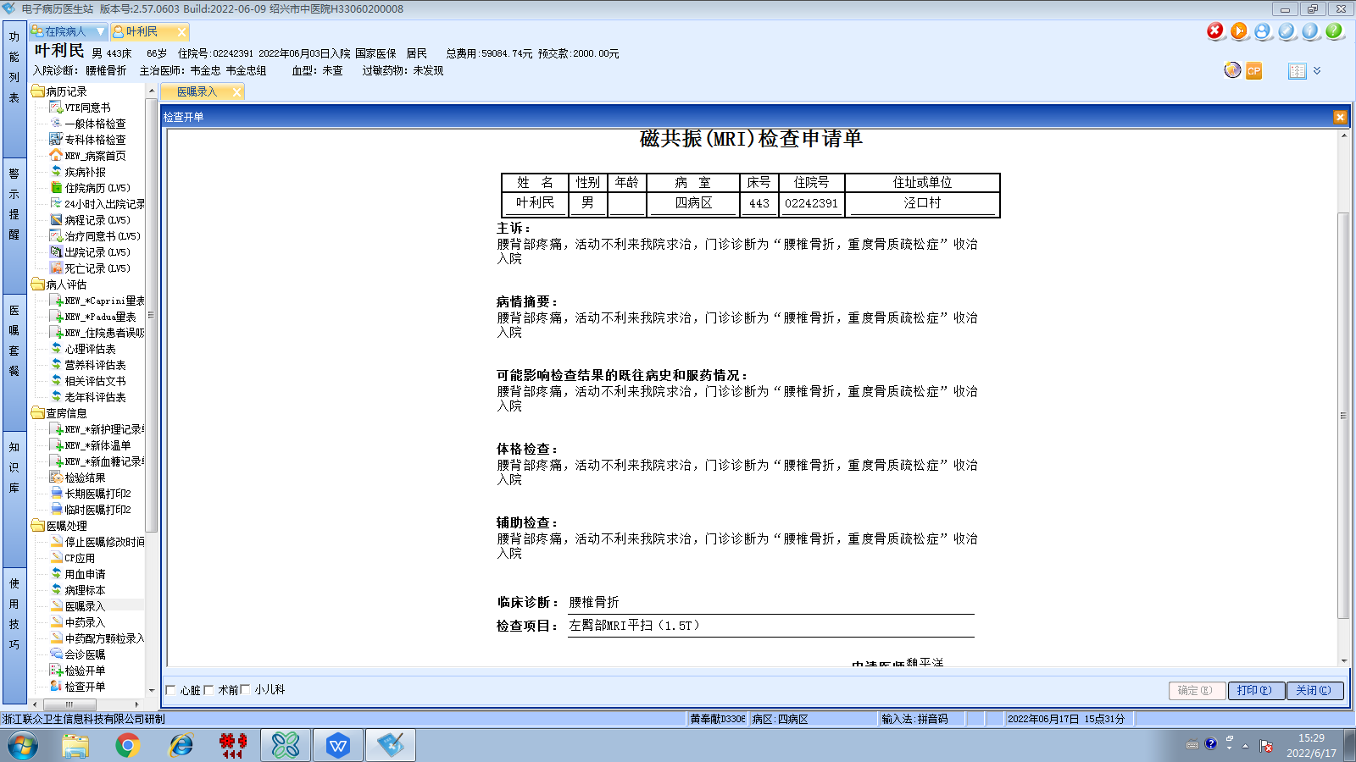韦金忠组
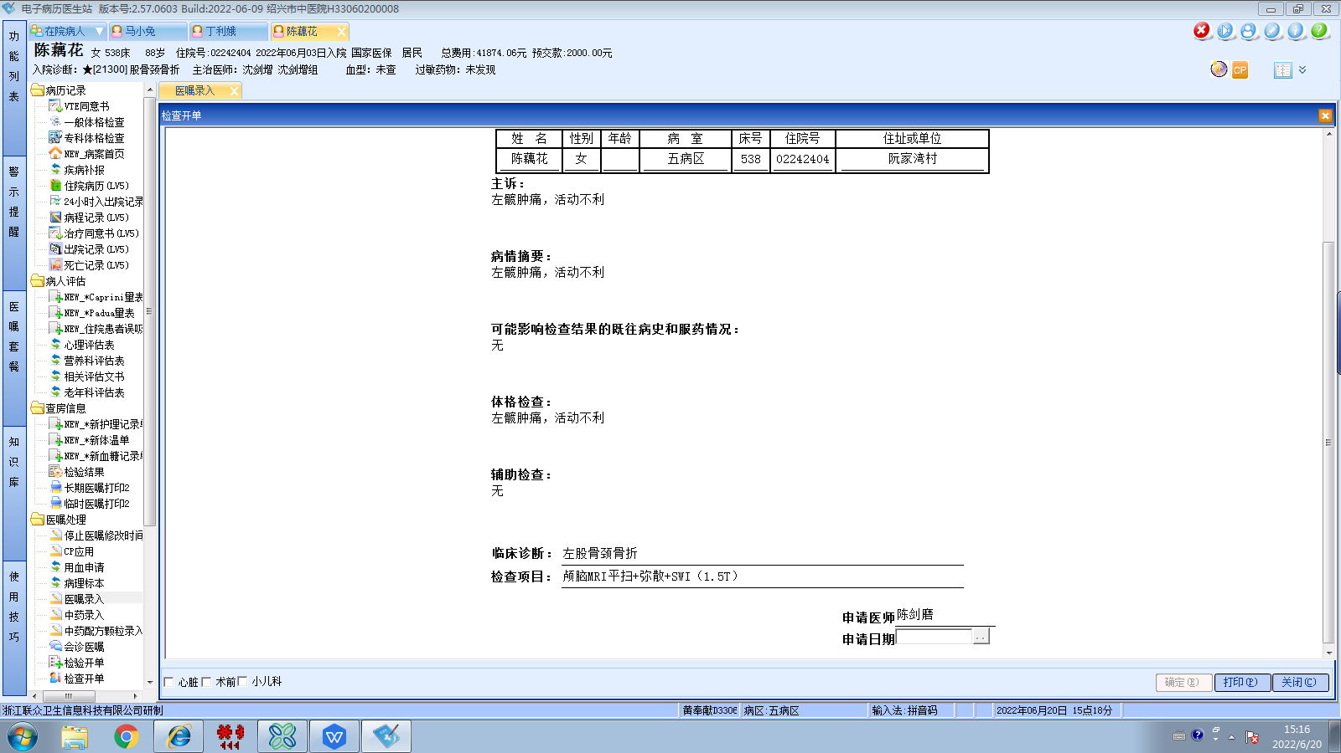沈剑增组
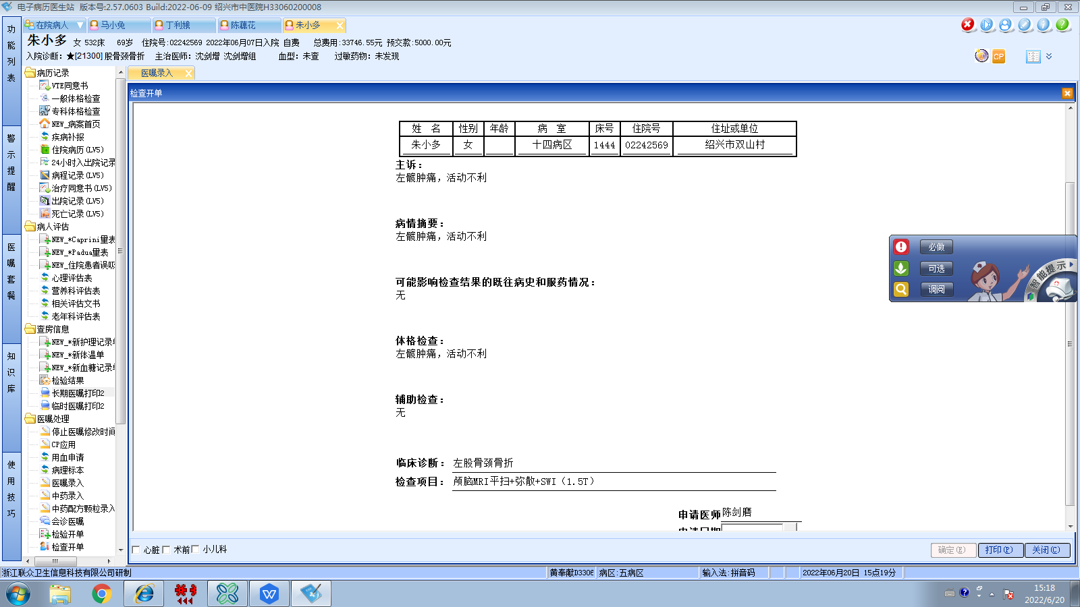沈剑增组
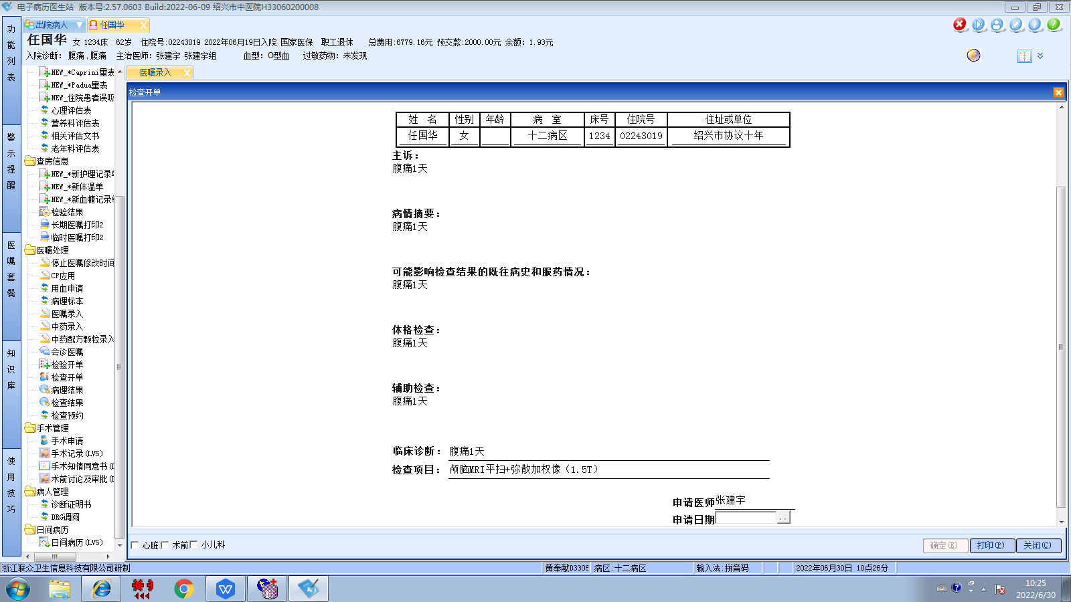张建宇组
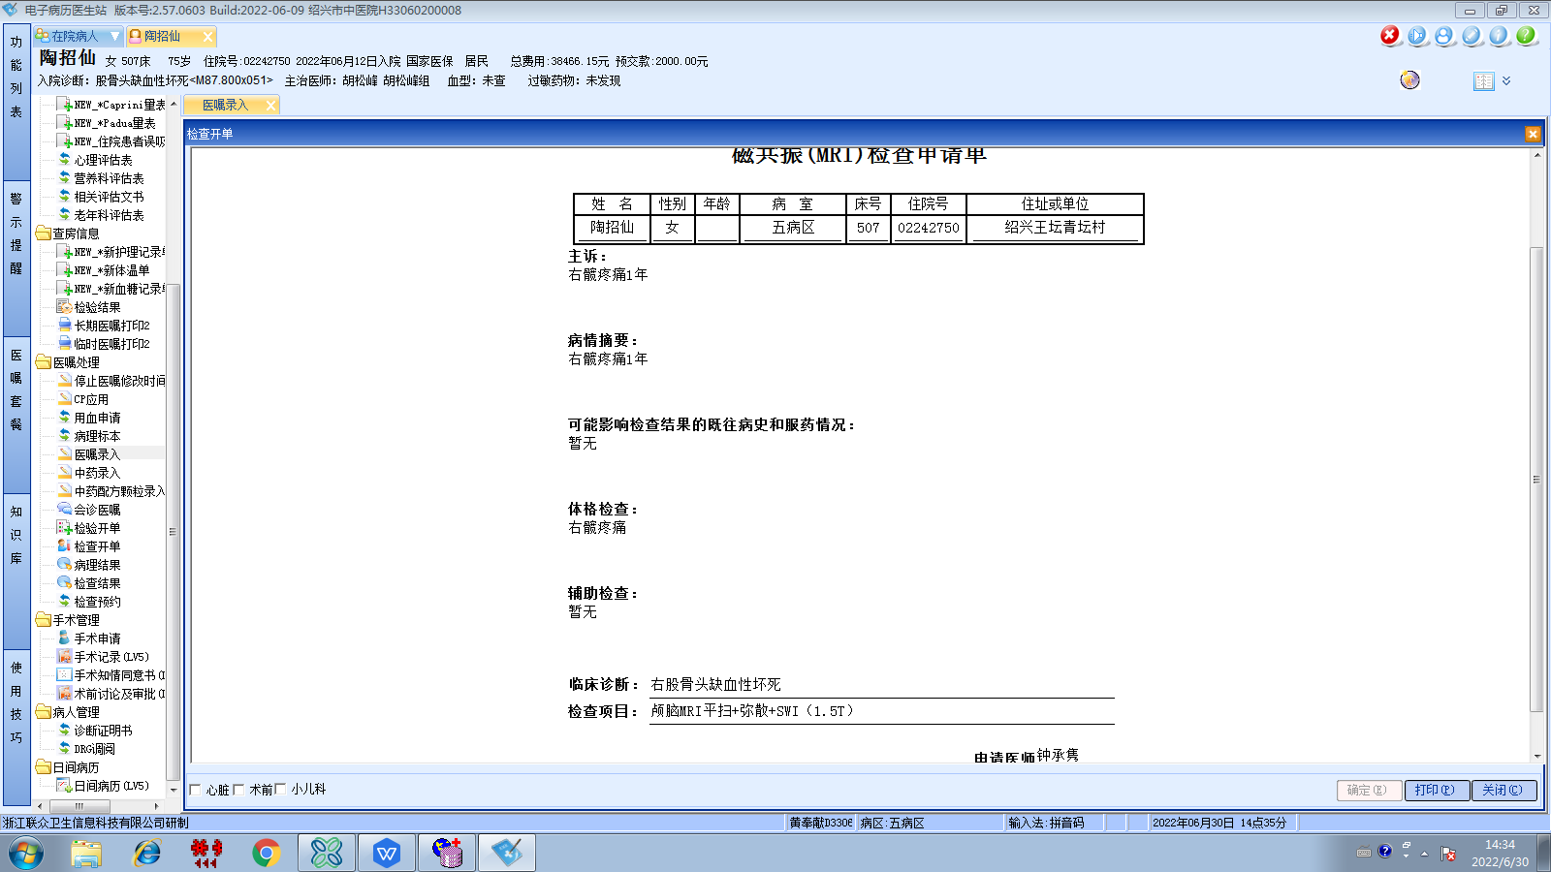胡松峰组
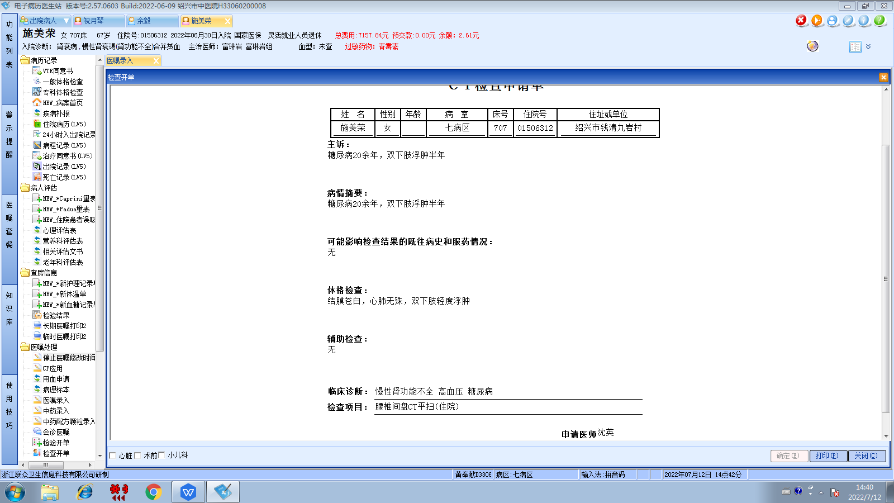富琳岩组
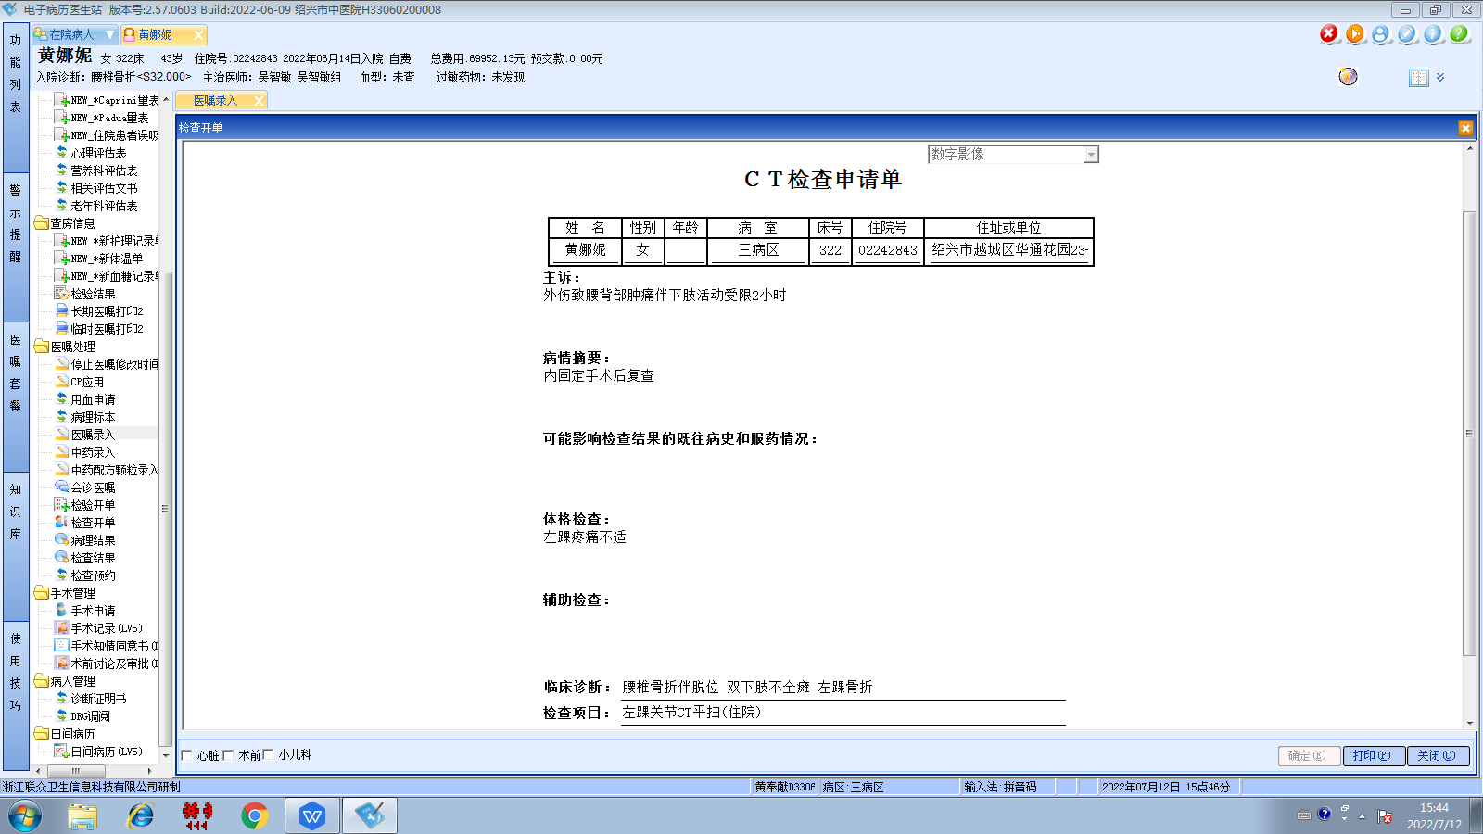吴智敏组
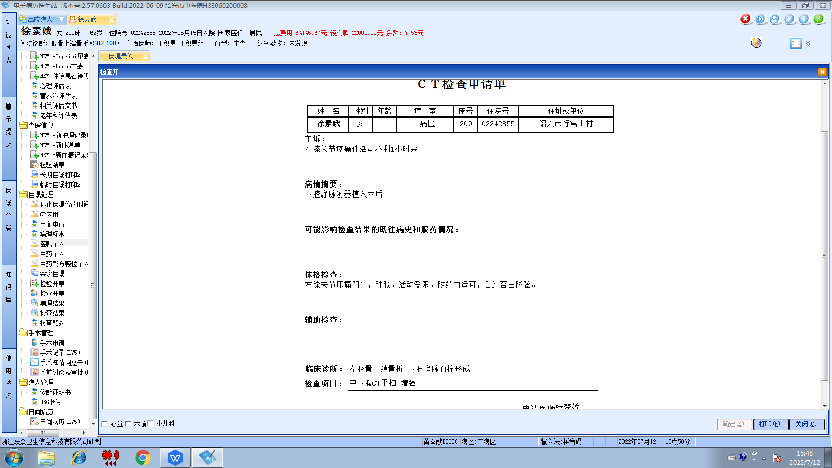丁积勇组
