7月检查申请单质控
住院号 | 检查单类型 | 开单日期 | 开单医师 |  |  | 检查项目
 |  |  |  | 主诉 | 病情摘要 |  | 既往史 | 体格检查 | 辅助检查 | 诊断 | 内容申请单不一致
02112119 | CT | 2022-6-29 | 沈兴潮 | √ | √ |  | √ | √ | √ | √ | √
02112119 | CT | 2022-6-30 | 周怡 | √ | √ |  | √ | √ | √ | √ | √
02243365 | MR | 2022-6-29 | 王冰清 | √ | √ |  | √ | √ | √ | √ | √
02243365 | CT | 2022-7-1 | 孙莉 | √ | √ |  | √ | √ | √ | √ | √
01710061 | CT | 2022-6-30 | 章村田 | √ | √ |  | √ | √ | √ | √ | √
01601012 | MR | 2022-7-1 | 孙利荣 | √ | √ |  | √ | √ | √ | √ | √
01914588 | CT | 2022-7-2 | 朱大明 | √ | √ |  | √ | √ | √ | √ | √
02006949 | MR | 2022-7-1 | 王轶辉 | √ | √ |  | √ | √ | √ | √ | √
02243381 | MR | 2022-7-1 | 吴智敏 | √ | √ |  | √ | √ | √ | √ | √
01911904 | MR | 2022-7-3 | 何薇 | √ | √ |  | √ | √ | √ | √ | ×
01911904 | CT | 2022-7-6 | 王一萍 | √ | √ |  | √ | √ | √ | √ | √
02239730 | MR | 2022-7-3 | 陆超锋 | √ | √ |  | √ | √ | √ | √ | √
02105883 | CT | 2022-7-5 | 王冰清 | √ | √ |  | √ | √ | √ | √ | √
02105883 | MR | 2022-7-4 | 王冰清 | √ | √ |  | √ | √ | √ | √ | √
02243509 | MR | 2022-7-5 | 裘鸿飞 | √ | √ |  | √ | √ | √ | √ | √
01914016 | CT | 2022-7-5 | 罗桢敏 | √ | √ |  | √ | √ | √ | √ | √
02243537 | MR | 2022-7-6 | 陶铁瑛 | √ | √ |  | √ | √ | √ | √ | √
02243596 | MR | 2022-7-5 | 叶玲玲 | √ | √ |  | √ | √ | √ | √ | √
02243593 | MR | 2022-7-7 | 何薇 | √ | √ |  | √ | √ | √ | √ | √
02001688 | CT | 2022-7-7 | 肖功 | √ | √ |  | √ | √ | √ | √ | √
01807608 | CT | 2022-7-6 | 许杨 | √ | √ |  | √ | √ | √ | √ | √
01511820 | CT | 2022-7-6 | 张梦娇 | √ | × |  | × | √ | × | √ | ×
02243433 | MR | 2022-7-5 | 魏平洋 | √ | √ |  | √ | √ | √ | √ | √
02243622 | CT | 2022-7-8 | 何易 | √ | √ |  | √ | √ | √ | √ | √
02243622 | MR | 2022-7-7 | 王一萍 | √ | √ |  | √ | √ | √ | √ | √
02243530 | MR | 2022-7-6 | 何建明 | √ | √ |  | √ | √ | √ | √ | ×
02243599 | MR | 2022-7-6 | 吴菲 | √ | √ |  | √ | √ | √ | √ | √
01701789 | MR | 2022-7-5 | 王冰清 | √ | √ |  | √ | √ | √ | √ | √
02243608 | MR | 2022-7-6 | 陈剑磨 | √ | √ |  | √ | √ | √ | √ | √
02107400 | MR | 2022-7-7 | 孙莉 | √ | √ |  | √ | √ | √ | √ | √
01312963 | CT | 2022-7-3 | 柴绍军 | √ | √ |  | √ | √ | √ | √ | √
02007451 | CT | 2022-7-8 | 王立刚 | √ | √ |  | √ | √ | √ | √ | √
02243631 | CT | 2022-7-7 | 章村田 | √ | √ |  | √ | √ | √ | √ | √
01713869 | CT | 2022-7-8 | 陆超锋 | √ | √ |  | √ | √ | √ | √ | √
01411182 | CT | 2022-7-7 | 罗桢敏 | √ | √ |  | √ | √ | √ | √ | √
02243706 | CT | 2022-7-8 | 魏平洋 | √ | √ |  | √ | √ | √ | √ | √
01912211 | CT | 2022-7-7 | 杨锋 | √ | √ |  | √ | √ | √ | √ | √
01712615 | CT | 2022-7-7 | 凌一鸣 | √ | × |  | × | √ | × | √ | ×
01602320 | CT | 2022-7-7 | 孙莉 | √ | √ |  | √ | √ | √ | √ | √
01505271 | CT | 2022-7-8 | 周怡 | √ | √ |  | √ | √ | √ | √ | √
02243686 | CT | 2022-7-8 | 何易 | √ | √ |  | √ | √ | √ | √ | √
01908870 | CT | 2022-7-12 | 许杨 | √ | √ |  | √ | √ | √ | √ | √
02243736 | MR | 2022-7-9 | 孙莉 | √ | √ |  | √ | √ | √ | √ | √
02001013 | CT | 2022-7-13 | 王一萍 | √ | √ |  | √ | √ | √ | √ | √
02243865 | CT/MR | 2022-7-13 | 谢睿 | √ | √ |  | √ | √ | √ | √ | ×
02243706 | MR | 2022-7-12 | 许杨 | √ | √ |  | √ | √ | √ | √ | √
02243770 | MR | 2022-7-11 | 张澍漾 | √ | √ |  | √ | √ | √ | √ | √
02243756 | CT | 2022-7-12 | 许杨 | √ | √ |  | √ | √ | √ | √ | √
01710656 | MR | 2022-7-15 | 王冰清 | √ | √ |  | √ | √ | √ | √ | √
02104970 | CT | 2022-7-11 | 朱观祥 | √ | √ |  | √ | √ | √ | √ | √
02110861 | CT | 2022-7-15 | 张春晓 | √ | √ |  | √ | √ | √ | √ | √
02243929 | MR | 2022-7-14 | 赵雄碧 | √ | √ |  | √ | √ | √ | √ | √
02243893 | MR | 2022-7-13 | 陶铁瑛 | √ | √ |  | √ | √ | √ | √ | √
02243996 | CT | 2022-7-16 | 刘悦 | √ | √ |  | √ | √ | √ | √ | ×
02243863 | MR | 2022-7-14 | 谢铭 | √ | √ |  | √ | √ | √ | √ | √
02111766 | CT | 2022-7-13 | 何薇 | √ | √ |  | √ | √ | √ | √ | √
01709572 | CT | 2022-7-11 | 谢睿 | √ | √ |  | √ | √ | √ | √ | √
01709572 | MR | 2022-7-13 | 谢睿 | √ | √ |  | √ | √ | √ | √ | √
02243866 | CT | 2022-7-15 | 王风永 | √ | √ |  | √ | √ | √ | √ | ×
02243982 | CT | 2022-7-17 | 夏炳江 | √ | √ |  | √ | √ | √ | √ | √
01901404 | CT | 2022-7-14 | 尤志新 | √ | √ |  | √ | √ | √ | √ | √
02243891 | MR | 2022-7-15 | 陈琦军 | √ | √ |  | √ | √ | √ | √ | √
01907996 | MR | 2022-7-18 | 王冰清 | √ | √ |  | √ | √ | √ | √ | √
01513491 | MR | 2022-7-15 | 王冰清 | √ | √ |  | √ | √ | √ | √ | √
02244071 | CT | 2022-7-18 | 魏平洋 | √ | √ |  | √ | √ | √ | √ | √
02244053 | CT/MR | 2022-7-19 | 王冰清 | √ | √ |  | √ | √ | √ | √ | √
02244100 | MR | 2022-7-19 | 王冰清 | √ | √ |  | √ | √ | √ | √ | √
02243939 | MR | 2022-7-15 | 刘潇 | √ | √ |  | √ | √ | √ | √ | √
01815957 | MR | 2022-7-17 | 孙莉 | √ | √ |  | √ | √ | √ | √ | √
01815956 | MR | 2022-7-17 | 孙莉 | √ | √ |  | √ | √ | √ | √ | √
02243926 | MR | 2022-7-18 | 陆超锋 | √ | √ |  | √ | √ | √ | √ | √
02100863 | MR | 2022-7-18 | 黄加鑫 | √ | √ |  | √ | √ | √ | √ | ×
02243836 | MR | 2022-7-20 | 张华良 | √ | √ |  | √ | √ | √ | √ | √
01902777 | CT | 2022-7-18 | 裘鸿飞 | √ | √ |  | √ | √ | √ | √ | √
02244053 | MR | 2022-7-18 | 王冰清 | √ | √ |  | √ | √ | √ | √ | √
02244057 | MR | 2022-7-18 | 王冰清 | √ | √ |  | √ | √ | √ | √ | √
02244057 | MR | 2022-7-19 | 王冰清 | √ | √ |  | √ | √ | √ | √ | √
01916294 | MR | 2022-7-18 | 边佳萍 | √ | √ |  | √ | √ | √ | √ | √
02100103 | CT | 2022-7-22 | 沈英 | √ | √ |  | √ | √ | √ | √ | √
02007924 | MR | 2022-7-19 | 陶铁瑛 | √ | √ |  | √ | √ | √ | √ | √
02244119 | MR | 2022-7-21 | 何易 | √ | √ |  | √ | √ | √ | √ | √
02244119 | CT | 2022-7-25 | 何易 | √ | √ |  | √ | √ | √ | √ | √
02244161 | MR | 2022-7-21 | 陈琦军 | √ | √ |  | √ | √ | √ | √ | √
02244191 | MR | 2022-7-22 | 孙莉 | √ | √ |  | √ | √ | √ | √ | √
01608980 | MR | 2022-7-22 | 裘鸿飞 | √ | √ |  | √ | √ | √ | √ | √
02244174 | MR | 2022-7-21 | 周怡 | √ | √ |  | √ | √ | √ | √ | √
02107404 | MR | 2022-7-23 | 樊晓琦 | √ | √ |  | √ | √ | √ | √ | √
02243984 | CT | 2022-7-24 | 刘依兰 | √ | √ |  | √ | √ | √ | √ | √
02212361 | CT | 2022-7-22 | 裘鸿飞 | √ | √ |  | √ | √ | √ | √ | √
02244132 | MR | 2022-7-23 | 刘悦 | √ | √ |  | √ | √ | √ | √ | √
02244229 | CT | 2022-7-23 | 朱海波 | √ | √ |  | √ | √ | √ | √ | √
02244051 | CT | 2022-7-23 | 谢立江 | √ | √ |  | √ | √ | √ | √ | √
02244294 | MR | 2022-7-24 | 王一萍 | √ | √ |  | √ | √ | √ | √ | √
01704203 | MR | 2022-7-25 | 王冰清 | √ | √ |  | √ | √ | √ | √ | √
01704203 | CT | 2022-7-26 | 孙莉 | √ | √ |  | √ | √ | √ | √ | √
01311467 | CT | 2022-7-25 | 裘鸿飞 | √ | √ |  | √ | √ | √ | √ | √
02102761 | MR | 2022-7-25 | 徐芳 | √ | √ |  | √ | √ | √ | √ | √
01914026 | CT | 2022-7-26 | 何薇 | √ | √ |  | √ | √ | √ | √ | √
02102996 | MR | 2022-7-25 | 秦培芝 | √ | √ |  | √ | √ | √ | √ | √
02104443 | MR | 2022-7-25 | 何易 | √ | √ |  | √ | √ | √ | √ | √
02238137 | MR | 2022-7-26 | 魏平洋 | √ | √ |  | √ | √ | √ | √ | √
02244383 | MR | 2022-7-27 | 张澍漾 | √ | √ |  | √ | √ | √ | √ | √
02244383 | CT | 2022-7-28 | 张澍漾 | √ | √ |  | √ | √ | √ | √ | √
02244369 | MR | 2022-7-27 | 王冰清 | √ | √ |  | √ | √ | √ | √ | √
02244369 | CT | 2022-7-29 | 王冰清 | √ | √ |  | √ | √ | √ | √ | √
02244402 | MR | 2022-7-27 | 沈兴潮 | √ | √ |  | √ | √ | √ | √ | √
01809161 | CT | 2022-7-27 | 尤志新 | √ | √ |  | √ | √ | √ | √ | √
02244333 | CT | 2022-7-26 | 许杨 | √ | √ |  | √ | √ | √ | √ | √
02244349 | MR | 2022-7-27 | 冯水娟 | √ | √ |  | √ | √ | √ | √ | √
02244348 | MR | 2022-7-27 | 冯水娟 | √ | √ |  | √ | √ | √ | √ | √
02244394 | CT | 2022-7-27 | 许杨 | √ | √ |  | √ | √ | √ | √ | √
01510547 | CT | 2022-7-29 | 王冰清 | √ | √ |  | √ | √ | √ | √ | √
01602844 | MR | 2022-7-28 | 叶玲玲 | √ | √ |  | √ | √ | √ | √ | √
02244421 | MR | 2022-7-28 | 边佳萍 | √ | √ |  | √ | √ | √ | √ | √
02244367 | MR | 2022-7-29 | 谢峰 | √ | √ |  | √ | √ | √ | √ | √
02244519 | MR | 2022-7-30 | 谢峰 | √ | √ |  | √ | √ | √ | √ | √
02242871 | CT | 2022-7-30 | 黎村丰 | √ | √ |  | √ | √ | √ | √ | √
01911615 | MR | 2022-7-30 | 刘运海 | √ | √ |  | √ | √ | √ | √ | √
02244453 | CT | 2022-7-30 | 王冰清 | √ | √ |  | √ | √ | √ | √ | √
注：对住院患者检查申请单进行专项检查，其中主诉、体格检查或诊断任缺一项者视为不合格申请单；非入院常规检查，如申请单内容与检查部位及要求不一致，亦视为不合格申请单。
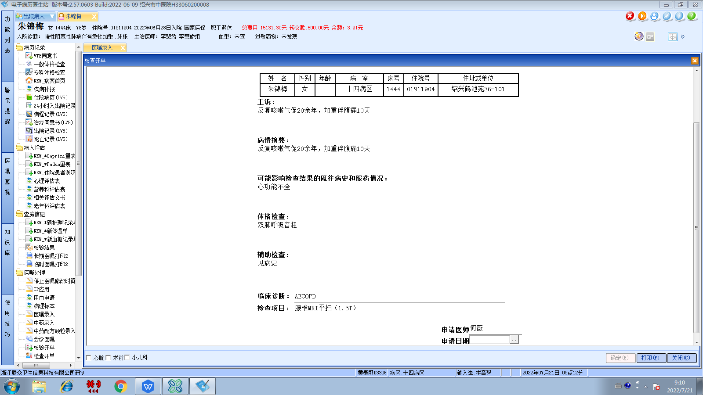李慧娇组
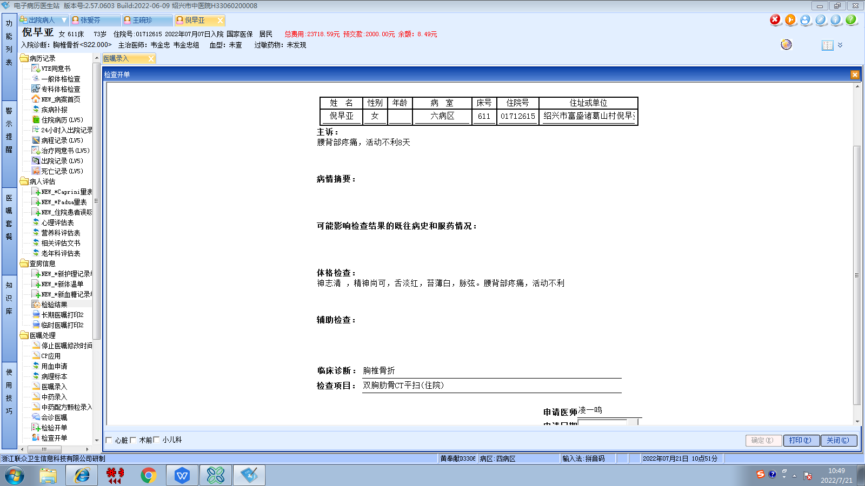韦金忠组
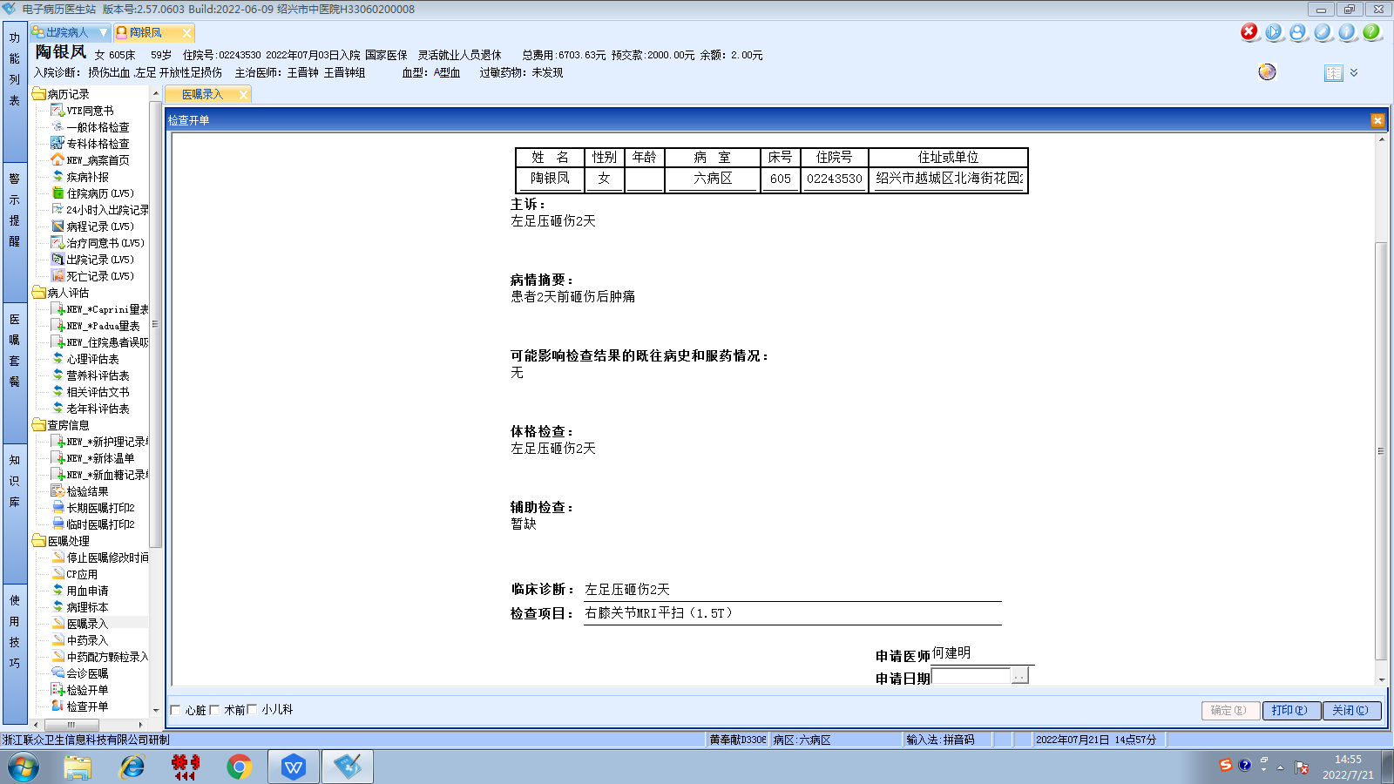王晋钟组
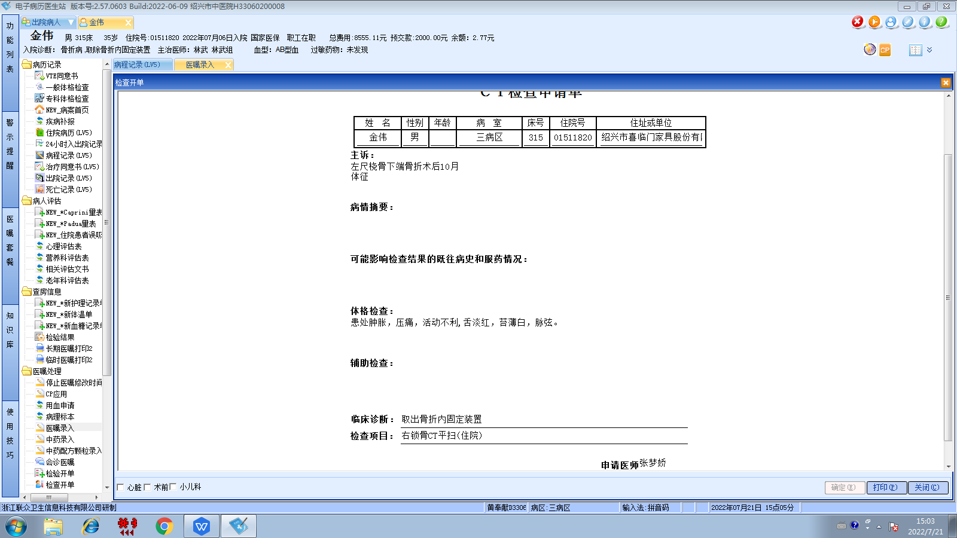林武组
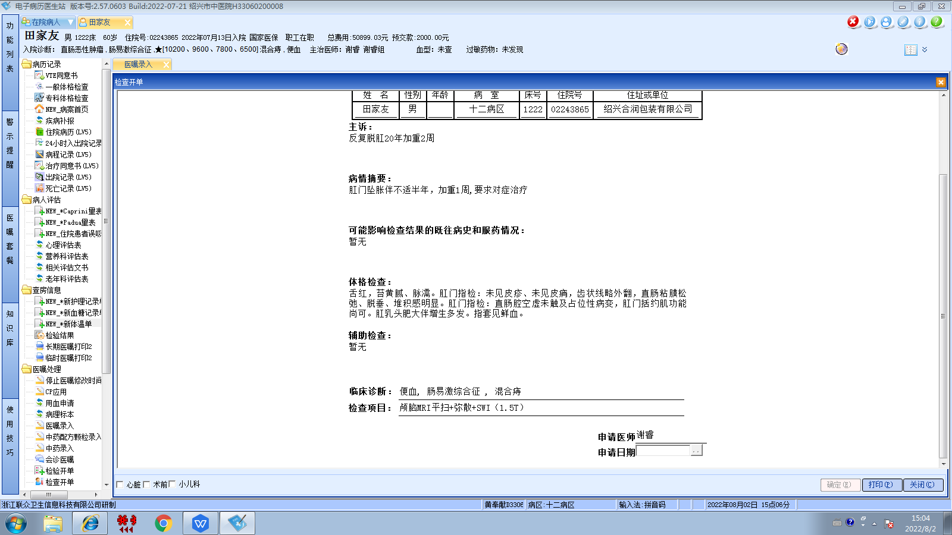谢睿组
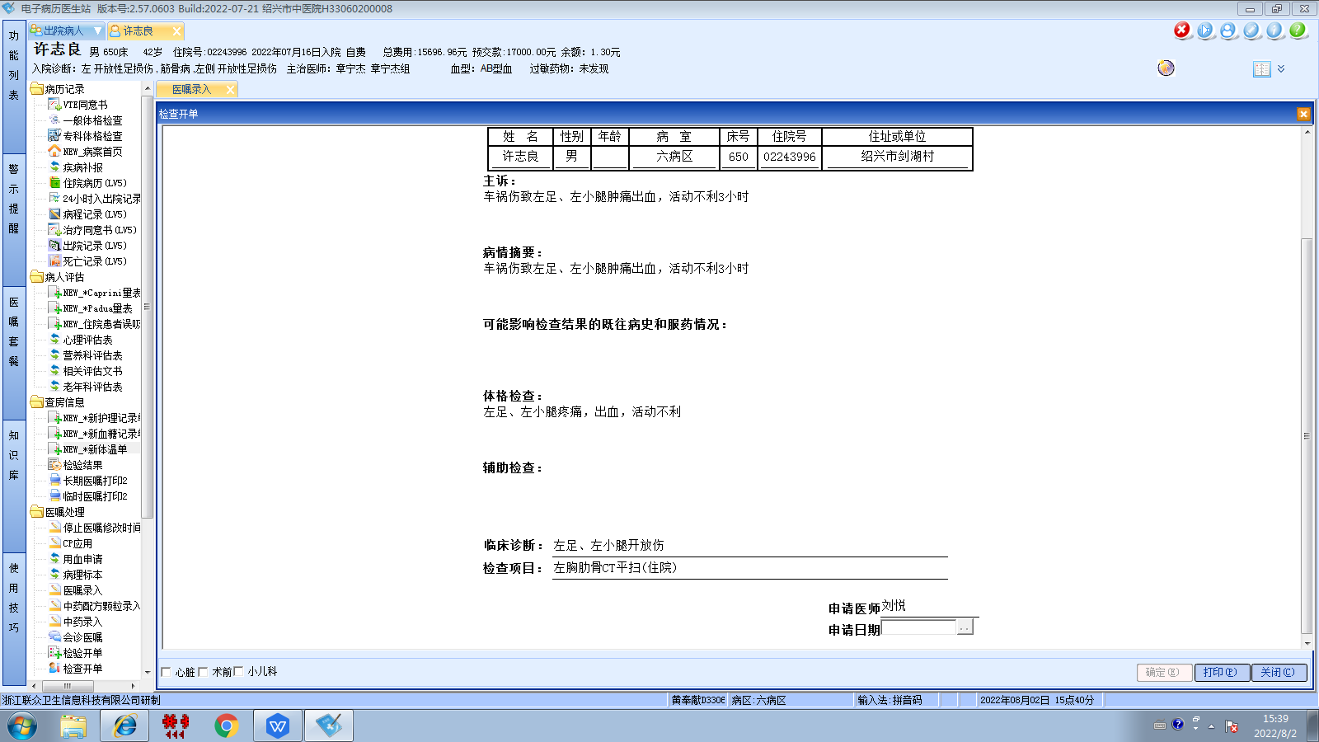章宁杰组
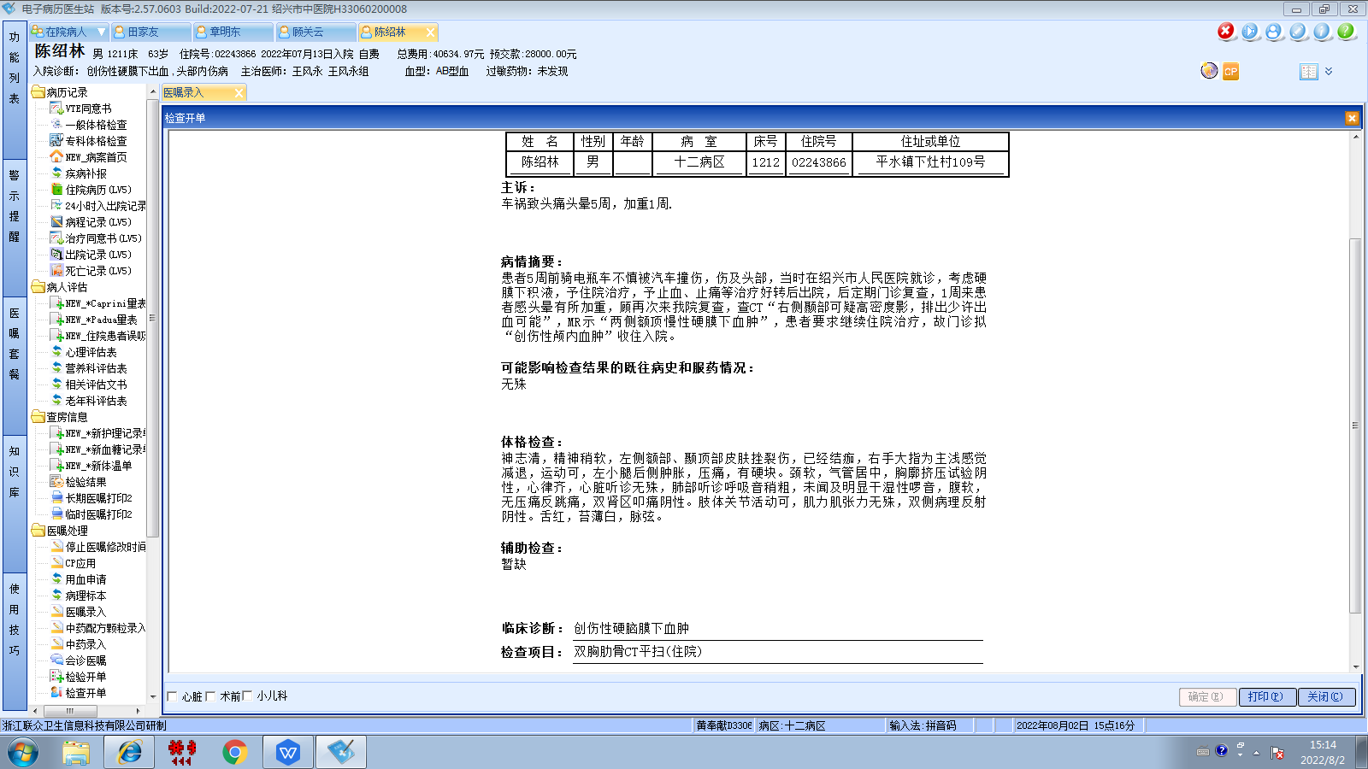王风永组
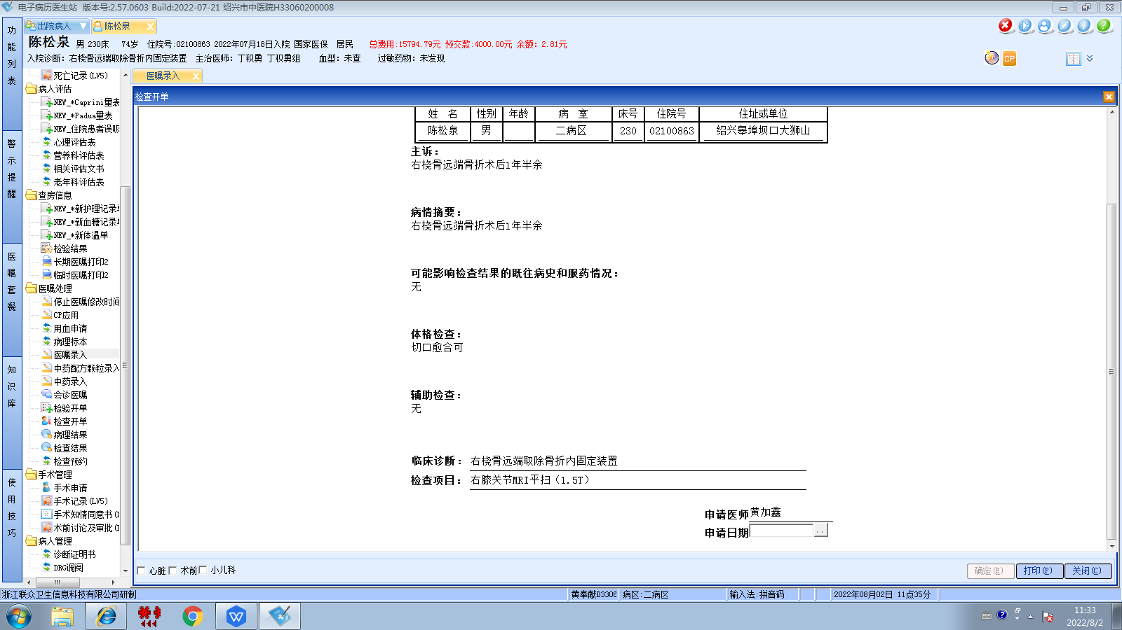丁积勇组

