8月检查申请单质控
住院号 | 检查单类型 | 开单日期 | 开单医师 |  |  | 检查项目
 |  |  |  | 主诉 | 病情摘要 |  | 既往史 | 体格检查 | 辅助检查 | 诊断 | 内容申请单不一致
02244184 | MR | 2022-7-30 | 王冰清 | √ | √ |  | √ | √ | √ | √ | √
02244184 | MR | 2022-8-2 | 王冰清 | √ | √ |  | √ | √ | √ | √ | √
02244543 | MR | 2022-7-31 | 张梦娇 | √ | √ |  | √ | √ | √ | √ | √
02244453 | MR | 2022-7-29 | 王冰清 | √ | √ |  | √ | √ | √ | √ | √
02244497 | MR | 2022-7-30 | 王晋钟 | √ | √ |  | √ | √ | √ | √ | √
02244517 | MR | 2022-7-30 | 许杨 | √ | √ |  | √ | √ | √ | √ | √
02244527 | MR | 2022-7-31 | 王立刚 | √ | √ |  | √ | √ | √ | √ | √
02244523 | MR | 2022-7-30 | 胡飞剑 | √ | √ |  | √ | √ | √ | √ | √
02244513 | MR | 2022-7-30 | 凌一鸣 | √ | √ |  | √ | √ | √ | √ | √
02244417 | CT | 2022-8-2 | 裘鸿飞 | √ | √ |  | √ | √ | √ | √ | √
02103466 | MR | 2022-7-31 | 裘鸿飞 | √ | √ |  | √ | √ | √ | √ | √
02244522 | MR | 2022-7-30 | 谢峰 | √ | √ |  | √ | √ | √ | √ | √
02244475 | MR | 2022-8-2 | 许杨 | √ | √ |  | √ | √ | √ | √ | √
01705898 | CT | 2022-8-2 | 王冰清 | √ | √ |  | √ | √ | √ | √ | √
02244610 | MR | 2022-8-2 | 孙玲玲 | √ | √ |  | √ | √ | √ | √ | √
02244467 | CT | 2022-8-4 | 冯梦雪 | √ | √ |  | √ | √ | √ | √ | √
01407944 | MR | 2022-8-3 | 边俊 | √ | √ |  | √ | √ | √ | √ | √
02244650 | MR | 2022-8-4 | 冯水娟 | √ | √ |  | √ | √ | √ | √ | √
02244676 | MR | 2022-8-3 | 秦培芝 | √ | √ |  | √ | √ | √ | √ | √
02244655 | MR | 2022-8-4 | 冯水娟 | √ | √ |  | √ | √ | √ | √ | √
02244615 | CT | 2022-8-2 | 谢睿 | √ | √ |  | √ | √ | √ | √ | √
02244615 | MR | 2022-8-3 | 谢睿 | √ | √ |  | √ | √ | √ | √ | √
01107704 | MR | 2022-8-3 | 刘磊 | √ | √ |  | √ | √ | √ | √ | √
02244696 | MR | 2022-8-6 | 董珍 | √ | √ |  | √ | √ | √ | √ | √
02244628 | MR | 2022-8-2 | 王冰清 | √ | √ |  | √ | √ | √ | √ | √
02244649 | MR | 2022-8-5 | 罗桢敏 | √ | √ |  | √ | √ | √ | √ | √
02244649 | MR | 2022-8-7 | 盛苏红 | √ | √ |  | √ | √ | √ | √ | √
02244599 | CT | 2022-8-6 | 吕宇航 | √ | √ |  | √ | √ | √ | √ | √
02244729 | MR | 2022-8-5 | 周怡 | √ | √ |  | √ | √ | √ | √ | √
01705797 | CT | 2022-8-5 | 孙利荣 | √ | √ |  | √ | √ | √ | √ | √
02244088 | CT | 2022-8-7 | 何易 | √ | √ |  | √ | √ | √ | √ | ×
02244566 | MR | 2022-8-7 | 林武 | √ | √ |  | √ | √ | √ | √ | √
01703343 | MR | 2022-8-7 | 陈琦军 | √ | √ |  | √ | √ | √ | √ | √
02244774 | MR | 2022-8-6 | 孙莉 | √ | √ |  | √ | √ | √ | √ | √
02244774 | CT | 2022-8-9 | 孙莉 | √ | √ |  | √ | √ | √ | √ | √
01812955 | MR | 2022-8-8 | 王冰清 | √ | √ |  | √ | √ | √ | √ | √
02104083 | MR | 2022-8-8 | 王冰清 | √ | √ |  | √ | √ | √ | √ | √
01909997 | CT | 2022-8-8 | 周怡 | √ | √ |  | √ | √ | √ | √ | √
01803429 | MR | 2022-8-10 | 付玉芳 | √ | √ |  | √ | √ | √ | √ | ×
02244867 | MR | 2022-8-8 | 陈剑磨 | √ | √ |  | √ | √ | √ | √ | √
01915546 | CT | 2022-8-9 | 孙莉 | √ | √ |  | √ | √ | √ | √ | √
02244910 | MR | 2022-8-10 | 何薇 | √ | √ |  | √ | √ | √ | √ | √
02244735 | CT | 2022-8-9 | 王敏龙 | √ | √ |  | √ | √ | √ | √ | ×
01810821 | CT/MR | 2022-8-11 | 何易 | √ | √ |  | √ | √ | √ | √ | √
02244909 | MR | 2022-8-10 | 王一萍 | √ | √ |  | √ | √ | √ | √ | √
02244870 | CT | 2022-8-8 | 柴绍军 | √ | √ |  | √ | √ | √ | √ | ×
02244935 | MR | 2022-8-10 | 胡飞剑 | √ | √ |  | √ | √ | √ | √ | √
02244860 | CT | 2022-8-8 | 罗桢敏 | √ | √ |  | √ | √ | √ | √ | √
02244878 | CT | 2022-8-11 | 沈英 | √ | √ |  | √ | √ | √ | √ | √
02244887 | MR | 2022-8-12 | 许杨 | √ | √ |  | √ | √ | √ | √ | √
02244599 | CT | 2022-8-11 | 谢铭 | √ | √ |  | √ | √ | √ | √ | √
02244829 | CT | 2022-8-10 | 罗桢敏 | √ | √ |  | √ | √ | √ | √ | √
02244836 | CT | 2022-8-8 | 盛苏红 | √ | √ |  | √ | √ | √ | √ | √
01610423 | CT | 2022-8-13 | 王冰清 | √ | √ |  | √ | √ | √ | √ | √
01610423 | MR | 2022-8-14 | 孙莉 | √ | √ |  | √ | √ | √ | √ | √
01610423 | MR | 2022-8-15 | 王冰清 | √ | √ |  | √ | √ | √ | √ | √
02245027 | CT | 2022-8-13 | 王风永 | √ | √ |  | √ | √ | √ | √ | √
02244979 | MR | 2022-8-12 | 刘兆龙 | √ | √ |  | √ | √ | √ | √ | √
01701625 | MR | 2022-8-13 | 李慧娇 | √ | √ |  | √ | √ | √ | √ | √
02245054 | CT | 2022-8-15 | 刘运海 | √ | √ |  | √ | √ | √ | √ | ×
02245013 | CT | 2022-8-16 | 边佳萍 | √ | √ |  | √ | √ | √ | √ | √
02244902 | CT | 2022-8-16 | 周怡 | √ | √ |  | √ | √ | √ | √ | ×
02244202 | MR | 2022-8-15 | 叶玲玲 | √ | √ |  | √ | √ | √ | √ | √
02245031 | MR | 2022-8-14 | 朱海波 | √ | √ |  | √ | √ | √ | √ | ×
02109198 | MR | 2022-8-14 | 陆超锋 | √ | √ |  | √ | √ | √ | √ | √
01910161 | MR | 2022-8-13 | 陈琦军 | √ | √ |  | √ | √ | √ | √ | √
01908860 | CT | 2022-8-18 | 陶铁瑛 | √ | √ |  | √ | √ | √ | √ | √
02245132 | MR | 2022-8-16 | 孟闯闯 | √ | √ |  | √ | √ | √ | √ | √
02244958 | CT | 2022-8-16 | 王冰清 | √ | √ |  | √ | √ | √ | √ | √
01908814 | CT | 2022-8-19 | 叶玲玲 | √ | √ |  | √ | √ | √ | √ | √
01207602 | MR | 2022-8-17 | 刘兆龙 | √ | √ |  | √ | √ | √ | √ | √
02245177 | CT | 2022-8-18 | 肖功 | √ | √ |  | √ | √ | √ | √ | ×
02245210 | MR | 2022-8-19 | 盛苏红 | √ | √ |  | √ | √ | √ | √ | √
02245233 | MR | 2022-8-19 | 沈沉 | √ | √ |  | √ | √ | √ | √ | √
01602102 | CT | 2022-8-19 | 王冰清 | √ | √ |  | √ | √ | √ | √ | √
02002003 | MR | 2022-8-19 | 孙莉 | √ | √ |  | √ | √ | √ | √ | √
01410745 | CT | 2022-8-18 | 凌一鸣 | √ | √ |  | √ | √ | √ | √ | √
01902401 | CT | 2022-8-21 | 赵艳明 | √ | √ |  | √ | √ | √ | √ | ×
02245271 | MR | 2022-8-21 | 肖功 | √ | √ |  | √ | √ | √ | √ | √
02243434 | MR | 2022-8-19 | 何薇 | √ | √ |  | √ | √ | √ | √ | √
02245266 | MR | 2022-8-20 | 孙玲玲 | √ | √ |  | √ | √ | √ | √ | √
02244812 | MR | 2022-8-22 | 凌一鸣 | √ | √ |  | √ | √ | √ | √ | √
01700551 | CT | 2022-8-23 | 龙平 | √ | √ |  | √ | √ | √ | √ | √
01412331 | MR | 2022-8-23 | 孙莉 | √ | √ |  | √ | √ | √ | √ | √
02244081 | CT/MR | 2022-8-23 | 孙莉 | √ | √ |  | √ | √ | √ | √ | √
02244333 | MR | 2022-8-24 | 黎村丰 | √ | √ |  | √ | √ | √ | √ | ×
01612994 | MR | 2022-8-23 | 魏平洋 | √ | √ |  | √ | √ | √ | √ | √
02245377 | MR | 2022-8-23 | 陶铁瑛 | √ | √ |  | √ | √ | √ | √ | ×
02245363 | CT | 2022-8-26 | 罗桢敏 | √ | √ |  | √ | √ | √ | √ | √
02245341 | MR | 2022-8-24 | 谢睿 | √ | √ |  | √ | √ | √ | √ | √
02245440 | MR | 2022-8-26 | 谢峰 | √ | √ |  | √ | √ | √ | √ | √
02245479 | MR | 2022-8-27 | 王立刚 | √ | √ |  | √ | √ | √ | √ | ×
02245470 | MR | 2022-8-27 | 凌一鸣 | √ | √ |  | √ | √ | √ | √ | √
02002079 | MR | 2022-8-26 | 刘悦 | √ | √ |  | √ | √ | √ | √ | √
02245471 | MR | 2022-8-27 | 陈思忆 | √ | √ |  | √ | √ | √ | √ | √
01804460 | MR | 2022-8-27 | 陈琦军 | √ | √ |  | √ | √ | √ | √ | √
02245518 | MR | 2022-8-29 | 王一萍 | √ | √ |  | √ | √ | √ | √ | √
02245534 | MR | 2022-8-29 | 王立刚 | √ | √ |  | √ | √ | √ | √ | √
02245526 | CT | 2022-8-29 | 刘运海 | √ | √ |  | √ | √ | √ | √ | ×
02240661 | MR | 2022-8-29 | 尤志新 | √ | √ |  | √ | √ | √ | √ | √
02245573 | CT | 2022-8-30 | 肖旭 | √ | √ |  | √ | √ | √ | √ | √
02245561 | MR | 2022-8-29 | 王冰清 | √ | √ |  | √ | √ | √ | √ | √
01408409 | MR | 2022-8-29 | 刘运海 | √ | √ |  | √ | √ | √ | √ | √
02245522 | CT | 2022-8-29 | 管仕强 | √ | √ |  | √ | √ | √ | √ | √
02245572 | CT | 2022-8-30 | 肖旭 | √ | √ |  | √ | √ | √ | √ | √
注：对住院患者检查申请单进行专项检查，其中主诉、体格检查或诊断任缺一项者视为不合格申请单；非入院常规检查，如申请单内容与检查部位及要求不一致，亦视为不合格申请单。
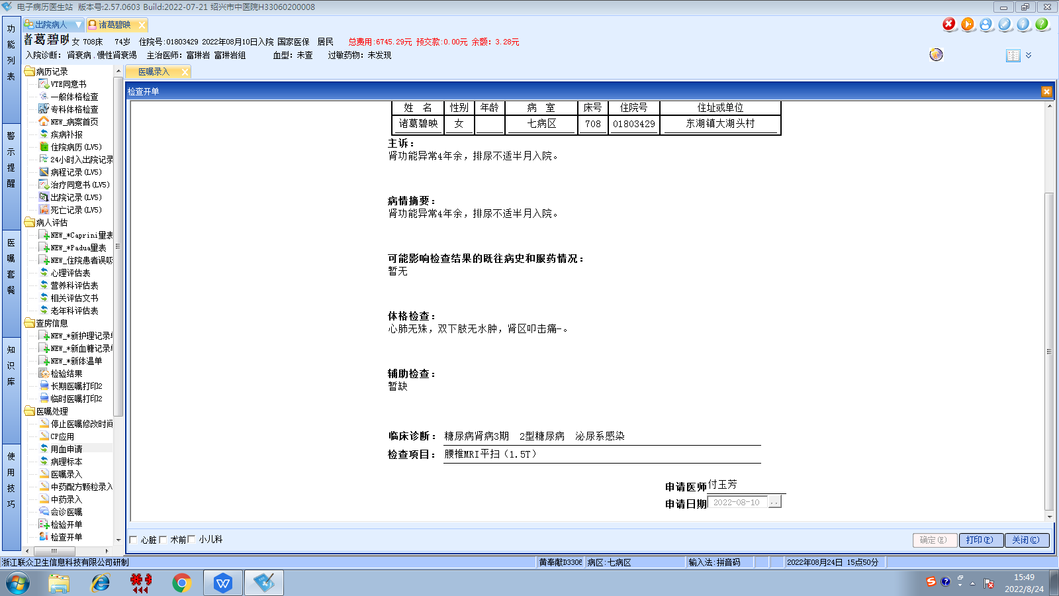富琳岩组
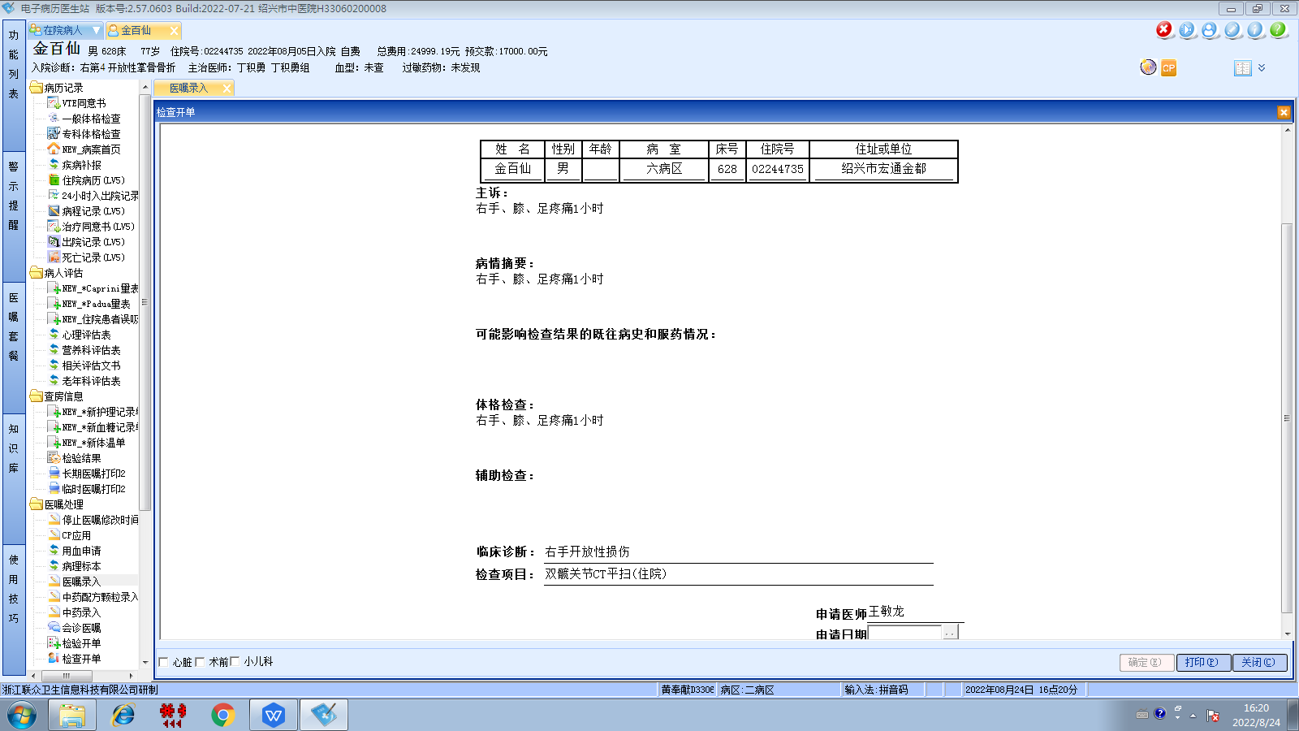丁积勇组
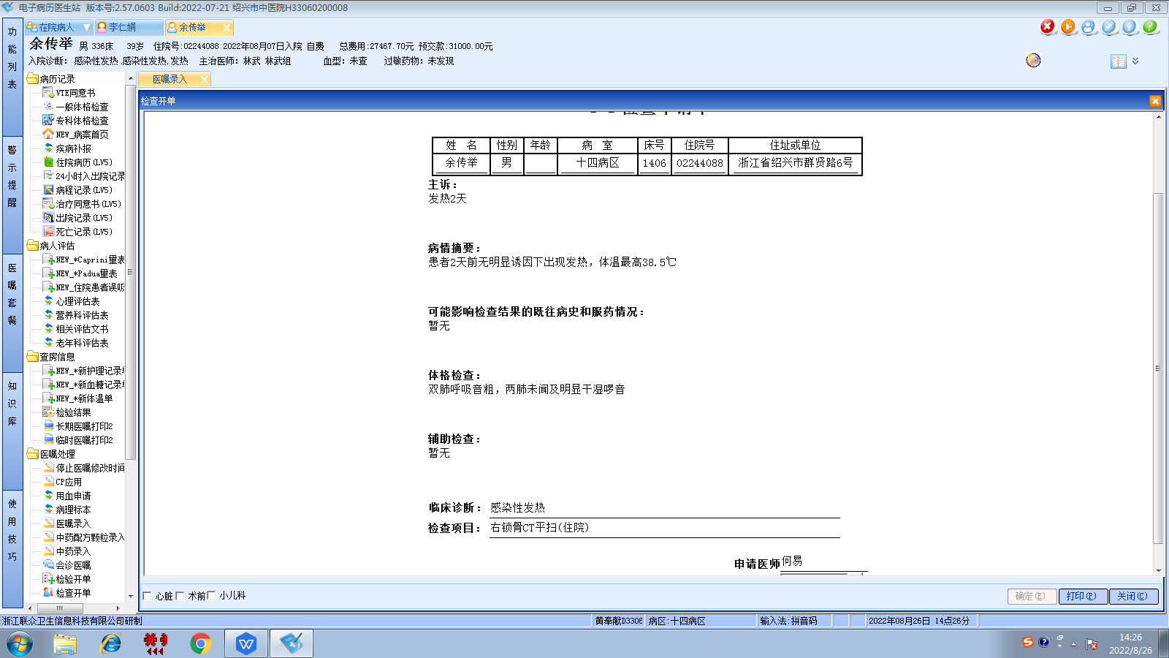李慧娇组
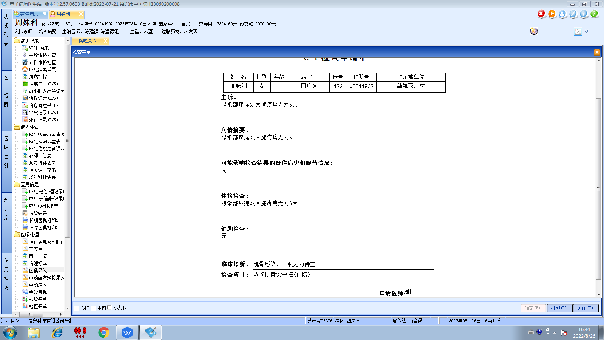陈建德组
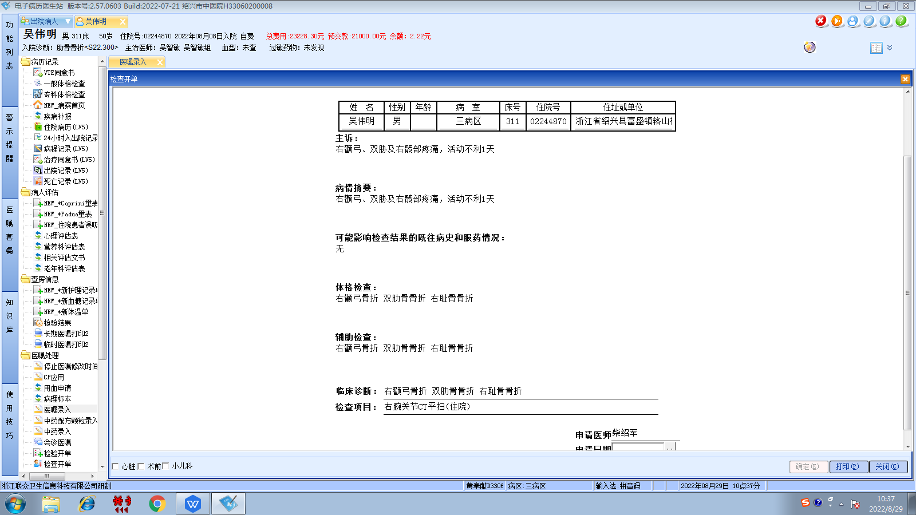吴智敏组
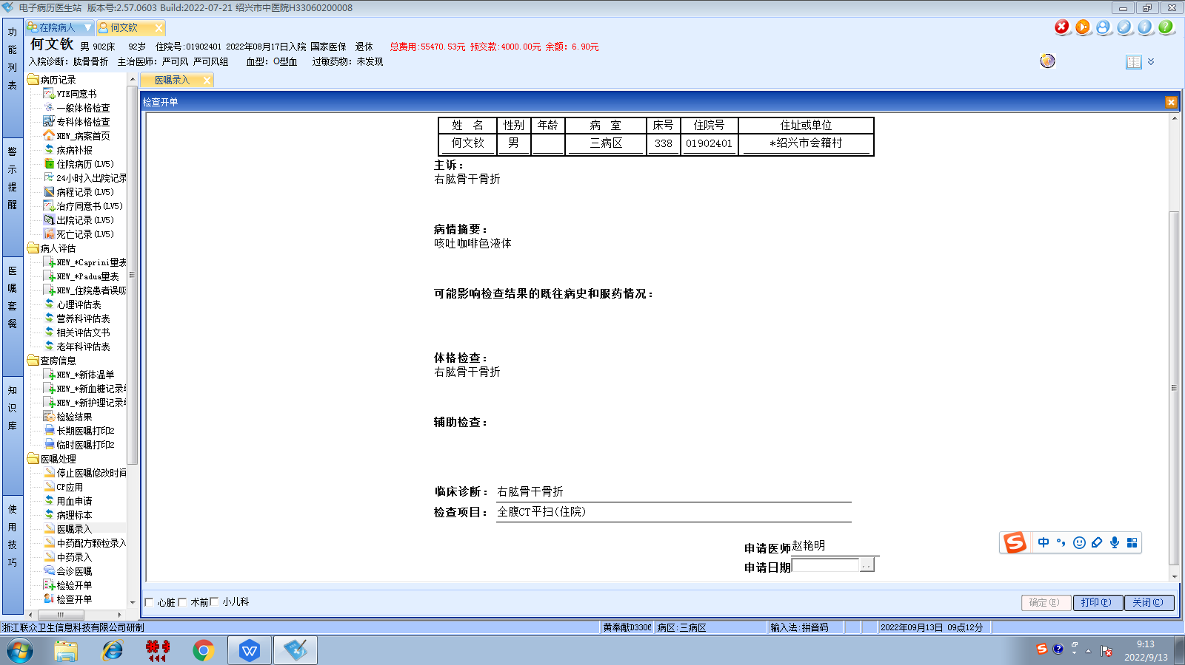林武组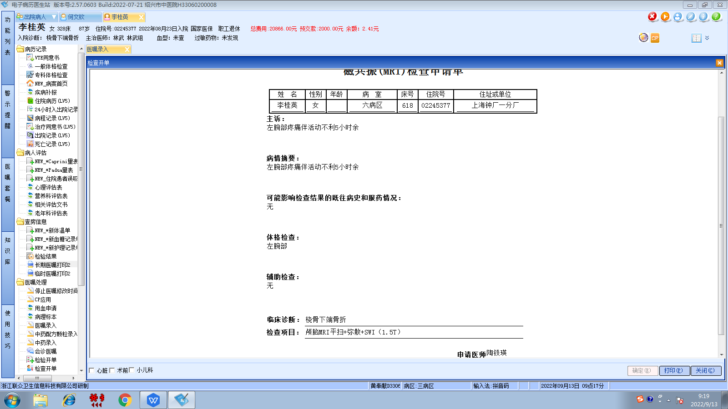林武组
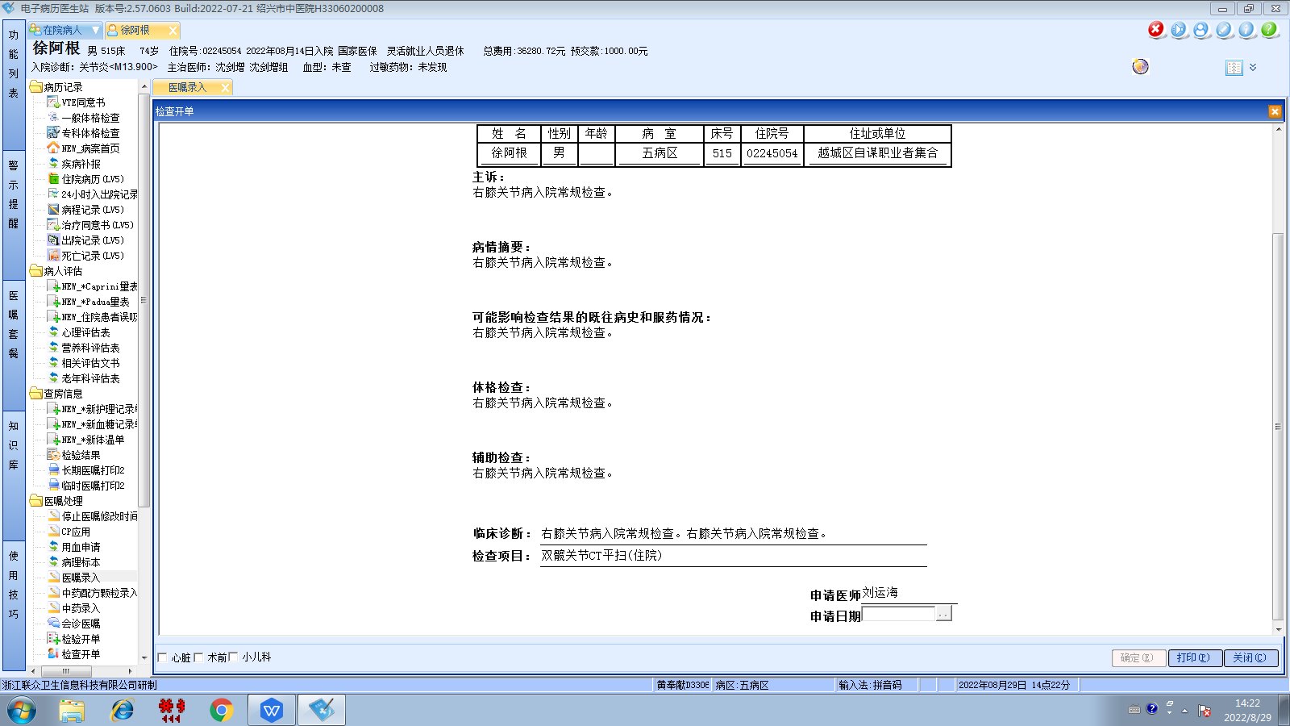沈剑增组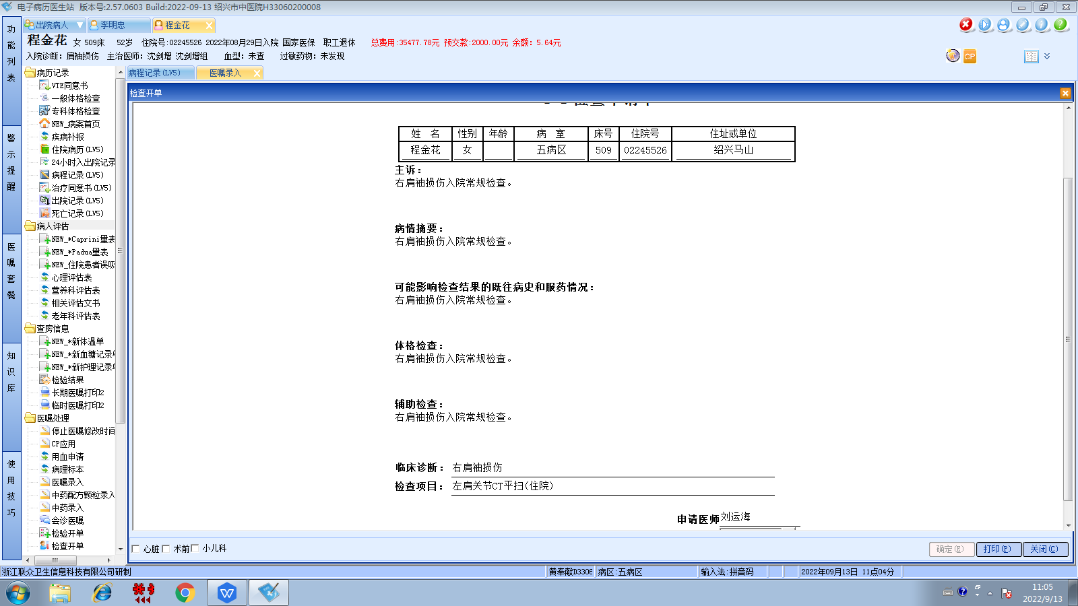沈剑增组
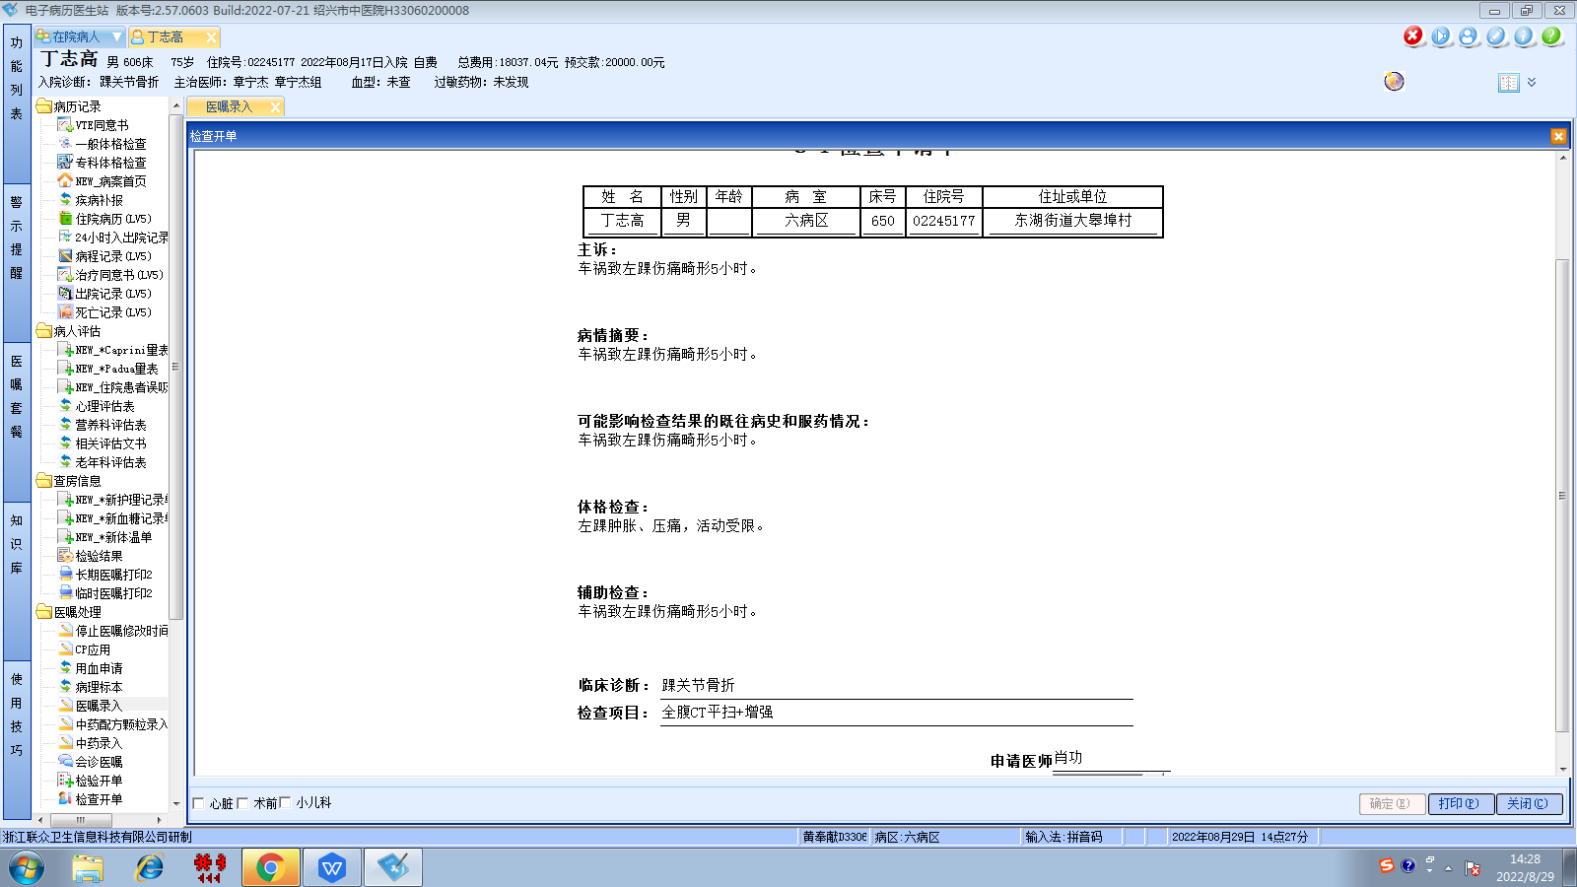章宁杰组
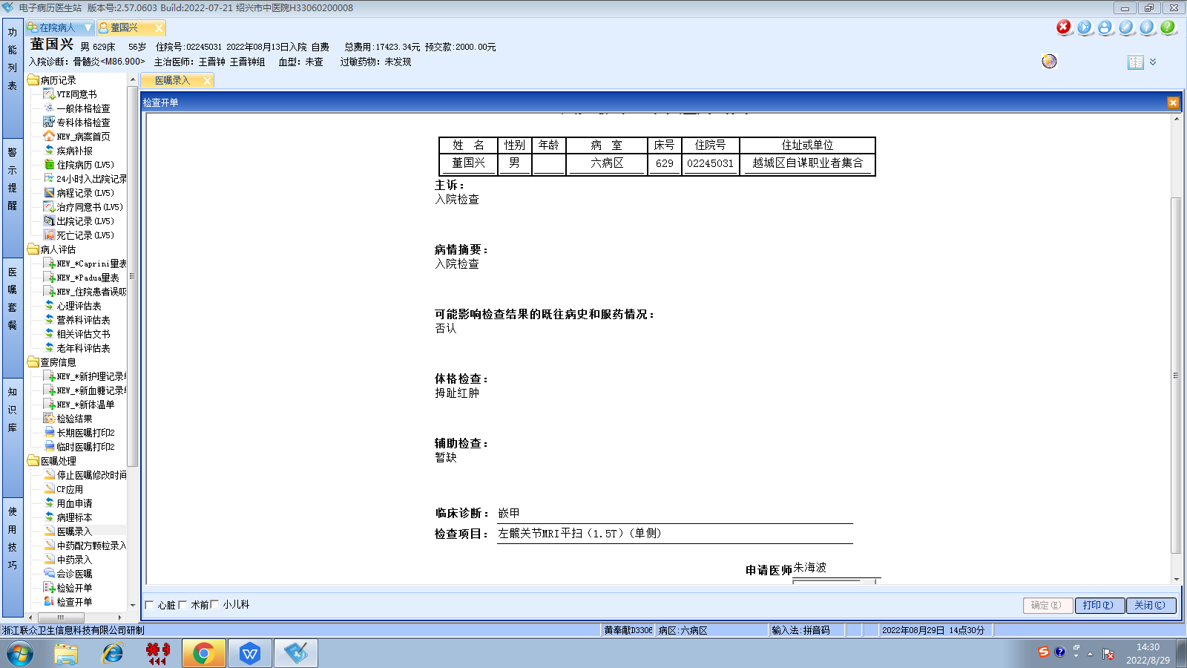王晋钟组
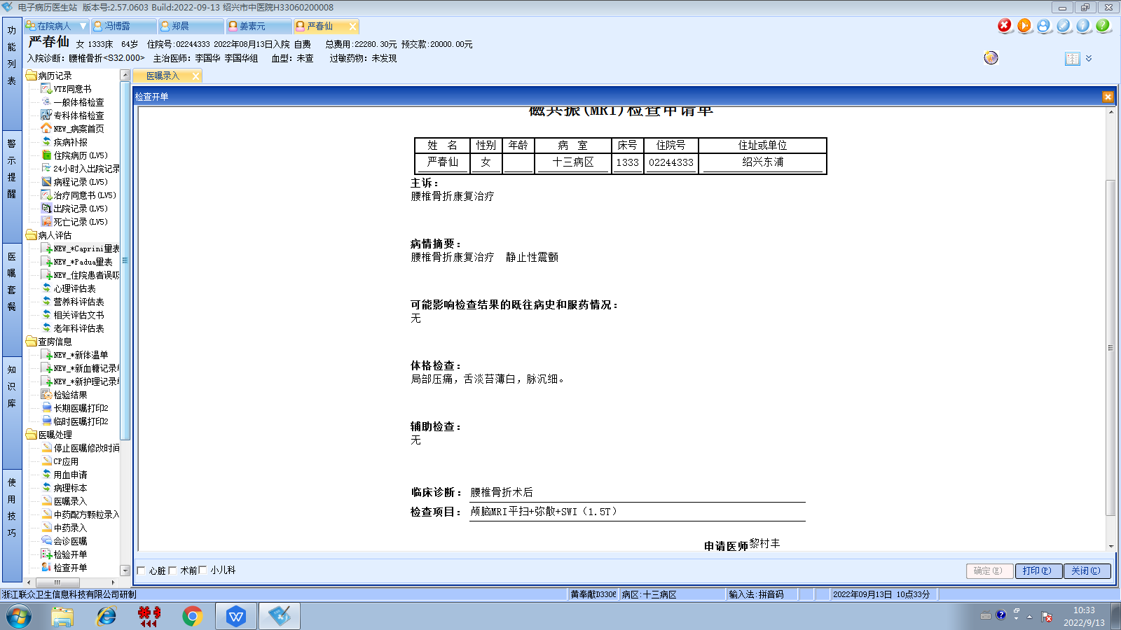李国华组
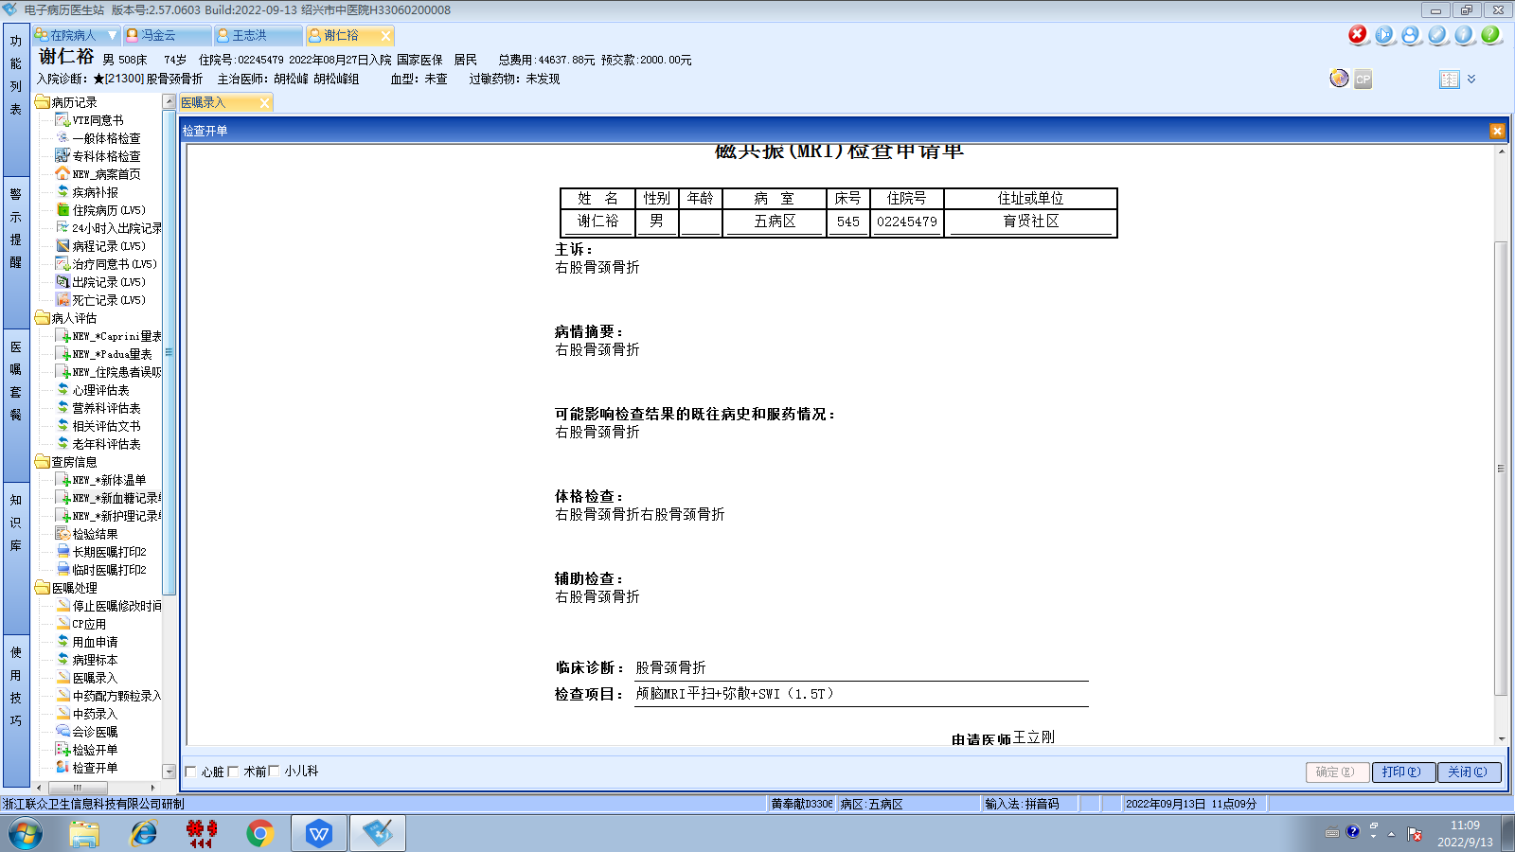胡松峰组

