9月检查申请单质控
住院号 | 检查单类型 | 开单日期 | 开单医师 |  |  | 检查项目
 |  |  |  | 主诉 | 病情摘要 |  | 既往史 | 体格检查 | 辅助检查 | 诊断 | 内容申请单不一致
02245267 | CT | 2022-9-1 | 王敏龙 | √ | √ |  | √ | √ | √ | √ | √
02245478 | MR | 2022-9-1 | 陶铁瑛 | √ | √ |  | √ | √ | √ | √ | √
02245666 | MR | 2022-9-2 | 盛苏红 | √ | √ |  | √ | √ | √ | √ | √
01804460 | MR | 2022-9-1 | 鲁剑梅 | √ | √ |  | √ | √ | √ | √ | √
02245023 | CT | 2022-9-2 | 王风永 | √ | √ |  | √ | √ | √ | √ | √
02245672 | MR | 2022-9-3 | 张华良 | √ | √ |  | √ | √ | √ | √ | √
02245745 | MR | 2022-9-5 | 鲁剑梅 | √ | √ |  | √ | √ | √ | √ | √
02245731 | MR | 2022-9-5 | 刘潇 | √ | √ |  | √ | √ | √ | √ | √
02245731 | CT | 2022-9-7 | 罗桢敏 | √ | √ |  | √ | √ | √ | √ | √
02245220 | CT | 2022-9-4 | 黎村丰 | √ | √ |  | √ | √ | √ | √ | ×
02002079 | MR | 2022-9-6 | 孙莉 | √ | √ |  | √ | √ | √ | √ | √
01913854 | MR | 2022-9-6 | 沈英 | √ | √ |  | √ | √ | √ | √ | ×
02245587 | CT | 2022-9-6 | 许伟攀 | √ | √ |  | √ | √ | √ | √ | √
02245798 | MR | 2022-9-6 | 鲁剑梅 | √ | √ |  | √ | √ | √ | √ | √
01805164 | CT | 2022-9-6 | 罗桢敏 | √ | √ |  | √ | √ | √ | √ | √
02245777 | MR | 2022-9-5 | 许杨 | √ | √ |  | √ | √ | √ | √ | √
02245822 | CT | 2022-9-6 | 周怡 | √ | √ |  | √ | √ | √ | √ | √
02245790 | MR | 2022-9-7 | 王立刚 | √ | √ |  | √ | √ | √ | √ | √
02245852 | MR | 2022-9-8 | 沈沉 | √ | √ |  | √ | √ | √ | √ | √
02245192 | CT | 2022-9-9 | 张华良 | √ | √ |  | √ | √ | √ | √ | √
02245798 | MR | 2022-9-8 | 鲁剑梅 | √ | √ |  | √ | √ | √ | √ | √
01311620 | CT | 2022-9-12 | 谢睿 | √ | √ |  | √ | √ | √ | √ | √
02245978 | CT | 2022-9-11 | 葛剑洪 | √ | √ |  | √ | √ | √ | √ | √
02245894 | CT | 2022-9-11 | 夏炳江 | √ | √ |  | √ | √ | √ | √ | √
02245871 | MR | 2022-9-11 | 陈剑磨 | √ | √ |  | √ | √ | √ | √ | √
01913724 | CT | 2022-9-12 | 凌一鸣 | √ | √ |  | √ | √ | √ | √ | √
02246040 | CT/MR | 2022-9-13 | 刘磊 | √ | √ |  | √ | √ | √ | √ | ×
01910874 | MR | 2022-9-13 | 李国华 | √ | √ |  | √ | √ | √ | √ | √
02245731 | MR | 2022-9-10 | 罗桢敏 | √ | √ |  | √ | √ | √ | √ | √
02246039 | CT | 2022-9-13 | 冯水娟 | √ | √ |  | √ | √ | √ | √ | √
02246110 | CT | 2022-9-15 | 凌一鸣 | √ | √ |  | √ | √ | √ | √ | √
02245891 | CT | 2022-9-14 | 公培强 | √ | √ |  | √ | √ | √ | √ | √
02246031 | CT | 2022-9-14 | 周怡 | √ | √ |  | √ | √ | √ | √ | ×
02246129 | CT | 2022-9-16 | 许伟攀 | √ | √ |  | √ | √ | √ | √ | √
02246044 | MR | 2022-9-16 | 刘依兰 | √ | √ |  | √ | √ | √ | √ | √
02246133 | MR | 2022-9-16 | 赵雄碧 | √ | √ |  | √ | √ | √ | √ | √
02246138 | MR | 2022-9-16 | 孙莉 | √ | √ |  | √ | √ | √ | √ | √
01103580 | CT | 2022-9-17 | 龙平 | √ | √ |  | √ | √ | √ | √ | ×
02110924 | CT | 2022-9-15 | 孙利荣 | √ | √ |  | √ | √ | √ | √ | √
01501281 | CT | 2022-9-16 | 肖功 | √ | √ |  | √ | √ | √ | √ | √
02244194 | CT | 2022-9-18 | 陆超锋 | √ | √ |  | √ | √ | √ | √ | √
02245845 | CT | 2022-9-17 | 凌一鸣 | √ | √ |  | √ | √ | √ | √ | √
02246239 | CT | 2022-9-19 | 谢睿 | √ | √ |  | √ | √ | √ | √ | ×
02246197 | MR | 2022-9-19 | 罗桢敏 | √ | √ |  | √ | √ | √ | √ | √
01304716 | MR | 2022-9-20 | 孙莉 | √ | √ |  | √ | √ | √ | √ | √
01806495 | CT | 2022-9-19 | 王一萍 | √ | √ |  | √ | √ | √ | √ | √
02246232 | MR | 2022-9-20 | 魏平洋 | √ | √ |  | √ | √ | √ | √ | ×
02246246 | MR | 2022-9-19 | 许伟攀 | √ | √ |  | √ | √ | √ | √ | ×
02246238 | MR | 2022-9-20 | 鲁剑梅 | √ | √ |  | √ | √ | √ | √ | √
02105506 | MR | 2022-9-21 | 陆超锋 | √ | √ |  | √ | √ | √ | √ | √
02246290 | CT | 2022-9-21 | 谢立江 | √ | √ |  | √ | √ | √ | √ | √
02245693 | CT | 2022-9-20 | 马军华 | √ | √ |  | √ | √ | √ | √ | √
01910192 | MR | 2022-9-21 | 金少威 | √ | √ |  | √ | √ | √ | √ | √
02008279 | MR | 2022-9-23 | 孙莉 | √ | √ |  | √ | √ | √ | √ | √
02246378 | MR | 2022-9-23 | 赵雄碧 | √ | √ |  | √ | √ | √ | √ | √
02101433 | MR | 2022-9-23 | 孙莉 | √ | √ |  | √ | √ | √ | √ | √
02246369 | CT | 2022-9-22 | 胡飞剑 | √ | √ |  | √ | √ | √ | √ | √
02246154 | MR | 2022-9-24 | 张梦娇 | √ | √ |  | √ | √ | √ | √ | √
02246303 | MR | 2022-9-23 | 管仕强 | √ | √ |  | √ | √ | √ | √ | √
02002148 | MR | 2022-9-23 | 马黎丽 | √ | √ |  | √ | √ | √ | √ | √
02246451 | MR | 2022-9-25 | 沈沉 | √ | √ |  | √ | √ | √ | √ | √
02245797 | MR | 2022-9-25 | 王一萍 | √ | √ |  | √ | √ | √ | √ | √
02246478 | CT | 2022-9-26 | 谢睿 | √ | √ |  | √ | √ | √ | √ | √
02246430 | MR | 2022-9-25 | 孙莉 | √ | √ |  | √ | √ | √ | √ | √
02103934 | CT | 2022-9-25 | 赵雄碧 | √ | √ |  | √ | √ | √ | √ | √
01909824 | MR | 2022-9-23 | 陈剑磨 | √ | √ |  | √ | √ | √ | √ | √
02107508 | CT | 2022-9-25 | 李国华 | √ | √ |  | √ | √ | √ | √ | √
01705697 | CT | 2022-9-25 | 马军华 | √ | √ |  | √ | √ | √ | √ | ×
02246172 | MR | 2022-9-28 | 凌一鸣 | √ | √ |  | √ | √ | √ | √ | √
02246443 | MR | 2022-9-25 | 孙莉 | √ | √ |  | √ | √ | √ | √ | √
注：对住院患者检查申请单进行专项检查，其中主诉、体格检查或诊断任缺一项者视为不合格申请单；非入院常规检查，如申请单内容与检查部位及要求不一致，亦视为不合格申请单。
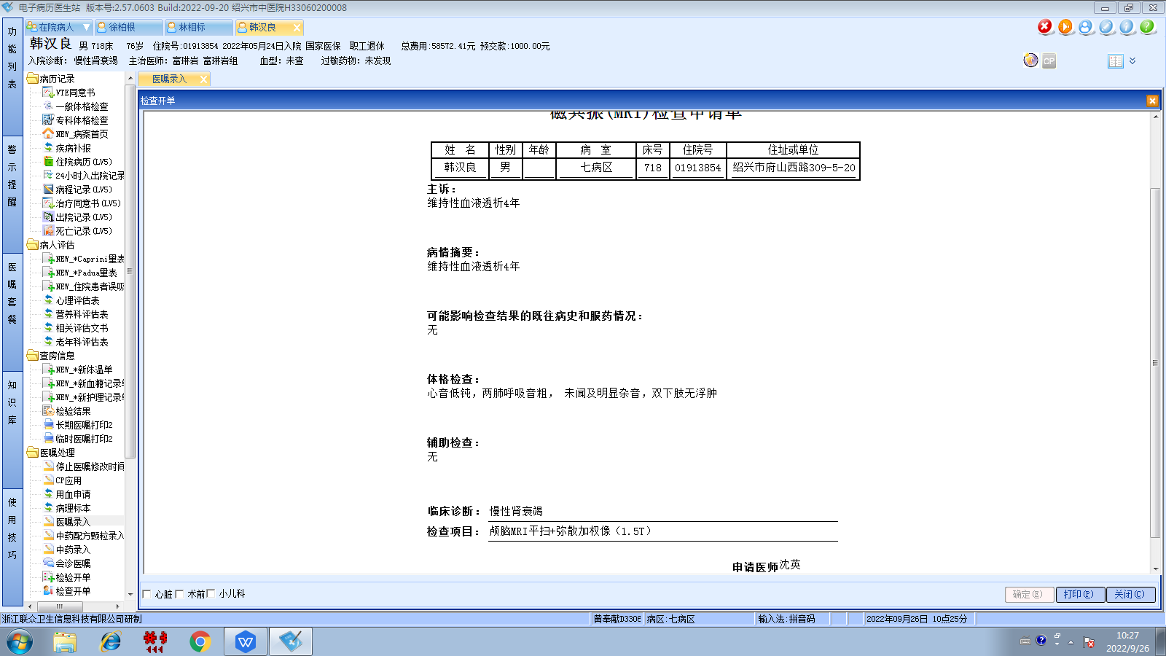富琳岩组
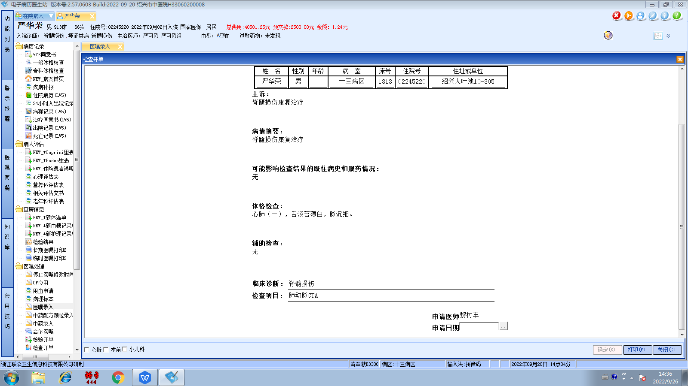李国华组
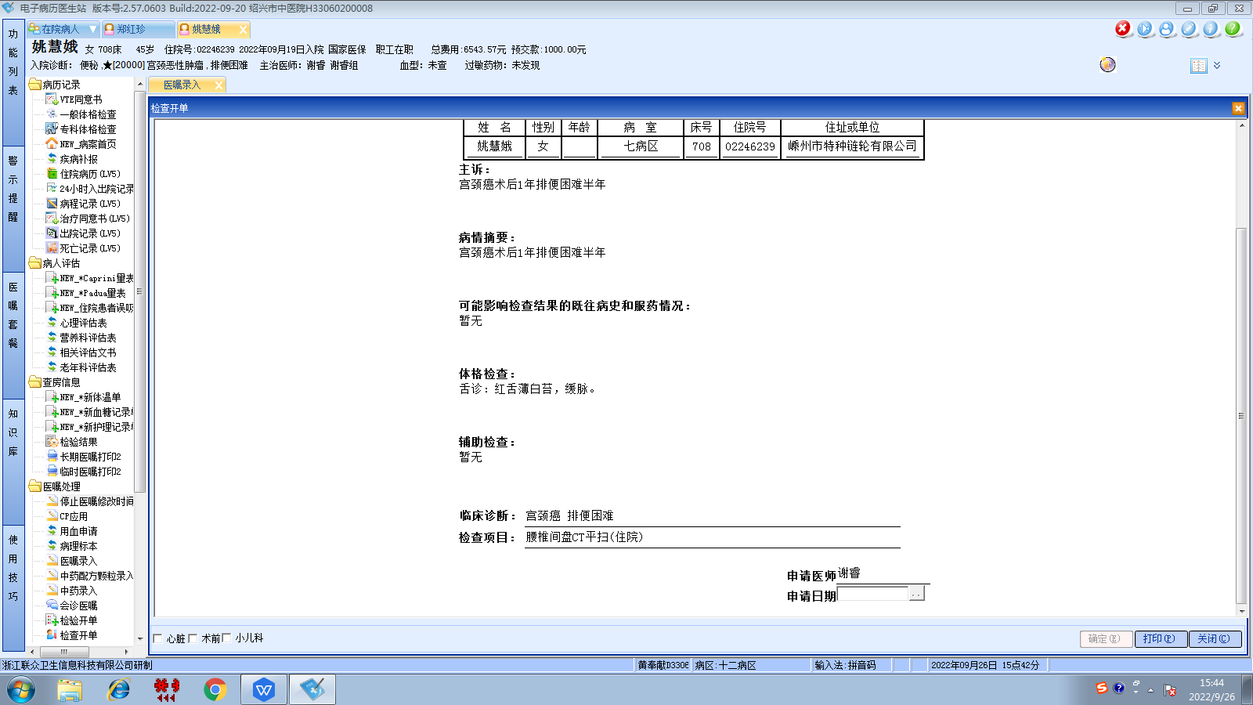谢睿组
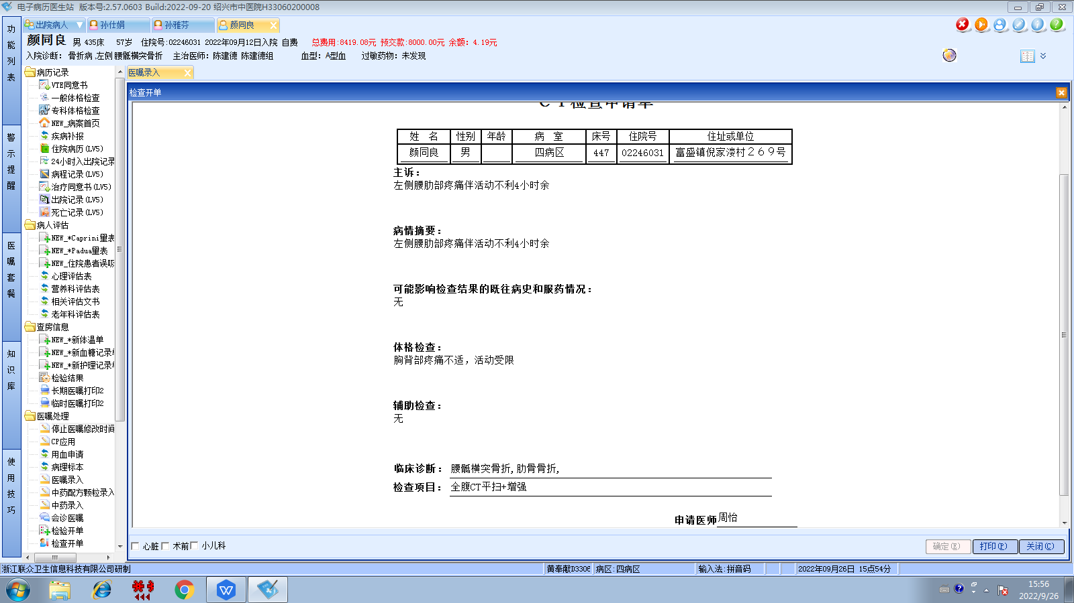陈建德组
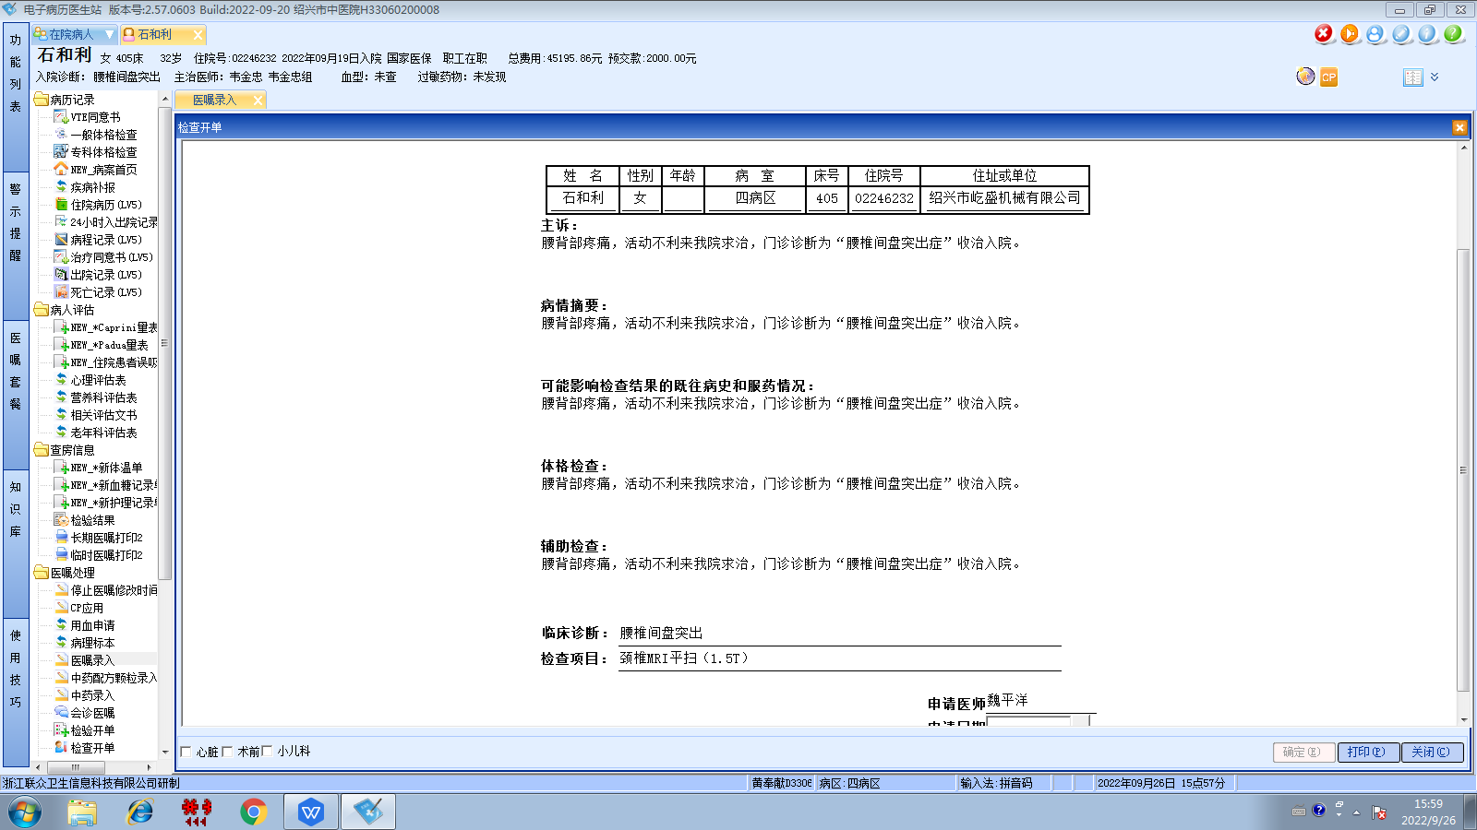韦金忠组
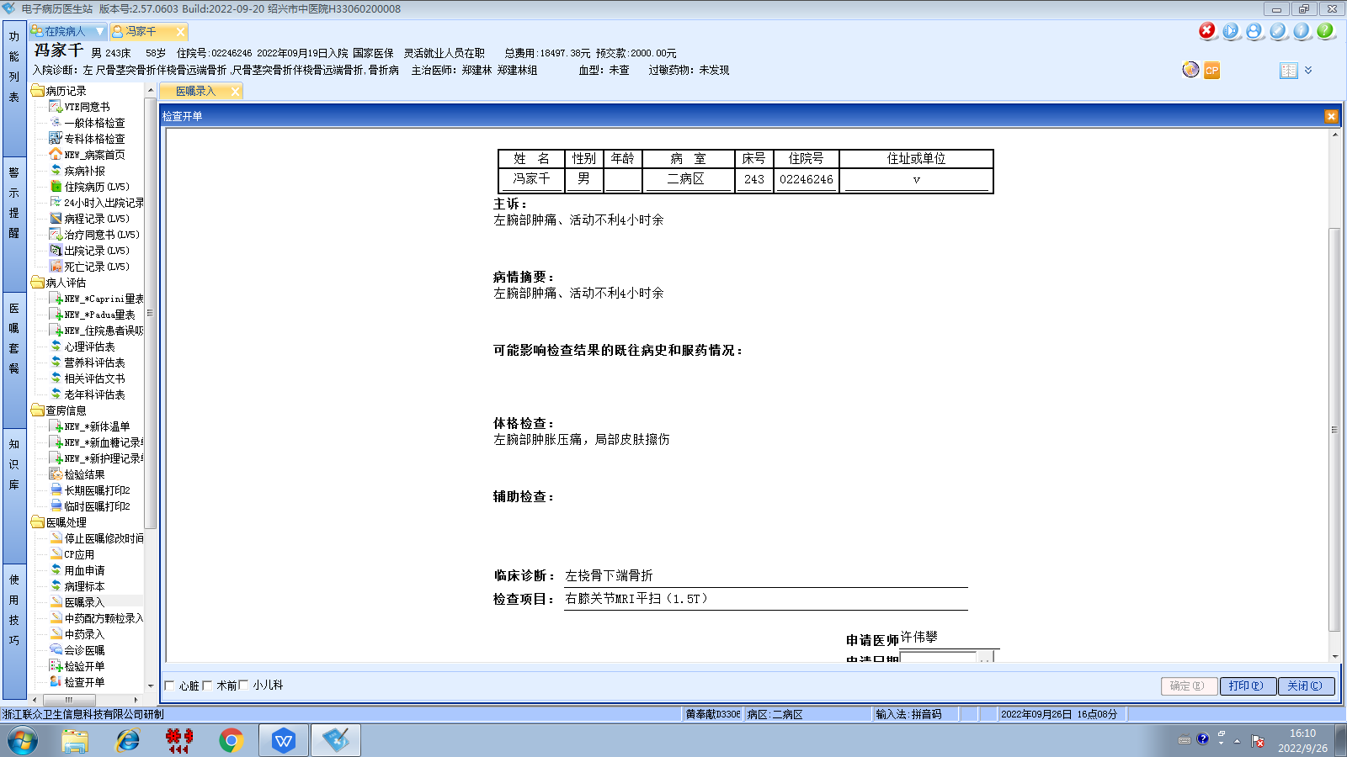郑建林组
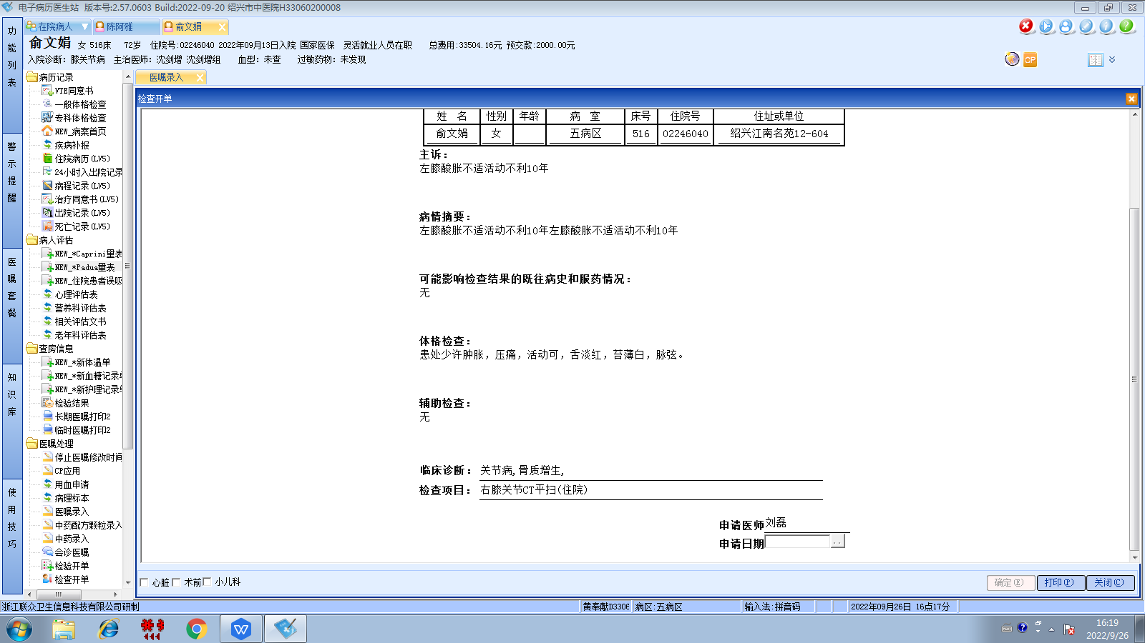沈剑增组
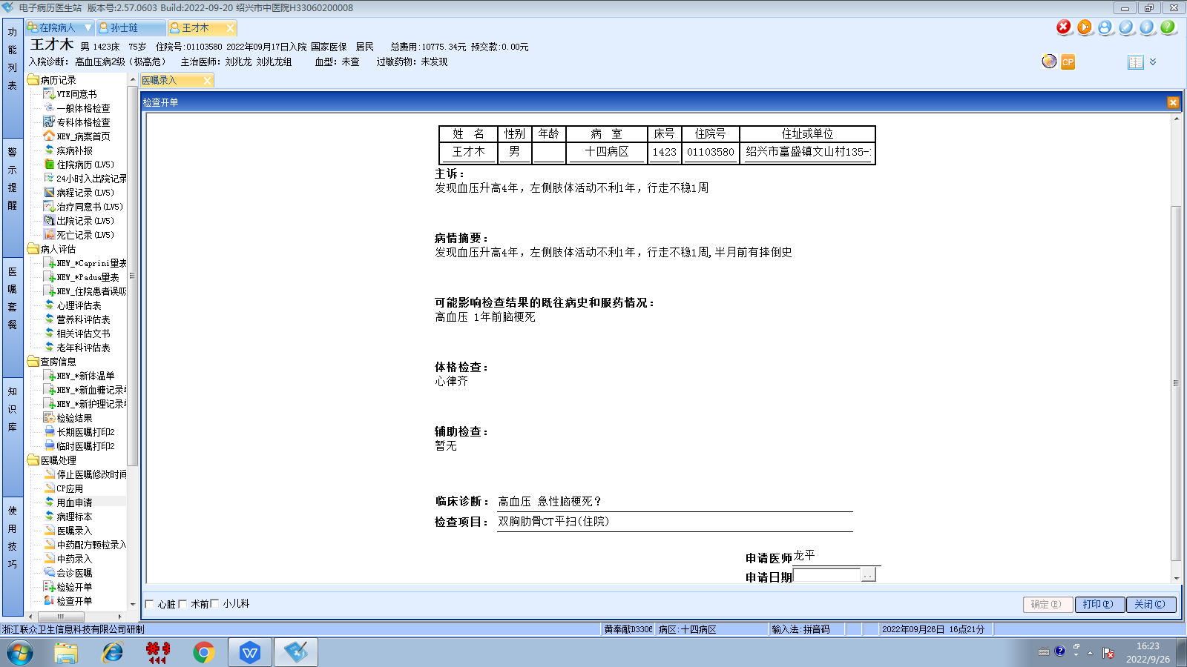刘兆龙组
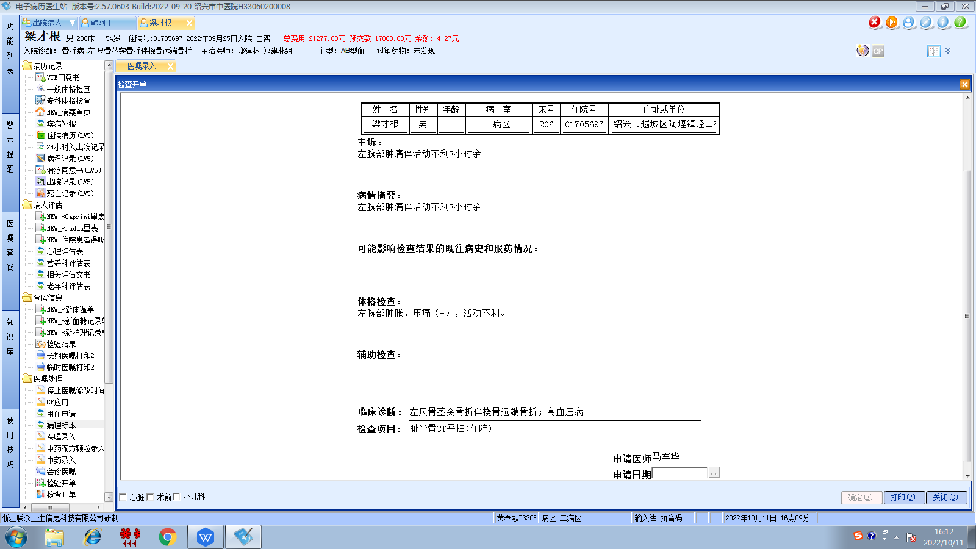郑建林组

