10月检查申请单质控
住院号 | 检查单类型 | 开单日期 | 开单医师 |  |  | 检查项目
 |  |  |  | 主诉 | 病情摘要 |  | 既往史 | 体格检查 | 辅助检查 | 诊断 | 内容申请单不一致
01811734 | CT | 2022-9-30 | 张桢阳 | √ | √ |  | √ | √ | √ | √ | √
01704968 | MR | 2022-10-1 | 陶铁瑛 | √ | √ |  | √ | √ | √ | √ | √
01805669 | MR | 2021-9-27 | 王冰清 | √ | √ |  | √ | √ | √ | √ | √
01815374 | MR | 2022-10-1 | 尤志新 | √ | √ |  | √ | √ | √ | √ | √
02244292 | MR | 2022-10-1 | 孟闯闯 | √ | √ |  | √ | √ | √ | √ | √
02212594 | CT | 2022-10-2 | 金建淼 | √ | √ |  | √ | √ | √ | √ | √
02246670 | MR | 2022-10-1 | 孙莉 | √ | √ |  | √ | √ | √ | √ | √
02246741 | MR | 2022-10-3 | 尤志新 | √ | √ |  | √ | √ | √ | √ | √
02246763 | CT | 2021-10-3 | 陈剑磨 | √ | √ |  | √ | √ | √ | √ | ×
02246718 | CT | 2022-10-4 | 朱海波 | √ | √ |  | √ | √ | √ | √ | √
01108200 | MR | 2022-10-5 | 王冰清 | √ | √ |  | √ | √ | √ | √ | √
01108200 | MR | 2022-10-6 | 孙莉 | √ | √ |  | √ | √ | √ | √ | √
02246770 | CT | 2022-10-3 | 许杨 | √ | √ |  | √ | √ | √ | √ | √
02254941 | CT | 2022-10-5 | 罗桢敏 | √ | √ |  | √ | √ | √ | √ | √
02106188 | MR | 2022-10-6 | 孙莉 | √ | √ |  | √ | √ | √ | √ | √
01510042 | MR | 2022-10-6 | 何易 | √ | √ |  | √ | √ | √ | √ | √
02254971 | CT | 2022-10-4 | 陶铁瑛 | √ | √ |  | √ | √ | √ | √ | √
02254984 | CT | 2022-10-5 | 黄加鑫 | √ | √ |  | √ | √ | √ | √ | √
02254998 | CT | 2022-10-5 | 肖功 | √ | √ |  | √ | √ | √ | √ | √
01507960 | CT/MR | 2022-10-5 | 陈剑磨 | √ | √ |  | √ | √ | √ | √ | √
01816450 | CT | 2022-10-8 | 何建明 | √ | √ |  | √ | √ | √ | √ | ×
02005106 | CT | 2022-10-8 | 支飞虎 | √ | √ |  | √ | √ | √ | √ | √
02255101 | CT | 2022-10-8 | 王磊 | √ | √ |  | √ | √ | √ | √ | √
02255064 | MR | 2022-10-7 | 丁雪艳 | √ | √ |  | √ | √ | √ | √ | √
01303798 | MR | 2022-10-7 | 胡飞剑 | √ | √ |  | √ | √ | √ | √ | ×
02255053 | CT | 2022-10-7 | 谢睿 | √ | √ |  | √ | √ | √ | √ | √
02255095 | MR | 2022-10-8 | 赵艳明 | √ | √ |  | √ | √ | √ | √ | √
02255090 | MR | 2022-10-7 | 陶铁瑛 | √ | √ |  | √ | √ | √ | √ | √
01613458 | MR | 2022-10-10 | 魏平洋 | √ | √ |  | √ | √ | √ | √ | √
02255149 | MR | 2022-10-9 | 黎云辉 | √ | √ |  | √ | √ | √ | √ | √
02255018 | CT | 2022-10-8 | 裘鸿飞 | √ | √ |  | √ | √ | √ | √ | √
02246529 | CT | 2022-10-10 | 陆超锋 | √ | √ |  | √ | √ | √ | √ | √
01714164 | MR | 2022-10-9 | 金少威 | √ | √ |  | √ | √ | √ | √ | √
01911904 | CT | 2022-10-6 | 何薇 | √ | √ |  | √ | √ | √ | √ | √
02255202 | CT | 2022-10-11 | 孙利荣 | √ | √ |  | √ | √ | √ | √ | √
02255008 | CT | 2022-10-9 | 陈剑磨 | √ | √ |  | √ | √ | √ | √ | √
02254943 | MR | 2022-10-9 | 王磊 | √ | √ |  | √ | √ | √ | √ | √
01915245 | MR | 2022-10-11 | 何薇 | √ | √ |  | √ | √ | √ | √ | √
02255224 | MR | 2022-10-11 | 张梦娇 | √ | √ |  | √ | √ | √ | √ | √
01813218 | MR | 2022-10-12 | 谢峰 | √ | √ |  | √ | √ | √ | √ | √
02255237 | MR | 2021-10-12 | 谢峰 | √ | √ |  | √ | √ | √ | √ | √
01106865 | MR | 2022-10-12 | 谢峰 | √ | √ |  | √ | √ | √ | √ | ×
02246026 | MR | 2022-10-14 | 葛剑洪 | √ | √ |  | √ | √ | √ | √ | √
02255310 | CT | 2022-10-14 | 陶铁瑛 | √ | √ |  | √ | √ | √ | √ | √
02110720 | CT | 2022-10-15 | 刘浩飞 | √ | √ |  | √ | √ | √ | √ | √
02004370 | MR | 2022-10-13 | 张学思 | √ | √ |  | √ | √ | √ | √ | √
02004370 | CT | 2022-10-16 | 凌一鸣 | √ | √ |  | √ | √ | √ | √ | √
01509450 | MR | 2022-10-13 | 钟承隽 | √ | √ |  | √ | √ | √ | √ | ×
02255259 | MR | 2022-10-12 | 王磊 | √ | √ |  | √ | √ | √ | √ | √
02246503 | CT | 2022-10-16 | 黎村丰 | √ | √ |  | √ | √ | √ | √ | ×
02255422 | CT | 2022-10-16 | 沈兴潮 | √ | √ |  | √ | √ | √ | √ | √
02255342 | MR | 2022-10-14 | 刘依兰 | √ | √ |  | √ | √ | √ | √ | √
02255323 | MR | 2022-10-14 | 王冰清 | √ | √ |  | √ | √ | √ | √ | √
02255275 | CT | 2022-10-17 | 陶铁瑛 | √ | √ |  | √ | √ | √ | √ | √
01608816 | CT | 2022-10-17 | 王一萍 | √ | √ |  | √ | √ | √ | √ | √
02242589 | MR | 2022-10-17 | 边佳萍 | √ | √ |  | √ | √ | √ | √ | √
02255386 | MR | 2022-10-16 | 魏平洋 | √ | √ |  | √ | √ | √ | √ | √
02255316 | MR | 2022-10-16 | 赵艳明 | √ | √ |  | √ | √ | √ | √ | √
02255290 | MR | 2022-10-13 | 王冰清 | √ | √ |  | √ | √ | √ | √ | √
02255450 | CT | 2022-10-17 | 谢睿 | √ | √ |  | √ | √ | √ | √ | √
02255362 | MR | 2022-10-17 | 陶铁瑛 | √ | √ |  | √ | √ | √ | √ | ×
01912269 | MR | 2022-10-17 | 王冰清 | √ | √ |  | √ | √ | √ | √ | √
01912269 | CT | 2022-10-20 | 孙莉 | √ | √ |  | √ | √ | √ | √ | √
01802608 | MR | 2022-10-18 | 刘兆龙 | √ | √ |  | √ | √ | √ | √ | √
02255451 | CT | 2022-10-19 | 陆超锋 | √ | √ |  | √ | √ | √ | √ | √
01902403 | MR | 2022-10-17 | 罗桢敏 | √ | √ |  | √ | √ | √ | √ | √
02255350 | MR | 2022-10-17 | 尤志新 | √ | √ |  | √ | √ | √ | √ | √
02255350 | MR | 2022-10-18 | 何易 | √ | √ |  | √ | √ | √ | √ | √
02255475 | MR | 2022-10-18 | 孟闯闯 | √ | √ |  | √ | √ | √ | √ | √
02255504 | MR | 2022-10-19 | 胡松峰 | √ | √ |  | √ | √ | √ | √ | √
02255473 | MR | 2022-10-19 | 王磊 | √ | √ |  | √ | √ | √ | √ | √
02007012 | MR | 2022-10-18 | 陈剑磨 | √ | √ |  | √ | √ | √ | √ | √
02255486 | MR | 2022-10-18 | 胡飞剑 | √ | √ |  | √ | √ | √ | √ | √
02255529 | MR | 2022-10-19 | 胡松峰 | √ | √ |  | √ | √ | √ | √ | √
02255484 | MR | 2022-10-18 | 魏平洋 | √ | √ |  | √ | √ | √ | √ | √
02255603 | MR | 2022-10-21 | 谢峰 | √ | √ |  | √ | √ | √ | √ | √
02255433 | MR | 2022-10-17 | 王冰清 | √ | √ |  | √ | √ | √ | √ | √
02255492 | MR | 2022-10-18 | 谢峰 | √ | √ |  | √ | √ | √ | √ | √
02255636 | CT | 2022-10-21 | 张桢阳 | √ | √ |  | √ | √ | √ | √ | √
02103249 | MR | 2022-10-21 | 孙莉 | √ | √ |  | √ | √ | √ | √ | √
01914501 | MR | 2022-10-20 | 尤志新 | √ | √ |  | √ | √ | √ | √ | √
02255649 | MR | 2022-10-22 | 魏平洋 | √ | √ |  | √ | √ | √ | √ | ×
02255588 | CT | 2022-10-23 | 支飞虎 | √ | √ |  | √ | √ | √ | √ | √
02109025 | MR | 2022-10-22 | 孙莉 | √ | √ |  | √ | √ | √ | √ | √
01801853 | MR | 2022-10-22 | 胡飞剑 | √ | √ |  | √ | √ | √ | √ | √
02255675 | MR | 2022-10-22 | 陶铁瑛 | √ | √ |  | √ | √ | √ | √ | √
02255437 | MR | 2022-10-22 | 罗桢敏 | √ | √ |  | √ | √ | √ | √ | √
02255248 | CT | 2022-10-25 | 王风永 | √ | √ |  | √ | √ | √ | √ | √
02255690 | MR | 2022-10-23 | 何易 | √ | √ |  | √ | √ | √ | √ | √
02255690 | MR | 2022-10-25 | 何易 | √ | √ |  | √ | √ | √ | √ | √
02255618 | MR | 2022-10-23 | 陆超锋 | √ | √ |  | √ | √ | √ | √ | √
02255708 | MR | 2022-10-23 | 王磊 | √ | √ |  | √ | √ | √ | √ | √
01814488 | CT | 2022-10-25 | 刘浩飞 | √ | √ |  | √ | √ | √ | √ | √
01903808 | MR | 2022-10-24 | 罗桢敏 | √ | √ |  | √ | √ | √ | √ | √
02255699 | CT | 2022-10-25 | 何易 | √ | √ |  | √ | √ | √ | √ | √
02255741 | MR | 2022-10-24 | 谢峰 | √ | √ |  | √ | √ | √ | √ | √
02255721 | CT | 2022-10-25 | 罗桢敏 | √ | √ |  | √ | √ | √ | √ | √
02255785 | MR | 2022-10-26 | 凌一鸣 | √ | √ |  | √ | √ | √ | √ | √
02255785 | CT | 2022-10-28 | 凌一鸣 | √ | √ |  | √ | √ | √ | √ | √
02255738 | MR | 2022-10-25 | 张澍漾 | √ | √ |  | √ | √ | √ | √ | √
02255302 | CT | 2022-10-28 | 王敏龙 | √ | √ |  | √ | √ | √ | √ | √
01705920 | MR | 2022-10-26 | 秦培芝 | √ | √ |  | √ | √ | √ | √ | √
01705920 | MR | 2022-10-28 | 朱大明 | √ | √ |  | √ | √ | √ | √ | √
02255780 | MR | 2022-10-26 | 朱海锋 | √ | √ |  | √ | √ | √ | √ | √
02245826 | MR | 2022-10-26 | 黎村丰 | √ | √ |  | √ | √ | √ | √ | √
02255835 | CT | 2022-10-29 | 张梦娇 | √ | √ |  | √ | √ | √ | √ | √
02255800 | MR | 2022-10-27 | 朱大明 | √ | √ |  | √ | √ | √ | √ | √
02255843 | CT | 2022-10-29 | 魏平洋 | √ | √ |  | √ | √ | √ | √ | √
02255696 | CT | 2022-10-31 | 沈家峰 | √ | √ |  | √ | √ | √ | √ | √
01908814 | CT | 2022-10-30 | 孙玲玲 | √ | √ |  | √ | √ | √ | √ | √
01205078 | MR | 2022-10-30 | 沈沉 | √ | √ |  | √ | √ | √ | √ | √
01816130 | MR | 2022-10-28 | 陈剑磨 | √ | √ |  | √ | √ | √ | √ | √
01602811 | CT | 2022-10-31 | 张澍漾 | √ | √ |  | √ | √ | √ | √ | √
02240046 | CT | 2022-10-30 | 刘运海 | √ | √ |  | √ | √ | √ | √ | √
注：对住院患者检查申请单进行专项检查，其中主诉、体格检查或诊断任缺一项者视为不合格申请单；非入院常规检查，如申请单内容与检查部位及要求不一致，亦视为不合格申请单。
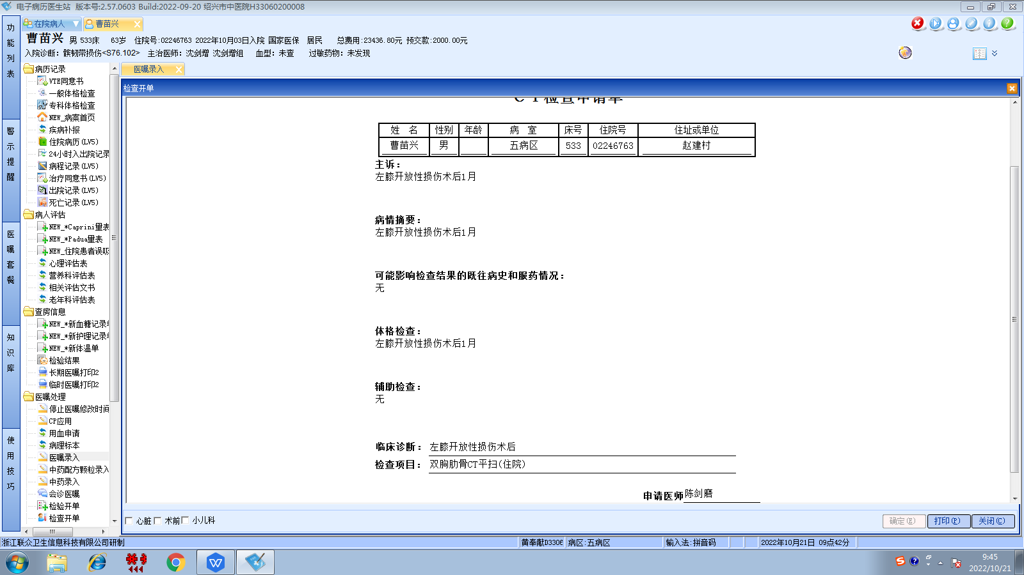沈剑增组
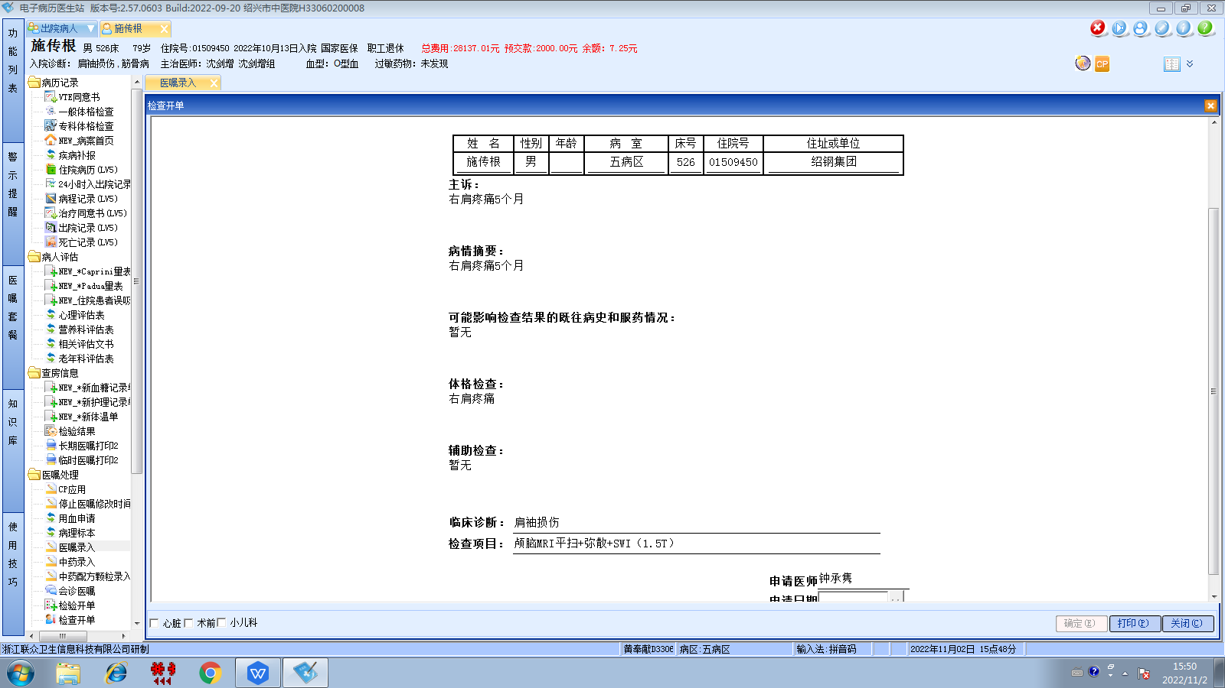沈剑增组
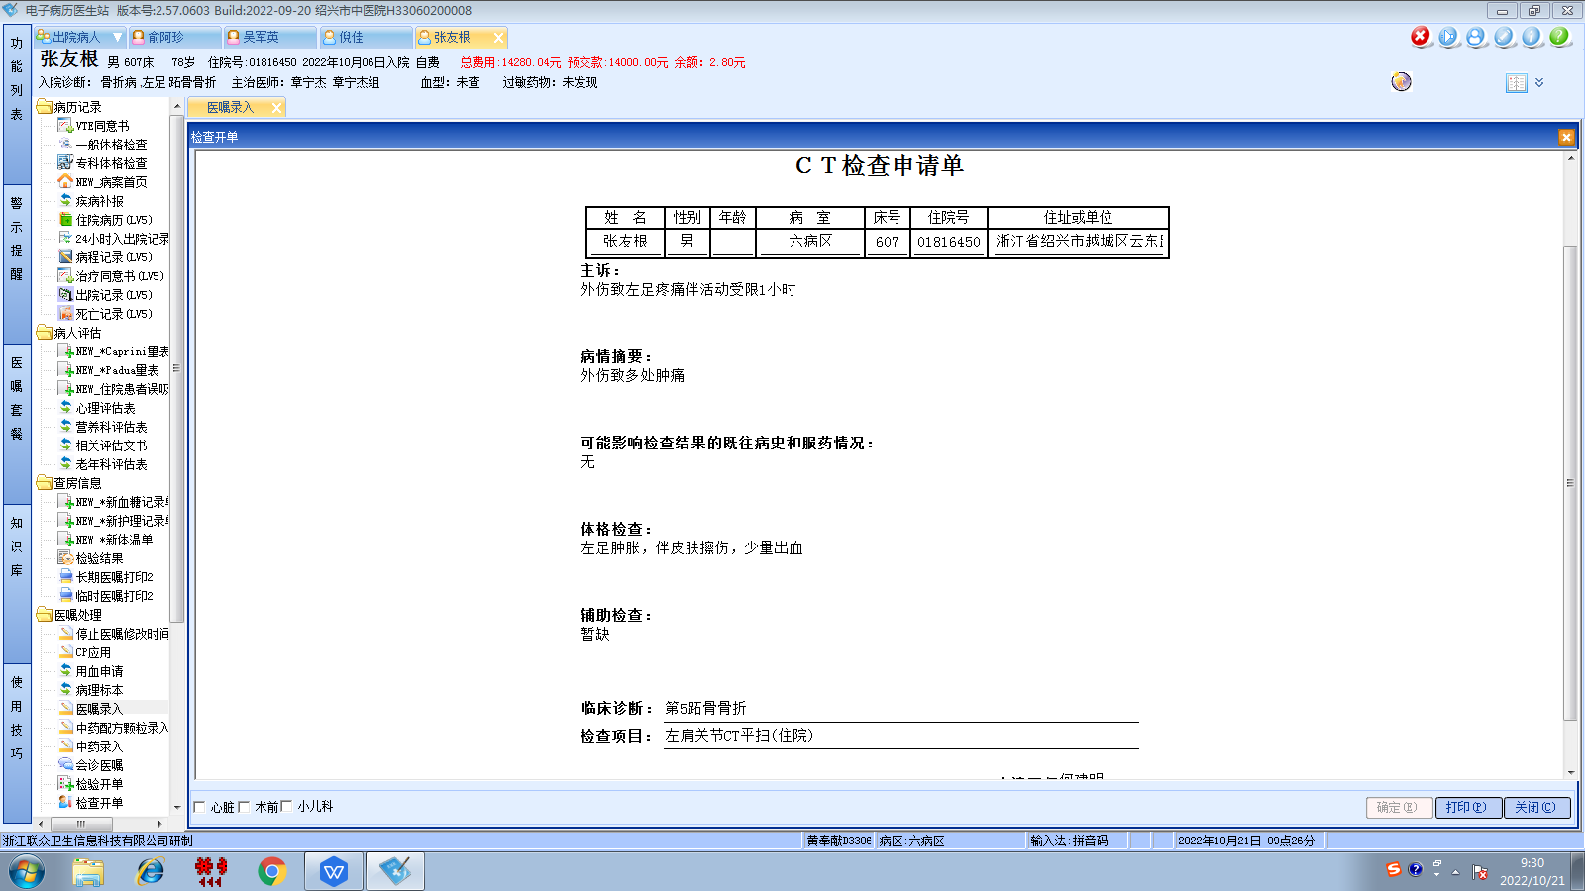章宁杰组
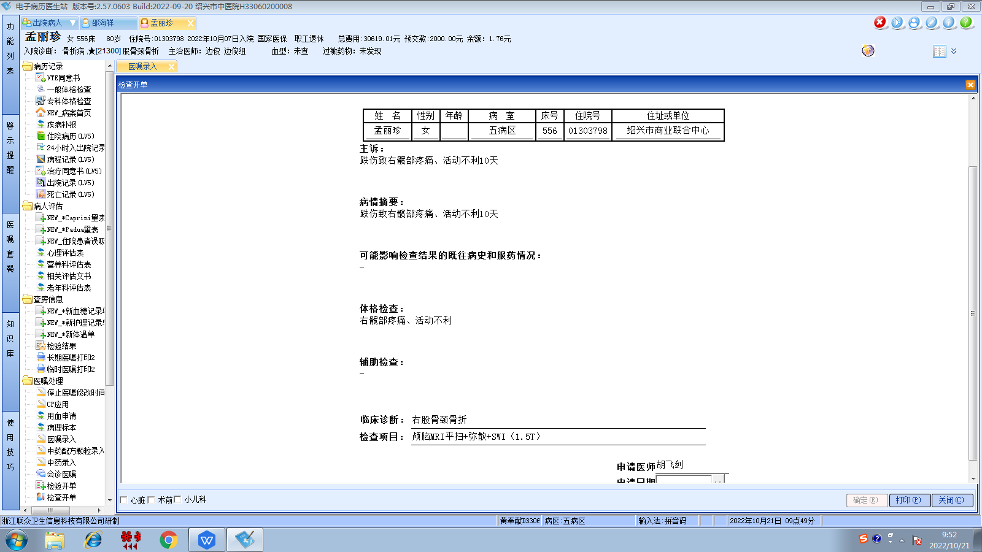胡松峰组
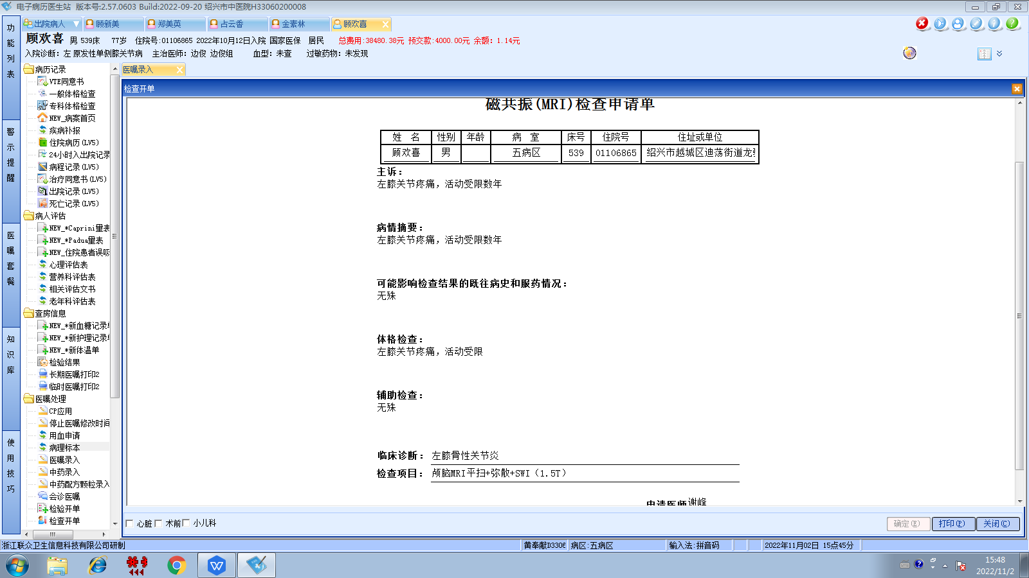边俊组
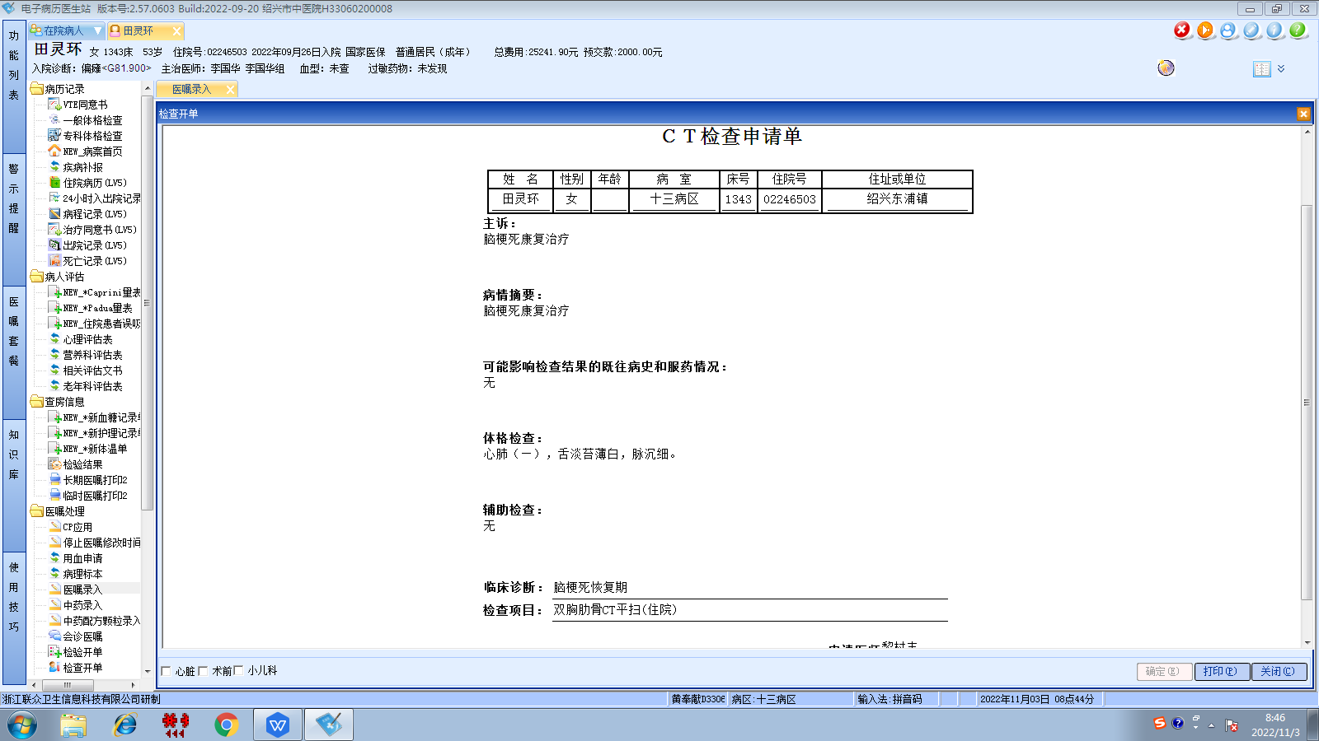李国华组
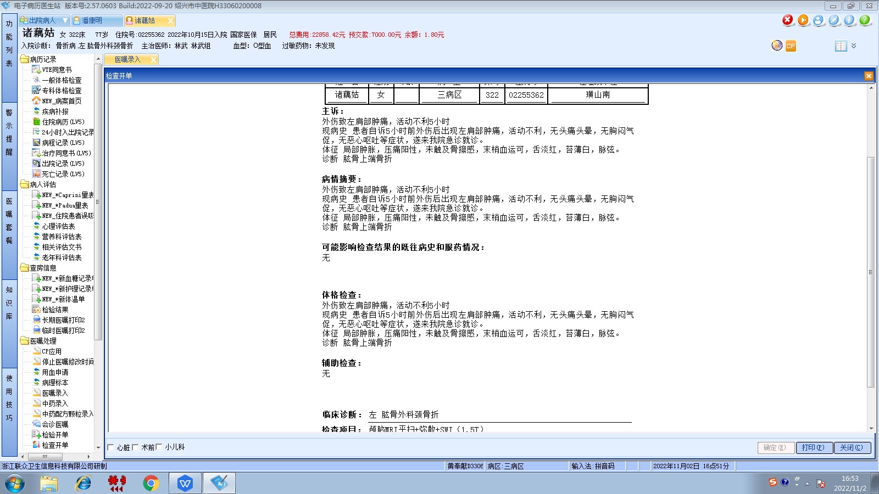林武组
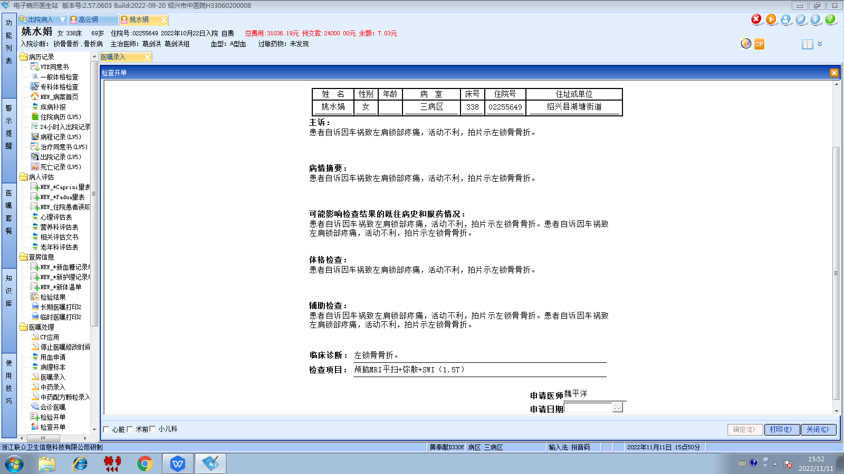葛剑洪组

