11月检查申请单质控
住院号 | 检查单类型 | 开单日期 | 开单医师 |  |  | 检查项目
 |  |  |  | 主诉 | 病情摘要 |  | 既往史 | 体格检查 | 辅助检查 | 诊断 | 内容申请单不一致
02256028 | MR | 2022-11-1 | 鲁剑梅 | √ | √ |  | √ | √ | √ | √ | √
02245788 | MR | 2022-11-1 | 朱海波 | √ | √ |  | √ | √ | √ | √ | √
02255998 | MR | 2022-10-31 | 谢峰 | √ | √ |  | √ | √ | √ | √ | √
01703946 | CT/MR | 2022-10-31 | 王一萍 | √ | √ |  | √ | √ | √ | √ | √
02255954 | MR | 2022-10-31 | 谢睿 | √ | √ |  | √ | √ | √ | √ | √
02255974 | MR | 2022-11-2 | 胡飞剑 | √ | √ |  | √ | √ | √ | √ | ×
02106845 | CT | 2022-10-31 | 冯梦雪 | √ | √ |  | √ | √ | √ | √ | √
02255925 | MR | 2022-11-1 | 陶铁瑛 | √ | √ |  | √ | √ | √ | √ | √
02255925 | CT | 2022-11-2 | 陶铁瑛 | √ | √ |  | √ | √ | √ | √ | √
02255955 | MR | 2022-11-1 | 孟闯闯 | √ | √ |  | √ | √ | √ | √ | √
02256074 | CT | 2022-11-2 | 许杨 | √ | √ |  | √ | √ | √ | √ | √
02256074 | CT | 2022-11-7 | 王一萍 | √ | √ |  | √ | √ | √ | √ | √
02256075 | MR | 2022-11-2 | 陈剑磨 | √ | √ |  | √ | √ | √ | √ | √
02256125 | MR | 2022-11-4 | 赵艳明 | √ | √ |  | √ | √ | √ | √ | √
02256125 | MR | 2022-11-6 | 陶铁瑛 | √ | √ |  | √ | √ | √ | √ | √
02256125 | MR | 2022-11-7 | 陶铁瑛 | √ | √ |  | √ | √ | √ | √ | √
01908088 | CT | 2022-11-4 | 龙平 | √ | √ |  | √ | √ | √ | √ | ×
02255988 | MR | 2022-11-4 | 胡烨琛 | √ | √ |  | √ | √ | √ | √ | √
02256090 | MR | 2022-11-5 | 李慧娇 | √ | √ |  | √ | √ | √ | √ | √
02256006 | CT | 2022-11-6 | 张建宇 | √ | √ |  | √ | √ | √ | √ | √
02108457 | MR | 2022-11-5 | 王冰清 | √ | √ |  | √ | √ | √ | √ | √
01413233 | MR | 2022-11-5 | 李慧娇 | √ | √ |  | √ | √ | √ | √ | √
02256105 | MR | 2022-11-6 | 孙玲玲 | √ | √ |  | √ | √ | √ | √ | √
02256077 | MR | 2022-11-3 | 孙莉 | √ | √ |  | √ | √ | √ | √ | √
02256143 | MR | 2022-11-4 | 谢峰 | √ | √ |  | √ | √ | √ | √ | √
02256161 | MR | 2022-11-5 | 谢峰 | √ | √ |  | √ | √ | √ | √ | √
02255649 | CT | 2022-11-9 | 张梦娇 | √ | √ |  | √ | √ | √ | √ | √
20108397 | MR | 2022-11-7 | 冯水娟 | √ | √ |  | √ | √ | √ | √ | √
02256186 | MR | 2022-11-6 | 沈家峰 | √ | √ |  | √ | √ | √ | √ | √
02256291 | CT | 2022-11-8 | 凌一鸣 | √ | √ |  | √ | √ | √ | √ | √
02256081 | MR | 2022-11-5 | 张华良 | √ | √ |  | √ | √ | √ | √ | √
02256248 | CT | 2022-11-8 | 谢睿 | √ | √ |  | √ | √ | √ | √ | ×
02002165 | CT | 2022-11-10 | 吴智敏 | √ | √ |  | √ | √ | √ | √ | √
02256385 | CT | 2022-11-11 | 吴智敏 | √ | √ |  | √ | √ | √ | √ | ×
01907770 | MR | 2022-11-9 | 钟承隽 | √ | √ |  | √ | √ | √ | √ | √
01811424 | MR | 2022-11-10 | 边俊 | √ | √ |  | √ | √ | √ | √ | √
02101072 | MR | 2022-11-9 | 鲁剑梅 | √ | √ |  | √ | √ | √ | √ | √
02101072 | MR | 2022-11-12 | 鲁剑梅 | √ | √ |  | √ | √ | √ | √ | √
01906614 | MR | 2022-11-10 | 张华良 | √ | √ |  | √ | √ | √ | √ | √
02256465 | MR | 2022-11-12 | 谢峰 | √ | √ |  | √ | √ | √ | √ | √
01504620 | MR | 2022-11-10 | 周健中 | √ | √ |  | √ | √ | √ | √ | √
02256355 | MR | 2022-11-12 | 李慧娇 | √ | √ |  | √ | √ | √ | √ | √
02256196 | MR | 2022-11-11 | 胡飞剑 | √ | √ |  | √ | √ | √ | √ | √
02102305 | MR | 2022-11-11 | 胡飞剑 | √ | √ |  | √ | √ | √ | √ | √
02256412 | MR | 2022-11-11 | 陶铁瑛 | √ | √ |  | √ | √ | √ | √ | √
01511447 | MR | 2022-11-12 | 李慧娇 | √ | √ |  | √ | √ | √ | √ | √
02255879 | MR | 2022-11-13 | 安星宇 | √ | √ |  | √ | √ | √ | √ | √
02256330 | MR | 2022-11-10 | 王冰清 | √ | √ |  | √ | √ | √ | √ | √
01916515 | MR | 2022-11-11 | 孙莉 | √ | √ |  | √ | √ | √ | √ | √
02104615 | MR | 2022-11-10 | 王冰清 | √ | √ |  | √ | √ | √ | √ | √
02256492 | MR | 2022-11-13 | 刘浩飞 | √ | √ |  | √ | √ | √ | √ | ×
02246163 | MR | 2022-11-10 | 王冰清 | √ | √ |  | √ | √ | √ | √ | √
02256361 | MR | 2022-11-11 | 孙莉 | √ | √ |  | √ | √ | √ | √ | √
01610385 | MR | 2022-11-12 | 谢峰 | √ | √ |  | √ | √ | √ | √ | √
02256401 | MR | 2022-11-15 | 马黎丽 | √ | √ |  | √ | √ | √ | √ | ×
02256301 | MR | 2022-11-15 | 黎云辉 | √ | √ |  | √ | √ | √ | √ | √
02256368 | MR | 2022-11-16 | 黎云辉 | √ | √ |  | √ | √ | √ | √ | √
02256595 | MR | 2022-11-16 | 胡飞剑 | √ | √ |  | √ | √ | √ | √ | ×
02256393 | MR | 2022-11-17 | 孙莉 | √ | √ |  | √ | √ | √ | √ | √
02256567 | CT | 2022-11-18 | 马军华 | √ | √ |  | √ | √ | √ | √ | √
01912571 | MR | 2022-11-16 | 公培强 | √ | √ |  | √ | √ | √ | √ | √
01401801 | CT | 2022-11-17 | 黄丽分 | √ | √ |  | √ | √ | √ | √ | √
02256554 | MR | 2022-11-16 | 盛苏红 | √ | √ |  | √ | √ | √ | √ | √
02256556 | MR | 2022-11-16 | 孙利荣 | √ | √ |  | √ | √ | √ | √ | √
02256648 | MR | 2022-11-17 | 许杨 | √ | √ |  | √ | √ | √ | √ | √
02256575 | MR | 2022-11-17 | 卢璐 | √ | √ |  | √ | √ | √ | √ | √
02239811 | MR | 2022-11-18 | 吴智敏 | √ | √ |  | √ | √ | √ | √ | √
02256575 | MR | 2022-11-18 | 卢璐 | √ | √ |  | √ | √ | √ | √ | √
01908916 | MR | 2022-11-19 | 胡飞剑 | √ | √ |  | √ | √ | √ | √ | √
02256774 | MR | 2022-11-19 | 张梦娇 | √ | √ |  | √ | √ | √ | √ | √
02256877 | CT | 2022-11-22 | 张梦娇 | √ | √ |  | √ | √ | √ | √ | √
02256859 | MR | 2022-11-21 | 胡飞剑 | √ | √ |  | √ | √ | √ | √ | √
01912571 | MR | 2022-11-20 | 李慧娇 | √ | √ |  | √ | √ | √ | √ | √
02242341 | CT | 2022-11-22 | 支飞虎 | √ | √ |  | √ | √ | √ | √ | √
02256702 | MR | 2022-11-18 | 陈剑磨 | √ | √ |  | √ | √ | √ | √ | √
02254984 | CT | 2022-11-21 | 黎村丰 | √ | √ |  | √ | √ | √ | √ | √
01913005 | CT | 2022-11-22 | 陈俊杰 | √ | √ |  | √ | √ | √ | √ | √
02256696 | MR | 2022-11-20 | 陈剑磨 | √ | √ |  | √ | √ | √ | √ | √
01203854 | MR | 2022-11-19 | 诸佳燕 | √ | √ |  | √ | √ | √ | √ | √
02256793 | CT | 2022-11-23 | 孙莉 | √ | √ |  | √ | √ | √ | √ | √
02239945 | MR | 2022-11-20 | 谢峰 | √ | √ |  | √ | √ | √ | √ | √
01914409 | MR | 2022-11-20 | 杨兴辉 | √ | √ |  | √ | √ | √ | √ | √
02256733 | CT | 2022-11-22 | 张澍漾 | √ | √ |  | √ | √ | √ | √ | √
02256860 | CT | 2022-11-21 | 钟承隽 | √ | √ |  | √ | √ | √ | √ | ×
02256914 | CT | 2022-11-23 | 沈兴潮 | √ | √ |  | √ | √ | √ | √ | √
02255857 | MR | 2022-11-23 | 尤志新 | √ | √ |  | √ | √ | √ | √ | √
02111204 | MR | 2022-11-19 | 王冰清 | √ | √ |  | √ | √ | √ | √ | √
01714048 | MR | 2022-11-21 | 公培强 | √ | √ |  | √ | √ | √ | √ | √
01907387 | CT | 2022-11-23 | 尤志新 | √ | √ |  | √ | √ | √ | √ | √
02109188 | MR | 2022-11-22 | 许杨 | √ | √ |  | √ | √ | √ | √ | √
01803479 | MR | 2022-11-20 | 许杨 | √ | √ |  | √ | √ | √ | √ | √
01905716 | MR | 2022-11-25 | 王家甜 | √ | √ |  | √ | √ | √ | √ | √
02256836 | MR | 2022-11-21 | 张学思 | √ | √ |  | √ | √ | √ | √ | √
02256761 | MR | 2022-11-24 | 冯水娟 | √ | √ |  | √ | √ | √ | √ | √
01908050 | MR | 2022-11-23 | 孙莉 | √ | √ |  | √ | √ | √ | √ | √
02256884 | MR | 2022-11-23 | 孙莉 | √ | √ |  | √ | √ | √ | √ | √
02256884 | CT | 2022-11-23 | 孙莉 | √ | √ |  | √ | √ | √ | √ | √
02256928 | MR | 2022-11-23 | 边俊 | √ | √ |  | √ | √ | √ | √ | √
01705306 | CT | 2022-11-23 | 裘鸿飞 | √ | √ |  | √ | √ | √ | √ | √
02256907 | MR | 2022-11-23 | 胡飞剑 | √ | √ |  | √ | √ | √ | √ | √
02256784 | CT | 2022-11-27 | 魏平洋 | √ | √ |  | √ | √ | √ | √ | √
02256999 | CT/MR | 2022-11-25 | 刘运海 | √ | √ |  | √ | √ | √ | √ | √
02103223 | MR | 2022-11-24 | 孙莉 | √ | √ |  | √ | √ | √ | √ | √
02257019 | MR | 2022-11-26 | 金建淼 | √ | √ |  | √ | √ | √ | √ | √
01914781 | MR | 2022-11-26 | 孙莉 | √ | √ |  | √ | √ | √ | √ | √
01405538 | CT | 2022-11-25 | 周怡 | √ | √ |  | √ | √ | √ | √ | √
02257073 | CT/MR | 2022-11-28 | 刘运海 | √ | √ |  | √ | √ | √ | √ | √
01311437 | MR | 2022-11-27 | 刘运海 | √ | √ |  | √ | √ | √ | √ | √
02256987 | MR | 2022-11-26 | 杨锋 | √ | √ |  | √ | √ | √ | √ | √
02257048 | CT/MR | 2022-11-27 | 张梦娇 | √ | × |  | × | √ | × | √ | ×
02257042 | MR | 2022-11-27 | 孙利荣 | √ | √ |  | √ | √ | √ | √ | √
02256951 | MR | 2022-11-26 | 龙平 | √ | √ |  | √ | √ | √ | √ | √
02257047 | CT | 2022-11-29 | 何建明 | √ | √ |  | √ | √ | √ | √ | ×
02257052 | MR | 2022-11-29 | 刘依兰 | √ | √ |  | √ | √ | √ | √ | ×
02257112 | MR | 2022-11-28 | 王冰清 | √ | √ |  | √ | √ | √ | √ | √
01909276 | MR | 2022-11-28 | 罗桢敏 | √ | √ |  | √ | √ | √ | √ | √
02256970 | CT | 2022-11-27 | 边俊 | √ | √ |  | √ | √ | √ | √ | √
02256525 | CT | 2022-11-28 | 马军华 | √ | √ |  | √ | √ | √ | √ | √
02105319 | MR | 2022-11-29 | 吴明 | √ | √ |  | √ | √ | √ | √ | √
01410852 | MR | 2022-11-28 | 陶铁瑛 | √ | √ |  | √ | √ | √ | √ | √
01412431 | CT | 2022-11-29 | 谢睿 | √ | √ |  | √ | √ | √ | √ | ×
02257149 | MR | 2022-11-28 | 王磊 | √ | √ |  | √ | √ | √ | √ | √
注：对住院患者检查申请单进行专项检查，其中主诉、体格检查或诊断任缺一项者视为不合格申请单；非入院常规检查，如申请单内容与检查部位及要求不一致，亦视为不合格申请单。
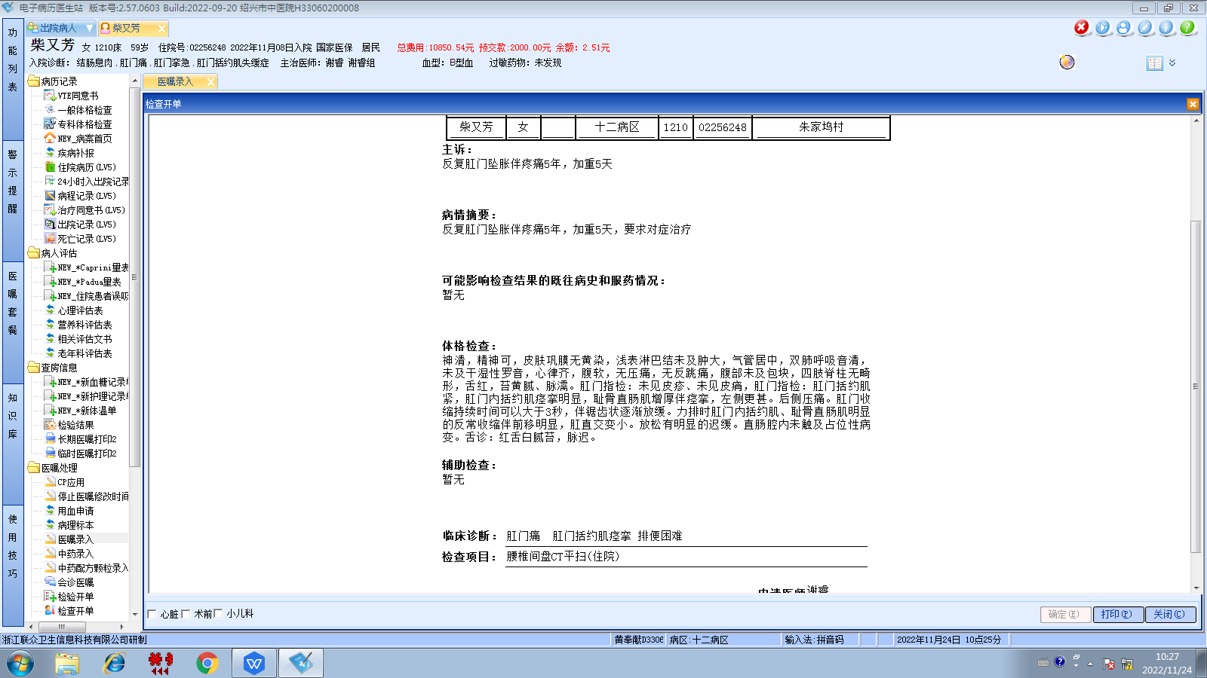谢睿组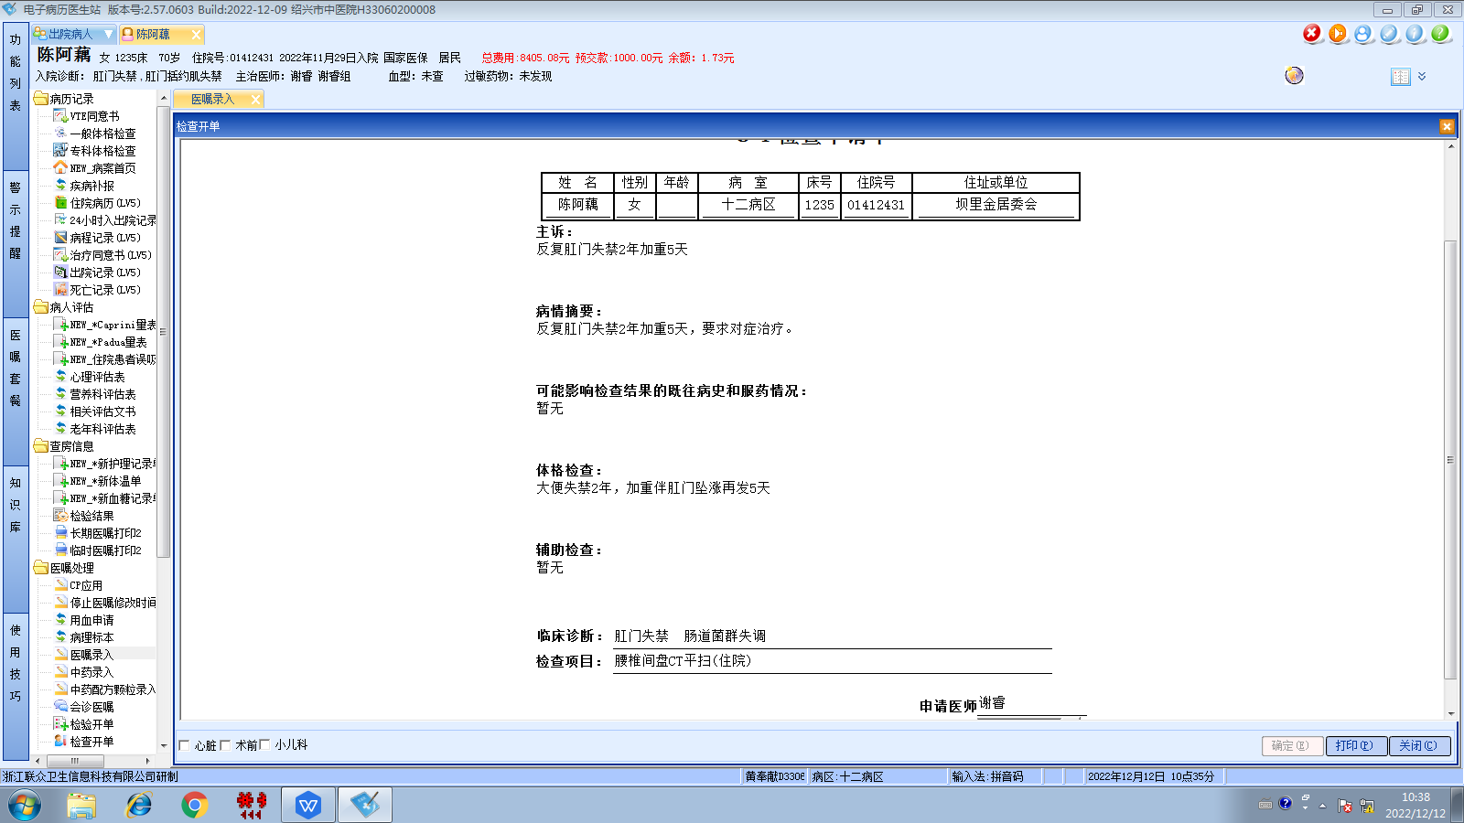谢睿组
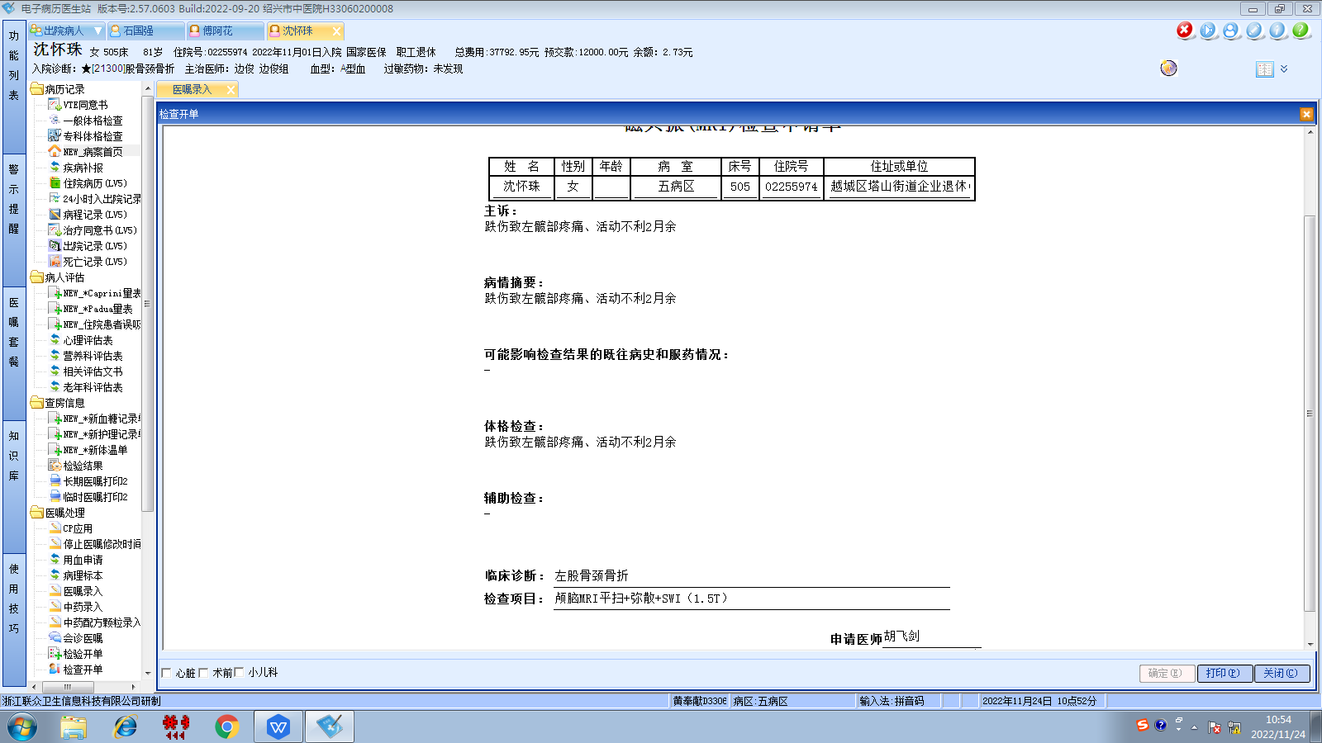边俊组
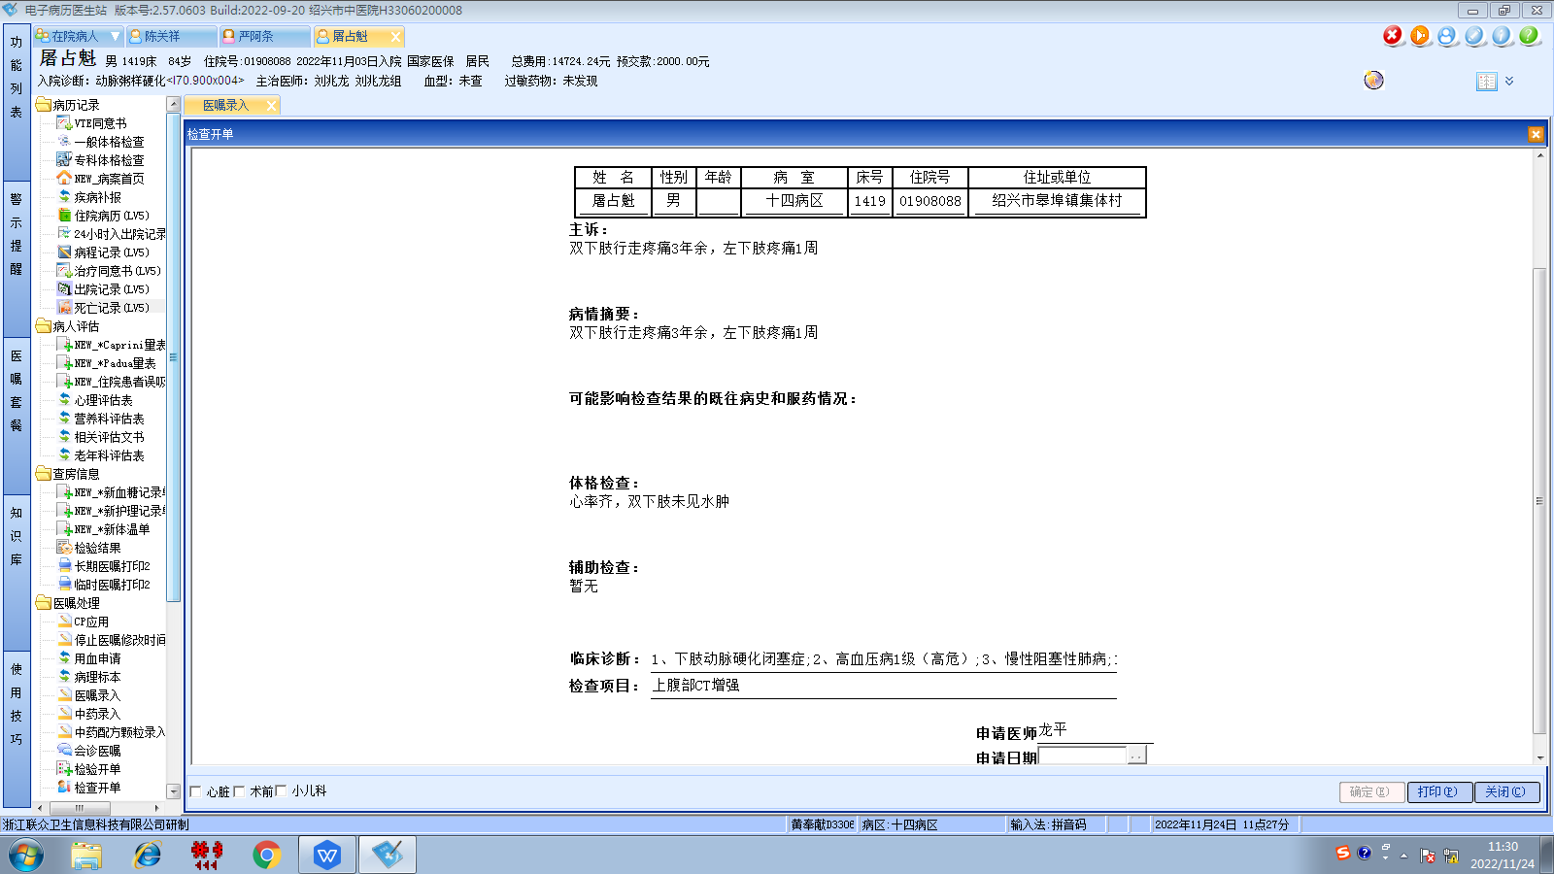刘兆龙组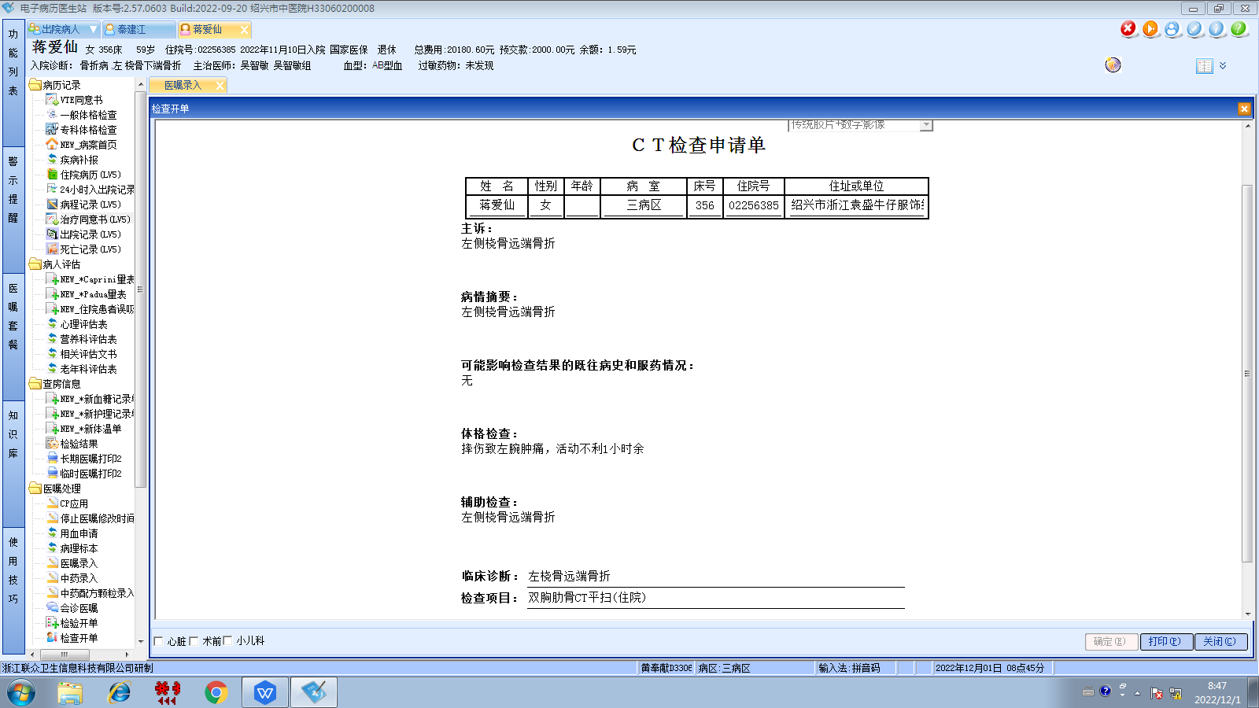吴智敏组
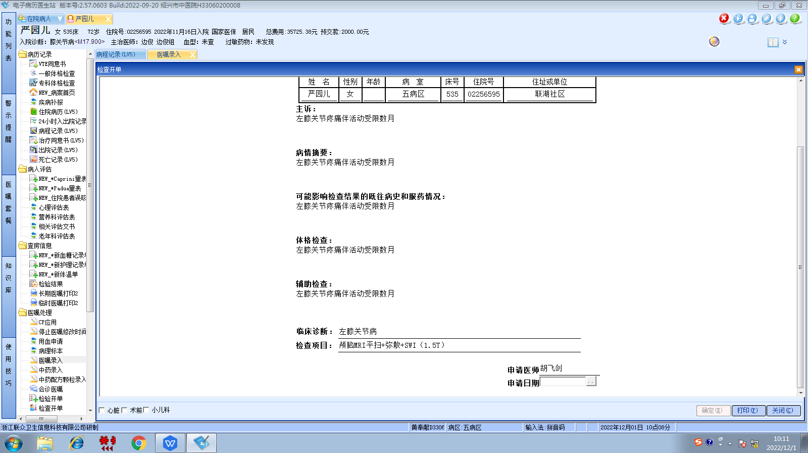边俊组
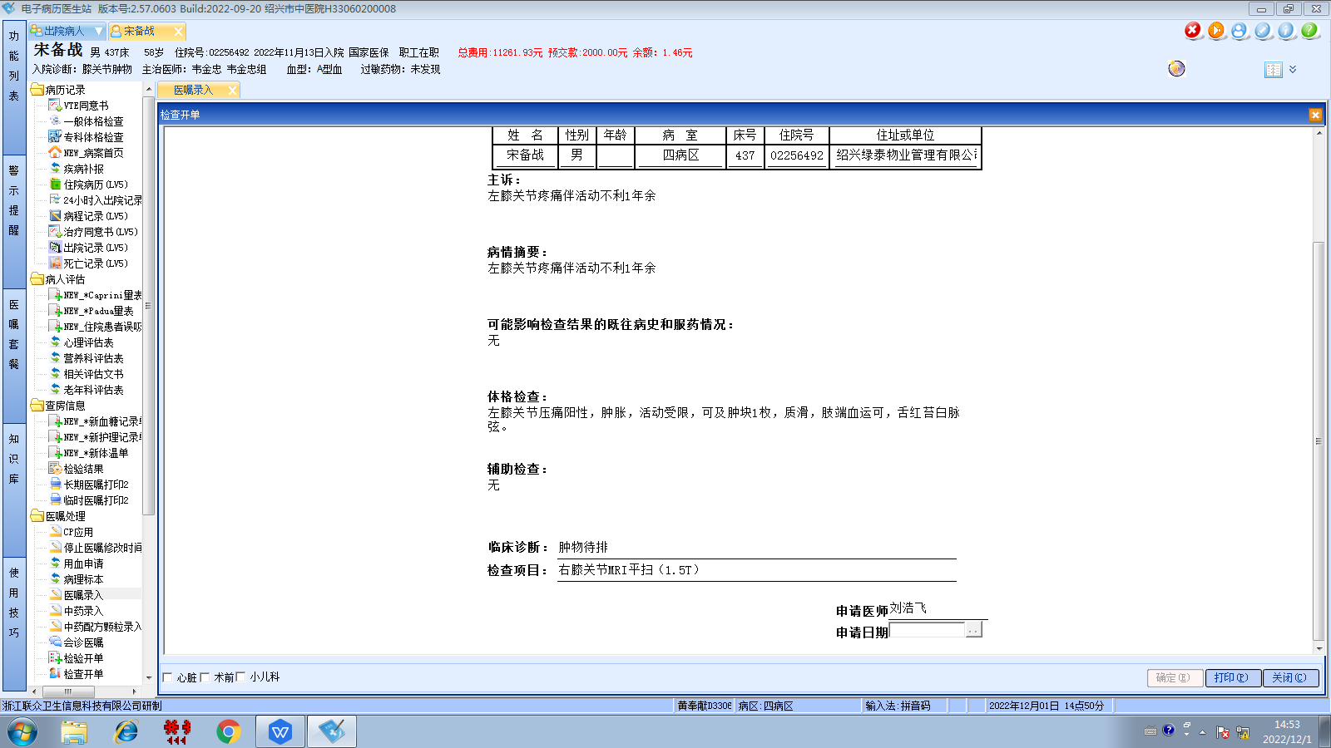韦金忠组
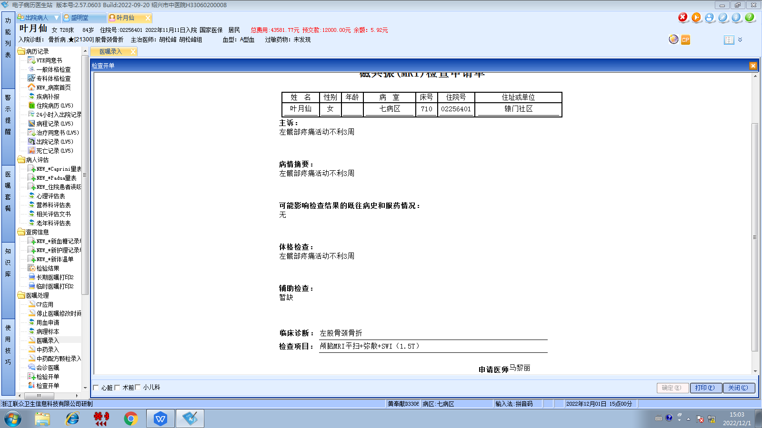富琳岩组
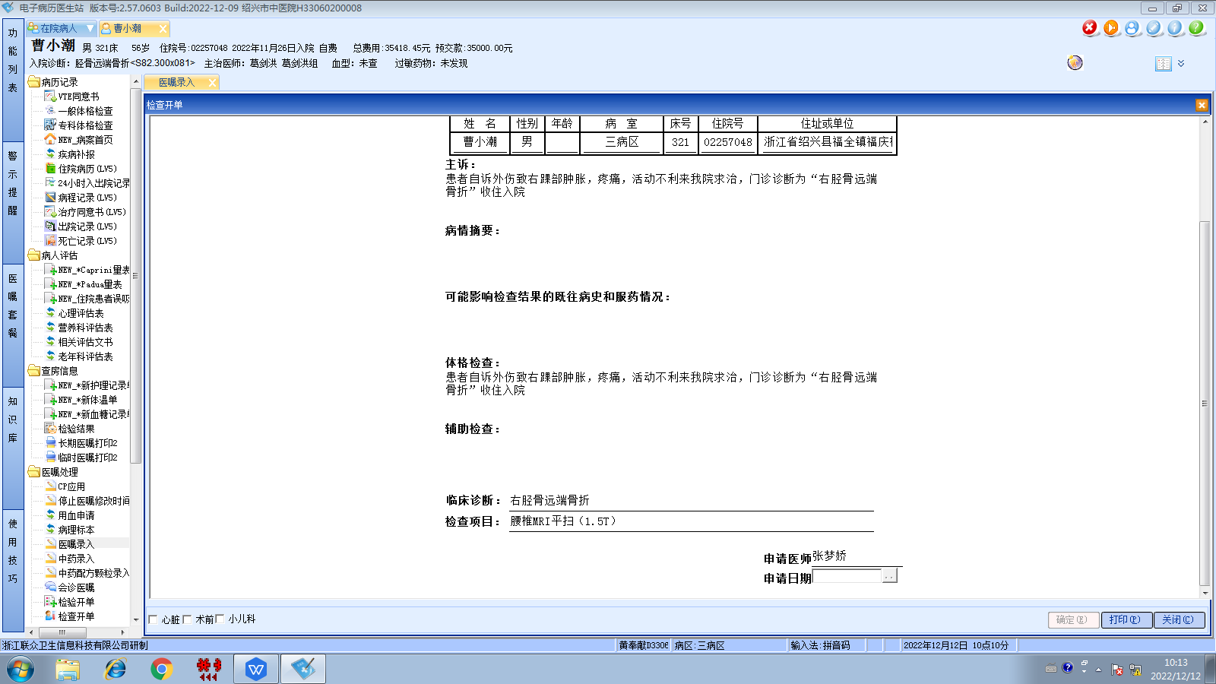葛剑洪组
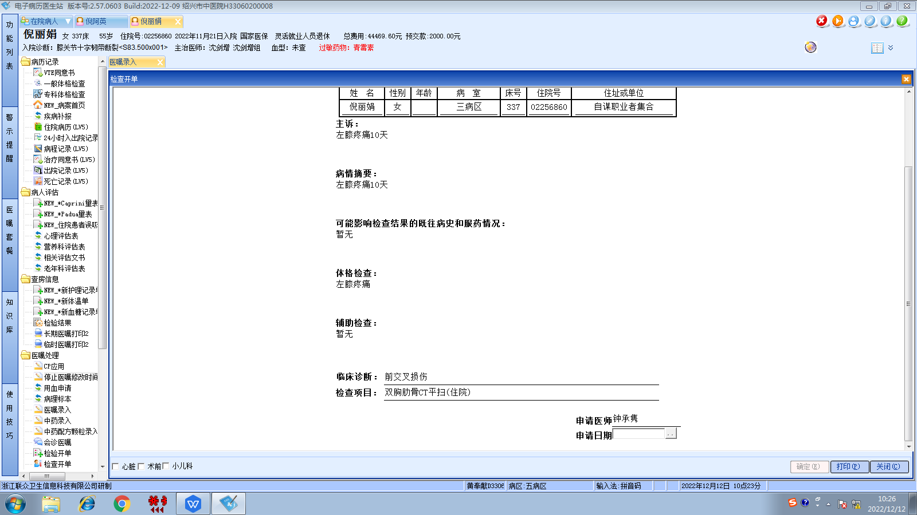沈剑增组
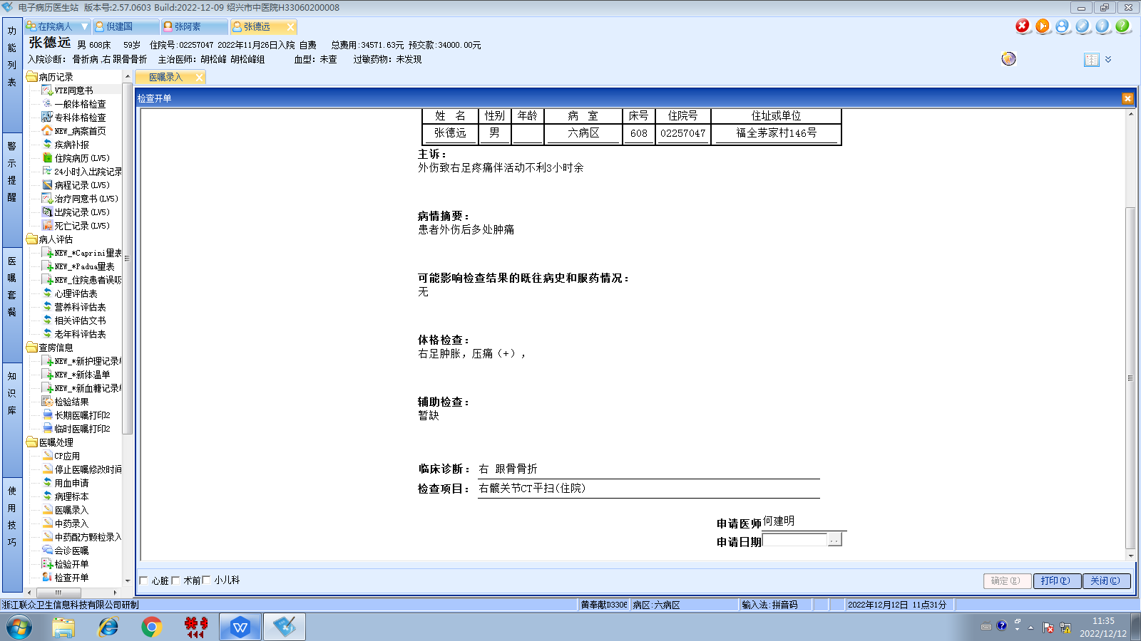章宁杰组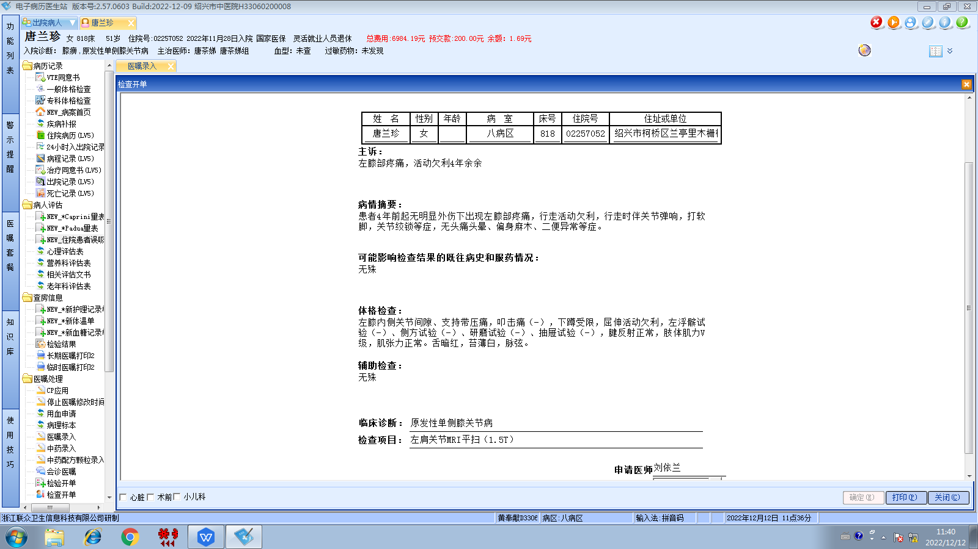唐茶娣组

