12月检查申请单质控
住院号 | 检查单类型 | 开单日期 | 开单医师 |  |  | 检查项目
 |  |  |  | 主诉 | 病情摘要 |  | 既往史 | 体格检查 | 辅助检查 | 诊断 | 内容申请单不一致
02110227 | MR | 2022-11-29 | 龚彬 | √ | √ |  | √ | √ | √ | √ | √
02257046 | CT | 2022-12-1 | 张梦娇 | √ | √ |  | √ | √ | √ | √ | ×
02257041 | MR | 2022-11-30 | 王风永 | √ | √ |  | √ | √ | √ | √ | ×
01900909 | CT | 2022-11-30 | 王晋钟 | √ | √ |  | √ | √ | √ | √ | √
01909276 | CT | 2022-11-29 | 罗桢敏 | √ | √ |  | √ | √ | √ | √ | √
02257181 | MR | 2022-12-1 | 周怡 | √ | √ |  | √ | √ | √ | √ | √
02257246 | CT | 2022-12-1 | 陶铁瑛 | √ | √ |  | √ | √ | √ | √ | √
02257246 | CT | 2022-12-4 | 王洪灿 | √ | √ |  | √ | √ | √ | √ | √
01509208 | MR | 2022-11-30 | 盛苏红 | √ | √ |  | √ | √ | √ | √ | √
02257131 | MR | 2022-11-30 | 边佳萍 | √ | √ |  | √ | √ | √ | √ | √
02257193 | MR | 2022-11-30 | 鲁剑梅 | √ | √ |  | √ | √ | √ | √ | √
02257252 | CT | 2022-12-2 | 刘运海 | √ | √ |  | √ | √ | √ | √ | √
01606168 | CT | 2022-12-3 | 张梦娇 | √ | √ |  | √ | √ | √ | √ | √
01811734 | MR | 2022-12-1 | 胡飞剑 | √ | √ |  | √ | √ | √ | √ | √
02257243 | CT | 2022-12-2 | 陈俊杰 | √ | √ |  | √ | √ | √ | √ | √
02257203 | MR | 2022-11-30 | 凌一鸣 | √ | √ |  | √ | √ | √ | √ | √
02257261 | MR | 2022-12-1 | 公培强 | √ | √ |  | √ | √ | √ | √ | √
01908035 | MR | 2022-11-30 | 王冰清 | √ | √ |  | √ | √ | √ | √ | √
02256293 | CT | 2022-12-4 | 夏炳江 | √ | √ |  | √ | √ | √ | √ | √
01902153 | MR | 2022-12-2 | 胡飞剑 | √ | √ |  | √ | √ | √ | √ | √
02257268 | CT | 2022-12-5 | 吴明 | √ | √ |  | √ | √ | √ | √ | √
01814030 | MR | 2022-12-1 | 王冰清 | √ | √ |  | √ | √ | √ | √ | √
01814030 | CT | 2022-12-6 | 王冰清 | √ | √ |  | √ | √ | √ | √ | √
02257260 | MR | 2022-12-4 | 陆超锋 | √ | √ |  | √ | √ | √ | √ | √
02256877 | MR | 2022-12-3 | 朱涵杰 | √ | √ |  | √ | √ | √ | √ | √
02257250 | MR | 2022-12-4 | 陆超锋 | √ | √ |  | √ | √ | √ | √ | √
02257271 | MR | 2022-12-3 | 龚彬 | √ | √ |  | √ | √ | √ | √ | √
02257284 | CT | 2022-12-6 | 朱海波 | √ | √ |  | √ | √ | √ | √ | √
01811424 | MR | 2022-12-4 | 李国华 | √ | √ |  | √ | √ | √ | √ | √
02257241 | MR | 2022-12-4 | 许杨 | √ | √ |  | √ | √ | √ | √ | √
02257231 | CT | 2022-12-6 | 张桢阳 | √ | √ |  | √ | √ | √ | √ | √
02238072 | MR | 2022-12-5 | 王冰清 | √ | √ |  | √ | √ | √ | √ | √
02257432 | MR | 2022-12-6 | 公培强 | √ | √ |  | √ | √ | √ | √ | √
01807251 | CT | 2022-12-5 | 谢睿 | √ | √ |  | √ | √ | √ | √ | √
02257429 | MR | 2022-12-6 | 胡飞剑 | √ | √ |  | √ | √ | √ | √ | √
02257396 | MR | 2022-12-6 | 张圣扬 | √ | √ |  | √ | √ | √ | √ | ×
02257064 | MR | 2022-12-5 | 吕宇航 | √ | √ |  | √ | √ | √ | √ | √
02110226 | CT | 2022-12-5 | 孙利荣 | √ | √ |  | √ | √ | √ | √ | √
02257405 | MR | 2022-12-6 | 王冰清 | √ | √ |  | √ | √ | √ | √ | √
02257415 | MR | 2022-12-7 | 尤志新 | √ | √ |  | √ | √ | √ | √ | √
01404314 | CT | 2022-12-9 | 刘浩飞 | √ | √ |  | √ | √ | √ | √ | √
02257444 | MR | 2022-12-7 | 边俊 | √ | √ |  | √ | √ | √ | √ | ×
02257367 | CT | 2022-12-7 | 张建宇 | √ | √ |  | √ | √ | √ | √ | √
02257381 | MR | 2022-12-9 | 刘悦 | √ | √ |  | √ | √ | √ | √ | √
02257263 | MR | 2022-12-4 | 陆超锋 | √ | √ |  | √ | √ | √ | √ | √
02257480 | MR | 2022-12-8 | 王冰清 | √ | √ |  | √ | √ | √ | √ | √
02257329 | MR | 2022-12-8 | 孙莉 | √ | √ |  | √ | √ | √ | √ | √
02257468 | CT | 2022-12-8 | 王磊 | √ | √ |  | √ | √ | √ | √ | ×
01917382 | MR | 2022-12-10 | 朱大明 | √ | √ |  | √ | √ | √ | √ | √
01813483 | CT | 2022-12-12 | 郑建林 | √ | √ |  | √ | √ | √ | √ | √
02257560 | MR | 2022-12-10 | 胡飞剑 | √ | √ |  | √ | √ | √ | √ | √
02257609 | MR | 2022-12-12 | 边俊 | √ | √ |  | √ | √ | √ | √ | √
02257568 | MR | 2022-12-11 | 陈剑磨 | √ | √ |  | √ | √ | √ | √ | √
02257541 | CT | 2022-12-12 | 陶铁瑛 | √ | √ |  | √ | √ | √ | √ | √
02257432 | MR | 2022-12-9 | 何易 | √ | √ |  | √ | √ | √ | √ | √
02257548 | MR | 2022-12-10 | 胡飞剑 | √ | √ |  | √ | √ | √ | √ | ×
02257447 | MR | 2022-12-11 | 刘潇 | √ | √ |  | √ | √ | √ | √ | √
02257411 | CT | 2022-12-9 | 孙莉 | √ | √ |  | √ | √ | √ | √ | √
01405383 | MR | 2022-12-12 | 边佳萍 | √ | √ |  | √ | √ | √ | √ | √
01715075 | CT | 2022-12-14 | 王冰清 | √ | √ |  | √ | √ | √ | √ | √
01715075 | MR | 2022-12-13 | 孙莉 | √ | √ |  | √ | √ | √ | √ | √
01513800 | CT | 2022-12-14 | 陆杰慧 | √ | √ |  | √ | √ | √ | √ | √
01908830 | CT | 2022-12-14 | 赵艳明 | √ | √ |  | √ | √ | √ | √ | √
01902946 | MR | 2022-12-13 | 孙莉 | √ | √ |  | √ | √ | √ | √ | √
02257646 | MR | 2022-12-14 | 王敏龙 | √ | √ |  | √ | √ | √ | √ | √
02257603 | MR | 2022-12-14 | 王家甜 | √ | √ |  | √ | √ | √ | √ | √
02257556 | CT | 2022-12-15 | 张桢阳 | √ | √ |  | √ | √ | √ | √ | √
01806495 | CT | 2022-12-15 | 尤志新 | √ | √ |  | √ | √ | √ | √ | √
02257650 | MR | 2022-12-13 | 何易 | √ | √ |  | √ | √ | √ | √ | √
02257630 | MR | 2022-12-14 | 沈学香 | √ | √ |  | √ | √ | √ | √ | √
01406160 | CT | 2022-12-14 | 陆杰慧 | √ | √ |  | √ | √ | √ | √ | √
02257585 | MR | 2022-12-12 | 王冰清 | √ | √ |  | √ | √ | √ | √ | √
02004139 | CT | 2022-12-14 | 周怡 | √ | √ |  | √ | √ | √ | √ | √
01604097 | MR | 2022-12-14 | 张梦娇 | √ | √ |  | √ | √ | √ | √ | ×
02106139 | CT | 2022-12-14 | 陆杰慧 | √ | √ |  | √ | √ | √ | √ | √
02257569 | MR | 2022-12-14 | 陈剑磨 | √ | √ |  | √ | √ | √ | √ | √
01816339 | MR | 2022-12-15 | 孙莉 | √ | √ |  | √ | √ | √ | √ | √
01508719 | MR | 2022-12-16 | 许杨 | √ | √ |  | √ | √ | √ | √ | √
02239124 | CT | 2022-12-17 | 马军华 | √ | √ |  | √ | √ | √ | √ | √
02241077 | MR | 2022-12-16 | 钱飞婷 | √ | √ |  | √ | √ | √ | √ | ×
02257698 | MR | 2022-12-16 | 许华强 | √ | √ |  | √ | √ | √ | √ | √
01711121 | MR | 2022-12-18 | 陈琦军 | √ | √ |  | √ | √ | √ | √ | √
02257810 | MR | 2022-12-19 | 谢峰 | √ | √ |  | √ | √ | √ | √ | √
01901888 | MR | 2022-12-19 | 陆杰慧 | √ | √ |  | √ | √ | √ | √ | ×
02257819 | MR | 2022-12-19 | 谢峰 | √ | √ |  | √ | √ | √ | √ | √
02102526 | MR | 2022-12-20 | 许杨 | √ | √ |  | √ | √ | √ | √ | √
01807251 | CT | 2022-12-19 | 王春春 | √ | √ |  | √ | √ | √ | √ | √
02257831 | CT | 2022-12-20 | 刘运海 | √ | √ |  | √ | √ | √ | √ | √
02238400 | CT | 2022-12-21 | 马军华 | √ | √ |  | √ | √ | √ | √ | √
02238400 | MR | 2022-12-21 | 刘悦 | √ | √ |  | √ | √ | √ | √ | √
01917100 | CT | 2022-12-23 | 朱大明 | √ | √ |  | √ | √ | √ | √ | √
02212285 | MR | 2022-12-21 | 凌一鸣 | √ | √ |  | √ | √ | √ | √ | √
01901888 | CT | 2022-12-23 | 朱大明 | √ | √ |  | √ | √ | √ | √ | √
02257868 | MR | 2022-12-22 | 陈剑磨 | √ | √ |  | √ | √ | √ | √ | √
02238392 | MR | 2022-12-22 | 边俊 | √ | √ |  | √ | √ | √ | √ | √
02257908 | MR | 2022-12-24 | 胡飞剑 | √ | √ |  | √ | √ | √ | √ | √
02257873 | MR | 2022-12-23 | 周怡 | √ | √ |  | √ | √ | √ | √ | √
02257897 | MR | 2022-12-24 | 边俊 | √ | √ |  | √ | √ | √ | √ | √
01804921 | MR | 2022-12-25 | 尤志新 | √ | √ |  | √ | √ | √ | √ | √
02257859 | CT | 2022-12-24 | 王洪灿 | √ | √ |  | √ | √ | √ | √ | √
02255486 | CT | 2022-12-26 | 刘潇 | √ | √ |  | √ | √ | √ | √ | √
01904911 | CT | 2022-12-27 | 张圣扬 | √ | √ |  | √ | √ | √ | √ | √
02257978 | CT | 2022-12-26 | 许海锋 | √ | √ |  | √ | √ | √ | √ | √
01400469 | MR | 2022-12-27 | 谢峰 | √ | √ |  | √ | √ | √ | √ | √
02257079 | MR | 2022-12-26 | 黎村丰 | √ | √ |  | √ | √ | √ | √ | √
02258036 | MR | 2022-12-27 | 谢峰 | √ | √ |  | √ | √ | √ | √ | √
01703199 | MR | 2022-12-28 | 王冰清 | √ | √ |  | √ | √ | √ | √ | √
01908298 | MR | 2022-12-28 | 尤志新 | √ | √ |  | √ | √ | √ | √ | √
02258049 | MR | 2022-12-28 | 谢峰 | √ | √ |  | √ | √ | √ | √ | √
02257969 | MR | 2022-12-25 | 胡飞剑 | √ | √ |  | √ | √ | √ | √ | √
02257987 | MR | 2022-12-26 | 张春晓 | √ | √ |  | √ | √ | √ | √ | √
02257907 | MR | 2022-12-26 | 朱大明 | √ | √ |  | √ | √ | √ | √ | √
02000395 | MR | 2022-12-27 | 刘潇 | √ | √ |  | √ | √ | √ | √ | √
02257953 | CT | 2022-12-28 | 胡飞剑 | √ | √ |  | √ | √ | √ | √ | √
02258077 | MR | 2022-12-28 | 张春晓 | √ | √ |  | √ | √ | √ | √ | √
02258097 | MR | 2022-12-29 | 胡飞剑 | √ | √ |  | √ | √ | √ | √ | √
02258126 | MR | 2022-12-29 | 胡飞剑 | √ | √ |  | √ | √ | √ | √ | √
02258150 | MR | 2022-12-30 | 冯水娟 | √ | √ |  | √ | √ | √ | √ | √
01302100 | MR | 2022-12-26 | 王冰清 | √ | √ |  | √ | √ | √ | √ | √
02258099 | MR | 2022-12-30 | 陶铁瑛 | √ | √ |  | √ | √ | √ | √ | √
01900352 | CT | 2022-12-29 | 许海锋 | √ | √ |  | √ | √ | √ | √ | √
02258143 | MR | 2022-12-30 | 孙莉 | √ | √ |  | √ | √ | √ | √ | √
02258179 | CT | 2022-12-30 | 王磊 | √ | √ |  | √ | √ | √ | √ | √
01703216 | MR | 2022-12-30 | 孙莉 | √ | √ |  | √ | √ | √ | √ | √
01709872 | MR | 2022-12-30 | 谢睿 | √ | √ |  | √ | √ | √ | √ | √
02256810 | MR | 2022-12-30 | 李国华 | √ | √ |  | √ | √ | √ | √ | √
02258071 | CT | 2022-12-30 | 王风永 | √ | √ |  | √ | √ | √ | √ | √
注：对住院患者检查申请单进行专项检查，其中主诉、体格检查或诊断任缺一项者视为不合格申请单；非入院常规检查，如申请单内容与检查部位及要求不一致，亦视为不合格申请单。

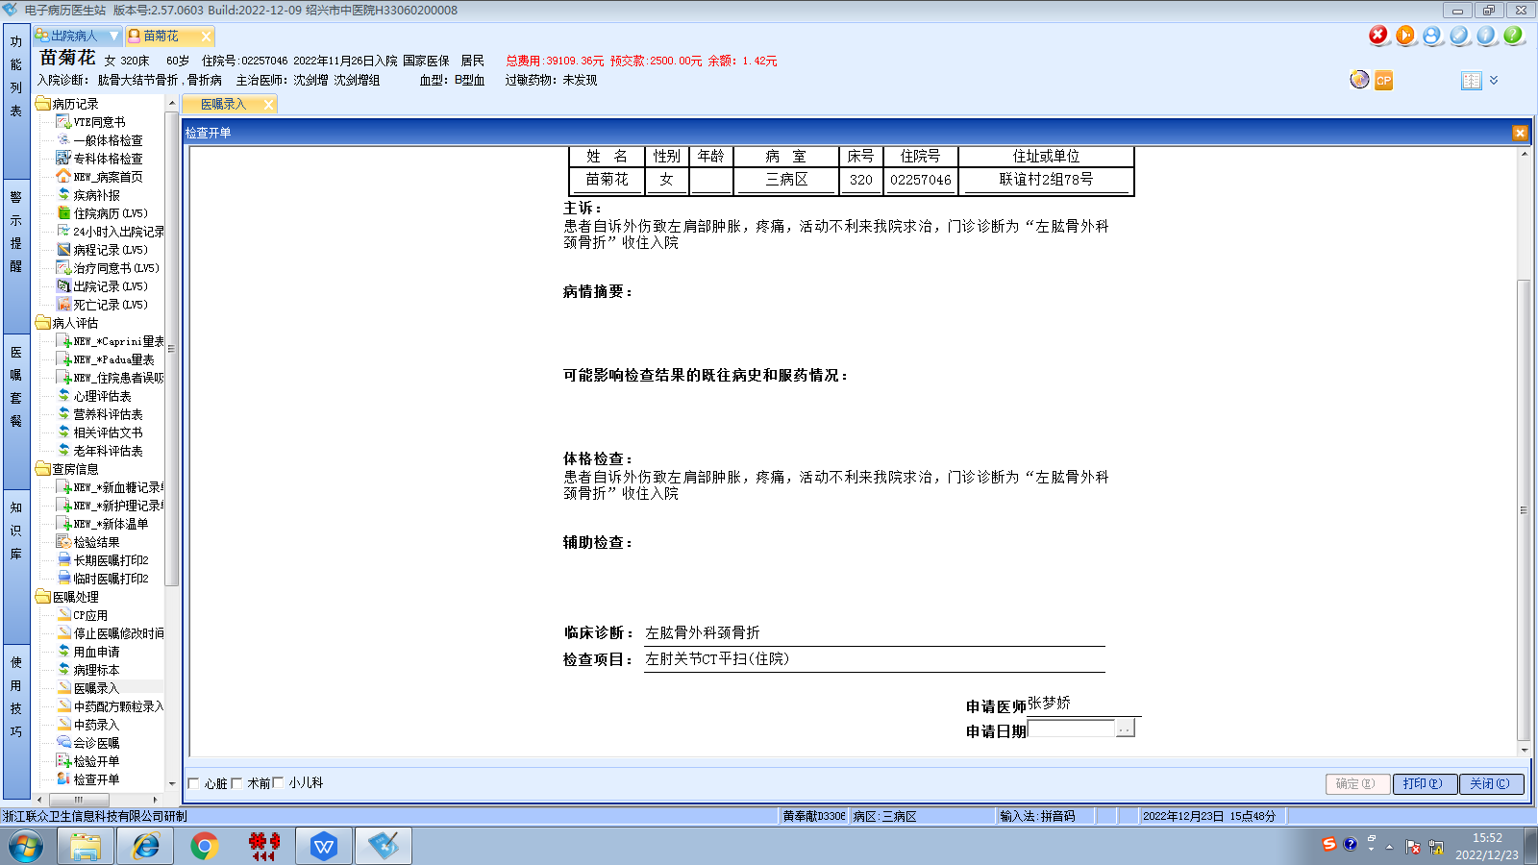葛剑洪组
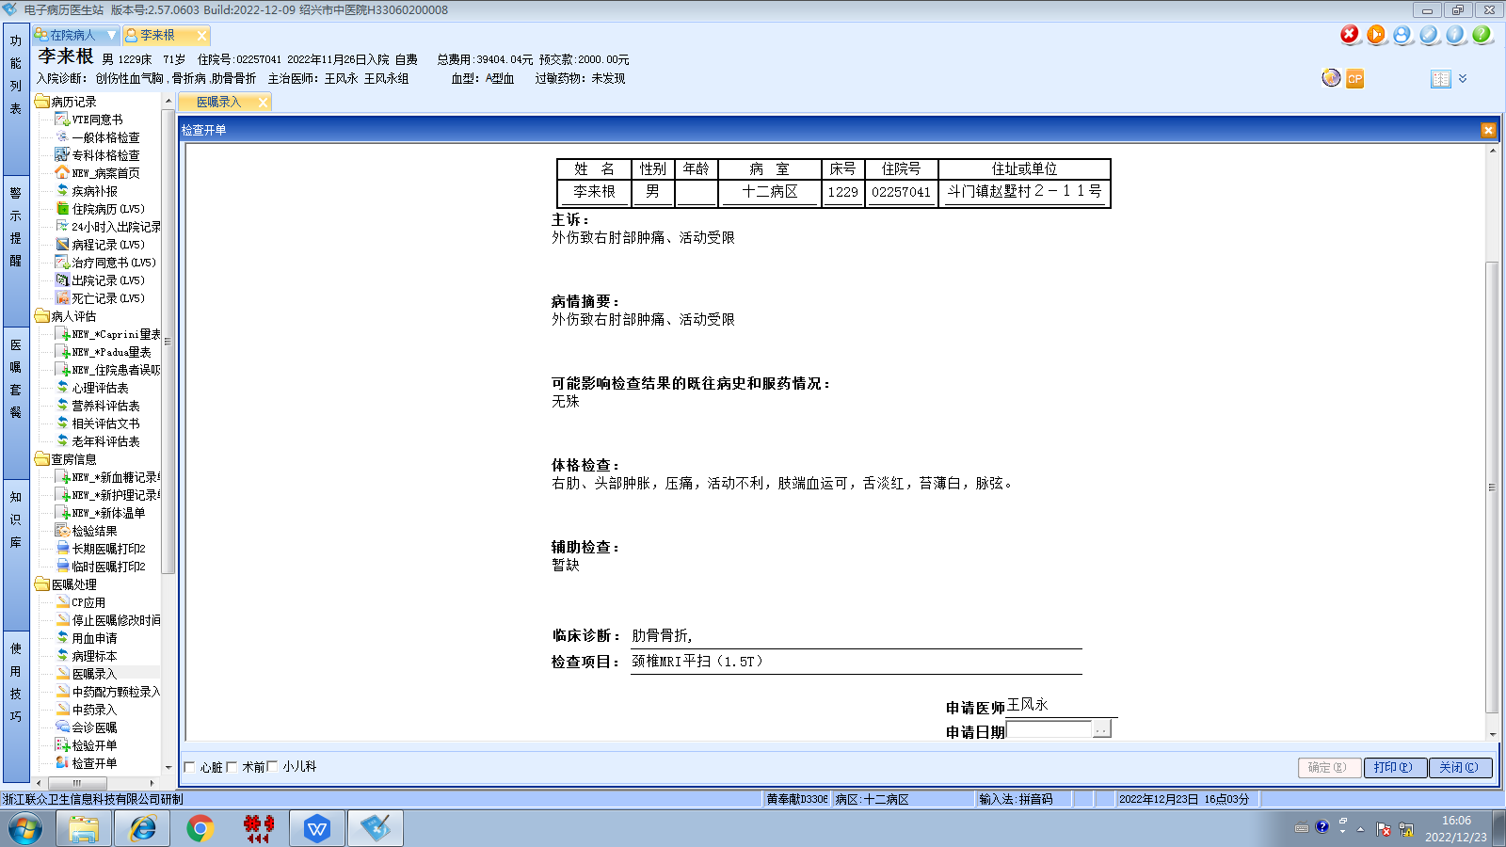王风永组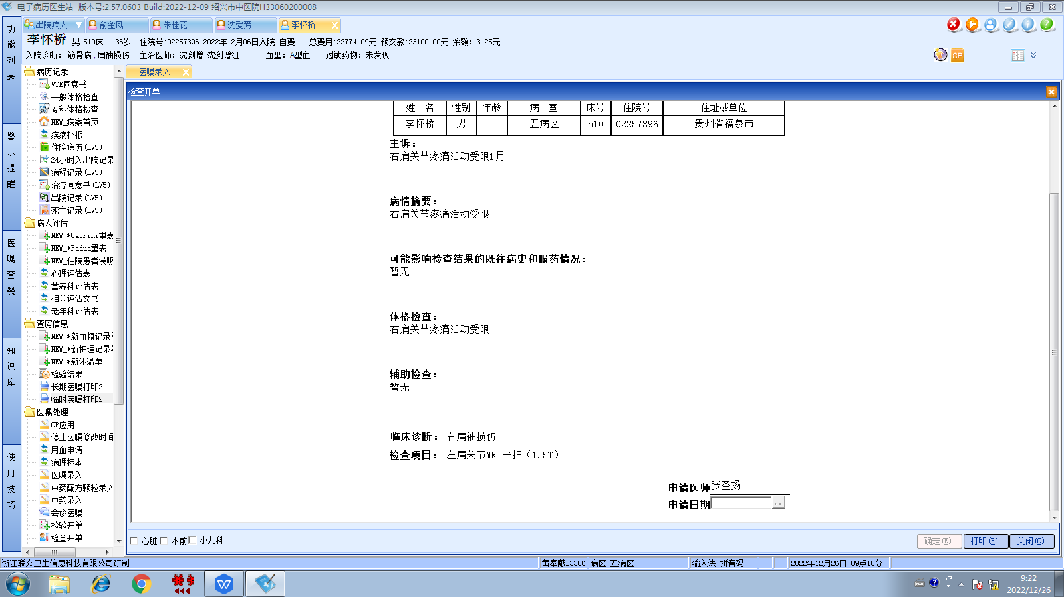沈剑增组
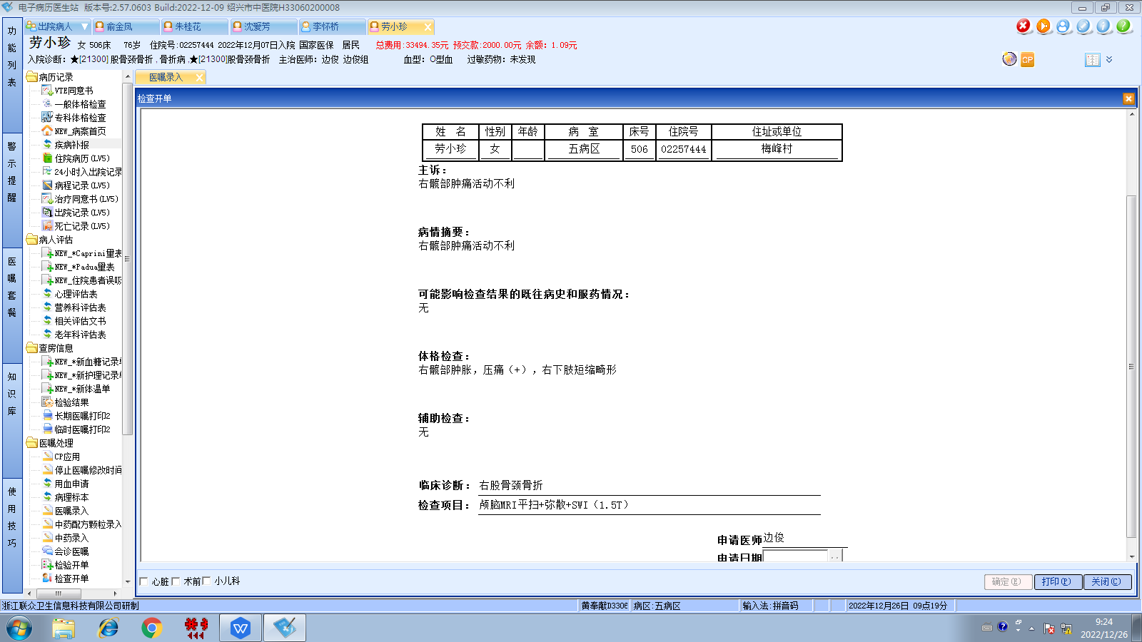边俊组
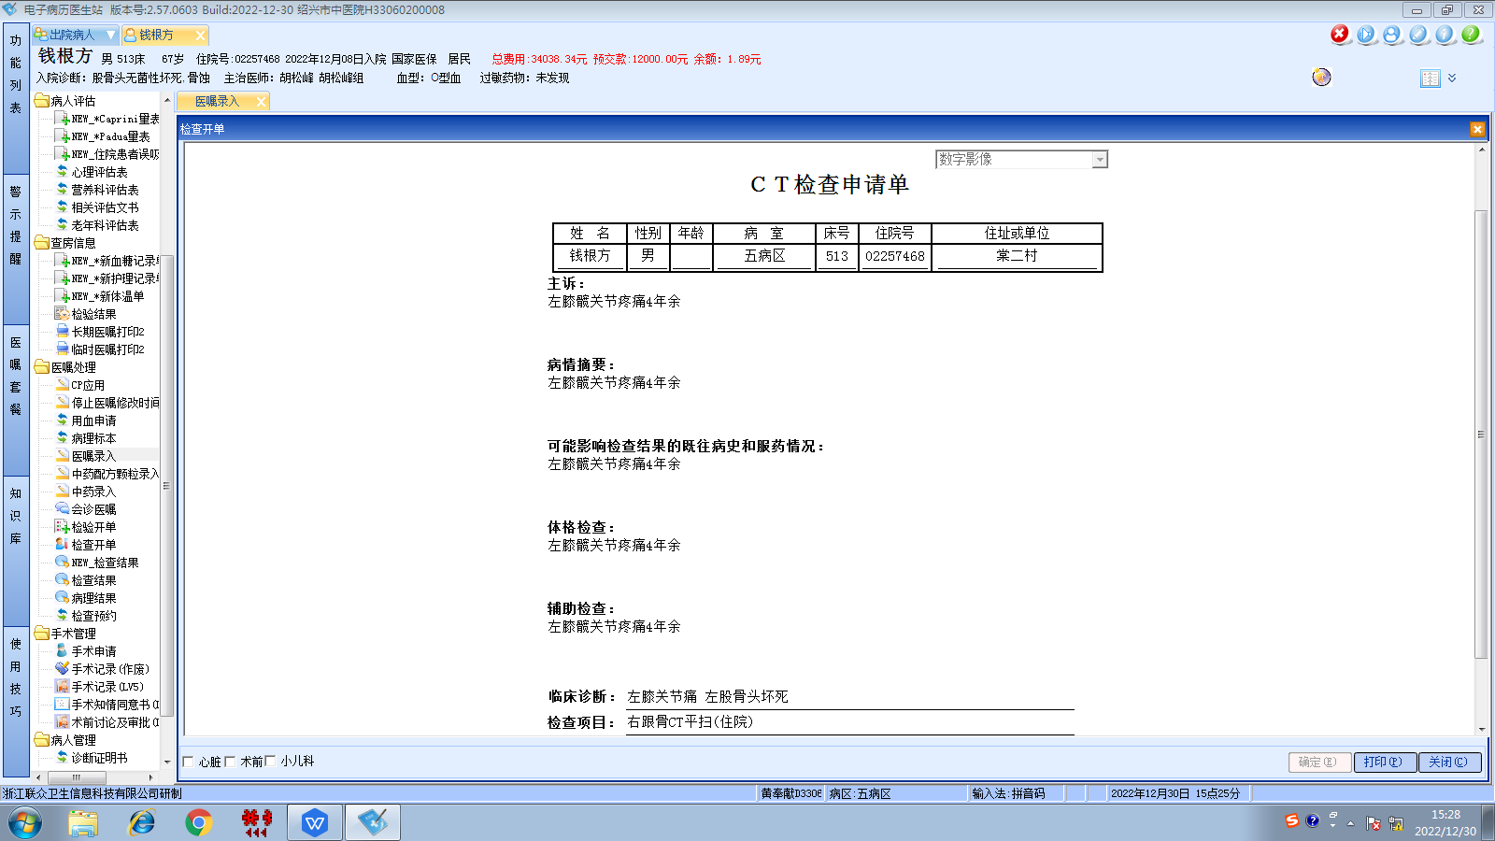胡松峰组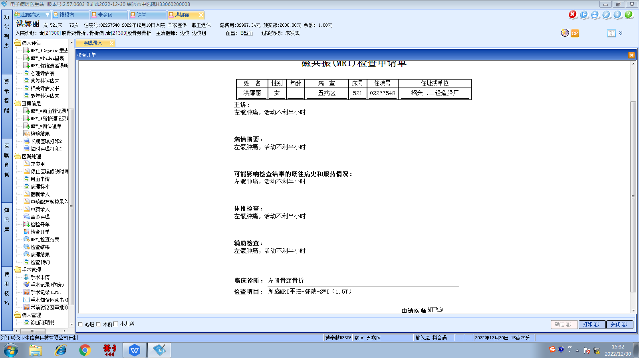边俊组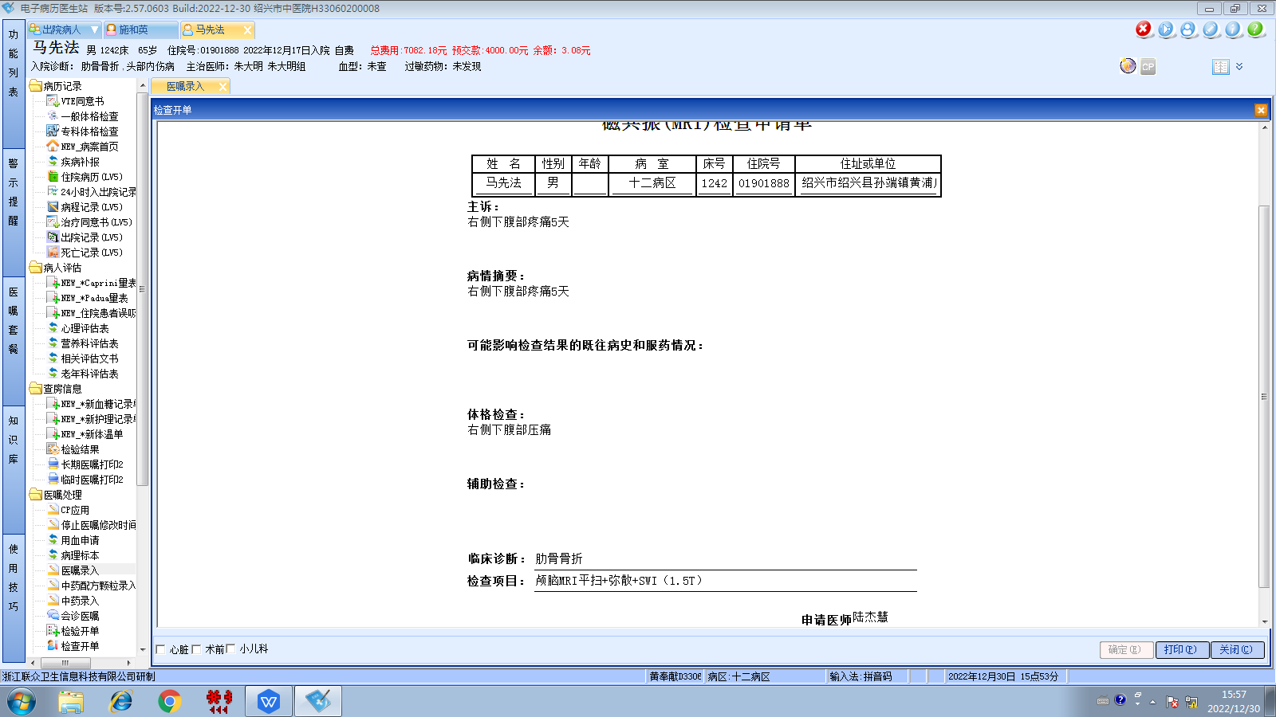朱大明组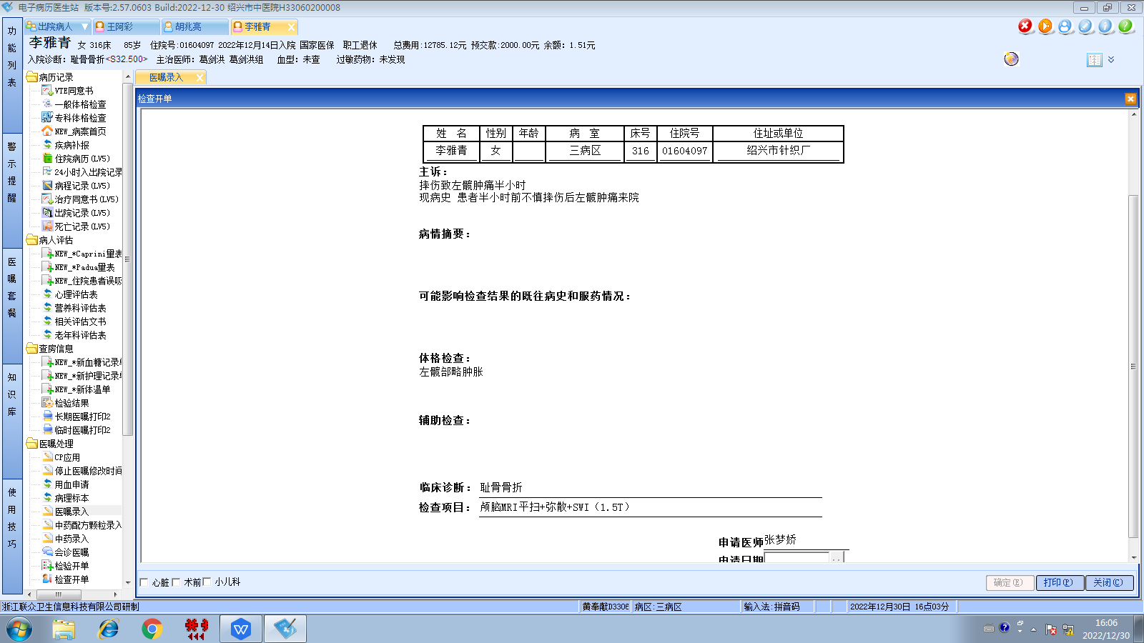葛剑洪组
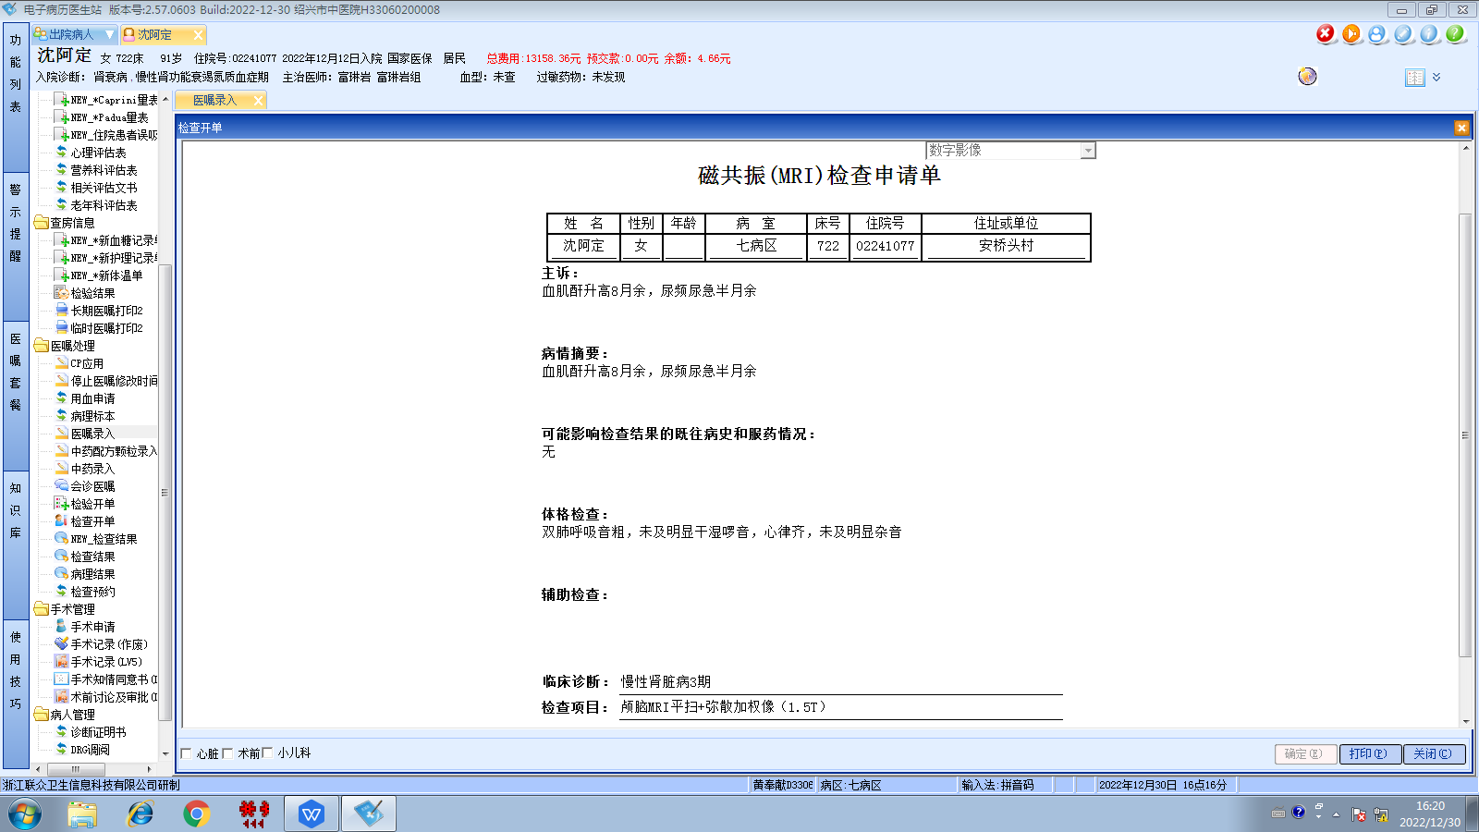富琳岩组

