1月检查申请单质控
住院号 | 检查单类型 | 开单日期 | 开单医师 |  |  | 检查项目
 |  |  |  | 主诉 | 病情摘要 |  | 既往史 | 体格检查 | 辅助检查 | 诊断 | 内容申请单不一致
01807815 | MR | 2023-1-1 | 谢峰 | √ | √ |  | √ | √ | √ | √ | √
02005800 | MR | 2022-12-31 | 王冰清 | √ | √ |  | √ | √ | √ | √ | √
02258194 | MR | 2022-12-31 | 边俊 | √ | √ |  | √ | √ | √ | √ | √
02258194 | CT | 2023-1-7 | 谢峰 | √ | √ |  | √ | √ | √ | √ | √
01509794 | MR | 2022-12-31 | 张圣扬 | √ | √ |  | √ | √ | √ | √ | √
02258210 | MR | 2022-12-31 | 边俊 | √ | √ |  | √ | √ | √ | √ | √
01612968 | CT | 2023-1-2 | 边俊 | √ | √ |  | √ | √ | √ | √ | √
02258064 | CT | 2023-1-3 | 张华良 | √ | √ |  | √ | √ | √ | √ | √
02258235 | MR | 2023-1-3 | 王一萍 | √ | √ |  | √ | √ | √ | √ | √
02258235 | MR | 2023-1-4 | 郑德财 | √ | √ |  | √ | √ | √ | √ | √
02258267 | MR | 2023-1-2 | 胡飞剑 | √ | √ |  | √ | √ | √ | √ | √
01914965 | MR | 2023-1-2 | 王一萍 | √ | √ |  | √ | √ | √ | √ | √
02258254 | MR | 2023-1-2 | 沈家峰 | √ | √ |  | √ | √ | √ | √ | √
02258047 | CT | 2023-1-6 | 支飞虎 | √ | √ |  | √ | √ | √ | √ | √
02258173 | CT | 2023-1-4 | 沈家峰 | √ | √ |  | √ | √ | √ | √ | √
02258173 | MR | 2023-1-6 | 龚彬 | √ | √ |  | √ | √ | √ | √ | √
02258325 | MR | 2023-1-4 | 边俊 | √ | √ |  | √ | √ | √ | √ | √
02258331 | MR | 2023-1-4 | 胡飞剑 | √ | √ |  | √ | √ | √ | √ | √
02258308 | MR | 2023-1-5 | 朱大明 | √ | √ |  | √ | √ | √ | √ | √
02257812 | MR | 2023-1-5 | 张圣扬 | √ | √ |  | √ | √ | √ | √ | √
02258274 | CT | 2023-1-3 | 凌一鸣 | √ | √ |  | √ | √ | √ | √ | √
02258399 | MR | 2023-1-7 | 谢峰 | √ | √ |  | √ | √ | √ | √ | √
01611341 | MR | 2023-1-7 | 尤志新 | √ | √ |  | √ | √ | √ | √ | √
02258390 | MR | 2023-1-7 | 谢峰 | √ | √ |  | √ | √ | √ | √ | √
02258387 | CT | 2023-1-7 | 刘浩飞 | √ | √ |  | √ | √ | √ | √ | √
01913744 | MR | 2023-1-6 | 尤志新 | √ | √ |  | √ | √ | √ | √ | √
01800620 | MR | 2023-1-8 | 王洪灿 | √ | √ |  | √ | √ | √ | √ | √
01510983 | MR | 2023-1-8 | 胡飞剑 | √ | √ |  | √ | √ | √ | √ | √
02258457 | MR | 2023-1-8 | 王洪灿 | √ | √ |  | √ | √ | √ | √ | √
02238400 | CT | 2023-1-9 | 刘悦 | √ | √ |  | √ | √ | √ | √ | √
01413193 | MR | 2023-1-7 | 刘潇 | √ | √ |  | √ | √ | √ | √ | √
02258205 | MR | 2023-1-1 | 王一萍 | √ | √ |  | √ | √ | √ | √ | √
02000594 | MR | 2023-1-2 | 鲁剑梅 | √ | √ |  | √ | √ | √ | √ | √
02258211 | CT | 2023-1-2 | 张新凡 | √ | √ |  | √ | √ | √ | √ | √
01908341 | CT | 2023-1-1 | 何易 | √ | √ |  | √ | √ | √ | √ | √
02111884 | MR | 2023-1-2 | 王冰清 | √ | √ |  | √ | √ | √ | √ | √
01801234 | MR | 2023-1-2 | 尤志新 | √ | √ |  | √ | √ | √ | √ | √
02258391 | MR | 2023-1-6 | 盛苏红 | √ | √ |  | √ | √ | √ | √ | √
01608239 | CT | 2023-1-11 | 陶铁瑛 | √ | √ |  | √ | √ | √ | √ | ×
02258509 | CT | 2023-1-10 | 王磊 | √ | √ |  | √ | √ | √ | √ | √
02258459 | MR | 2023-1-10 | 王风永 | √ | √ |  | √ | √ | √ | √ | √
01909930 | CT | 2023-1-11 | 陶铁瑛 | √ | √ |  | √ | √ | √ | √ | √
02001744 | MR | 2023-1-11 | 孟闯闯 | √ | √ |  | √ | √ | √ | √ | √
02258567 | CT | 2023-1-11 | 王立刚 | √ | √ |  | √ | √ | √ | √ | √
02107180 | MR | 2023-1-11 | 谢睿 | √ | √ |  | √ | √ | √ | √ | √
02110208 | MR | 2023-1-12 | 孙玲玲 | √ | √ |  | √ | √ | √ | √ | √
02258580 | CT | 2023-1-12 | 许海锋 | √ | √ |  | √ | √ | √ | √ | ×
01809174 | MR | 2023-1-13 | 胡飞剑 | √ | √ |  | √ | √ | √ | √ | √
02108289 | MR | 2023-1-12 | 胡飞剑 | √ | √ |  | √ | √ | √ | √ | ×
02104164 | MR | 2023-1-13 | 许海锋 | √ | √ |  | √ | √ | √ | √ | √
02258668 | MR | 2023-1-15 | 胡松峰 | √ | √ |  | √ | √ | √ | √ | √
02258667 | CT | 2023-1-15 | 肖旭 | √ | √ |  | √ | √ | √ | √ | ×
02258623 | MR | 2023-1-13 | 胡飞剑 | √ | √ |  | √ | √ | √ | √ | √
02258618 | MR | 2023-1-14 | 沈剑增 | √ | √ |  | √ | √ | √ | √ | √
02258375 | CT | 2023-1-16 | 肖功 | √ | √ |  | √ | √ | √ | √ | √
02258671 | MR | 2023-1-15 | 胡飞剑 | √ | √ |  | √ | √ | √ | √ | ×
02258621 | MR | 2023-1-14 | 沈剑增 | √ | √ |  | √ | √ | √ | √ | ×
02258625 | CT | 2023-1-14 | 赵艳明 | √ | √ |  | √ | √ | √ | √ | √
02258685 | CT | 2023-1-17 | 王风永 | √ | √ |  | √ | √ | √ | √ | ×
02258593 | MR | 2023-1-13 | 孙莉 | √ | √ |  | √ | √ | √ | √ | √
02258715 | MR | 2023-1-17 | 沈波 | √ | √ |  | √ | √ | √ | √ | ×
01710853 | MR | 2023-1-14 | 张澍漾 | √ | √ |  | √ | √ | √ | √ | √
01710853 | MR | 2023-1-16 | 张澍漾 | √ | √ |  | √ | √ | √ | √ | √
02258597 | MR | 2023-1-13 | 孙莉 | √ | √ |  | √ | √ | √ | √ | √
01508981 | MR | 2023-1-18 | 吴明 | √ | √ |  | √ | √ | √ | √ | ×
02258658 | MR | 2023-1-16 | 赵艳明 | √ | √ |  | √ | √ | √ | √ | √
02258653 | MR | 2023-1-16 | 刘悦 | √ | √ |  | √ | √ | √ | √ | √
02258696 | MR | 2023-1-16 | 许杨 | √ | √ |  | √ | √ | √ | √ | ×
02258694 | MR | 2023-1-16 | 边俊 | √ | √ |  | √ | √ | √ | √ | √
02258698 | MR | 2023-1-16 | 王冰清 | √ | √ |  | √ | √ | √ | √ | ×
01816076 | MR | 2023-1-18 | 王敏龙 | √ | √ |  | √ | √ | √ | √ | ×
01901558 | CT | 2023-1-23 | 刘悦 | √ | √ |  | √ | √ | √ | √ | √
02258721 | MR | 2023-1-17 | 王冰清 | √ | √ |  | √ | √ | √ | √ | √
02258774 | MR | 2023-1-22 | 边俊 | √ | √ |  | √ | √ | √ | √ | √
02258827 | CT | 2023-1-25 | 柴绍军 | √ | √ |  | √ | √ | √ | √ | √
01709922 | CT | 2023-1-26 | 马军华 | √ | √ |  | √ | √ | √ | √ | √
02258797 | MR | 2023-1-24 | 谢峰 | √ | √ |  | √ | √ | √ | √ | ×
01603272 | MR | 2023-1-26 | 刘浩飞 | √ | √ |  | √ | √ | √ | √ | ×
02258882 | MR | 2023-1-26 | 胡飞剑 | √ | √ |  | √ | √ | √ | √ | ×
02258833 | MR | 2023-1-26 | 陈建德 | √ | √ |  | √ | √ | √ | √ | ×
01901609 | MR | 2023-1-26 | 杨锋 | √ | √ |  | √ | √ | √ | √ | √
02258432 | MR | 2023-1-25 | 胡松峰 | √ | √ |  | √ | √ | √ | √ | ×
01709243 | CT | 2023-1-29 | 孙莉 | √ | √ |  | √ | √ | √ | √ | √
02259028 | MR | 2023-1-28 | 肖功 | √ | √ |  | √ | √ | √ | √ | √
01802251 | CT | 2023-1-29 | 孙莉 | √ | √ |  | √ | √ | √ | √ | √
02258895 | MR | 2023-1-27 | 鲁剑梅 | √ | √ |  | √ | √ | √ | √ | √
01909267 | CT | 2023-1-29 | 孙莉 | √ | √ |  | √ | √ | √ | √ | √
01909267 | MR | 2023-1-28 | 王冰清 | √ | √ |  | √ | √ | √ | √ | √
02258975 | CT | 2023-1-29 | 谢睿 | √ | √ |  | √ | √ | √ | √ | ×
02258990 | MR | 2023-1-28 | 王磊 | √ | √ |  | √ | √ | √ | √ | √
02258566 | CT | 2023-1-29 | 陆超锋 | √ | √ |  | √ | √ | √ | √ | ×
02258974 | MR | 2023-1-28 | 王磊 | √ | √ |  | √ | √ | √ | √ | √
01502648 | MR | 2023-1-28 | 陶铁瑛 | √ | √ |  | √ | √ | √ | √ | ×
02256188 | MR | 2023-1-29 | 边俊 | √ | √ |  | √ | √ | √ | √ | √
01802262 | MR | 2023-1-27 | 章联欢 | √ | √ |  | √ | √ | √ | √ | ×
01805547 | CT | 2023-1-30 | 王风永 | √ | √ |  | √ | √ | √ | √ | √
注：对住院患者检查申请单进行专项检查，其中主诉、体格检查或诊断任缺一项者视为不合格申请单；非入院常规检查，如申请单内容与检查部位及要求不一致，亦视为不合格申请单。
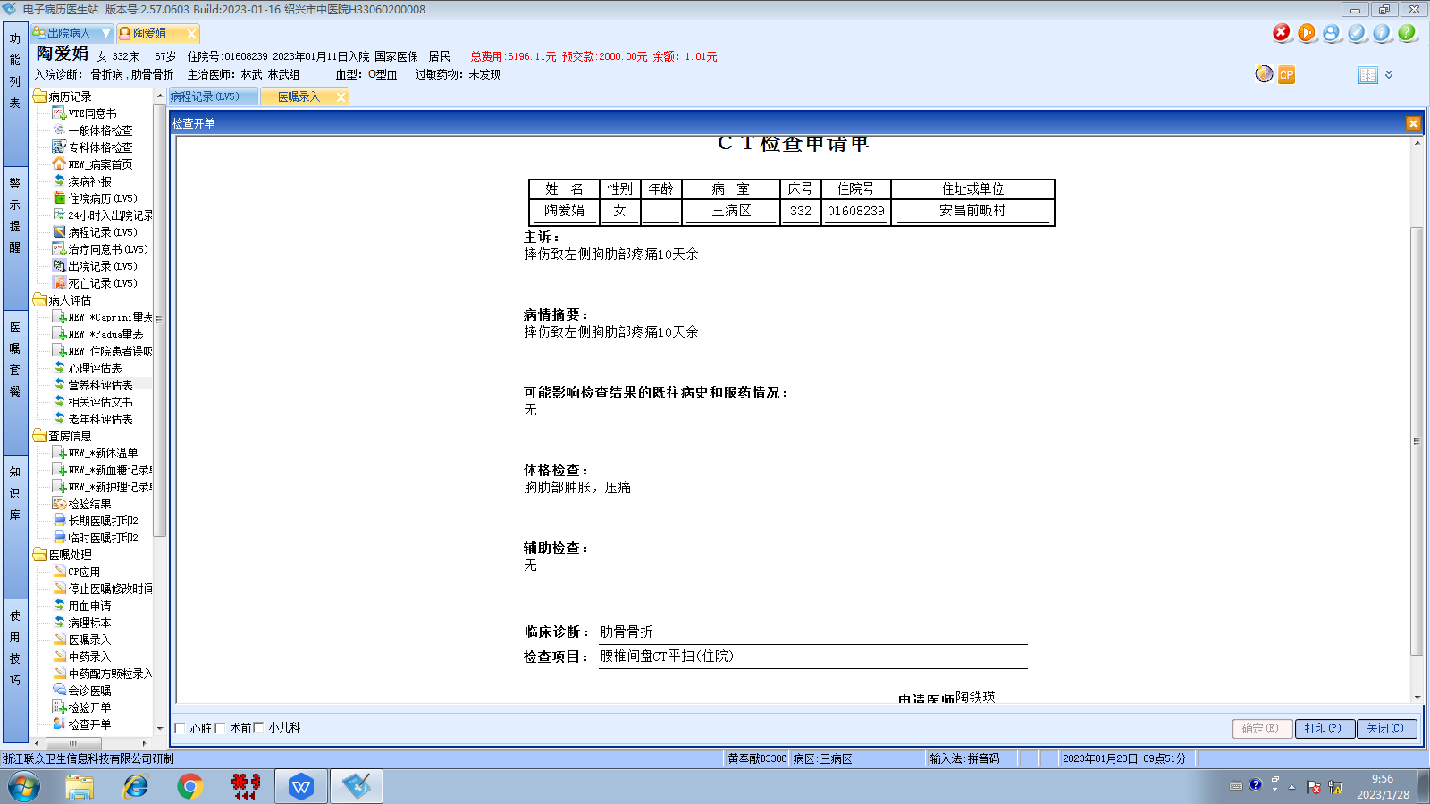林武组
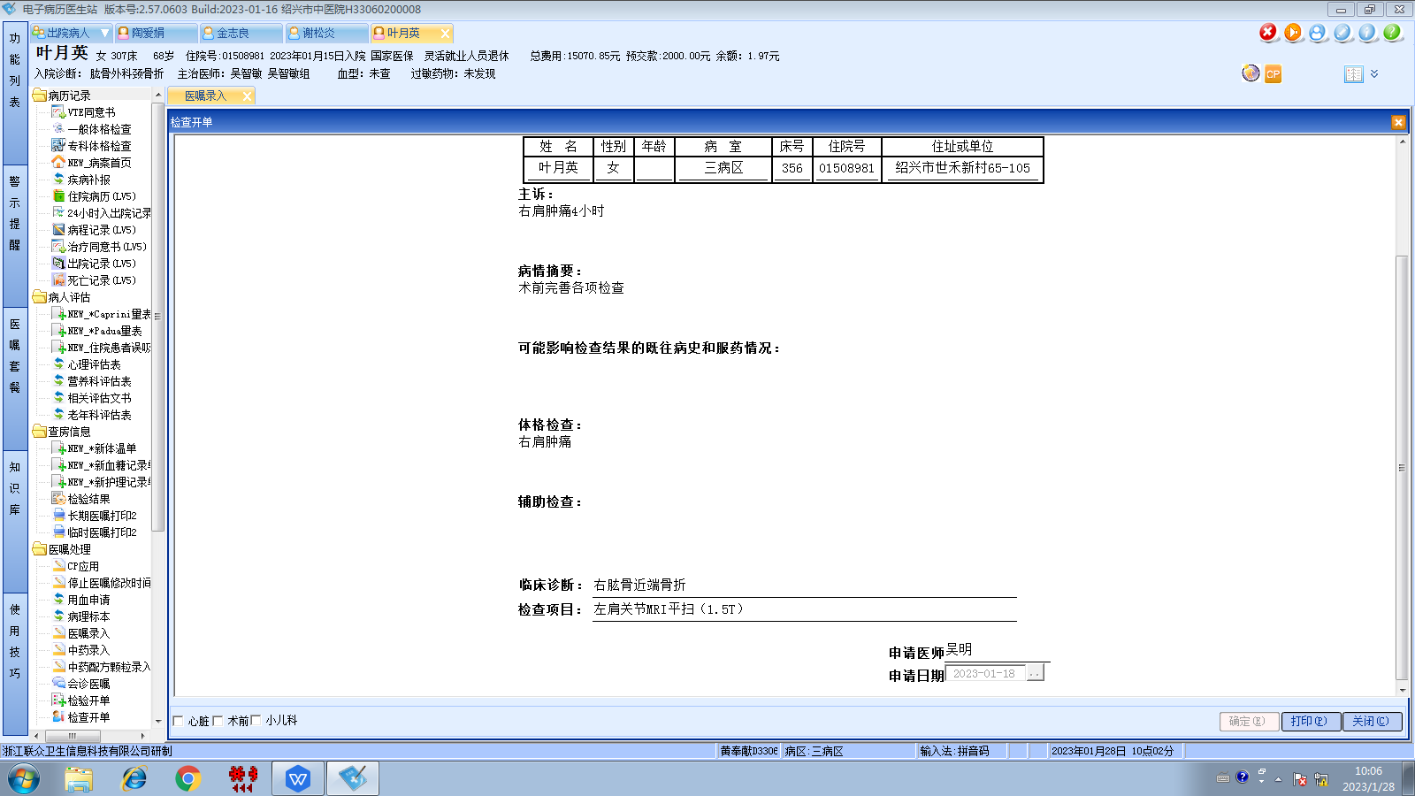吴智敏组
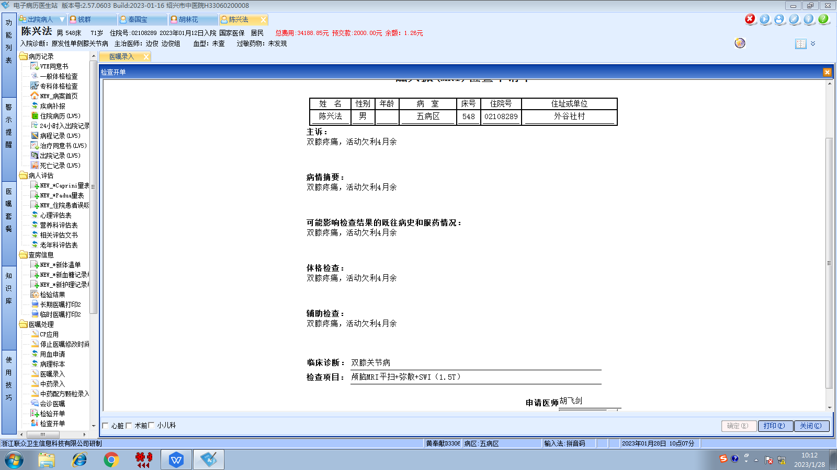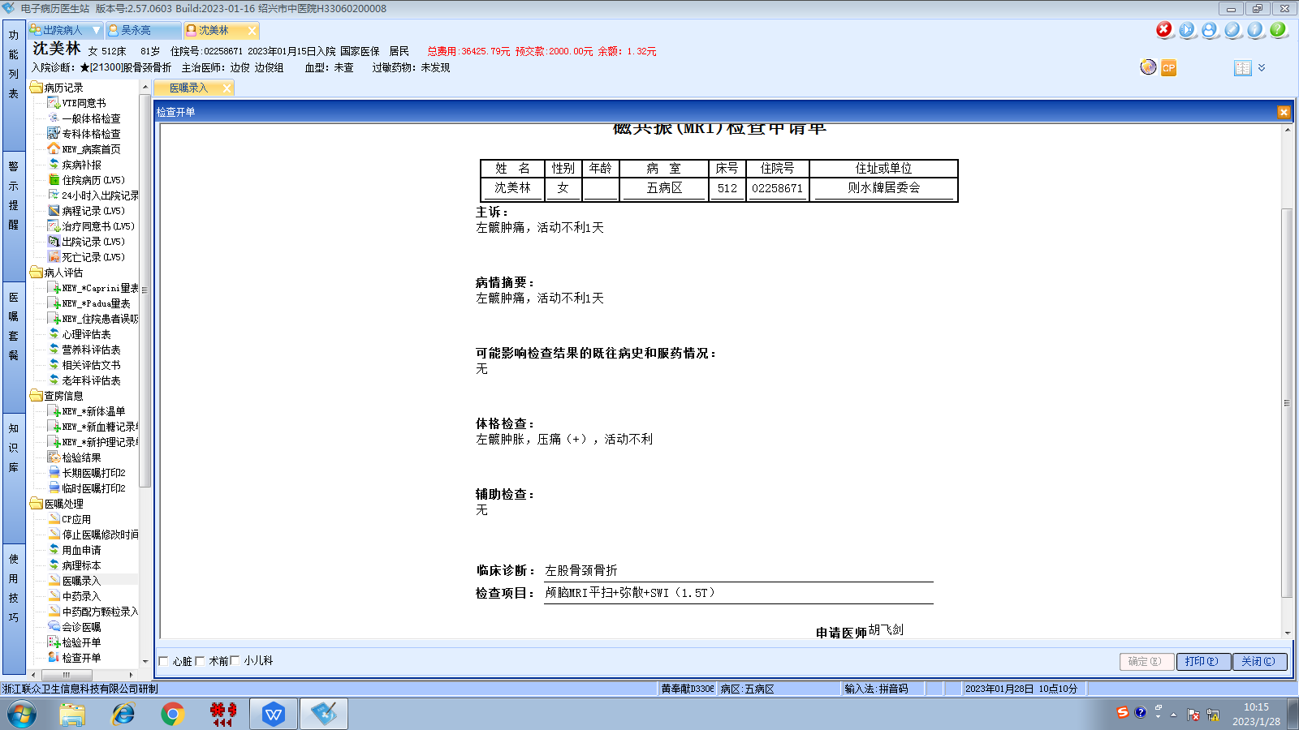边俊组
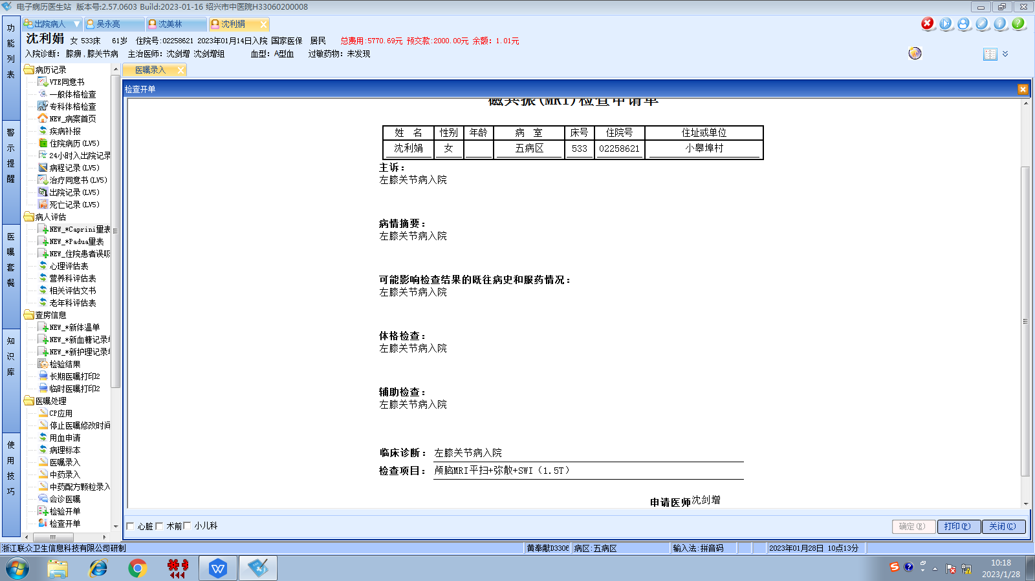沈剑增组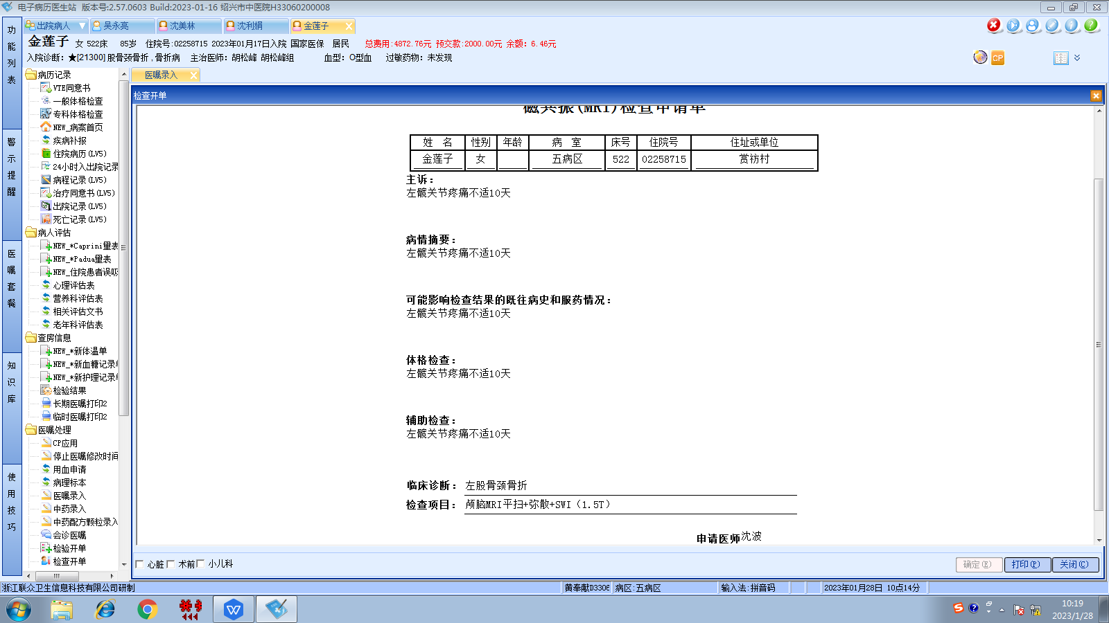胡松峰组
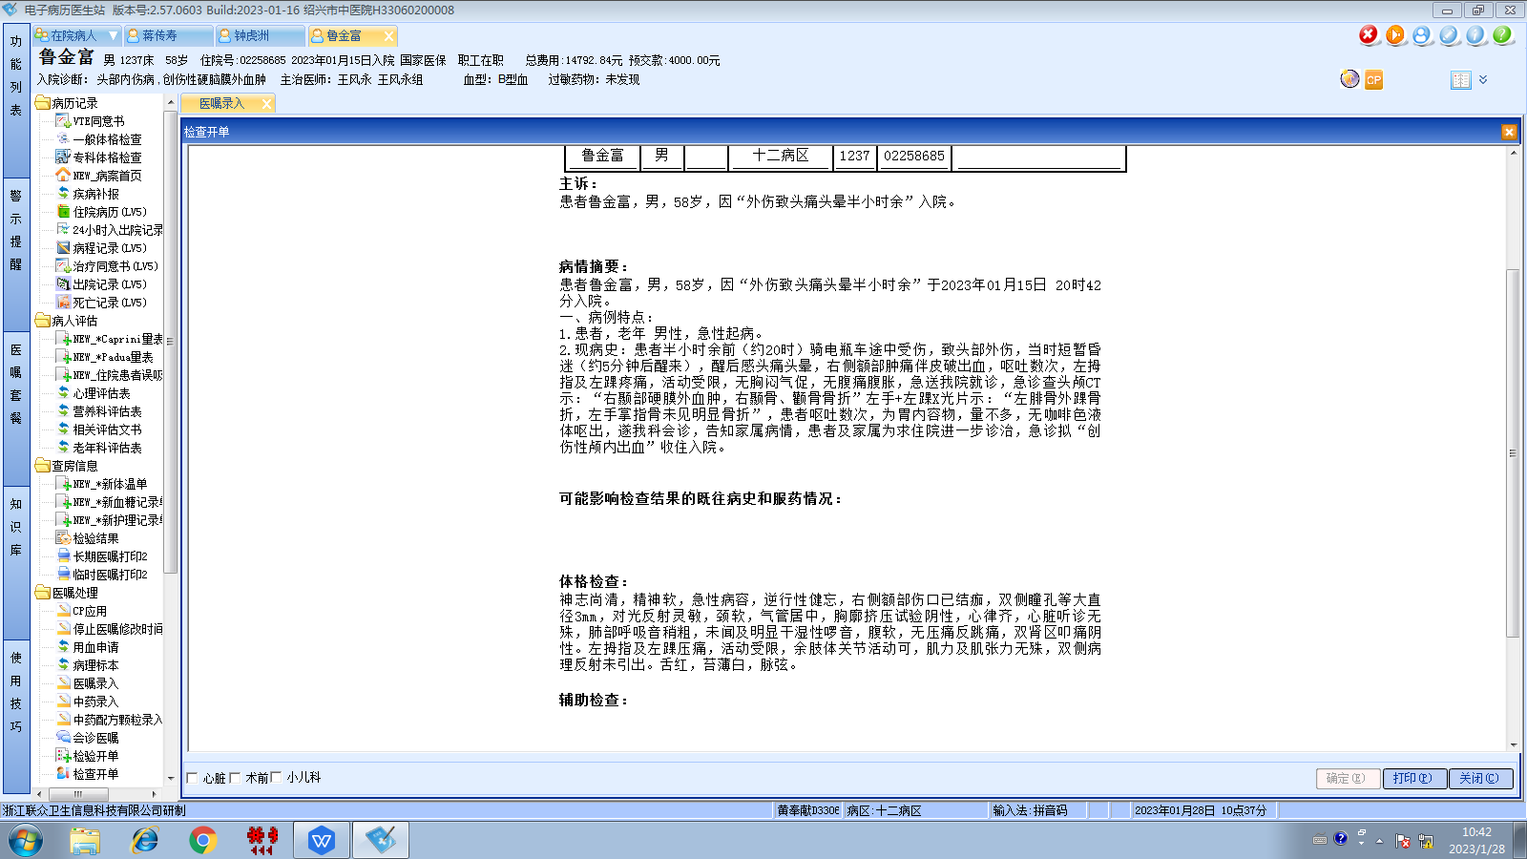王风永组
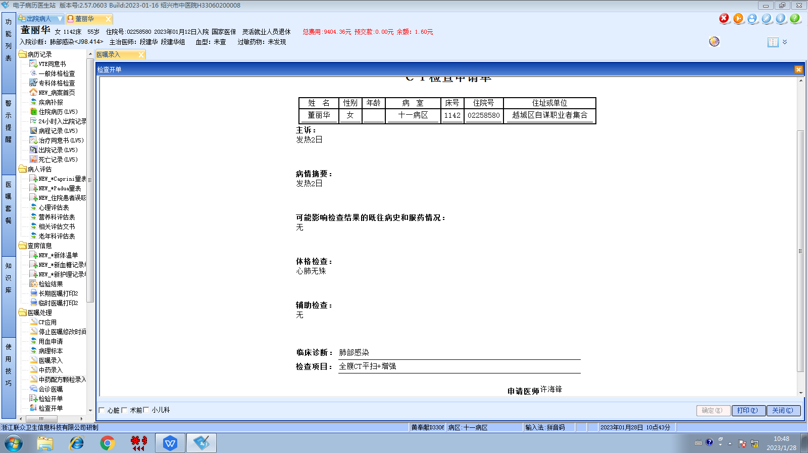段建华组
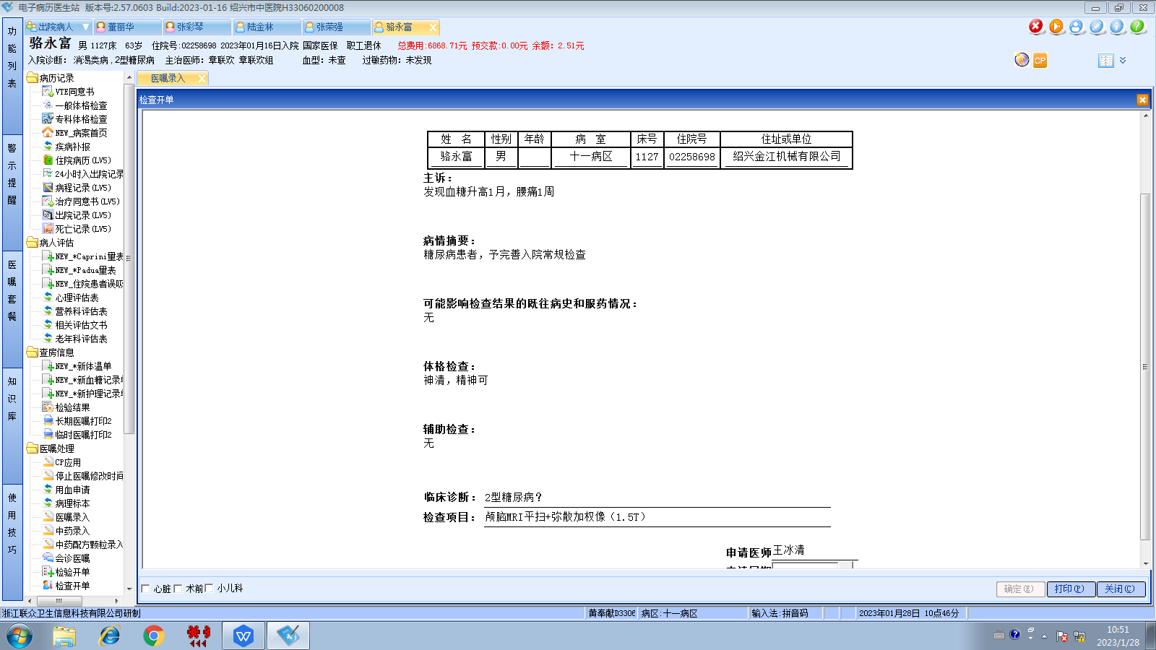章联欢组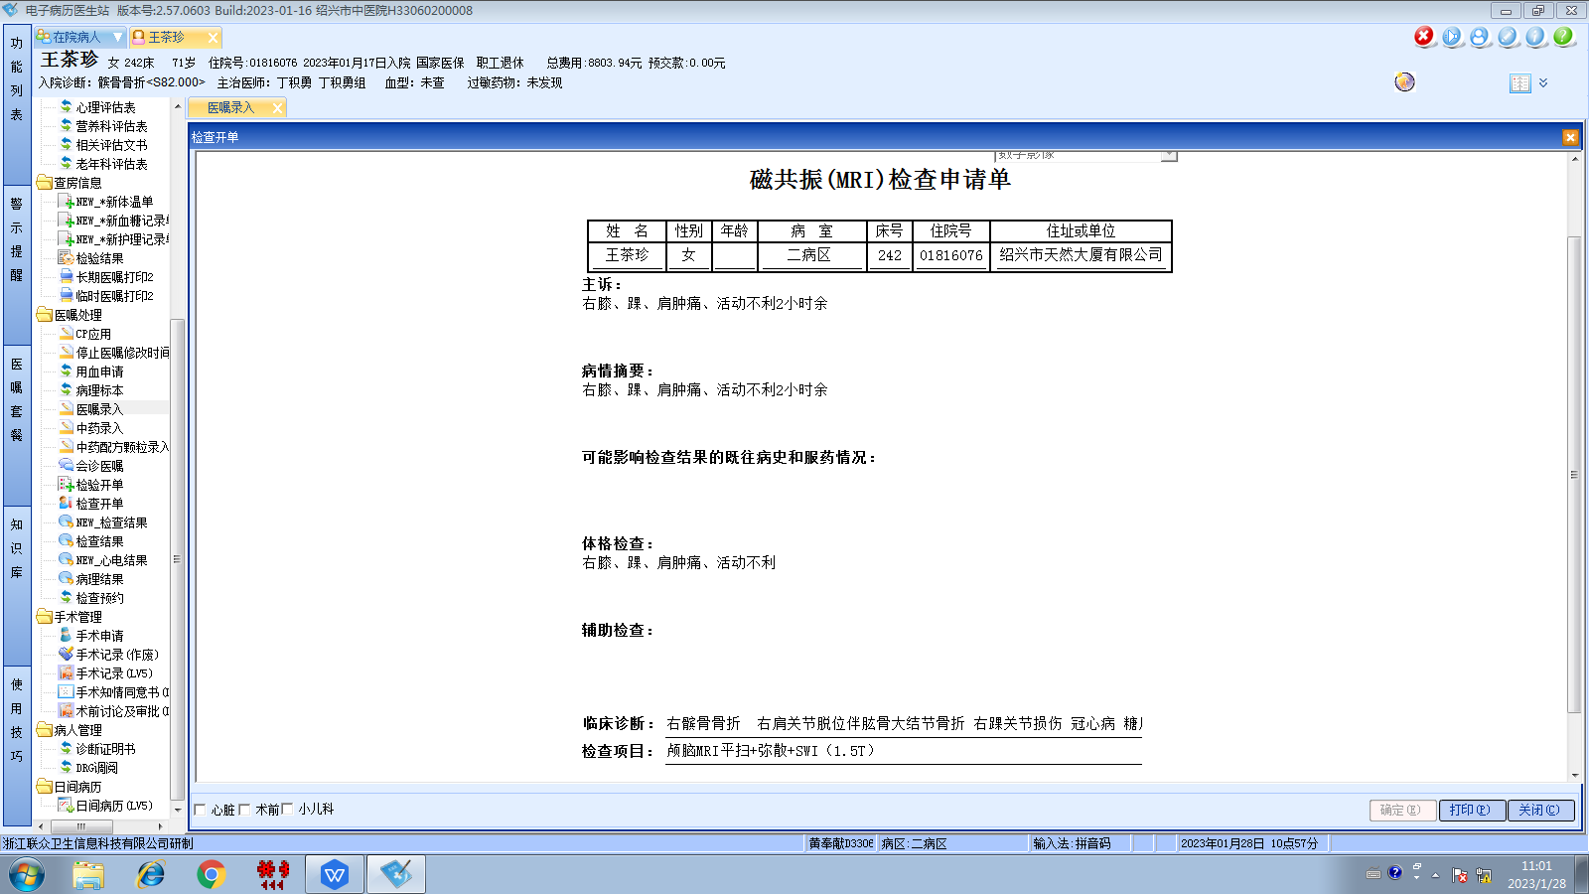丁积勇组
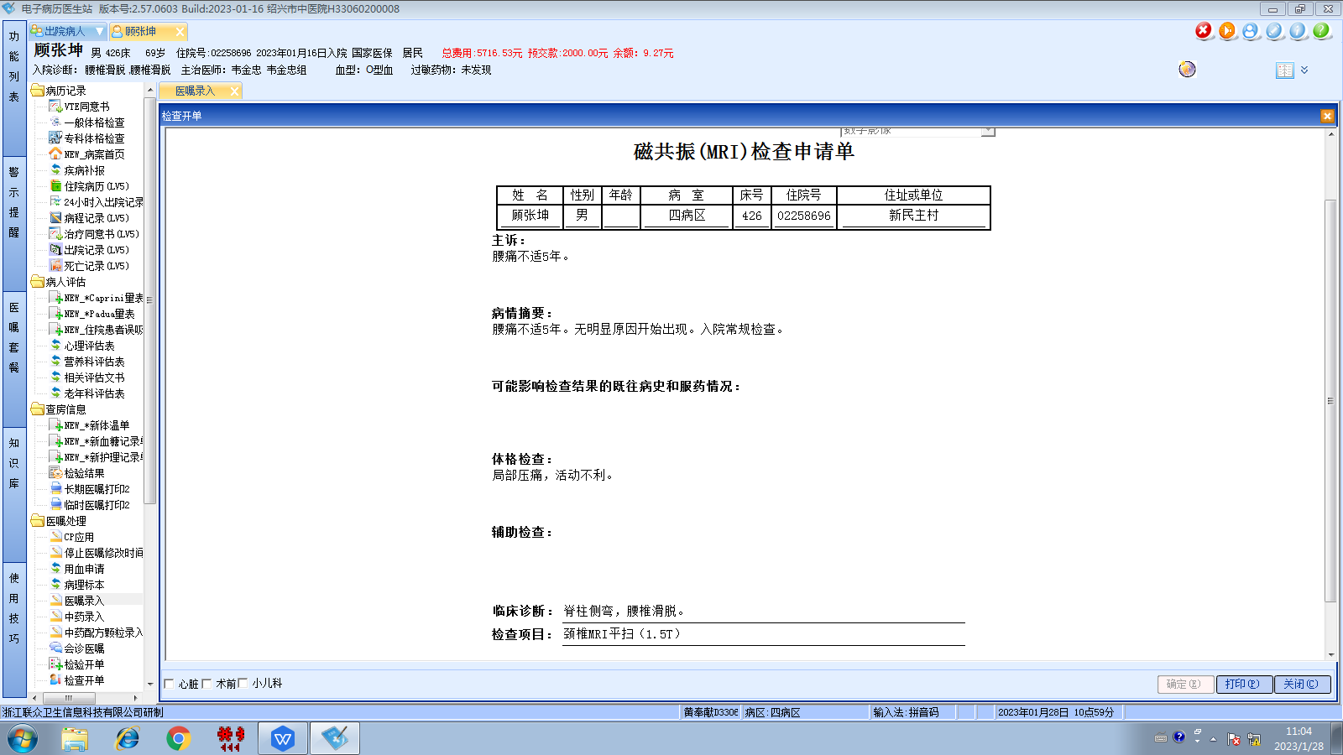韦金忠组
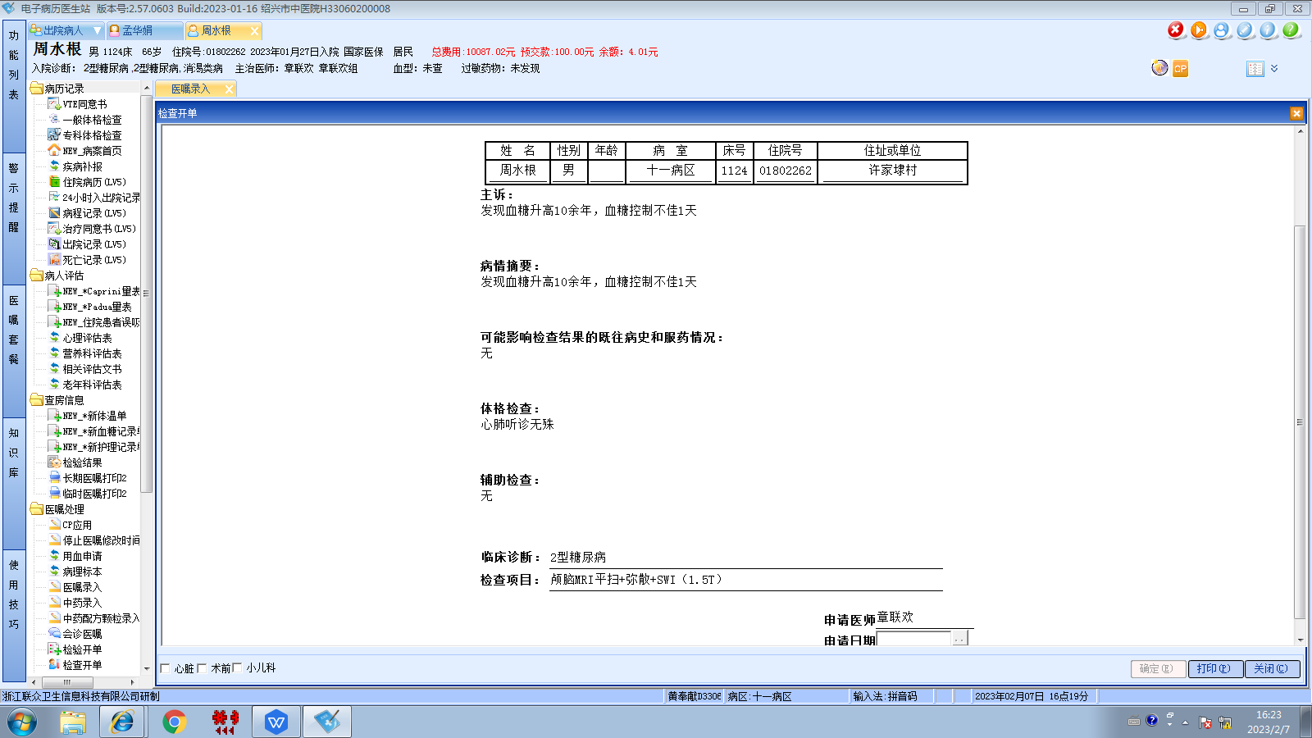章联欢组
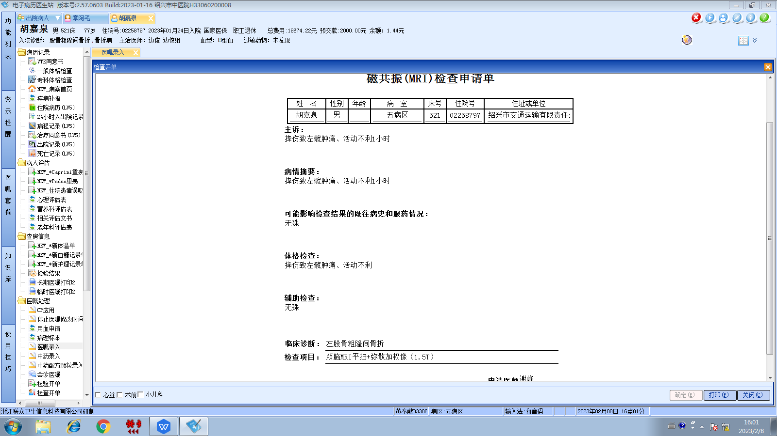边俊组
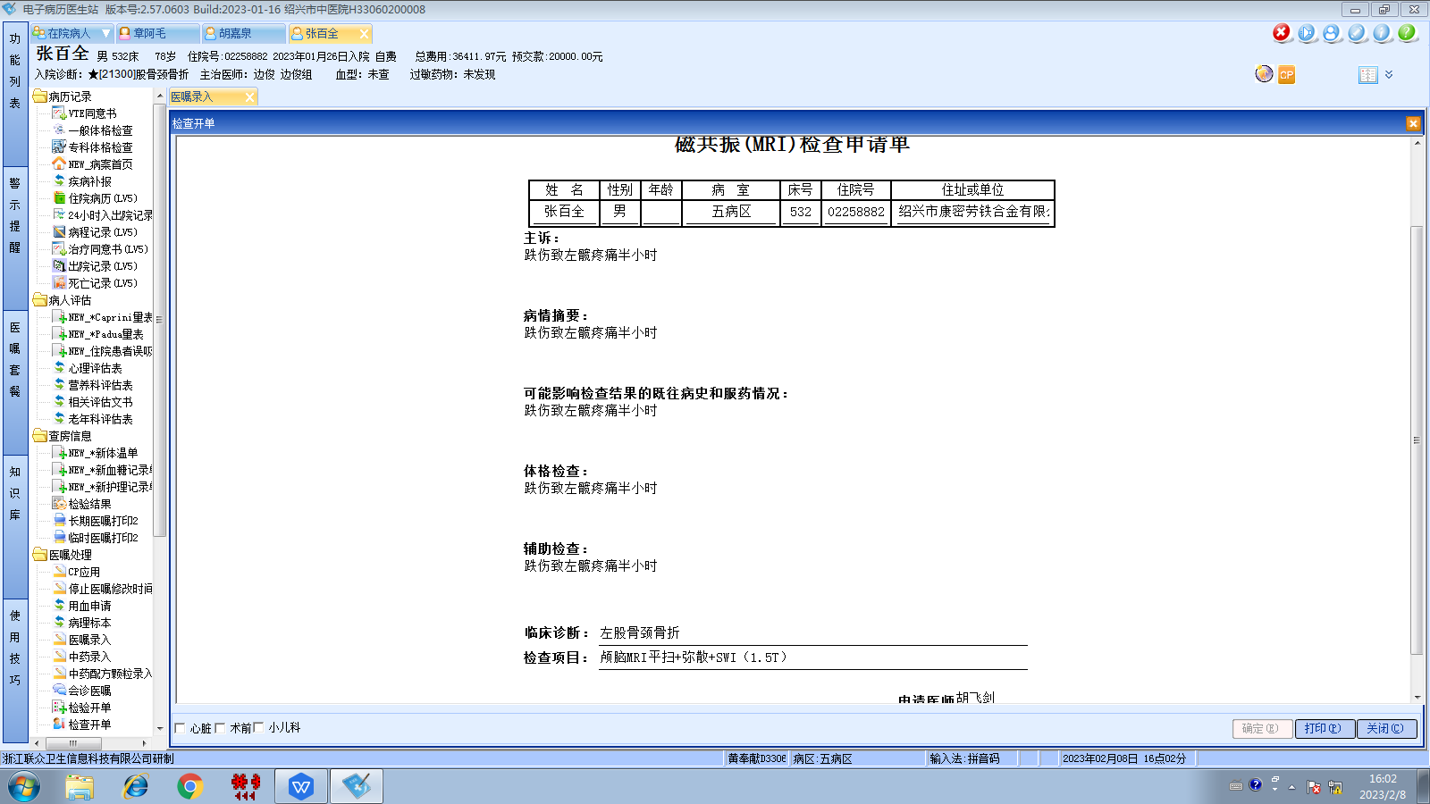边俊组
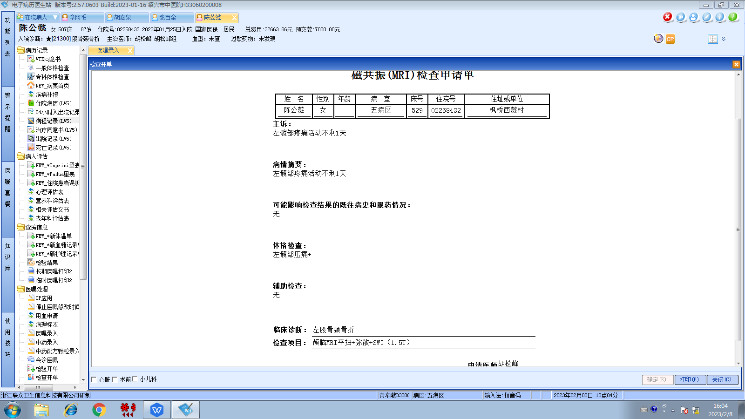胡松峰组
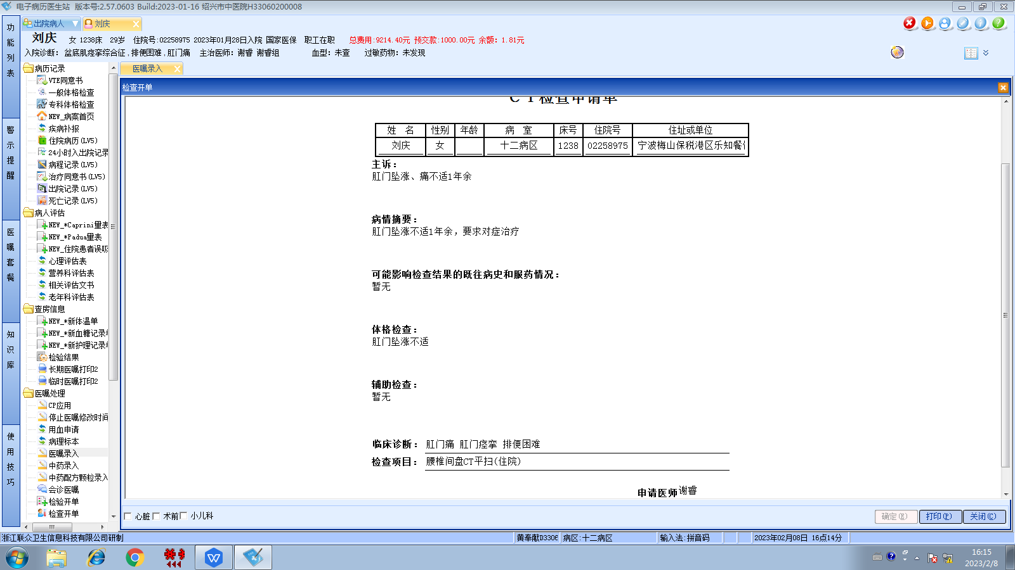谢睿组
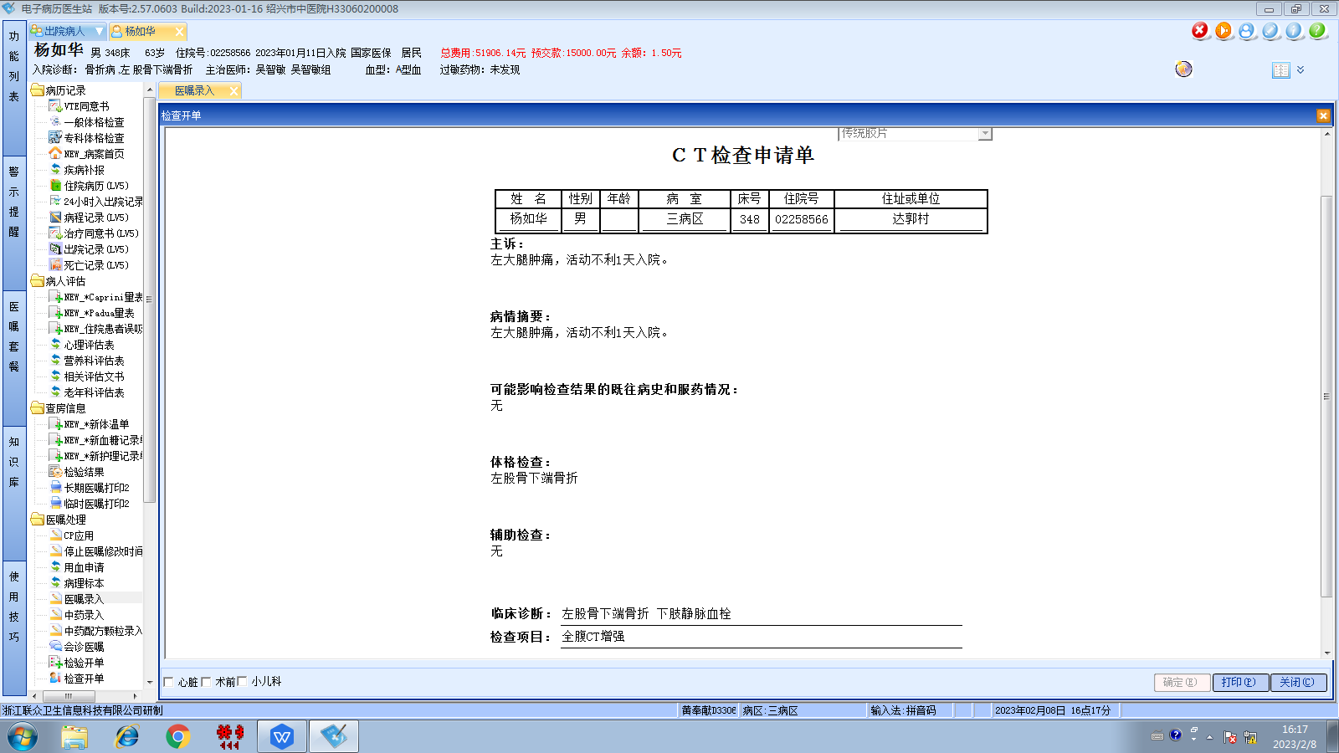吴智敏组
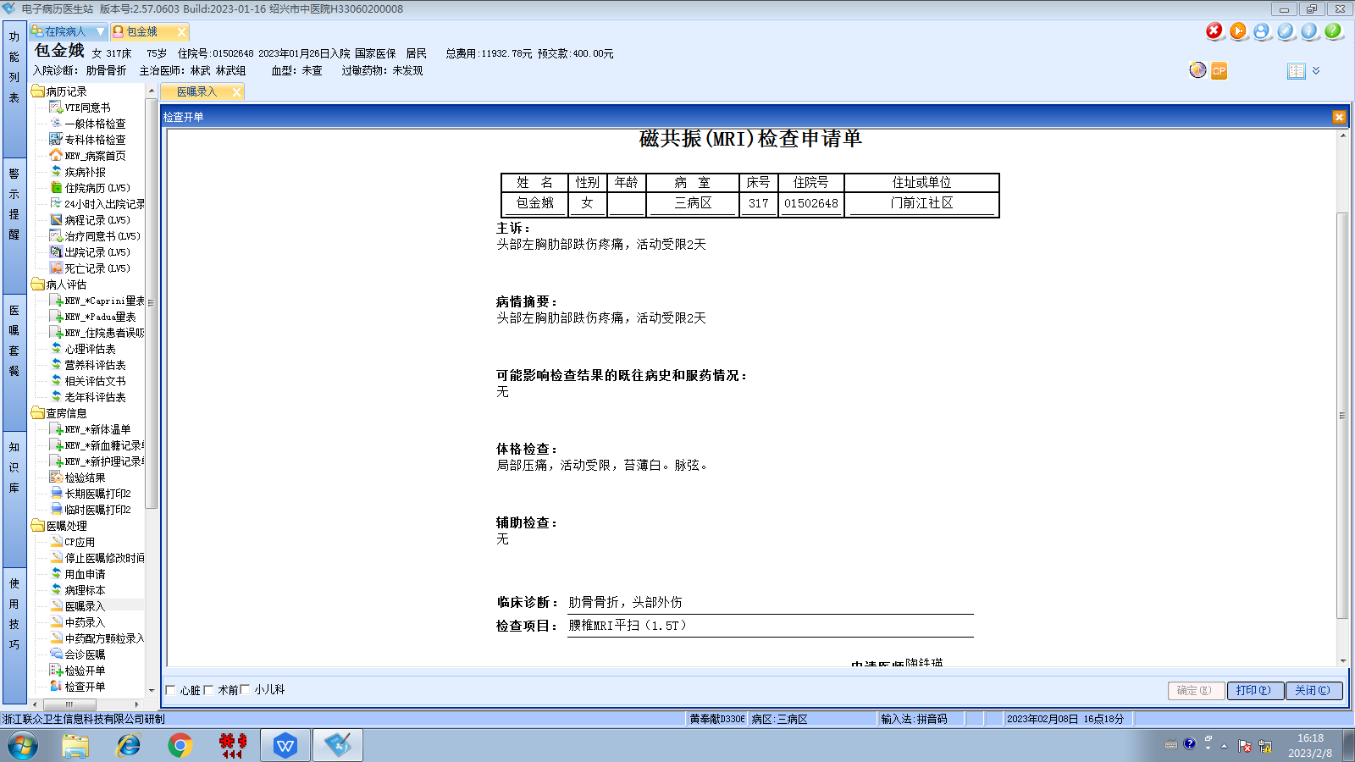林武组
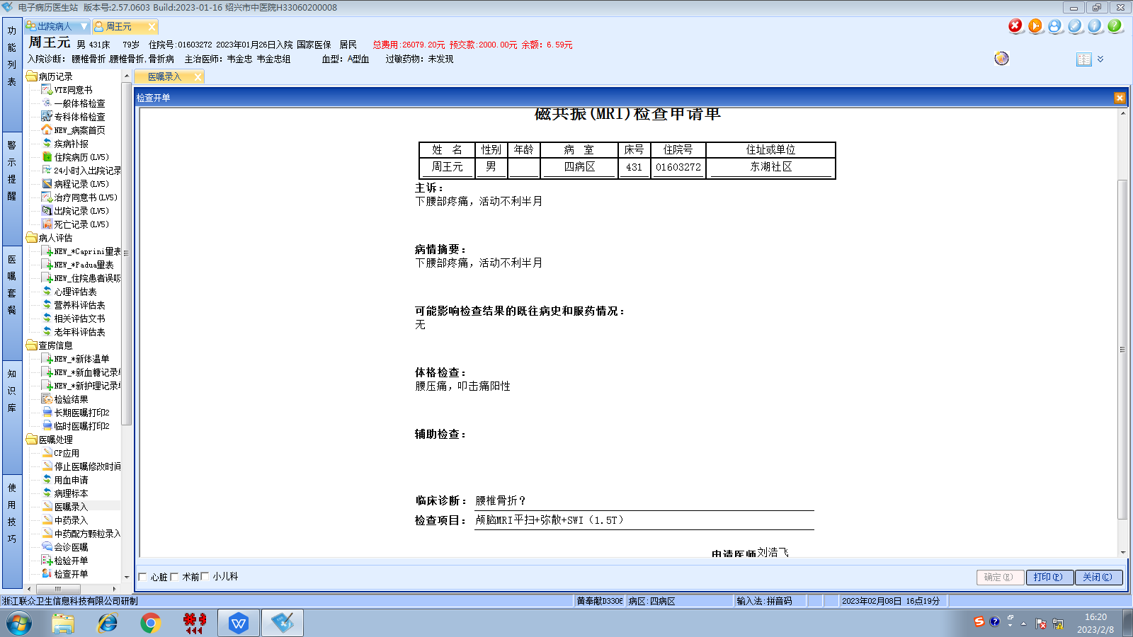韦金忠组
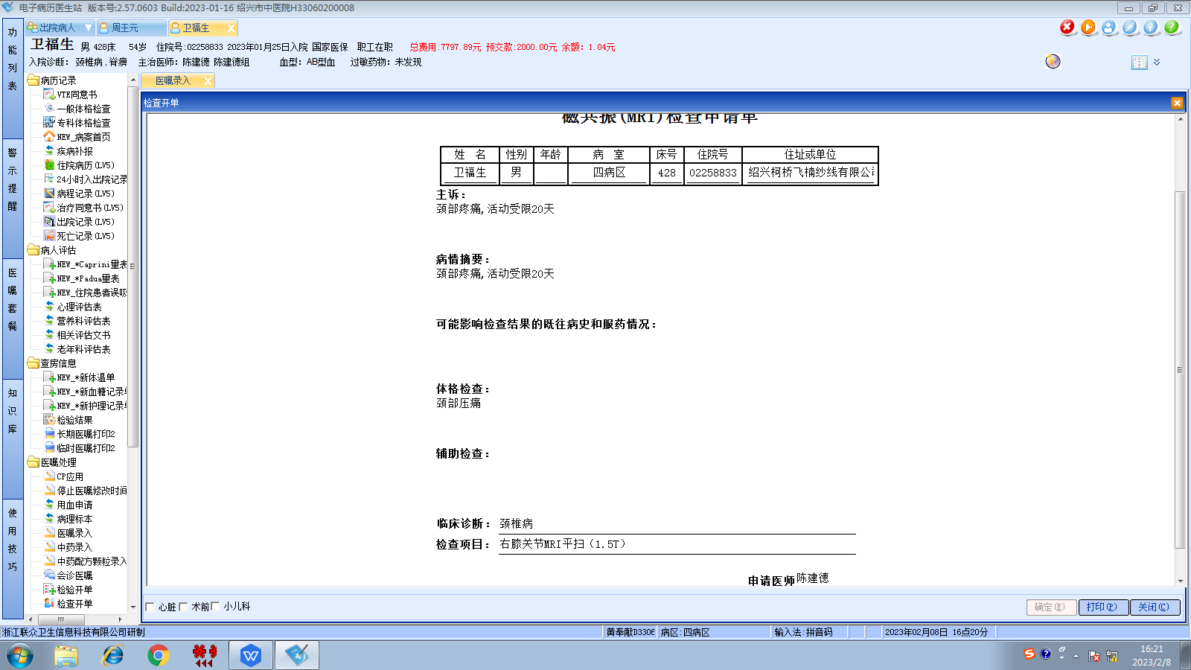陈建德组

