3月检查申请单质控
住院号 | 检查单类型 | 开单日期 | 开单医师 |  |  | 检查项目
 |  |  |  | 主诉 | 病情摘要 |  | 既往史 | 体格检查 | 辅助检查 | 诊断 | 内容申请单不一致
02260248 | CT | 2023-3-1 | 张桢阳 | √ | √ |  | √ | √ | √ | √ | √
02260248 | CT | 2023-3-1 | 王敏龙 | √ | √ |  | √ | √ | √ | √ | √
01303375 | CT | 2023-2-27 | 张梦娇 | √ | √ |  | √ | √ | √ | √ | √
02260118 | MR | 2023-2-24 | 刘浩飞 | √ | √ |  | √ | √ | √ | √ | √
01808197 | MR | 2023-2-26 | 孙莉 | √ | √ |  | √ | √ | √ | √ | √
02260130 | CT | 2023-2-28 | 安艳军 | √ | √ |  | √ | √ | √ | √ | √
02260071 | MR | 2023-2-26 | 王珊珊 | √ | √ |  | √ | √ | √ | √ | √
02260071 | MR | 2023-3-2 | 许海锋 | √ | √ |  | √ | √ | √ | √ | √
02260051 | MR | 2023-2-26 | 卢璐 | √ | √ |  | √ | √ | √ | √ | √
02102221 | CT | 2023-3-2 | 王敏龙 | √ | √ |  | √ | √ | √ | √ | √
02101971 | MR | 2023-3-2 | 罗桢敏 | √ | √ |  | √ | √ | √ | √ | √
01900062 | CT/MR | 2023-3-4 | 王立波 | √ | √ |  | √ | √ | √ | √ | √
02259725 | MR | 2023-3-1 | 张圣扬 | √ | √ |  | √ | √ | √ | √ | √
01207306 | CT | 2023-3-3 | 孙玲玲 | √ | √ |  | √ | √ | √ | √ | √
02007764 | CT | 2023-3-5 | 刘运海 | √ | √ |  | √ | √ | √ | √ | √
02007764 | MR | 2023-3-4 | 谢峰 | √ | √ |  | √ | √ | √ | √ | ×
01910193 | CT | 2023-2-28 | 王冰清 | √ | √ |  | √ | √ | √ | √ | √
02260311 | CT | 2023-3-3 | 陆超锋 | √ | √ |  | √ | √ | √ | √ | √
02260247 | MR | 2023-3-1 | 张学思 | √ | √ |  | √ | √ | √ | √ | √
02003628 | CT | 2023-3-6 | 王冰清 | √ | √ |  | √ | √ | √ | √ | √
02003628 | MR | 2023-3-3 | 孙莉 | √ | √ |  | √ | √ | √ | √ | √
02003628 | MR | 2023-3-4 | 孙莉 | √ | √ |  | √ | √ | √ | √ | √
02260457 | CT/MR | 2023-3-6 | 苗超峰 | √ | √ |  | √ | √ | √ | √ | √
02260275 | MR | 2023-3-3 | 沈沉 | √ | √ |  | √ | √ | √ | √ | √
02260517 | CT | 2023-3-7 | 吴明 | √ | √ |  | √ | √ | √ | √ | √
02260517 | CT | 2023-3-6 | 王洪灿 | √ | √ |  | √ | √ | √ | √ | √
02260517 | CT | 2023-3-8 | 吴明 | √ | √ |  | √ | √ | √ | √ | √
02104787 | MR | 2023-3-4 | 卢璐 | √ | √ |  | √ | √ | √ | √ | √
01914501 | CT | 2023-3-6 | 谢超 | √ | √ |  | √ | √ | √ | √ | √
02260387 | MR | 2023-3-5 | 朱大明 | √ | √ |  | √ | √ | √ | √ | √
02260360 | MR | 2023-3-8 | 王珊珊 | √ | √ |  | √ | √ | √ | √ | √
01812364 | CT | 2023-3-7 | 郑德财 | √ | √ |  | √ | √ | √ | √ | √
02001578 | CT | 2023-3-5 | 王冰清 | √ | √ |  | √ | √ | √ | √ | √
02260585 | CT | 2023-3-8 | 兰垂世 | √ | √ |  | √ | √ | √ | √ | ×
02260290 | MR | 2023-3-10 | 谢超 | √ | √ |  | √ | √ | √ | √ | √
02260477 | MR | 2023-3-7 | 孙玲玲 | √ | √ |  | √ | √ | √ | √ | √
02260101 | MR | 2023-3-7 | 张圣扬 | √ | √ |  | √ | √ | √ | √ | √
02260537 | MR | 2023-3-8 | 胡飞剑 | √ | √ |  | √ | √ | √ | √ | ×
02260558 | CT | 2023-3-8 | 刘浩飞 | √ | √ |  | √ | √ | √ | √ | √
02260361 | MR | 2023-3-7 | 卢璐 | √ | √ |  | √ | √ | √ | √ | √
02260595 | MR | 2023-3-8 | 兰垂世 | √ | √ |  | √ | √ | √ | √ | √
02001080 | MR | 2023-3-8 | 胡飞剑 | √ | √ |  | √ | √ | √ | √ | √
02260450 | MR | 2023-3-6 | 陈剑磨 | √ | √ |  | √ | √ | √ | √ | √
02260649 | MR | 2023-3-11 | 沈剑增 | √ | √ |  | √ | √ | √ | √ | √
02260152 | CT | 2023-3-11 | 何银银 | √ | √ |  | √ | √ | √ | √ | √
02260101 | MR | 2023-3-7 | 张圣扬 | √ | √ |  | √ | √ | √ | √ | √
02260723 | MR | 2023-3-12 | 胡飞剑 | √ | √ |  | √ | √ | √ | √ | √
02007764 | CT | 2023-3-13 | 谢峰 | √ | √ |  | √ | √ | √ | √ | √
02259669 | CT | 2023-3-11 | 王敏龙 | √ | √ |  | √ | √ | √ | √ | √
01714048 | MR | 2023-3-9 | 苗超峰 | √ | √ |  | √ | √ | √ | √ | √
01613901 | MR | 2023-3-10 | 谢峰 | √ | √ |  | √ | √ | √ | √ | √
02260749 | MR | 2023-3-12 | 胡飞剑 | √ | √ |  | √ | √ | √ | √ | √
02260667 | MR | 2023-3-10 | 谢峰 | √ | √ |  | √ | √ | √ | √ | √
02260545 | MR | 2023-3-9 | 何易 | √ | √ |  | √ | √ | √ | √ | √
02260543 | CT | 2023-3-10 | 安艳军 | √ | √ |  | √ | √ | √ | √ | √
02260629 | MR | 2023-3-12 | 沈沉 | √ | √ |  | √ | √ | √ | √ | √
02260629 | MR | 2023-3-13 | 杨锋 | √ | √ |  | √ | √ | √ | √ | √
02260681 | MR | 2023-3-11 | 谢峰 | √ | √ |  | √ | √ | √ | √ | √
02260551 | MR | 2023-3-15 | 何薇 | √ | √ |  | √ | √ | √ | √ | √
01512904 | MR | 2023-3-12 | 郑德财 | √ | √ |  | √ | √ | √ | √ | √
02260475 | MR | 2023-3-12 | 马军华 | √ | √ |  | √ | √ | √ | √ | √
02260557 | MR | 2023-3-13 | 陶铁瑛 | √ | √ |  | √ | √ | √ | √ | √
02260671 | MR | 2023-3-13 | 王珊珊 | √ | √ |  | √ | √ | √ | √ | √
02260635 | MR | 2023-3-12 | 朱涵杰 | √ | √ |  | √ | √ | √ | √ | √
02260874 | CT | 2023-3-15 | 张桢阳 | √ | √ |  | √ | √ | √ | √ | √
02260477 | MR | 2023-3-12 | 孙玲玲 | √ | √ |  | √ | √ | √ | √ | √
02260634 | MR | 2023-3-13 | 王立波 | √ | √ |  | √ | √ | √ | √ | √
02260760 | MR | 2023-3-15 | 谢峰 | √ | √ |  | √ | √ | √ | √ | √
02260724 | MR | 2023-3-12 | 张梦娇 | √ | √ |  | √ | √ | √ | √ | √
02260656 | MR | 2023-3-12 | 马军华 | √ | √ |  | √ | √ | √ | √ | √
02260736 | CT | 2023-3-13 | 刘潇 | √ | √ |  | √ | √ | √ | √ | √
01802683 | MR | 2023-3-13 | 张梦娇 | √ | √ |  | √ | √ | √ | √ | √
02260889 | CT | 2023-3-16 | 刘运海 | √ | √ |  | √ | √ | √ | √ | √
01906606 | CT/MR | 2023-3-15 | 谢超 | √ | √ |  | √ | √ | √ | √ | √
02260248 | CT | 2023-3-17 | 王敏龙 | √ | √ |  | √ | √ | √ | √ | √
02260805 | MR | 2023-3-14 | 刘悦 | √ | √ |  | √ | √ | √ | √ | √
01202433 | MR | 2023-3-14 | 王珊珊 | √ | √ |  | √ | √ | √ | √ | √
02260826 | MR | 2023-3-14 | 兰垂世 | √ | √ |  | √ | √ | √ | √ | √
02260715 | MR | 2023-3-15 | 杨锋 | √ | √ |  | √ | √ | √ | √ | √
02260554 | CT | 2023-3-15 | 谢超 | √ | √ |  | √ | √ | √ | √ | √
02260823 | MR | 2023-3-14 | 沈兴潮 | √ | √ |  | √ | √ | √ | √ | √
02260806 | CT | 2023-3-18 | 冯水娟 | √ | √ |  | √ | √ | √ | √ | √
02260752 | MR | 2023-3-12 | 陈剑磨 | √ | √ |  | √ | √ | √ | √ | √
01404542 | MR | 2023-3-15 | 沈剑增 | √ | √ |  | √ | √ | √ | √ | √
02260932 | CT | 2023-3-19 | 胡少丹 | √ | √ |  | √ | √ | √ | √ | √
02260913 | MR | 2023-3-20 | 陈剑磨 | √ | √ |  | √ | √ | √ | √ | √
02261001 | CT | 2023-3-22 | 何薇 | √ | √ |  | √ | √ | √ | √ | √
01901614 | MR | 2023-3-22 | 孙玲玲 | √ | √ |  | √ | √ | √ | √ | √
01103614 | MR | 2023-3-22 | 陶铁瑛 | √ | √ |  | √ | √ | √ | √ | √
02260884 | CT | 2023-3-21 | 沈剑增 | √ | √ |  | √ | √ | √ | √ | √
02261039 | MR | 2023-3-22 | 边佳萍 | √ | √ |  | √ | √ | √ | √ | √
02261137 | MR | 2023-3-22 | 王敏龙 | √ | √ |  | √ | √ | √ | √ | √
02259595 | CT | 2023-3-22 | 安星宇 | √ | √ |  | √ | √ | √ | √ | √
02261195 | MR | 2023-3-24 | 胡飞剑 | √ | √ |  | √ | √ | √ | √ | √
02261231 | CT | 2023-3-25 | 陆超锋 | √ | √ |  | √ | √ | √ | √ | √
02246122 | MR | 2023-3-22 | 许杨 | √ | √ |  | √ | √ | √ | √ | √
02260997 | MR | 2023-3-25 | 朱海波 | √ | √ |  | √ | √ | √ | √ | √
02261042 | CT | 2023-3-23 | 许杨 | √ | √ |  | √ | √ | √ | √ | √
02261214 | CT | 2023-3-26 | 朱海波 | √ | √ |  | √ | √ | √ | √ | ×
02261192 | MR | 2023-3-24 | 张圣扬 | √ | √ |  | √ | √ | √ | √ | √
02244369 | MR | 2023-3-24 | 姜洪叶 | √ | √ |  | √ | √ | √ | √ | √
02244369 | MR | 2023-3-30 | 沈英 | √ | √ |  | √ | √ | √ | √ | √
01913653 | MR | 2023-3-24 | 陶铁瑛 | √ | √ |  | √ | √ | √ | √ | √
02260863 | MR | 2023-3-24 | 王敏龙 | √ | √ |  | √ | √ | √ | √ | √
01704167 | CT/MR | 2023-3-26 | 陈剑磨 | √ | √ |  | √ | √ | √ | √ | √
01104015 | CT | 2023-3-28 | 何易 | √ | √ |  | √ | √ | √ | √ | √
02261217 | MR | 2023-3-27 | 卢璐 | √ | √ |  | √ | √ | √ | √ | √
01305399 | CT | 2023-3-27 | 王敏龙 | √ | √ |  | √ | √ | √ | √ | √
02104176 | MR | 2023-3-27 | 张学思 | √ | √ |  | √ | √ | √ | √ | √
02261223 | MR | 2023-3-25 | 谢峰 | √ | √ |  | √ | √ | √ | √ | √
02261189 | MR | 2023-3-24 | 张学思 | √ | √ |  | √ | √ | √ | √ | √
02261358 | MR | 2023-3-29 | 许杨 | √ | √ |  | √ | √ | √ | √ | √
02107558 | CT | 2023-3-28 | 凌一鸣 | √ | √ |  | √ | √ | √ | √ | √
02261276 | CT | 2023-3-29 | 朱涵杰 | √ | √ |  | √ | √ | √ | √ | √
02261315 | MR | 2023-3-28 | 张学思 | √ | √ |  | √ | √ | √ | √ | √
02245534 | MR | 2023-3-28 | 张学思 | √ | √ |  | √ | √ | √ | √ | √
01915655 | MR | 2023-3-26 | 陈剑磨 | √ | √ |  | √ | √ | √ | √ | √
02261240 | MR | 2023-3-26 | 孙玲玲 | √ | √ |  | √ | √ | √ | √ | √
02261324 | MR | 2023-3-29 | 兰垂士 | √ | √ |  | √ | √ | √ | √ | ×
01913379 | CT | 2023-3-31 | 孙莉 | √ | √ |  | √ | √ | √ | √ | √
02261272 | MR | 2023-3-30 | 龚彬 | √ | √ |  | √ | √ | √ | √ | √
注：对住院患者检查申请单进行专项检查，其中主诉、体格检查或诊断任缺一项者视为不合格申请单；非入院常规检查，如申请单内容与检查部位及要求不一致，亦视为不合格申请单。
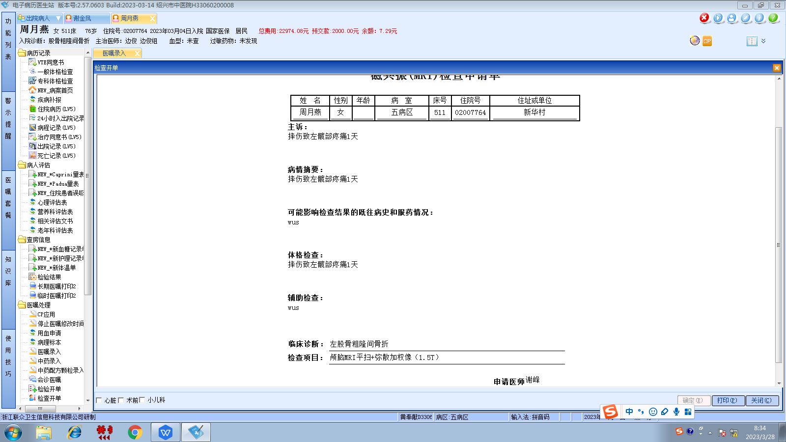边俊组
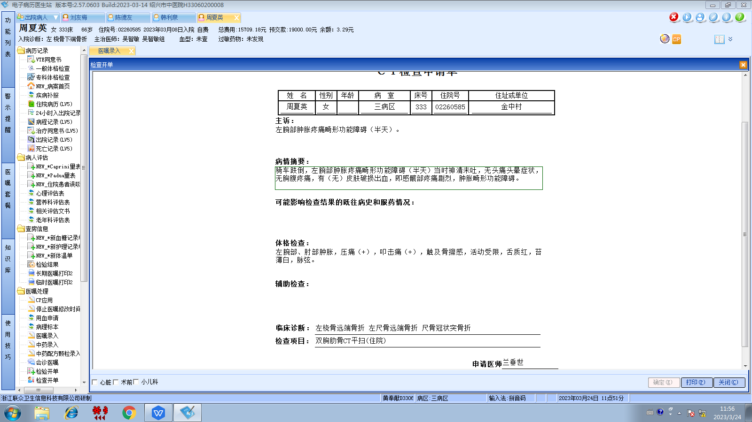吴智敏组
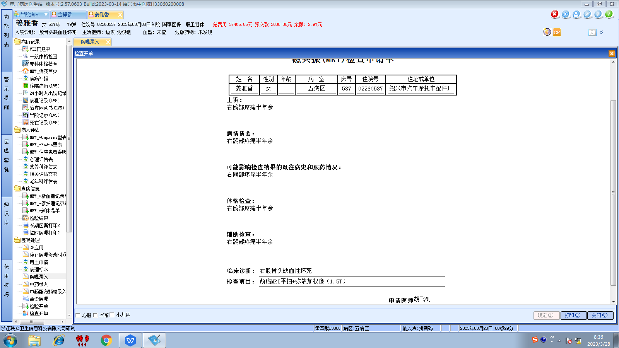边俊组
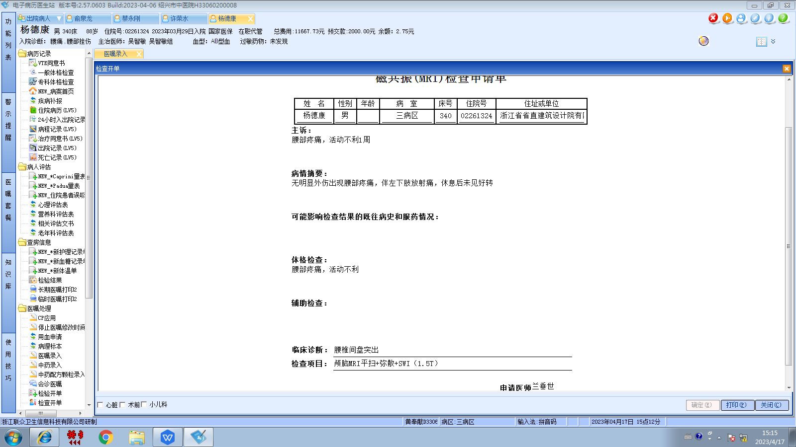吴智敏组
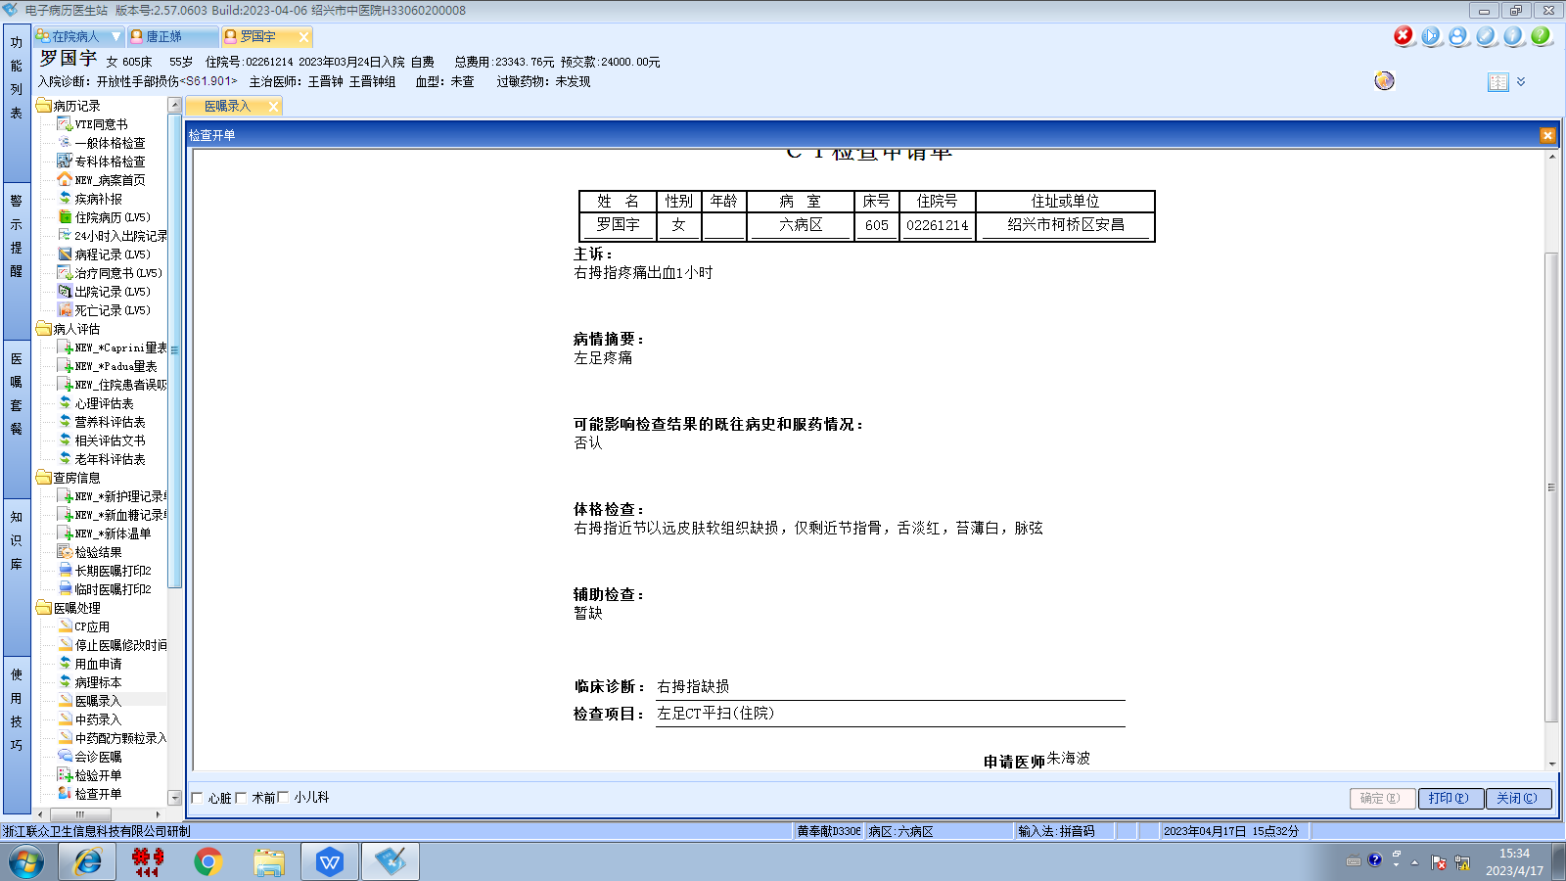王晋钟组

