5月检查申请单质控
住院号 | 检查单类型 | 开单日期 | 开单医师 |  |  | 检查项目
 |  |  |  | 主诉 | 病情摘要 |  | 既往史 | 体格检查 | 辅助检查 | 诊断 | 内容申请单不一致
02262484 | MR | 2023-4-26 | 张梦娇 | √ | √ |  | √ | √ | √ | √ | √
02262631 | MR | 2023-4-30 | 赵雄碧 | √ | √ |  | √ | √ | √ | √ | √
02004996 | CT | 2023-4-29 | 孟闯闯 | √ | √ |  | √ | √ | √ | √ | √
02262564 | CT | 2023-4-30 | 夏炳江 | √ | √ |  | √ | √ | √ | √ | √
02262607 | CT | 2023-5-1 | 吴明 | √ | √ |  | √ | √ | √ | √ | √
02262607 | MR | 2023-5-3 | 吴智敏 | √ | √ |  | √ | √ | √ | √ | √
02262547 | CT | 2023-4-30 | 苗超峰 | √ | √ |  | √ | √ | √ | √ | √
01809685 | MR | 2023-5-1 | 谢峰 | √ | √ |  | √ | √ | √ | √ | √
01706484 | CT | 2023-5-1 | 张春晓 | √ | √ |  | √ | √ | √ | √ | √
01705674 | MR | 2023-5-2 | 谢睿 | √ | √ |  | √ | √ | √ | √ | √
01903388 | MR | 2023-4-29 | 谢超 | √ | √ |  | √ | √ | √ | √ | √
01603935 | MR | 2023-5-1 | 杨兴辉 | √ | √ |  | √ | √ | √ | √ | √
02262562 | MR | 2023-5-2 | 诸佳燕 | √ | √ |  | √ | √ | √ | √ | √
02262821 | MR | 2023-5-4 | 边俊 | √ | √ |  | √ | √ | √ | √ | √
02108669 | CT | 2023-5-3 | 孙莉 | √ | √ |  | √ | √ | √ | √ | √
02262720 | MR | 2023-5-3 | 郑德财 | √ | √ |  | √ | √ | √ | √ | √
02262578 | MR | 2023-5-1 | 王珊珊 | √ | √ |  | √ | √ | √ | √ | √
02262567 | MR | 2023-5-2 | 王珊珊 | √ | √ |  | √ | √ | √ | √ | √
02262260 | MR | 2023-5-5 | 谢峰 | √ | √ |  | √ | √ | √ | √ | √
02262667 | MR | 2023-5-4 | 杜菲 | √ | √ |  | √ | √ | √ | √ | √
02005531 | MR | 2023-5-2 | 沈沉 | √ | √ |  | √ | √ | √ | √ | √
02262840 | MR | 2023-5-4 | 何易 | √ | √ |  | √ | √ | √ | √ | √
02262798 | CT | 2023-5-3 | 陶铁瑛 | √ | √ |  | √ | √ | √ | √ | √
02262853 | MR | 2023-5-5 | 王立波 | √ | √ |  | √ | √ | √ | √ | √
02260248 | MR | 2023-5-7 | 张桢阳 | √ | √ |  | √ | √ | √ | √ | √
02262701 | MR | 2023-5-7 | 陈剑磨 | √ | √ |  | √ | √ | √ | √ | √
01509760 | CT | 2023-5-6 | 孙莉 | √ | √ |  | √ | √ | √ | √ | √
02262908 | MR | 2023-5-8 | 陶铁瑛 | √ | √ |  | √ | √ | √ | √ | √
02262764 | CT | 2023-5-6 | 支飞虎 | √ | √ |  | √ | √ | √ | √ | √
02262988 | MR | 2023-5-8 | 沈沉 | √ | √ |  | √ | √ | √ | √ | √
02262825 | MR | 2023-5-5 | 杜菲 | √ | √ |  | √ | √ | √ | √ | √
02262784 | MR | 2023-5-5 | 边佳萍 | √ | √ |  | √ | √ | √ | √ | √
02262858 | MR | 2023-5-5 | 王珊珊 | √ | √ |  | √ | √ | √ | √ | √
01816331 | MR | 2023-5-8 | 谢睿 | √ | √ |  | √ | √ | √ | √ | √
02263000 | CT | 2023-5-9 | 许华强 | √ | √ |  | √ | √ | √ | √ | √
02262934 | MR | 2023-5-7 | 孙玲玲 | √ | √ |  | √ | √ | √ | √ | √
02262882 | MR | 2023-5-8 | 刘磊 | √ | √ |  | √ | √ | √ | √ | √
02263011 | MR | 2023-5-9 | 付玉芳 | √ | √ |  | √ | √ | √ | √ | √
01813575 | MR | 2023-5-8 | 夏建宇 | √ | √ |  | √ | √ | √ | √ | √
02255027 | MR | 2023-5-8 | 兰垂世 | √ | √ |  | √ | √ | √ | √ | √
02262819 | MR | 2023-5-10 | 王立波 | √ | √ |  | √ | √ | √ | √ | √
02261214 | MR | 2023-5-9 | 朱海波 | √ | √ |  | √ | √ | √ | √ | ×
01708771 | MR | 2023-5-11 | 胡飞剑 | √ | √ |  | √ | √ | √ | √ | √
02262869 | MR | 2023-5-11 | 张梦娇 | √ | √ |  | √ | √ | √ | √ | √
02263110 | MR | 2023-5-12 | 金少威 | √ | √ |  | √ | √ | √ | √ | √
02263070 | CT | 2023-5-13 | 陈俊杰 | √ | √ |  | √ | √ | √ | √ | ×
02263070 | MR | 2023-5-15 | 吕宇航 | √ | √ |  | √ | √ | √ | √ | √
01901908 | CT | 2023-5-10 | 王家甜 | √ | √ |  | √ | √ | √ | √ | √
01910240 | MR | 2023-5-11 | 卢璐 | √ | √ |  | √ | √ | √ | √ | √
02263056 | MR | 2023-5-12 | 安星宇 | √ | √ |  | √ | √ | √ | √ | √
02263225 | CT | 2023-5-14 | 秦培芝 | √ | √ |  | √ | √ | √ | √ | √
02263084 | MR | 2023-5-12 | 朱涵杰 | √ | √ |  | √ | √ | √ | √ | ×
02242721 | MR | 2023-5-12 | 王冰清 | √ | √ |  | √ | √ | √ | √ | √
02263101 | MR | 2023-5-13 | 张梦娇 | √ | √ |  | √ | √ | √ | √ | √
01900902 | MR | 2023-5-14 | 赵艳明 | √ | √ |  | √ | √ | √ | √ | √
01709122 | MR | 2023-5-12 | 赵艳明 | √ | √ |  | √ | √ | √ | √ | √
02263246 | CT | 2023-5-16 | 诸佳燕 | √ | √ |  | √ | √ | √ | √ | √
02263246 | MR | 2023-5-17 | 王风永 | √ | √ |  | √ | √ | √ | √ | √
02262890 | CT | 2023-5-16 | 朱江 | √ | √ |  | √ | √ | √ | √ | √
02108582 | MR | 2023-5-15 | 苗超峰 | √ | √ |  | √ | √ | √ | √ | √
20101948 | MR | 2023-5-16 | 朱涵杰 | √ | √ |  | √ | √ | √ | √ | √
01915815 | MR | 2023-5-16 | 胡飞剑 | √ | √ |  | √ | √ | √ | √ | √
02263278 | MR | 2023-5-15 | 陈剑磨 | √ | √ |  | √ | √ | √ | √ | √
01510608 | CT | 2023-5-15 | 王敏龙 | √ | √ |  | √ | √ | √ | √ | √
01913570 | MR | 2023-5-16 | 张桢阳 | √ | √ |  | √ | √ | √ | √ | √
02263211 | CT | 2023-5-15 | 苗超峰 | √ | √ |  | √ | √ | √ | √ | √
02263211 | MR | 2023-5-19 | 何易 | √ | √ |  | √ | √ | √ | √ | √
02263052 | CT | 2023-5-16 | 钱飞婷 | √ | √ |  | √ | √ | √ | √ | √
02263235 | CT | 2023-5-17 | 孙莉 | √ | √ |  | √ | √ | √ | √ | √
02263235 | CT | 2023-5-19 | 孙莉 | √ | √ |  | √ | √ | √ | √ | √
02263197 | CT | 2023-5-17 | 夏建宇 | √ | √ |  | √ | √ | √ | √ | √
01903645 | CT | 2023-5-18 | 诸佳燕 | √ | √ |  | √ | √ | √ | √ | √
01806697 | CT | 2023-5-19 | 孙莉 | √ | √ |  | √ | √ | √ | √ | √
02263259 | MR | 2023-5-19 | 沈家峰 | √ | √ |  | √ | √ | √ | √ | √
02263290 | MR | 2023-5-19 | 沈家峰 | √ | √ |  | √ | √ | √ | √ | √
02263376 | MR | 2023-5-19 | 孙莉 | √ | √ |  | √ | √ | √ | √ | √
01509991 | MR | 2023-5-19 | 樊晓琦 | √ | √ |  | √ | √ | √ | √ | √
02263301 | MR | 2023-5-20 | 王冰清 | √ | √ |  | √ | √ | √ | √ | √
02263298 | MR | 2023-5-21 | 孙莉 | √ | √ |  | √ | √ | √ | √ | √
02263426 | MR | 2023-5-20 | 刘悦 | √ | √ |  | √ | √ | √ | √ | √
02263478 | MR | 2023-5-21 | 沈沉 | √ | √ |  | √ | √ | √ | √ | √
01714048 | CT | 2023-5-22 | 郑德财 | √ | √ |  | √ | √ | √ | √ | √
02263388 | MR | 2023-5-23 | 朱海波 | √ | √ |  | √ | √ | √ | √ | √
02244390 | MR | 2023-5-22 | 张学思 | √ | √ |  | √ | √ | √ | √ | √
02263523 | MR | 2023-5-22 | 边俊 | √ | √ |  | √ | √ | √ | √ | √
02263395 | CT | 2023-5-23 | 谢立江 | √ | √ |  | √ | √ | √ | √ | √
02263505 | MR | 2023-5-23 | 杜菲 | √ | √ |  | √ | √ | √ | √ | √
02263505 | CT | 2023-5-23 | 王珊珊 | √ | √ |  | √ | √ | √ | √ | √
02263503 | MR | 2023-5-22 | 王珊珊 | √ | √ |  | √ | √ | √ | √ | √
01912220 | MR | 2023-5-21 | 孙玲玲 | √ | √ |  | √ | √ | √ | √ | √
02263508 | CT | 2023-5-24 | 孙莉 | √ | √ |  | √ | √ | √ | √ | √
02244369 | MR | 2023-5-25 | 张建宇 | √ | √ |  | √ | √ | √ | √ | √
01303818 | MR | 2023-5-22 | 张梦娇 | √ | √ |  | √ | √ | √ | √ | √
02263499 | MR | 2023-5-26 | 卢璐 | √ | √ |  | √ | √ | √ | √ | √
02263499 | MR | 2023-5-26 | 沈沉 | √ | √ |  | √ | √ | √ | √ | √
02263564 | CT | 2023-5-26 | 金建淼 | √ | √ |  | √ | √ | √ | √ | √
02263613 | CT | 2023-5-25 | 陆超锋 | √ | √ |  | √ | √ | √ | √ | √
02263613 | MR | 2023-5-30 | 陆超锋 | √ | √ |  | √ | √ | √ | √ | √
02263524 | MR | 2023-5-24 | 张梦娇 | √ | √ |  | √ | √ | √ | √ | √
02263495 | MR | 2023-5-24 | 陈剑磨 | √ | √ |  | √ | √ | √ | √ | √
02258467 | CT | 2023-5-26 | 王一萍 | √ | √ |  | √ | √ | √ | √ | √
01510314 | CT | 2023-5-28 | 郑德财 | √ | √ |  | √ | √ | √ | √ | √
02106743 | CT | 2023-5-29 | 罗桢敏 | √ | √ |  | √ | √ | √ | √ | √
02263686 | MR | 2023-5-28 | 沈沉 | √ | √ |  | √ | √ | √ | √ | √
01814471 | MR | 2023-5-28 | 何易 | √ | √ |  | √ | √ | √ | √ | √
02263691 | CT | 2023-5-31 | 孙莉 | √ | √ |  | √ | √ | √ | √ | √
01208955 | CT | 2023-5-29 | 赵艳明 | √ | √ |  | √ | √ | √ | √ | √
02263579 | MR | 2023-5-30 | 王珊珊 | √ | √ |  | √ | √ | √ | √ | √
注：对住院患者检查申请单进行专项检查，其中主诉、体格检查或诊断任缺一项者视为不合格申请单；非入院常规检查，如申请单内容与检查部位及要求不一致，亦视为不合格申请单。
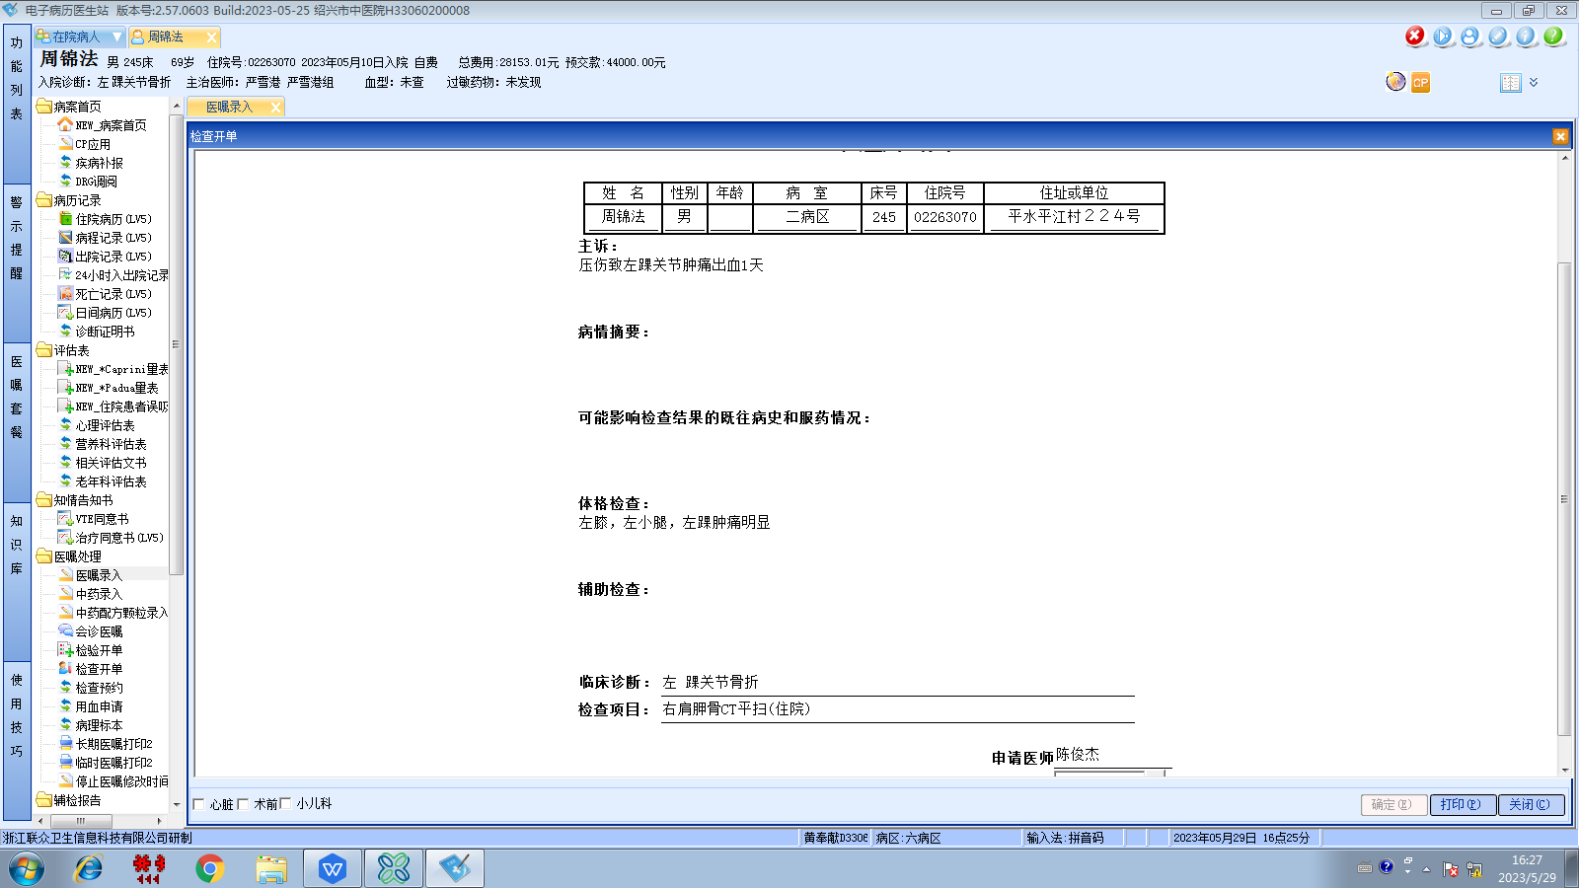严雪港组
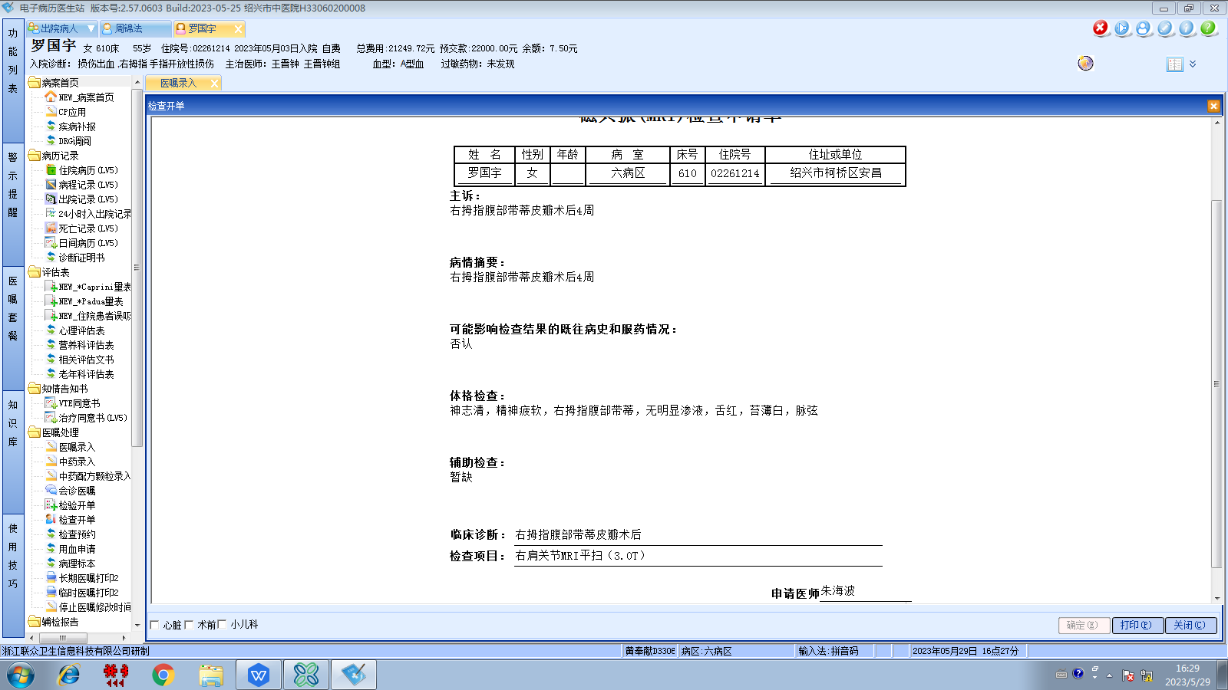王晋钟组
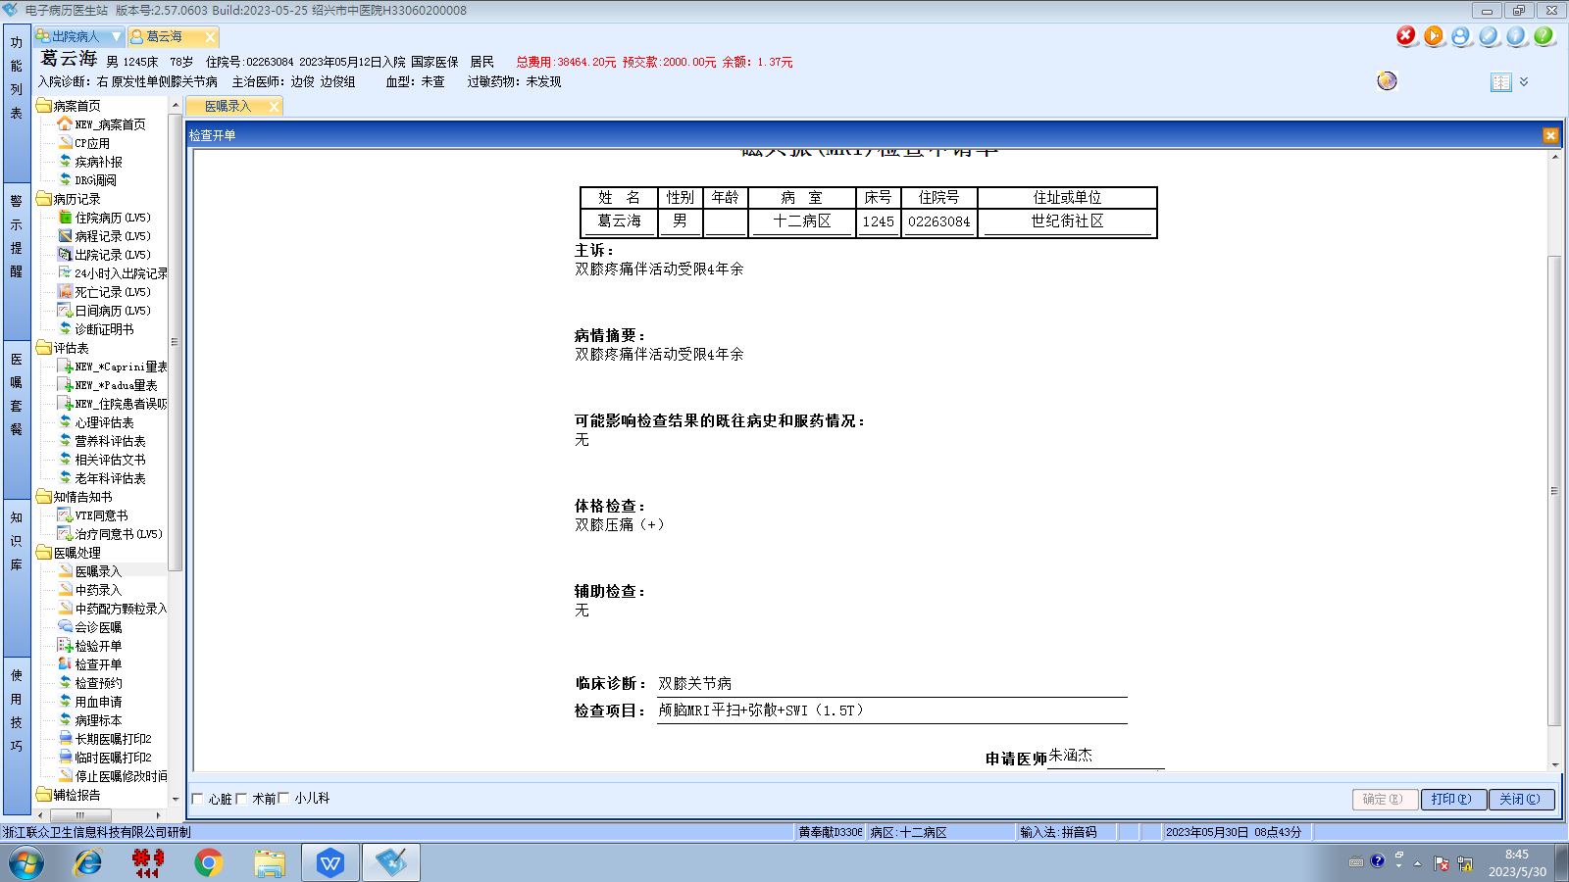边俊组

