6月检查申请单质控
住院号 | 检查单类型 | 开单日期 | 开单医师 |  |  | 检查项目
 |  |  |  | 主诉 | 病情摘要 |  | 既往史 | 体格检查 | 辅助检查 | 诊断 | 内容申请单不一致
02263803 | MR | 2023-5-30 | 胡飞剑 | √ | √ |  | √ | √ | √ | √ | √
01911181 | CT | 2023-5-31 | 裘鸿飞 | √ | √ |  | √ | √ | √ | √ | √
01914772 | CT | 2023-6-1 | 孟闯闯 | √ | √ |  | √ | √ | √ | √ | √
02001851 | MR | 2023-5-31 | 杨锋 | √ | √ |  | √ | √ | √ | √ | √
02001851 | MR | 2023-5-30 | 卢璐 | √ | √ |  | √ | √ | √ | √ | √
02008275 | MR | 2023-5-30 | 张春晓 | √ | √ |  | √ | √ | √ | √ | √
02263676 | MR | 2023-5-31 | 王磊 | √ | √ |  | √ | √ | √ | √ | √
02263907 | CT | 2023-6-2 | 孙莉 | √ | √ |  | √ | √ | √ | √ | √
02263845 | CT | 2023-6-2 | 陆超锋 | √ | √ |  | √ | √ | √ | √ | √
02263921 | MR | 2023-6-1 | 边俊 | √ | √ |  | √ | √ | √ | √ | √
02244202 | MR | 2023-6-2 | 沈沉 | √ | √ |  | √ | √ | √ | √ | √
01900363 | CT | 2023-6-3 | 王冰清 | √ | √ |  | √ | √ | √ | √ | √
02263888 | MR | 2023-6-1 | 尤志新 | √ | √ |  | √ | √ | √ | √ | √
02263888 | CT | 2023-6-5 | 王一萍 | √ | √ |  | √ | √ | √ | √ | √
02263688 | MR | 2023-6-1 | 陶铁瑛 | √ | √ |  | √ | √ | √ | √ | √
02263889 | MR | 2023-6-1 | 张梦娇 | √ | √ |  | √ | √ | √ | √ | √
02263894 | MR | 2023-6-2 | 罗桢敏 | √ | √ |  | √ | √ | √ | √ | √
02263894 | MR | 2023-6-2 | 盛苏红 | √ | √ |  | √ | √ | √ | √ | √
02263869 | MR | 2023-5-31 | 张梦娇 | √ | √ |  | √ | √ | √ | √ | √
02263428 | CT | 2023-6-2 | 刘悦 | √ | √ |  | √ | √ | √ | √ | √
02263887 | MR | 2023-6-1 | 张梦娇 | √ | √ |  | √ | √ | √ | √ | √
01608892 | CT | 2023-6-2 | 刘悦 | √ | √ |  | √ | √ | √ | √ | √
01706623 | CT | 2023-6-3 | 王冰清 | √ | √ |  | √ | √ | √ | √ | √
01706623 | CT | 2023-6-4 | 孙莉 | √ | √ |  | √ | √ | √ | √ | √
01914556 | CT/MR | 2023-6-2 | 王珊珊 | √ | √ |  | √ | √ | √ | √ | √
01914556 | MR | 2023-6-6 | 沈沉 | √ | √ |  | √ | √ | √ | √ | √
02263940 | CT | 2023-6-2 | 周怡 | √ | √ |  | √ | √ | √ | √ | √
02264025 | MR | 2023-6-4 | 钟承隽 | √ | √ |  | √ | √ | √ | √ | √
02263854 | MR | 2023-6-3 | 杨锋 | √ | √ |  | √ | √ | √ | √ | √
02105288 | MR | 2023-6-4 | 胡飞剑 | √ | √ |  | √ | √ | √ | √ | √
02264041 | MR | 2023-6-6 | 王冰清 | √ | √ |  | √ | √ | √ | √ | √
01613784 | MR | 2023-6-6 | 谢峰 | √ | √ |  | √ | √ | √ | √ | √
02264102 | MR | 2023-6-6 | 边俊 | √ | √ |  | √ | √ | √ | √ | √
02264098 | CT | 2023-6-6 | 马军华 | √ | √ |  | √ | √ | √ | √ | √
02263871 | CT | 2023-6-6 | 王风永 | √ | √ |  | √ | √ | √ | √ | √
02245766 | CT | 2023-6-9 | 马军华 | √ | √ |  | √ | √ | √ | √ | √
02264204 | CT | 2023-6-9 | 王风永 | √ | √ |  | √ | √ | √ | √ | √
02264125 | MR | 2023-6-6 | 谢峰 | √ | √ |  | √ | √ | √ | √ | √
02264127 | MR | 2023-6-8 | 支飞虎 | √ | √ |  | √ | √ | √ | √ | √
02264127 | CT | 2023-6-10 | 张建宇 | √ | √ |  | √ | √ | √ | √ | √
02264074 | MR | 2023-6-8 | 孙利荣 | √ | √ |  | √ | √ | √ | √ | √
02264114 | CT | 2023-6-9 | 陆超锋 | √ | √ |  | √ | √ | √ | √ | √
02263836 | CT | 2023-6-10 | 秦培芝 | √ | √ |  | √ | √ | √ | √ | √
01708149 | MR | 2023-6-10 | 杨锋 | √ | √ |  | √ | √ | √ | √ | √
01911771 | CT | 2023-6-10 | 谢超 | √ | √ |  | √ | √ | √ | √ | √
02264119 | MR | 2023-6-8 | 姜洪叶 | √ | √ |  | √ | √ | √ | √ | √
02264189 | MR | 2023-6-8 | 胡飞剑 | √ | √ |  | √ | √ | √ | √ | √
02264188 | CT | 2023-6-11 | 陆超锋 | √ | √ |  | √ | √ | √ | √ | √
02264334 | MR | 2023-6-12 | 沈兴潮 | √ | √ |  | √ | √ | √ | √ | √
01509945 | MR | 2023-6-8 | 孙莉 | √ | √ |  | √ | √ | √ | √ | √
02264255 | CT | 2023-6-11 | 孟闯闯 | √ | √ |  | √ | √ | √ | √ | √
01602490 | MR | 2023-6-12 | 孙利荣 | √ | √ |  | √ | √ | √ | √ | √
01809039 | MR | 2023-6-11 | 葛剑洪 | √ | √ |  | √ | √ | √ | √ | √
01814471 | CT | 2023-6-13 | 马黎丽 | √ | √ |  | √ | √ | √ | √ | √
02264330 | CT | 2023-6-12 | 孙利荣 | √ | √ |  | √ | √ | √ | √ | √
02264206 | CT | 2023-6-13 | 张学思 | √ | √ |  | √ | √ | √ | √ | √
02263613 | CT | 2023-6-13 | 柴绍军 | √ | √ |  | √ | √ | √ | √ | √
02003733 | MR | 2023-6-13 | 王冰清 | √ | √ |  | √ | √ | √ | √ | √
02264298 | MR | 2023-6-13 | 周怡 | √ | √ |  | √ | √ | √ | √ | √
02238758 | CT | 2023-6-14 | 李国华 | √ | √ |  | √ | √ | √ | √ | √
02264375 | CT | 2023-6-14 | 刘运海 | √ | √ |  | √ | √ | √ | √ | √
02241890 | MR | 2023-6-13 | 朱海波 | √ | √ |  | √ | √ | √ | √ | √
01906285 | CT | 2023-6-15 | 孙莉 | √ | √ |  | √ | √ | √ | √ | √
02263929 | CT | 2023-6-14 | 卢璐 | √ | √ |  | √ | √ | √ | √ | √
02264523 | MR | 2023-6-16 | 边俊 | √ | √ |  | √ | √ | √ | √ | √
01712812 | MR | 2023-6-14 | 边佳萍 | √ | √ |  | √ | √ | √ | √ | √
02264460 | MR | 2023-6-15 | 周怡 | √ | √ |  | √ | √ | √ | √ | √
02264421 | MR | 2023-6-15 | 王家甜 | √ | √ |  | √ | √ | √ | √ | √
02264143 | CT | 2023-6-16 | 柴绍军 | √ | √ |  | √ | √ | √ | √ | √
02242292 | CT | 2023-6-16 | 陶铁瑛 | √ | √ |  | √ | √ | √ | √ | √
02264477 | MR | 2023-6-16 | 赵艳明 | √ | √ |  | √ | √ | √ | √ | √
02264551 | MR | 2023-6-17 | 陶铁瑛 | √ | √ |  | √ | √ | √ | √ | √
02264046 | MR | 2023-6-17 | 赵艳明 | √ | √ |  | √ | √ | √ | √ | √
02104835 | MR | 2023-6-19 | 刘浩飞 | √ | √ |  | √ | √ | √ | √ | √
02264365 | MR | 2023-6-18 | 沈沉 | √ | √ |  | √ | √ | √ | √ | √
01701915 | MR | 2023-6-17 | 王家甜 | √ | √ |  | √ | √ | √ | √ | √
02264552 | MR | 2023-6-17 | 钟承隽 | √ | √ |  | √ | √ | √ | √ | √
02264356 | CT | 2023-6-20 | 张梦娇 | √ | √ |  | √ | √ | √ | √ | √
02104864 | MR | 2023-6-19 | 孙利荣 | √ | √ |  | √ | √ | √ | √ | √
02264367 | MR | 2023-6-18 | 杜菲 | √ | √ |  | √ | √ | √ | √ | √
02264207 | MR | 2023-6-19 | 陈剑磨 | √ | √ |  | √ | √ | √ | √ | √
02264601 | MR | 2023-6-18 | 陈剑磨 | √ | √ |  | √ | √ | √ | √ | ×
02264052 | MR | 2023-6-19 | 秦培芝 | √ | √ |  | √ | √ | √ | √ | √
01401035 | MR | 2023-6-20 | 赵艳明 | √ | √ |  | √ | √ | √ | √ | √
02261201 | CT | 2023-6-18 | 许杨 | √ | √ |  | √ | √ | √ | √ | √
02003751 | MR | 2023-6-20 | 郑德财 | √ | √ |  | √ | √ | √ | √ | √
02264764 | CT | 2023-6-22 | 赵艳明 | √ | √ |  | √ | √ | √ | √ | √
02264743 | MR | 2023-6-21 | 胡飞剑 | √ | √ |  | √ | √ | √ | √ | √
02264693 | MR | 2023-6-22 | 陶铁瑛 | √ | √ |  | √ | √ | √ | √ | √
01900596 | MR | 2023-6-21 | 王家甜 | √ | √ |  | √ | √ | √ | √ | √
02264749 | MR | 2023-6-22 | 胡飞剑 | √ | √ |  | √ | √ | √ | √ | √
01703547 | MR | 2023-6-22 | 刘悦 | √ | √ |  | √ | √ | √ | √ | √
01914356 | MR | 2023-6-23 | 张梦娇 | √ | √ |  | √ | √ | √ | √ | √
02264871 | CT | 2023-6-24 | 王风永 | √ | √ |  | √ | √ | √ | √ | ×
02264816 | MR | 2023-6-23 | 刘浩飞 | √ | √ |  | √ | √ | √ | √ | ×
02264629 | MR | 2023-6-23 | 王风永 | √ | √ |  | √ | √ | √ | √ | √
02264796 | CT | 2023-6-23 | 孙玲玲 | √ | √ |  | √ | √ | √ | √ | √
02264872 | CT | 2023-6-27 | 王敏龙 | √ | √ |  | √ | √ | √ | √ | √
02264912 | MR | 2023-6-25 | 赵艳明 | √ | √ |  | √ | √ | √ | √ | √
02261171 | MR | 2023-6-25 | 李国华 | √ | √ |  | √ | √ | √ | √ | √
01506390 | CT | 2023-6-27 | 罗桢敏 | √ | √ |  | √ | √ | √ | √ | √
02264918 | CT | 2023-6-26 | 刘运海 | √ | √ |  | √ | √ | √ | √ | √
02264978 | MR | 2023-6-27 | 胡飞剑 | √ | √ |  | √ | √ | √ | √ | ×
02239416 | MR | 2023-6-25 | 孙玲玲 | √ | √ |  | √ | √ | √ | √ | √
02265058 | CT | 2023-6-29 | 陆超锋 | √ | √ |  | √ | √ | √ | √ | √
02264915 | MR | 2023-6-29 | 许杨 | √ | √ |  | √ | √ | √ | √ | √
02264017 | MR | 2023-6-29 | 边佳萍 | √ | √ |  | √ | √ | √ | √ | √
注：对住院患者检查申请单进行专项检查，其中主诉、体格检查或诊断任缺一项者视为不合格申请单；非入院常规检查，如申请单内容与检查部位及要求不一致，亦视为不合格申请单。

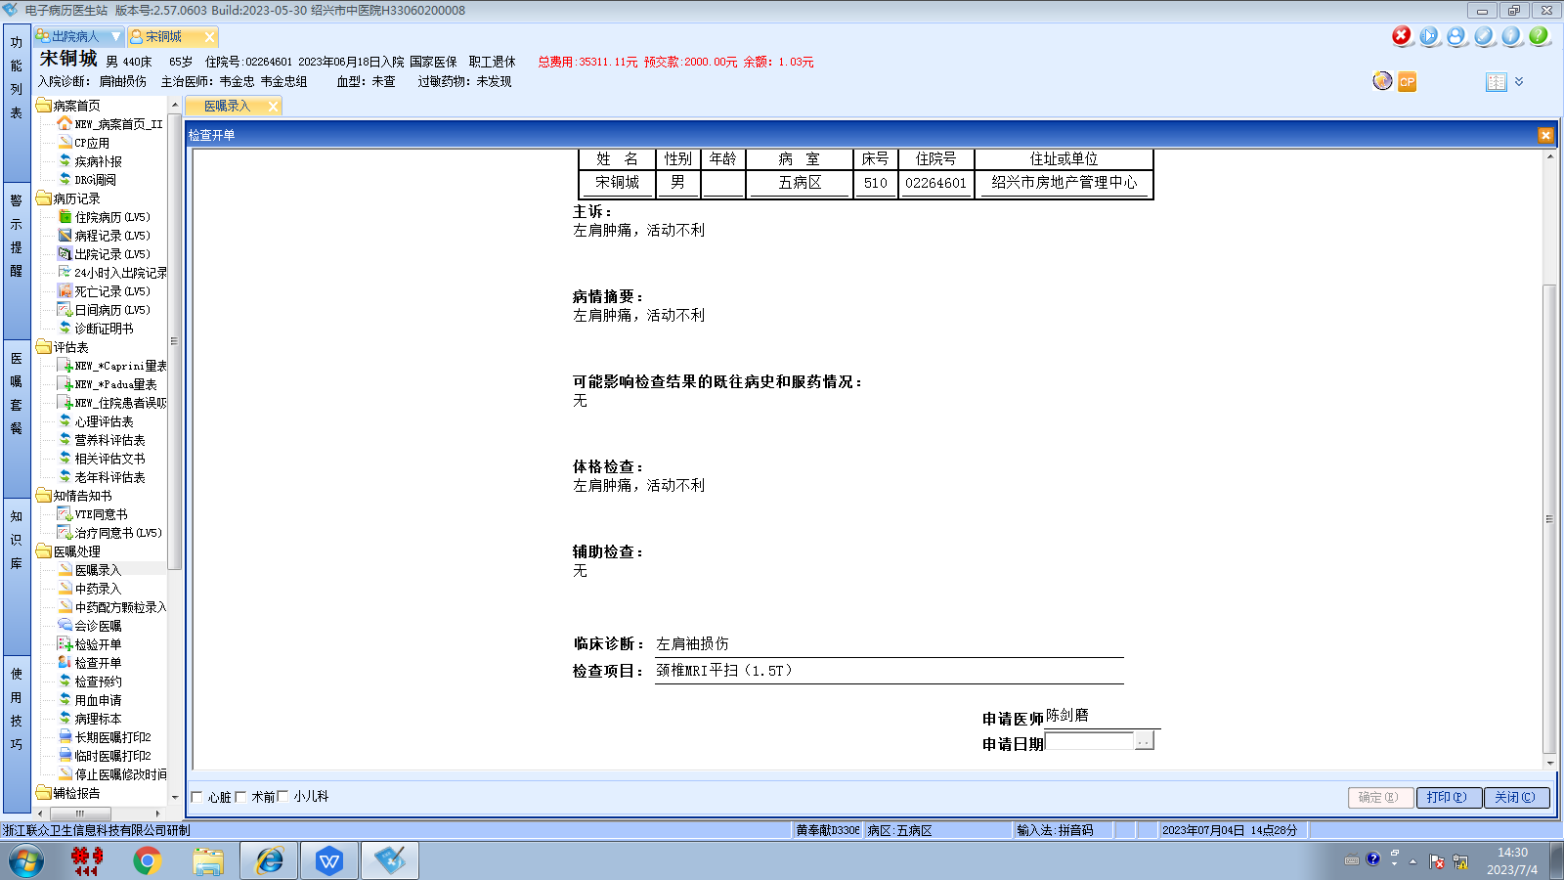沈剑增组
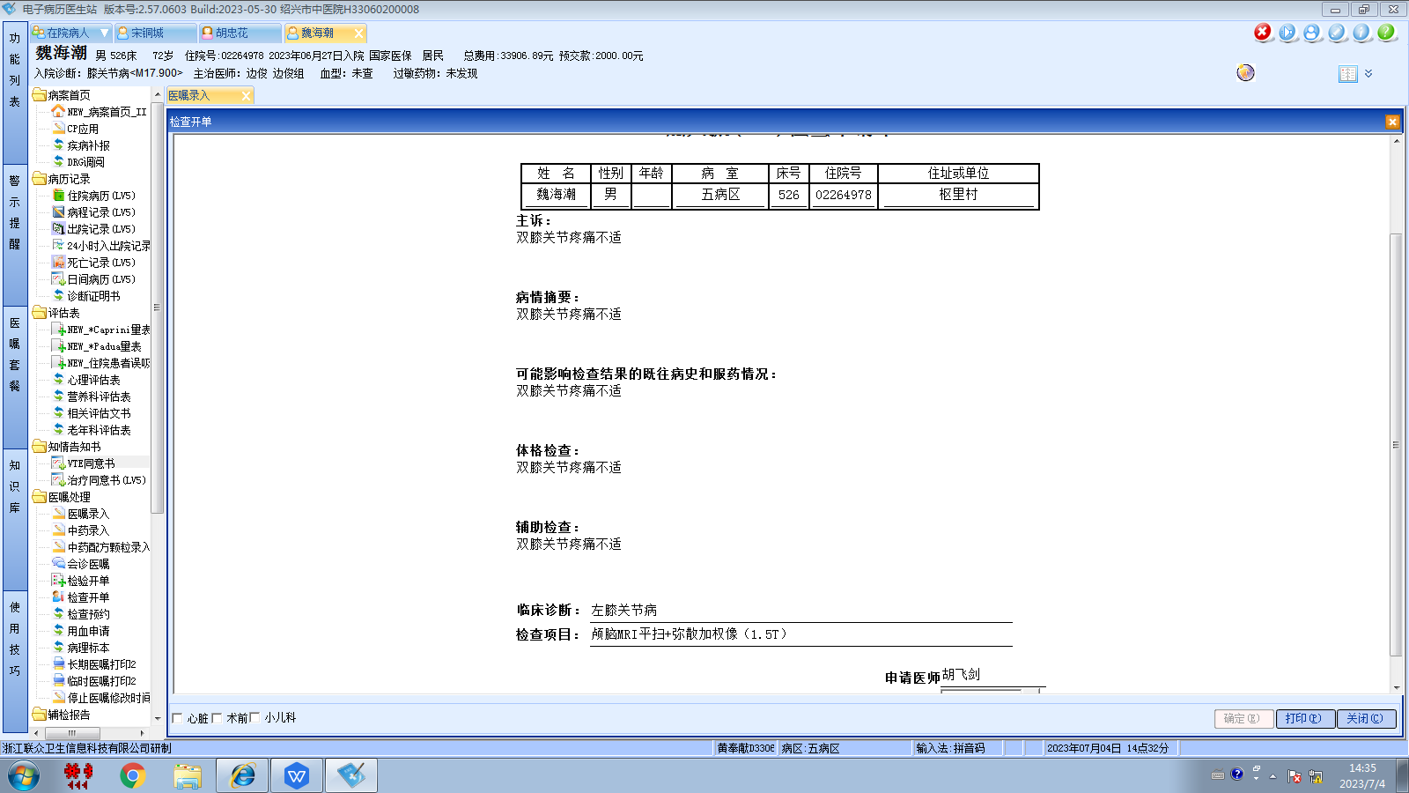边俊组
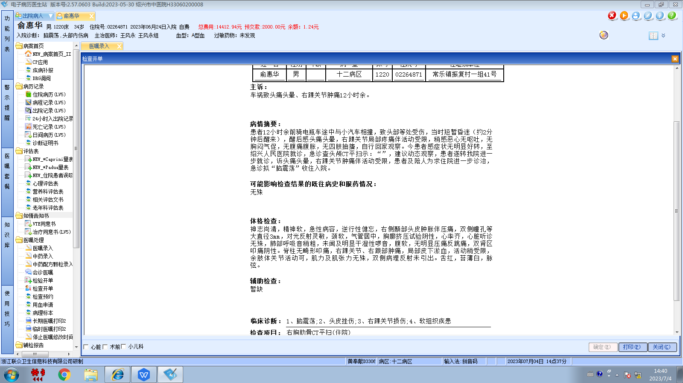王风永组
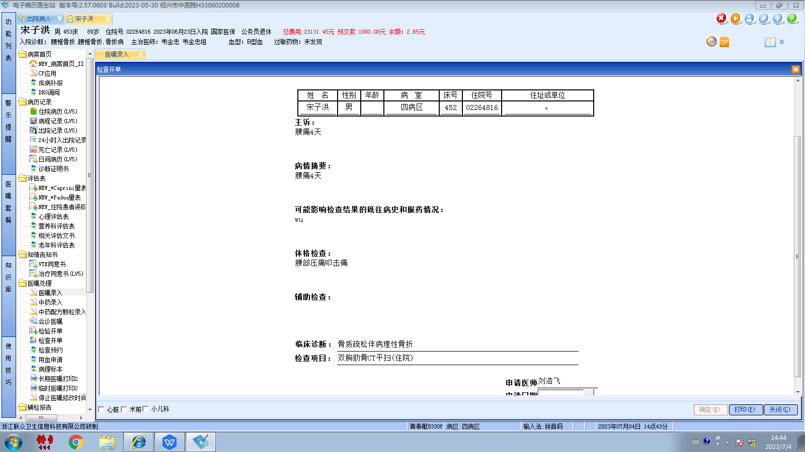韦金忠组

