7月检查申请单质控
住院号 | 检查单类型 | 开单日期 | 开单医师 |  |  | 检查项目
 |  |  |  | 主诉 | 病情摘要 |  | 既往史 | 体格检查 | 辅助检查 | 诊断 | 内容申请单不一致
02265058 | MR | 2023-6-30 | 陆超锋 | √ | √ |  | √ | √ | √ | √ | √
02264871 | MR | 2023-6-29 | 王风永 | √ | √ |  | √ | √ | √ | √ | √
02102258 | MR | 2023-6-29 | 陈剑磨 | √ | √ |  | √ | √ | √ | √ | √
02102258 | MR | 2023-7-5 | 钟承隽 | √ | √ |  | √ | √ | √ | √ | √
02265068 | MR | 2023-6-30 | 卢璐 | √ | √ |  | √ | √ | √ | √ | √
02100505 | CT | 2023-6-27 | 孙莉 | √ | √ |  | √ | √ | √ | √ | √
02265031 | CT | 2023-6-30 | 郑德财 | √ | √ |  | √ | √ | √ | √ | √
02265109 | CT | 2023-7-1 | 张桢阳 | √ | √ |  | √ | √ | √ | √ | √
02264921 | CT | 2023-6-30 | 王家甜 | √ | √ |  | √ | √ | √ | √ | √
02261467 | MR | 2023-6-30 | 李国华 | √ | √ |  | √ | √ | √ | √ | √
02264933 | CT | 2023-6-28 | 杨兴辉 | √ | √ |  | √ | √ | √ | √ | √
02265095 | CT | 2023-7-4 | 姜洪叶 | √ | √ |  | √ | √ | √ | √ | √
02265146 | MR | 2023-7-3 | 王轶辉 | √ | √ |  | √ | √ | √ | √ | √
02265150 | CT/MR | 2023-7-4 | 诸佳燕 | √ | √ |  | √ | √ | √ | √ | √
02264872 | MR | 2023-7-3 | 王敏龙 | √ | √ |  | √ | √ | √ | √ | √
02265204 | MR | 2023-7-3 | 谢峰 | √ | √ |  | √ | √ | √ | √ | √
02265114 | MR | 2023-7-4 | 张圣扬 | √ | √ |  | √ | √ | √ | √ | √
02100634 | CT | 2023-7-6 | 魏平洋 | √ | √ |  | √ | √ | √ | √ | √
02265252 | MR | 2023-7-5 | 王风永 | √ | √ |  | √ | √ | √ | √ | √
01904148 | MR | 2023-7-5 | 凌一鸣 | √ | √ |  | √ | √ | √ | √ | √
02265284 | MR | 2023-7-7 | 胡飞剑 | √ | √ |  | √ | √ | √ | √ | ×
02264406 | CT | 2023-7-7 | 张桢阳 | √ | √ |  | √ | √ | √ | √ | ×
02265271 | CT | 2023-7-8 | 包益辉 | √ | √ |  | √ | √ | √ | √ | √
02265275 | MR | 2023-7-6 | 沈学香 | √ | √ |  | √ | √ | √ | √ | √
02239945 | CT | 2023-7-8 | 谢超 | √ | √ |  | √ | √ | √ | √ | √
02265064 | CT | 2023-7-8 | 张桢阳 | √ | √ |  | √ | √ | √ | √ | √
02245217 | MR | 2023-7-6 | 胡飞剑 | √ | √ |  | √ | √ | √ | √ | ×
02245936 | CT | 2023-7-8 | 马军华 | √ | √ |  | √ | √ | √ | √ | ×
02265405 | MR | 2023-7-8 | 张桢阳 | √ | √ |  | √ | √ | √ | √ | √
02265383 | MR | 2023-7-9 | 陈剑磨 | √ | √ |  | √ | √ | √ | √ | ×
01701953 | MR | 2023-7-9 | 边佳萍 | √ | √ |  | √ | √ | √ | √ | √
02265434 | MR | 2023-7-8 | 兰垂世 | √ | √ |  | √ | √ | √ | √ | √
02265394 | MR | 2023-7-10 | 朱海波 | √ | √ |  | √ | √ | √ | √ | √
02102114 | CT | 2023-7-11 | 张华良 | √ | √ |  | √ | √ | √ | √ | √
02265446 | MR | 2023-7-9 | 许杨 | √ | √ |  | √ | √ | √ | √ | √
02265245 | MR | 2023-7-10 | 王冰清 | √ | √ |  | √ | √ | √ | √ | √
02264804 | CT | 2023-7-10 | 许伟攀 | √ | √ |  | √ | √ | √ | √ | √
02265411 | MR | 2023-7-11 | 刘磊 | √ | √ |  | √ | √ | √ | √ | ×
02265513 | MR | 2023-7-12 | 尤志新 | √ | √ |  | √ | √ | √ | √ | √
02100949 | MR | 2023-7-11 | 陆超锋 | √ | √ |  | √ | √ | √ | √ | √
02264526 | MR | 2023-7-10 | 凌一鸣 | √ | × |  | × | √ | × | √ | ×
02265540 | CT/MR | 2023-7-11 | 沈学香 | √ | √ |  | √ | √ | √ | √ | √
02265540 | CT | 2023-7-14 | 张建宇 | √ | √ |  | √ | √ | √ | √ | √
02265405 | MR | 2023-7-11 | 王敏龙 | √ | √ |  | √ | √ | √ | √ | √
02265383 | MR | 2023-7-9 | 陈剑磨 | √ | √ |  | √ | √ | √ | √ | √
01913175 | MR | 2023-7-12 | 张建宇 | √ | √ |  | √ | √ | √ | √ | √
02265502 | MR | 2023-7-12 | 胡烨琛 | √ | √ |  | √ | √ | √ | √ | √
02265543 | MR | 2023-7-12 | 张学思 | √ | √ |  | √ | √ | √ | √ | √
02102756 | MR | 2023-7-12 | 许伟攀 | √ | √ |  | √ | √ | √ | √ | √
02265471 | MR | 2023-7-13 | 陈剑磨 | √ | √ |  | √ | √ | √ | √ | √
02265648 | CT | 2023-7-14 | 张梦娇 | √ | × |  | × | √ | × | √ | ×
02265429 | MR | 2023-7-13 | 苗超峰 | √ | √ |  | √ | √ | √ | √ | √
01402198 | MR | 2023-7-13 | 罗桢敏 | √ | √ |  | √ | √ | √ | √ | √
02265422 | MR | 2023-7-15 | 凌一鸣 | √ | √ |  | √ | √ | √ | √ | √
02265681 | MR | 2023-7-14 | 刘磊 | √ | √ |  | √ | √ | √ | √ | ×
02109029 | MR | 2023-7-16 | 杜菲 | √ | √ |  | √ | √ | √ | √ | √
02265712 | MR | 2023-7-15 | 张桢阳 | √ | √ |  | √ | √ | √ | √ | √
02265712 | CT | 2023-7-19 | 王敏龙 | √ | √ |  | √ | √ | √ | √ | √
02265598 | MR | 2023-7-16 | 谢立江 | √ | √ |  | √ | √ | √ | √ | √
01908547 | CT | 2023-7-17 | 陶铁瑛 | √ | √ |  | √ | √ | √ | √ | √
02004140 | CT | 2023-7-18 | 王冰清 | √ | √ |  | √ | √ | √ | √ | √
02265676 | CT | 2023-7-17 | 章联欢 | √ | √ |  | √ | √ | √ | √ | √
02265481 | MR | 2023-7-17 | 俞梅 | √ | √ |  | √ | √ | √ | √ | √
02265625 | CT | 2023-7-17 | 王家甜 | √ | √ |  | √ | √ | √ | √ | √
02265608 | CT | 2023-7-19 | 刘浩飞 | √ | √ |  | √ | √ | √ | √ | √
01808165 | CT | 2023-7-19 | 张新凡 | √ | √ |  | √ | √ | √ | √ | √
02265512 | CT | 2023-7-14 | 谢睿 | √ | √ |  | √ | √ | √ | √ | √
02003953 | CT | 2023-7-19 | 孙莉 | √ | √ |  | √ | √ | √ | √ | √
01406896 | MR | 2023-7-18 | 张梦娇 | √ | √ |  | √ | √ | √ | √ | √
02265782 | MR | 2023-7-19 | 诸佳燕 | √ | √ |  | √ | √ | √ | √ | √
02254989 | CT | 2023-7-17 | 王风永 | √ | √ |  | √ | √ | √ | √ | √
01910022 | MR | 2023-7-18 | 王珊珊 | √ | √ |  | √ | √ | √ | √ | √
02102258 | MR | 2023-7-21 | 吕宇航 | √ | √ |  | √ | √ | √ | √ | √
02265715 | CT | 2023-7-21 | 孙莉 | √ | √ |  | √ | √ | √ | √ | √
01712789 | MR | 2023-7-19 | 郑德财 | √ | √ |  | √ | √ | √ | √ | √
02265765 | MR | 2023-7-19 | 王敏龙 | √ | √ |  | √ | √ | √ | √ | √
01708960 | CT | 2023-7-22 | 王磊 | √ | √ |  | √ | √ | √ | √ | √
02259120 | MR | 2023-7-22 | 蔡路炜 | √ | √ |  | √ | √ | √ | √ | √
02265849 | CT | 2023-7-24 | 许杨 | √ | √ |  | √ | √ | √ | √ | √
02265990 | MR | 2023-7-23 | 陶铁瑛 | √ | √ |  | √ | √ | √ | √ | √
02265890 | MR | 2023-7-22 | 刘悦 | √ | √ |  | √ | √ | √ | √ | √
01908907 | MR | 2023-7-21 | 程爵富 | √ | √ |  | √ | √ | √ | √ | √
02256314 | CT | 2023-7-25 | 赵艳明 | √ | √ |  | √ | √ | √ | √ | √
02238008 | MR | 2023-7-25 | 兰垂世 | √ | √ |  | √ | √ | √ | √ | √
02266039 | MR | 2023-7-24 | 陶铁瑛 | √ | √ |  | √ | √ | √ | √ | √
02264816 | MR | 2023-7-25 | 何易 | √ | √ |  | √ | √ | √ | √ | √
02265712 | CT | 2023-7-26 | 王风永 | √ | √ |  | √ | √ | √ | √ | √
02265712 | CT | 2023-7-30 | 王风永 | √ | √ |  | √ | √ | √ | √ | √
02265996 | CT | 2023-7-26 | 赵艳明 | √ | √ |  | √ | √ | √ | √ | √
02265540 | MR | 2023-7-25 | 沈学香 | √ | √ |  | √ | √ | √ | √ | √
02003025 | MR | 2023-7-26 | 赵艳明 | √ | √ |  | √ | √ | √ | √ | √
01909657 | MR | 2023-7-26 | 沈沉 | √ | √ |  | √ | √ | √ | √ | √
02266019 | MR | 2023-7-25 | 夏建宇 | √ | √ |  | √ | √ | √ | √ | √
02266167 | CT | 2023-7-28 | 王风永 | × | × |  | √ | √ | √ | √ | ×
01512141 | MR | 2023-7-28 | 何易 | √ | √ |  | √ | √ | √ | √ | √
01609375 | MR | 2023-7-28 | 杨兴辉 | √ | √ |  | √ | √ | √ | √ | √
01914144 | MR | 2023-7-28 | 兰垂世 | √ | √ |  | √ | √ | √ | √ | √
02266153 | MR | 2023-7-29 | 卢璐 | √ | √ |  | √ | √ | √ | √ | √
02266151 | MR | 2023-7-28 | 盛苏红 | √ | √ |  | √ | √ | √ | √ | √
02266052 | MR | 2023-7-27 | 边佳萍 | √ | √ |  | √ | √ | √ | √ | √
01816226 | MR | 2023-7-28 | 王珊珊 | √ | √ |  | √ | √ | √ | √ | √
02265993 | MR | 2023-7-29 | 沈学香 | √ | √ |  | √ | √ | √ | √ | ×
20091941 | MR | 2023-7-29 | 张圣扬 | √ | √ |  | √ | √ | √ | √ | √
02245217 | MR | 2023-7-27 | 胡飞剑 | √ | √ |  | √ | √ | √ | √ | √
02255765 | CT | 2023-7-31 | 黎村丰 | √ | √ |  | √ | √ | √ | √ | √
02266250 | MR | 2023-7-29 | 樊晓琦 | √ | √ |  | √ | √ | √ | √ | √
02266285 | CT | 2023-7-31 | 朱涵杰 | √ | √ |  | √ | √ | √ | √ | ×
02266027 | CT | 2023-7-28 | 王冰清 | √ | √ |  | √ | √ | √ | √ | √
注：对住院患者检查申请单进行专项检查，其中主诉、体格检查或诊断任缺一项者视为不合格申请单；非入院常规检查，如申请单内容与检查部位及要求不一致，亦视为不合格申请单。
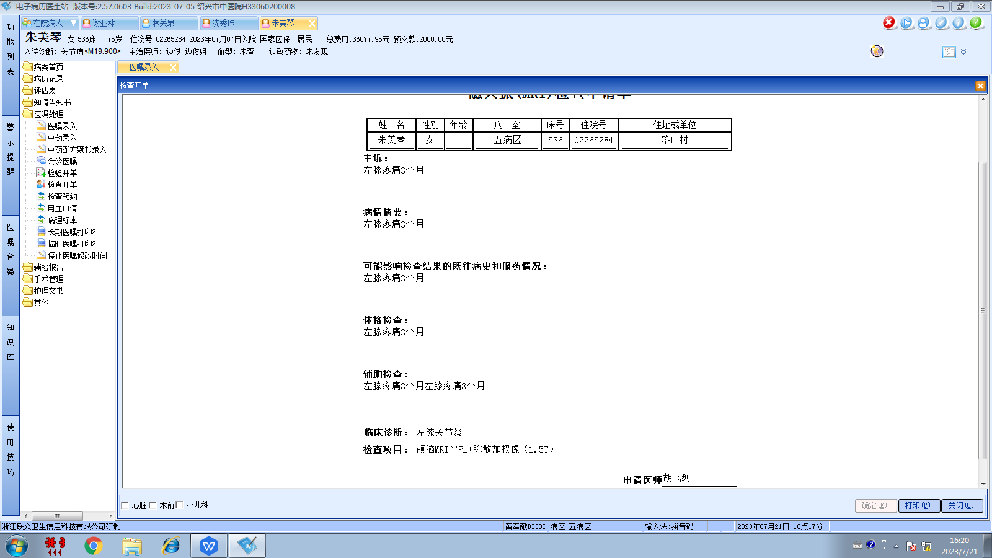边俊组
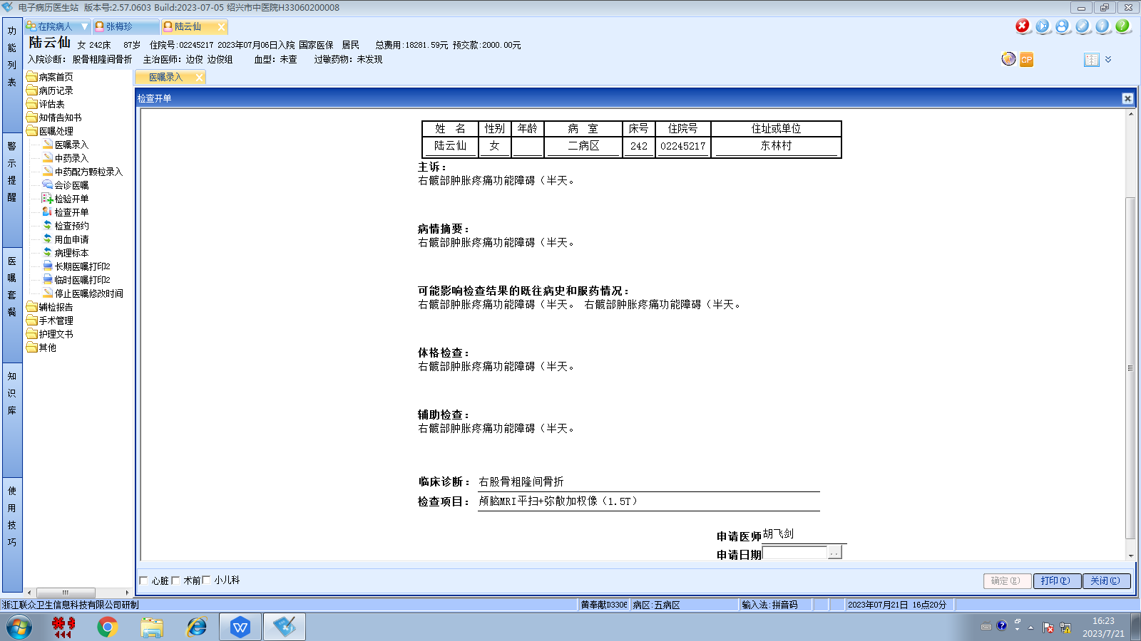边俊组
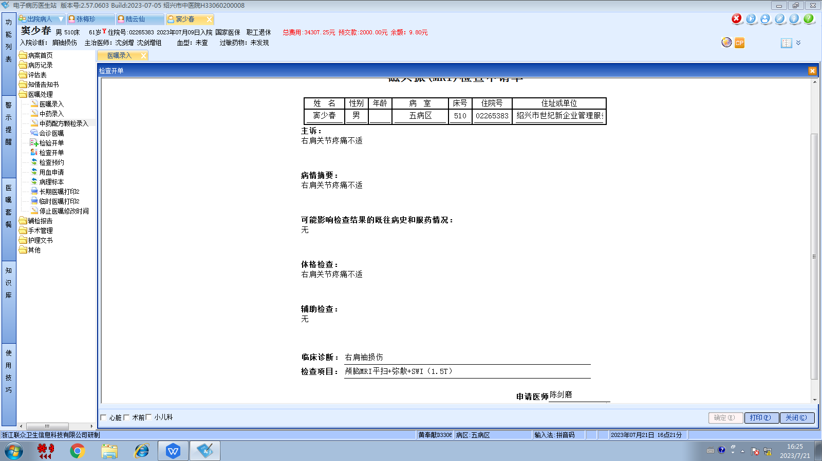沈剑增组
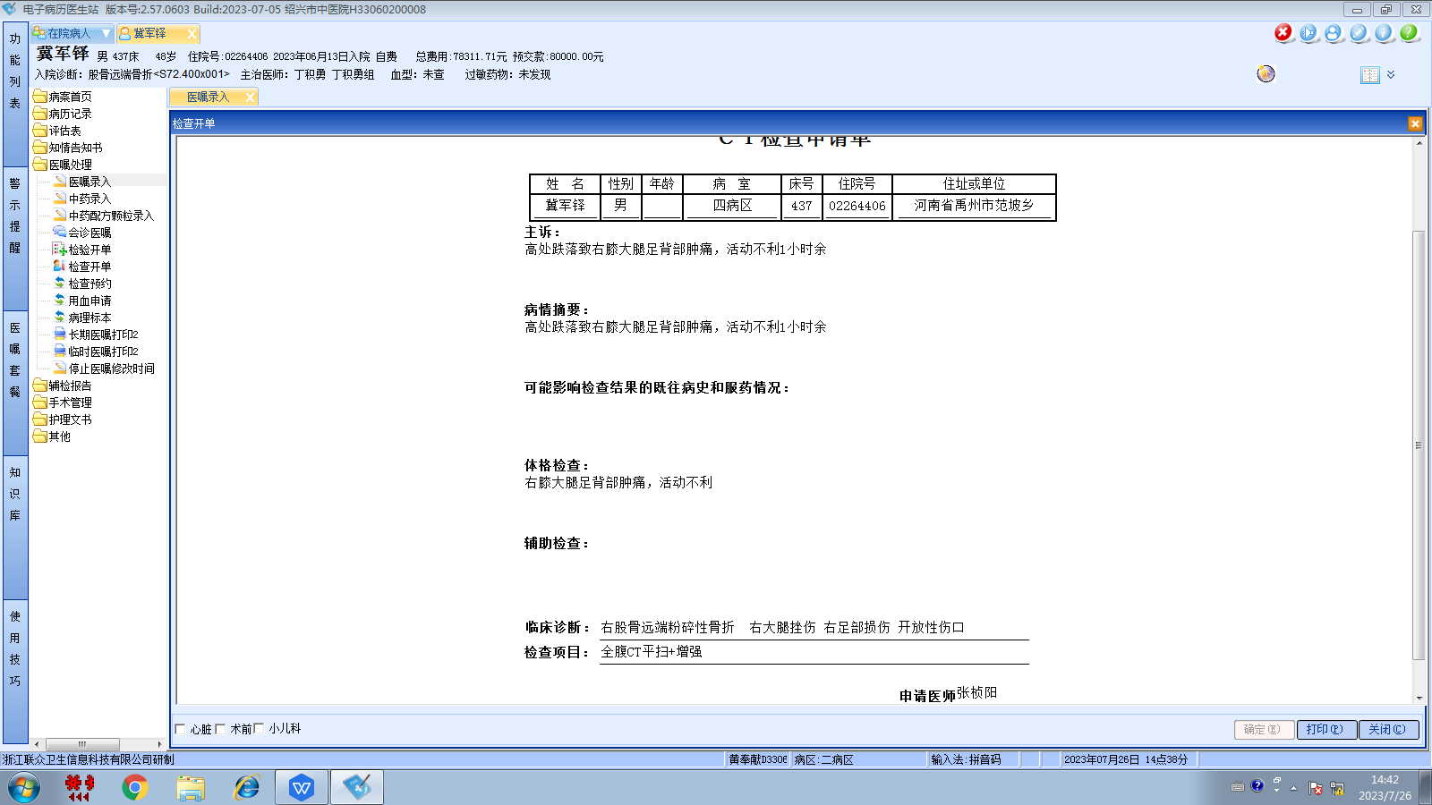丁积勇组
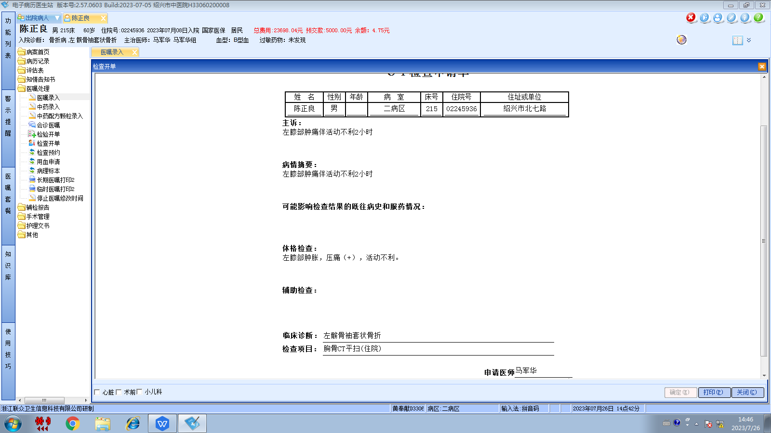马军华组
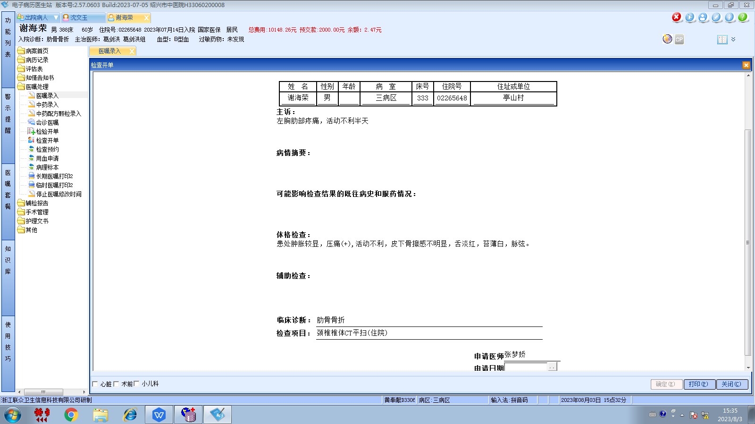葛剑洪组
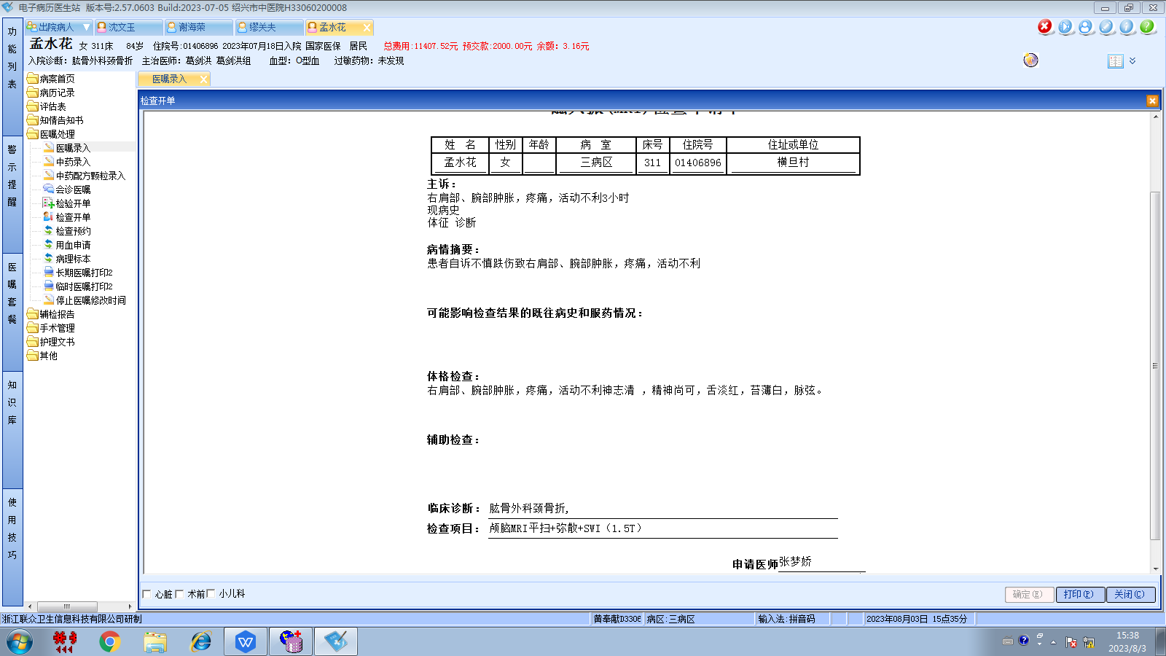葛剑洪组
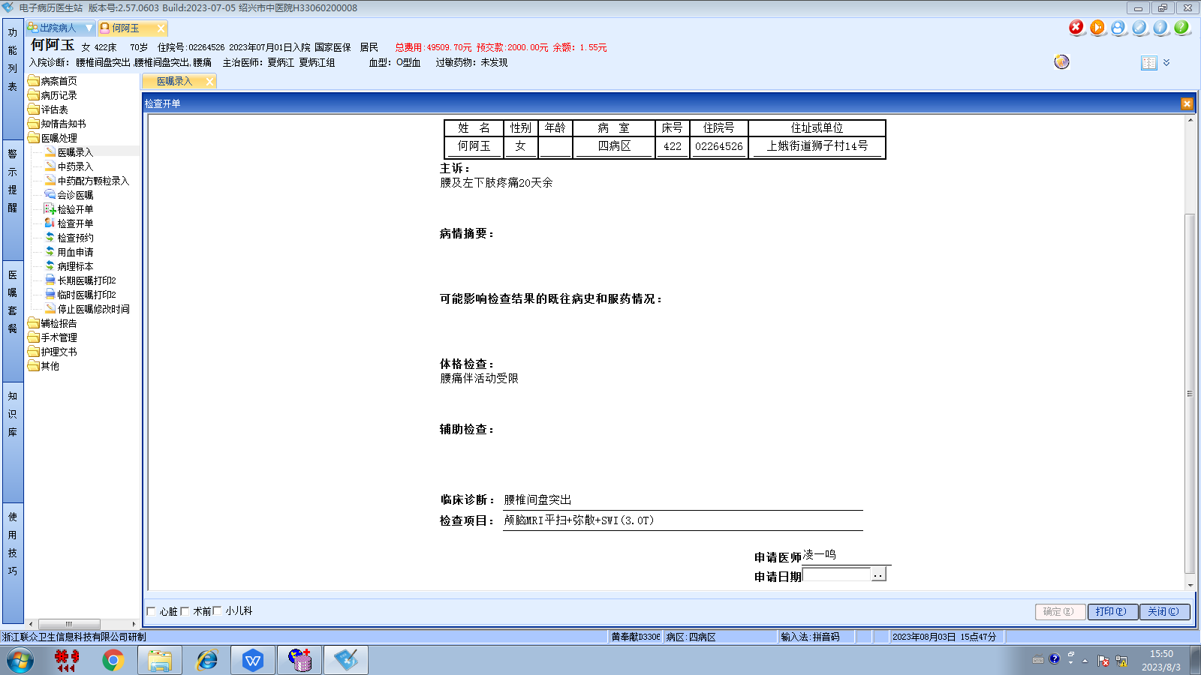夏炳江组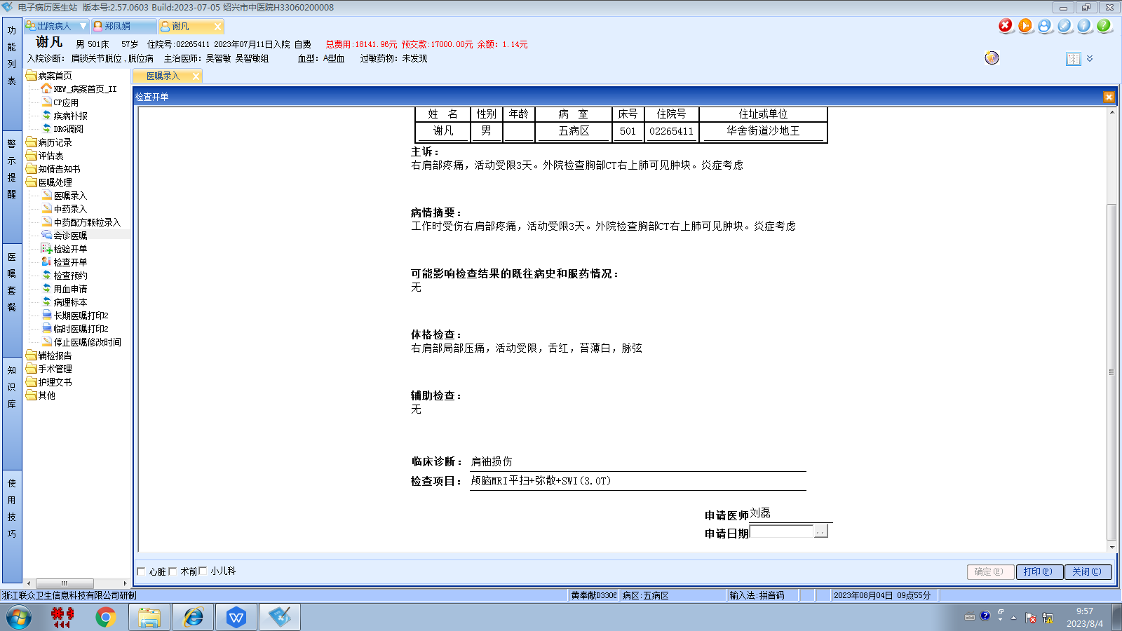刘磊组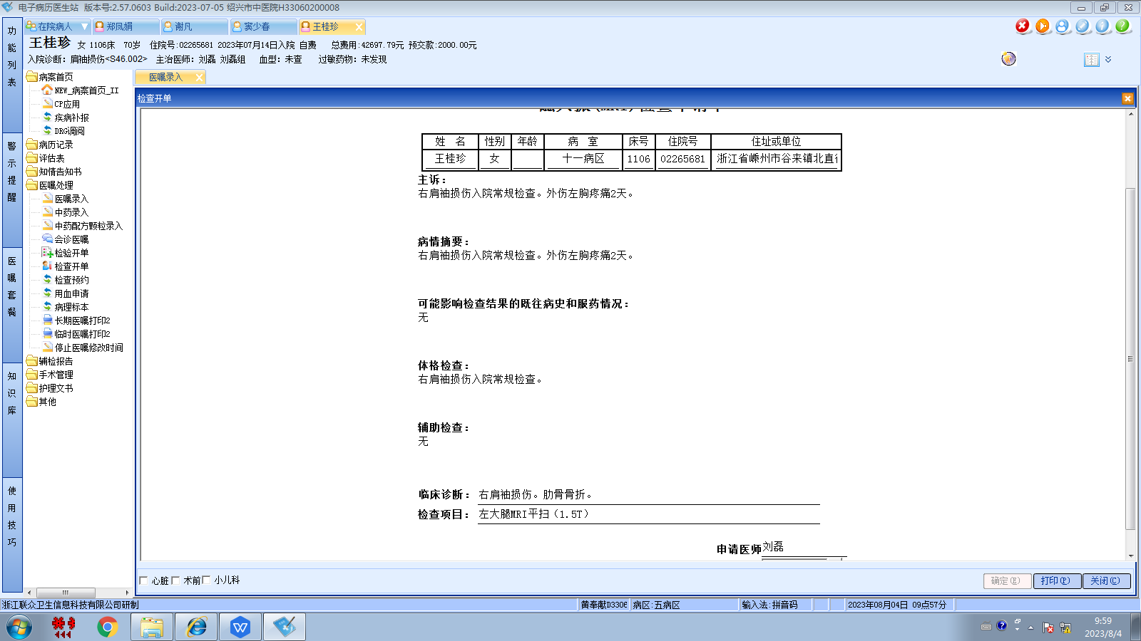刘磊组
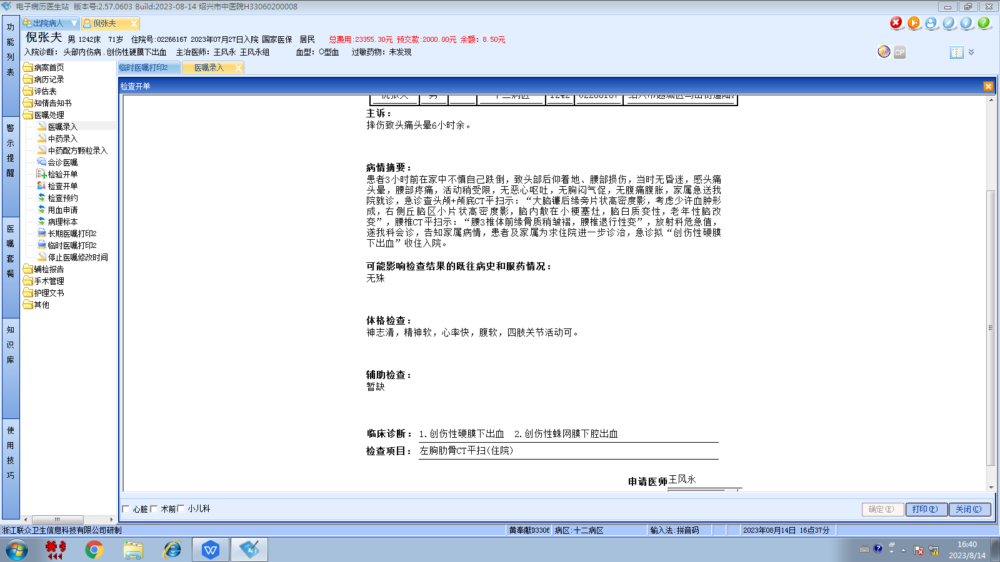王风永组
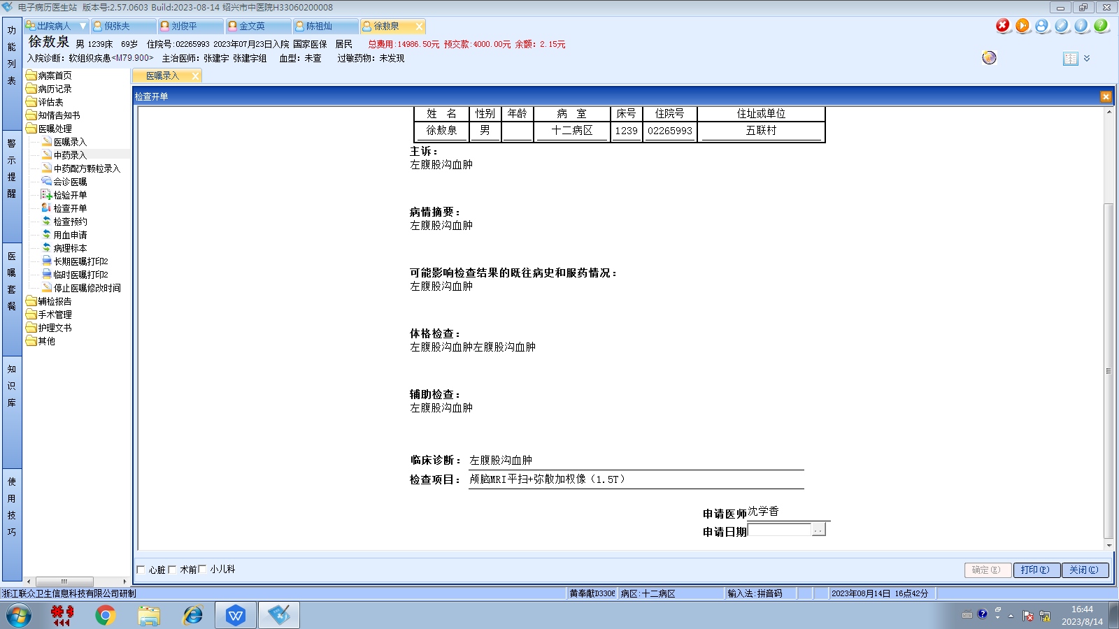张建宇组
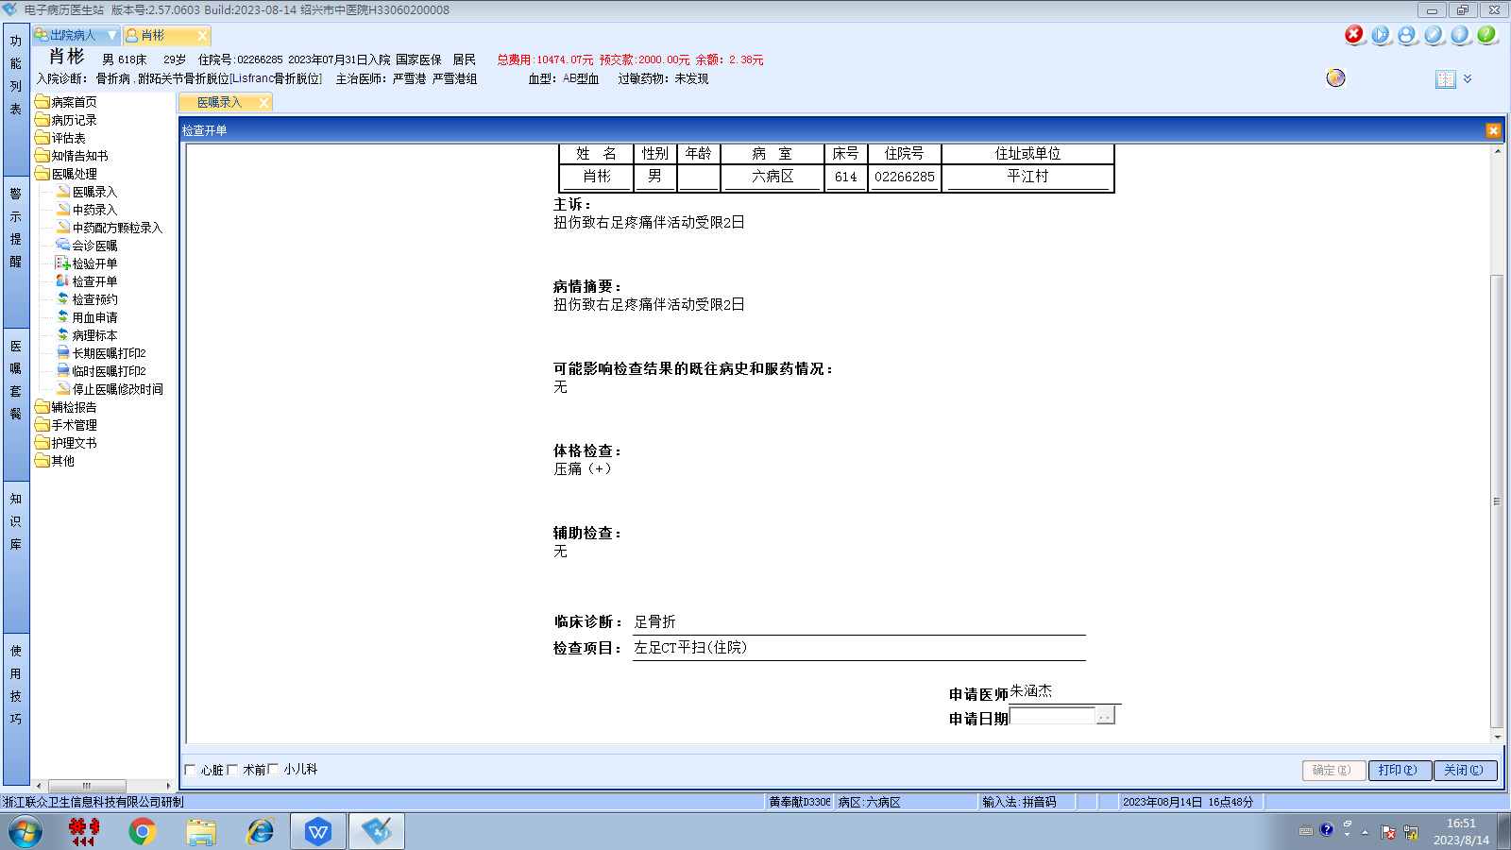严雪港组

