8月检查申请单质控
住院号 | 检查单类型 | 开单日期 | 开单医师 |  |  | 检查项目
 |  |  |  | 主诉 | 病情摘要 |  | 既往史 | 体格检查 | 辅助检查 | 诊断 | 内容申请单不一致
01512141 | MR | 2023-7-30 | 何易 | √ | √ |  | √ | √ | √ | √ | √
02266226 | CT | 2023-7-31 | 刘运海 | √ | √ |  | √ | √ | √ | √ | √
01411804 | CT | 2023-7-31 | 张梦娇 | √ | √ |  | √ | √ | √ | √ | √
02266003 | CT | 2023-8-1 | 陆超锋 | √ | √ |  | √ | √ | √ | √ | √
02266253 | CT | 2023-7-29 | 王风永 | √ | √ |  | √ | √ | √ | √ | √
02266253 | MR | 2023-7-31 | 王风永 | √ | √ |  | √ | √ | √ | √ | √
02266253 | MR | 2023-8-1 | 王风永 | √ | √ |  | √ | √ | √ | √ | √
02106083 | MR | 2023-7-31 | 兰垂世 | √ | √ |  | √ | √ | √ | √ | √
02106083 | MR | 2023-8-3 | 胡飞剑 | √ | √ |  | √ | √ | √ | √ | √
02266250 | MR | 2023-7-31 | 周怡 | √ | √ |  | √ | √ | √ | √ | √
02264816 | MR | 2023-7-30 | 郑德财 | √ | √ |  | √ | √ | √ | √ | √
02266181 | MR | 2023-7-31 | 冯梦雪 | √ | √ |  | √ | √ | √ | √ | √
02266289 | MR | 2023-8-1 | 陶铁瑛 | √ | √ |  | √ | √ | √ | √ | √
02266202 | MR | 2023-7-30 | 孙莉 | √ | √ |  | √ | √ | √ | √ | √
02266073 | MR | 2023-7-31 | 杨荟璇 | √ | √ |  | √ | √ | √ | √ | √
02007791 | CT | 2023-8-2 | 张新凡 | √ | √ |  | √ | √ | √ | √ | ×
02244380 | MR | 2023-8-1 | 谢峰 | √ | √ |  | √ | √ | √ | √ | √
02266411 | CT | 2023-8-3 | 刘运海 | √ | √ |  | √ | √ | √ | √ | √
02266321 | MR | 2023-8-2 | 刘悦 | √ | √ |  | √ | √ | √ | √ | √
02266342 | MR | 2023-8-3 | 孙利荣 | √ | √ |  | √ | √ | √ | √ | √
02265712 | CT | 2023-8-4 | 王风永 | √ | √ |  | √ | √ | √ | √ | √
02266412 | CT | 2023-8-4 | 张梦娇 | √ | √ |  | √ | √ | √ | √ | √
02266355 | MR | 2023-8-3 | 刘悦 | √ | √ |  | √ | √ | √ | √ | √
02266442 | MR | 2023-8-3 | 胡飞剑 | √ | √ |  | √ | √ | √ | √ | √
02266399 | MR | 2023-8-4 | 卢璐 | √ | √ |  | √ | √ | √ | √ | √
02266316 | CT | 2023-8-5 | 王冰清 | √ | √ |  | √ | √ | √ | √ | √
02266547 | CT | 2023-8-5 | 周怡 | √ | √ |  | √ | √ | √ | √ | √
01908518 | MR | 2023-8-4 | 王冰清 | √ | √ |  | √ | √ | √ | √ | √
01908518 | CT/MR | 2023-8-3 | 冯梦雪 | √ | √ |  | √ | √ | √ | √ | √
02266464 | MR | 2023-8-4 | 杜菲 | √ | √ |  | √ | √ | √ | √ | √
02266015 | MR | 2023-8-4 | 李国华 | √ | √ |  | √ | √ | √ | √ | √
01917162 | MR | 2023-8-4 | 王轶辉 | √ | √ |  | √ | √ | √ | √ | ×
02003137 | MR | 2023-8-4 | 胡飞剑 | √ | √ |  | √ | √ | √ | √ | √
02266311 | CT | 2023-8-5 | 王冰清 | √ | √ |  | √ | √ | √ | √ | √
02266364 | MR | 2023-8-4 | 冯水娟 | √ | √ |  | √ | √ | √ | √ | √
02266494 | MR | 2023-8-4 | 杨锋 | √ | √ |  | √ | √ | √ | √ | √
02266336 | MR | 2023-8-5 | 张梦娇 | √ | √ |  | √ | √ | √ | √ | √
02265161 | MR | 2023-8-4 | 苗超峰 | √ | √ |  | √ | √ | √ | √ | √
02266553 | MR | 2023-8-5 | 谢超 | √ | √ |  | √ | √ | √ | √ | √
02266553 | MR | 2023-8-6 | 郑德财 | √ | √ |  | √ | √ | √ | √ | √
02265452 | MR | 2023-8-6 | 冯梦雪 | √ | √ |  | √ | √ | √ | √ | √
02238008 | MR | 2023-8-6 | 胡飞剑 | √ | √ |  | √ | √ | √ | √ | √
01607102 | MR | 2023-8-7 | 胡飞剑 | √ | √ |  | √ | √ | √ | √ | √
02007118 | MR | 2023-8-8 | 杜菲 | √ | √ |  | √ | √ | √ | √ | √
02266606 | MR | 2023-8-9 | 陈剑磨 | √ | √ |  | √ | √ | √ | √ | √
01909878 | MR | 2023-8-7 | 孙玲玲 | √ | √ |  | √ | √ | √ | √ | √
01800097 | MR | 2023-8-7 | 诸佳燕 | √ | √ |  | √ | √ | √ | √ | √
02266636 | MR | 2023-8-7 | 赵雄碧 | √ | √ |  | √ | √ | √ | √ | √
02266421 | MR | 2023-8-7 | 许杨 | √ | √ |  | √ | √ | √ | √ | ×
02266373 | CT | 2023-8-2 | 赵艳明 | √ | √ |  | √ | √ | √ | √ | √
02266373 | CT | 2023-8-10 | 陶铁瑛 | √ | √ |  | √ | √ | √ | √ | √
01807689 | MR | 2023-8-9 | 王立波 | √ | √ |  | √ | √ | √ | √ | √
02266652 | MR | 2023-8-10 | 边佳萍 | √ | √ |  | √ | √ | √ | √ | √
02266433 | MR | 2023-8-10 | 吴明 | √ | √ |  | √ | √ | √ | √ | √
02266694 | MR | 2023-8-9 | 张梦娇 | √ | √ |  | √ | √ | √ | √ | √
02266699 | MR | 2023-8-10 | 朱大明 | √ | √ |  | √ | √ | √ | √ | √
01103657 | MR | 2023-8-10 | 冯梦雪 | √ | √ |  | √ | √ | √ | √ | √
01103657 | CT | 2023-8-13 | 孙莉 | √ | √ |  | √ | √ | √ | √ | √
01200653 | MR | 2023-8-9 | 诸佳燕 | √ | √ |  | √ | √ | √ | √ | √
02266421 | MR | 2023-8-8 | 沈兴潮 | √ | √ |  | √ | √ | √ | √ | ×
02266610 | MR | 2023-8-11 | 张学思 | √ | √ |  | √ | √ | √ | √ | ×
02266714 | MR | 2023-8-11 | 沈沉 | √ | √ |  | √ | √ | √ | √ | √
01708172 | CT | 2023-8-10 | 葛剑洪 | √ | √ |  | √ | √ | √ | √ | √
01510617 | MR | 2023-8-11 | 边佳萍 | √ | √ |  | √ | √ | √ | √ | √
02266800 | MR | 2023-8-12 | 王珊珊 | √ | √ |  | √ | √ | √ | √ | √
02266800 | MR | 2023-8-13 | 杜菲 | √ | √ |  | √ | √ | √ | √ | √
01805112 | MR | 2023-8-12 | 王冰清 | √ | √ |  | √ | √ | √ | √ | √
02266813 | MR | 2023-8-12 | 田悦越 | √ | √ |  | √ | √ | √ | √ | √
02266847 | MR | 2023-8-14 | 吴明 | √ | √ |  | √ | √ | √ | √ | √
01608276 | MR | 2023-8-13 | 杜菲 | √ | √ |  | √ | √ | √ | √ | √
01608276 | MR | 2023-8-15 | 杜菲 | √ | √ |  | √ | √ | √ | √ | √
02266836 | MR | 2023-8-13 | 胡飞剑 | √ | √ |  | √ | √ | √ | √ | ×
01410478 | CT | 2023-8-14 | 苗超峰 | √ | √ |  | √ | √ | √ | √ | √
02266770 | MR | 2023-8-13 | 杜菲 | √ | √ |  | √ | √ | √ | √ | √
02262870 | MR | 2023-8-15 | 卢璐 | √ | √ |  | √ | √ | √ | √ | √
01810722 | MR | 2023-8-14 | 冯水娟 | √ | √ |  | √ | √ | √ | √ | √
01203436 | MR | 2023-8-15 | 兰垂世 | √ | √ |  | √ | √ | √ | √ | ×
02266908 | CT/MR | 2023-8-17 | 吕宇航 | √ | √ |  | √ | √ | √ | √ | √
02266904 | CT | 2023-8-16 | 张梦娇 | √ | × |  | × | √ | × | √ | ×
02266837 | MR | 2023-8-16 | 杜菲 | √ | √ |  | √ | √ | √ | √ | √
02266876 | MR | 2023-8-15 | 沈学香 | √ | √ |  | √ | √ | √ | √ | √
02005131 | MR | 2023-8-16 | 陆超锋 | √ | √ |  | √ | √ | √ | √ | √
02267019 | MR | 2023-8-18 | 兰垂世 | √ | √ |  | √ | √ | √ | √ | ×
02266977 | CT | 2023-8-17 | 张梦娇 | √ | × |  | × | √ | × | √ | ×
02266952 | MR | 2023-8-16 | 陶铁瑛 | √ | √ |  | √ | √ | √ | √ | √
02266931 | MR | 2023-8-16 | 兰垂世 | √ | √ |  | √ | √ | √ | √ | √
01405390 | CT | 2023-8-18 | 吕宇航 | √ | √ |  | √ | √ | √ | √ | √
01501817 | CT | 2023-8-19 | 刘浩飞 | √ | √ |  | √ | √ | √ | √ | √
02266554 | CT | 2023-8-19 | 鲁剑梅 | √ | √ |  | √ | √ | √ | √ | √
01900343 | CT | 2023-8-19 | 孙莉 | √ | √ |  | √ | √ | √ | √ | √
02267050 | CT | 2023-8-19 | 王风永 | √ | √ |  | √ | √ | √ | √ | ×
01913495 | CT/MR | 2023-8-20 | 冯梦雪 | √ | √ |  | √ | √ | √ | √ | √
02266764 | MR | 2023-8-20 | 王敏龙 | √ | √ |  | √ | √ | √ | √ | √
02259357 | CT | 2023-8-20 | 沈沉 | √ | √ |  | √ | √ | √ | √ | √
01306262 | MR | 2023-8-21 | 苗超峰 | √ | √ |  | √ | √ | √ | √ | √
02265180 | MR | 2023-7-7 | 谢睿 | √ | √ |  | √ | √ | √ | √ | √
02265180 | MR | 2023-8-26 | 冯水娟 | √ | √ |  | √ | √ | √ | √ | √
02267123 | MR | 2023-8-21 | 俞梅 | √ | √ |  | √ | √ | √ | √ | √
02106753 | MR | 2023-8-20 | 沈沉 | √ | √ |  | √ | √ | √ | √ | √
02241772 | MR | 2023-8-23 | 兰垂世 | √ | √ |  | √ | √ | √ | √ | √
01108803 | MR | 2023-8-22 | 沈沉 | √ | √ |  | √ | √ | √ | √ | √
02267161 | CT | 2023-8-22 | 张华良 | √ | √ |  | √ | √ | √ | √ | √
01904996 | MR | 2023-8-21 | 钟承隽 | √ | √ |  | √ | √ | √ | √ | √
02000094 | MR | 2023-8-23 | 谢超 | √ | √ |  | √ | √ | √ | √ | √
02267202 | MR | 2023-8-23 | 兰垂世 | √ | √ |  | √ | √ | √ | √ | √
02102258 | MR | 2023-8-24 | 安星宇 | √ | √ |  | √ | √ | √ | √ | √
01304496 | CT | 2023-8-25 | 王立波 | √ | √ |  | √ | √ | √ | √ | √
02267109 | MR | 2023-8-21 | 杜菲 | √ | √ |  | √ | √ | √ | √ | √
01811288 | MR | 2023-8-25 | 周怡 | √ | √ |  | √ | √ | √ | √ | √
02244521 | MR | 2023-8-26 | 许伟攀 | √ | √ |  | √ | √ | √ | √ | √
02267008 | CT | 2023-8-24 | 周怡 | √ | √ |  | √ | √ | √ | √ | √
02242979 | CT | 2023-8-25 | 罗桢敏 | √ | √ |  | √ | √ | √ | √ | √
02266931 | CT | 2023-8-22 | 罗桢敏 | √ | √ |  | √ | √ | √ | √ | √
02267343 | CT | 2023-8-27 | 葛剑洪 | √ | √ |  | √ | √ | √ | √ | √
02267385 | CT | 2023-8-28 | 胡少丹 | √ | √ |  | √ | √ | √ | √ | √
02267359 | CT | 2023-8-28 | 王春春 | √ | √ |  | √ | √ | √ | √ | √
02267359 | MR | 2023-8-28 | 谢睿 | √ | √ |  | √ | √ | √ | √ | √
02267359 | CT | 2023-8-31 | 凌一鸣 | √ | √ |  | √ | √ | √ | √ | √
02267359 | MR | 2023-8-31 | 张学思 | √ | √ |  | √ | √ | √ | √ | √
02267302 | CT | 2023-8-29 | 王冰清 | √ | √ |  | √ | √ | √ | √ | √
02267362 | MR | 2023-8-29 | 谢峰 | √ | √ |  | √ | √ | √ | √ | √
02267362 | MR | 2023-8-27 | 兰垂世 | √ | √ |  | √ | √ | √ | √ | √
01209015 | MR | 2023-8-29 | 王冰清 | √ | √ |  | √ | √ | √ | √ | √
02267342 | MR | 2023-8-27 | 陶铁瑛 | √ | √ |  | √ | √ | √ | √ | √
02267366 | MR | 2023-8-28 | 冯水娟 | √ | √ |  | √ | √ | √ | √ | √
02267174 | CT | 2023-8-31 | 王敏龙 | √ | √ |  | √ | √ | √ | √ | √
02267354 | CT | 2023-8-31 | 王敏龙 | √ | √ |  | √ | √ | √ | √ | √
注：对住院患者检查申请单进行专项检查，其中主诉、体格检查或诊断任缺一项者视为不合格申请单；非入院常规检查，如申请单内容与检查部位及要求不一致，亦视为不合格申请单。
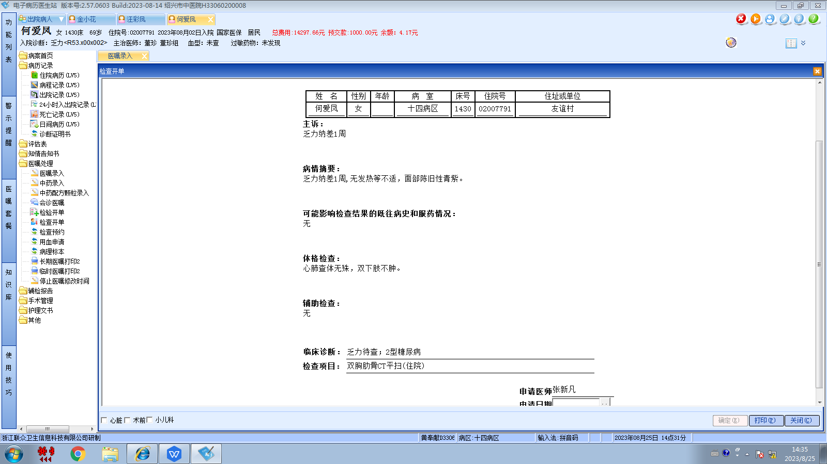董珍组
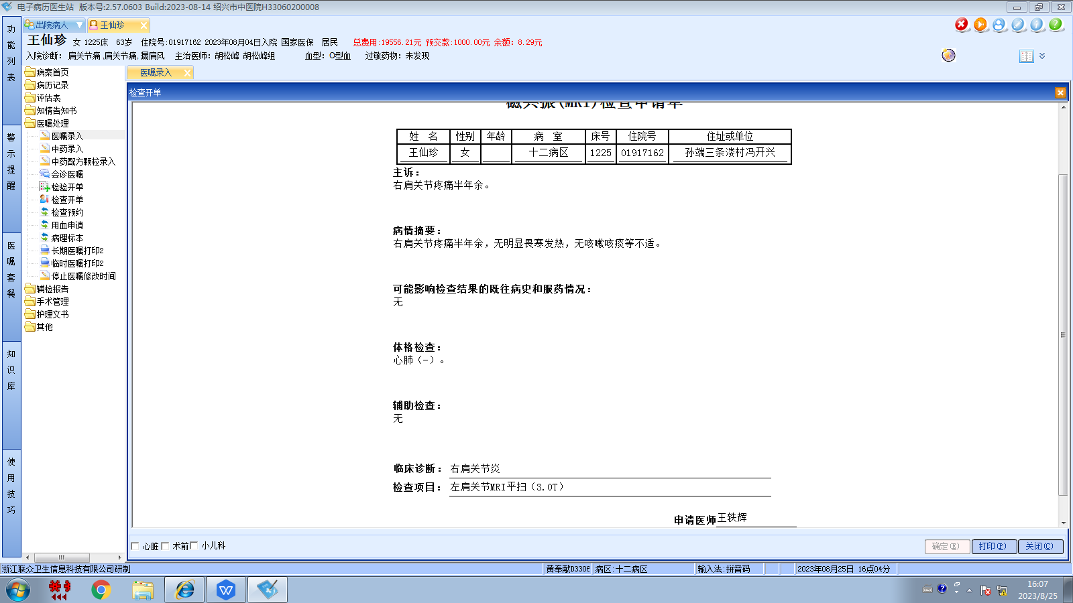董珍组
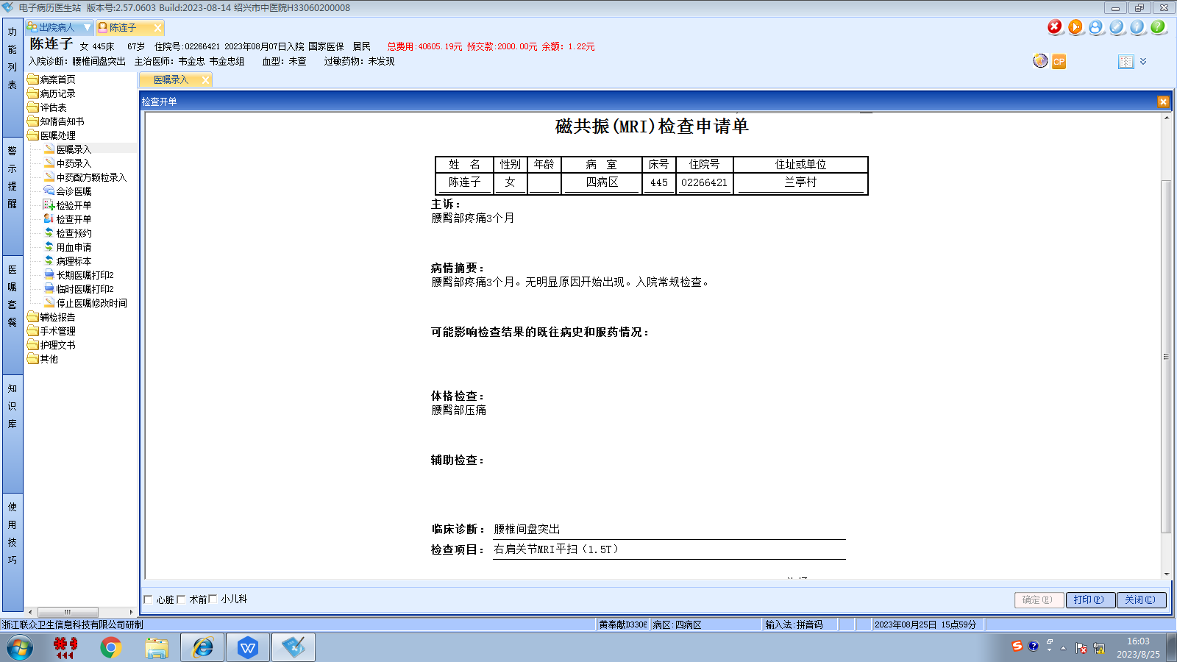韦金忠组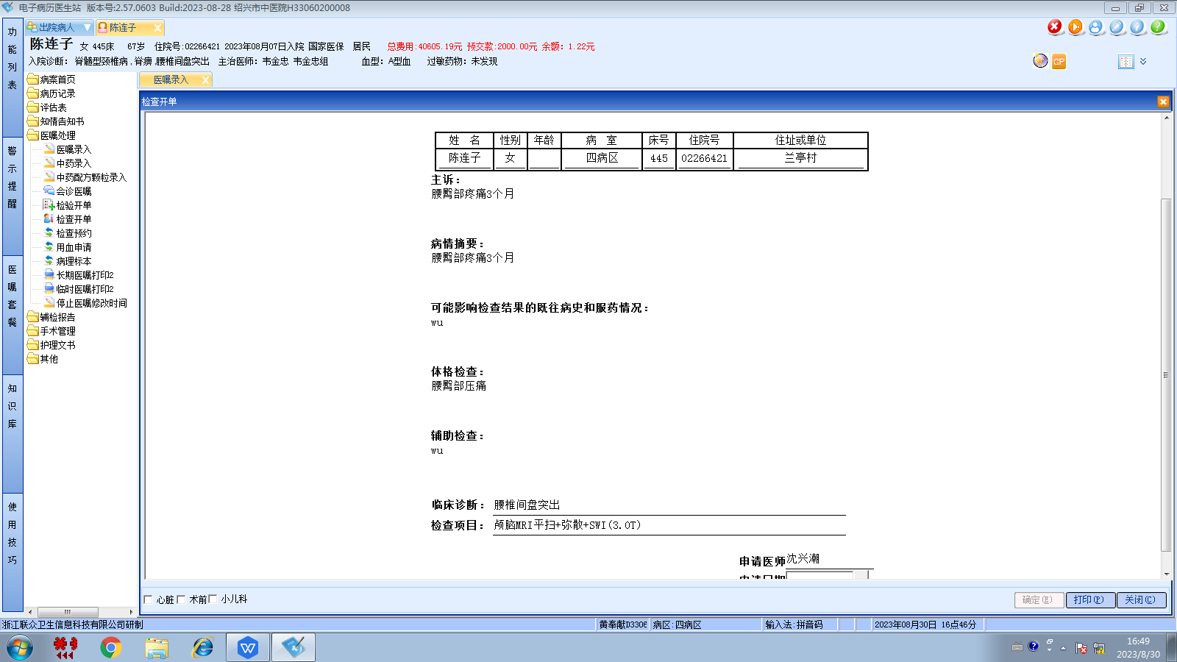韦金忠组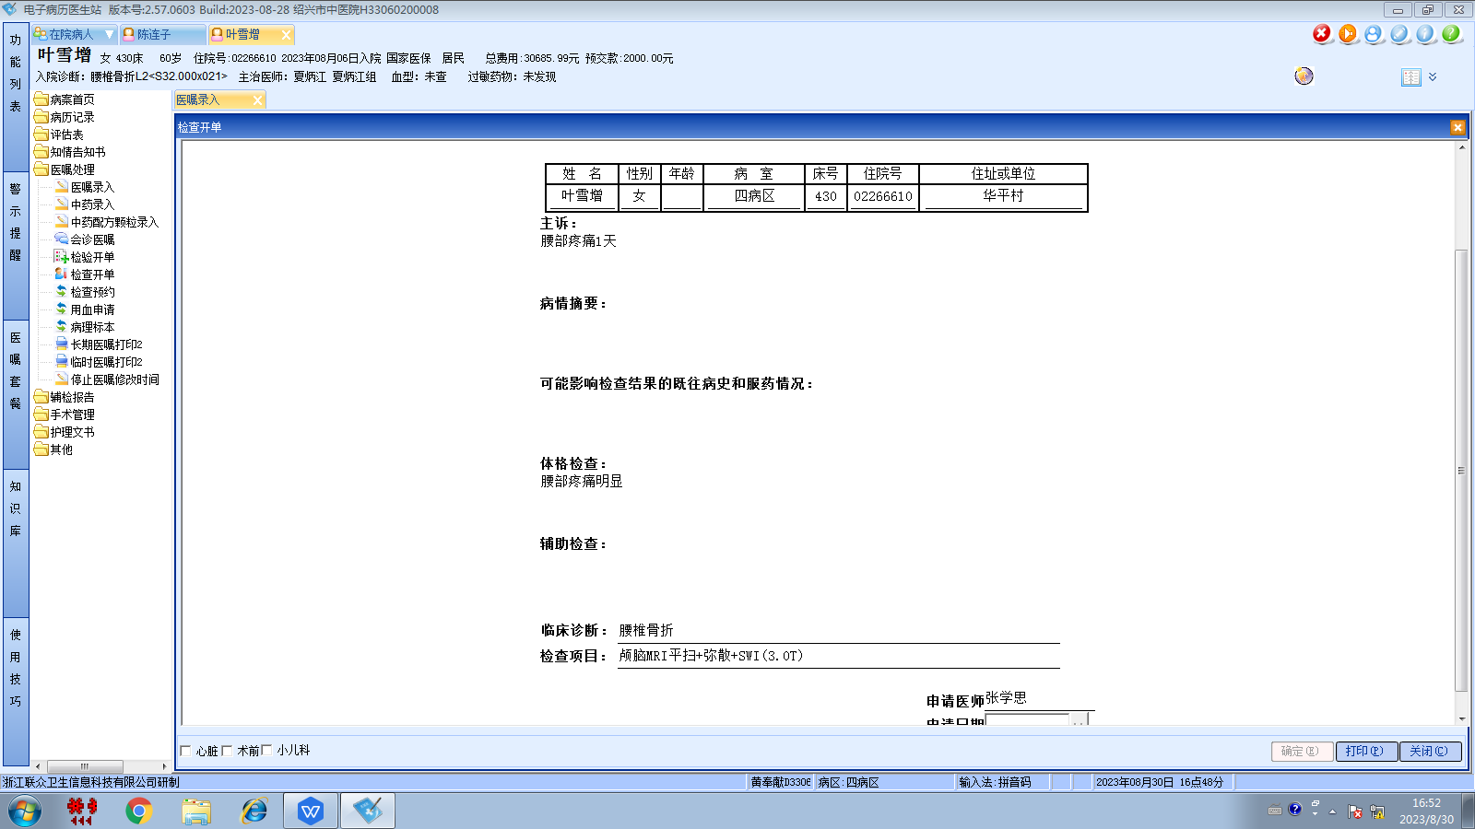夏炳江组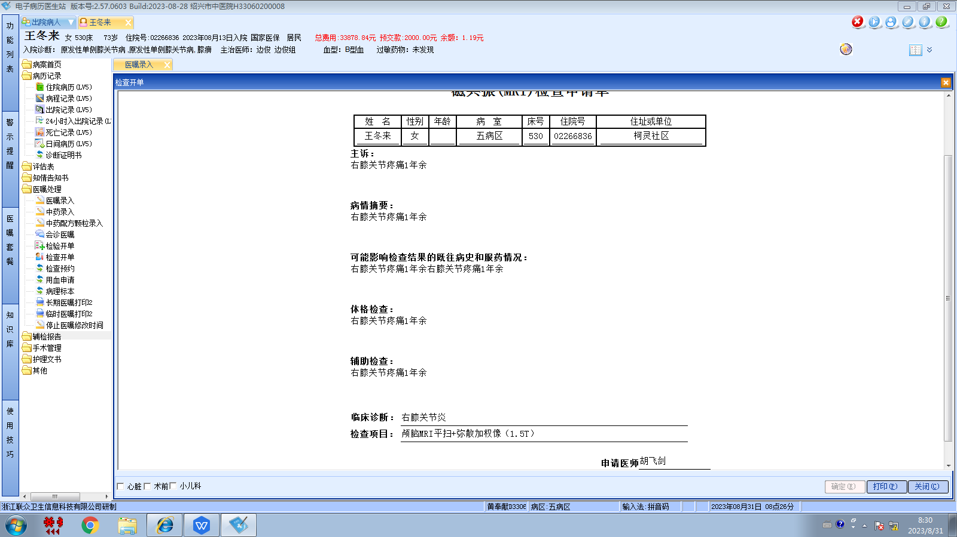边俊组
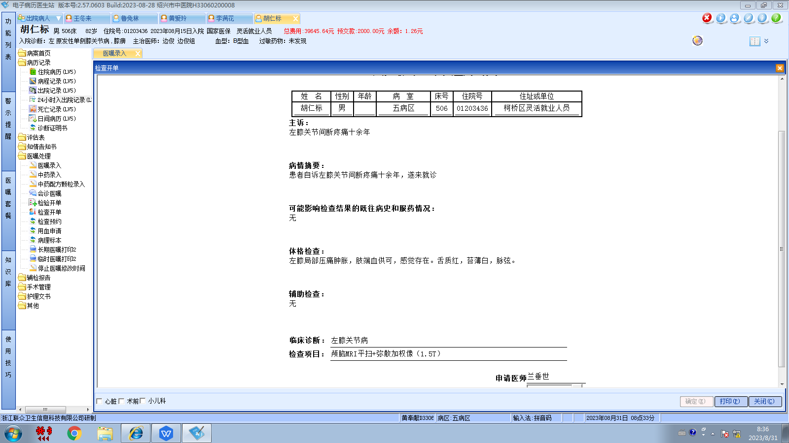边俊组
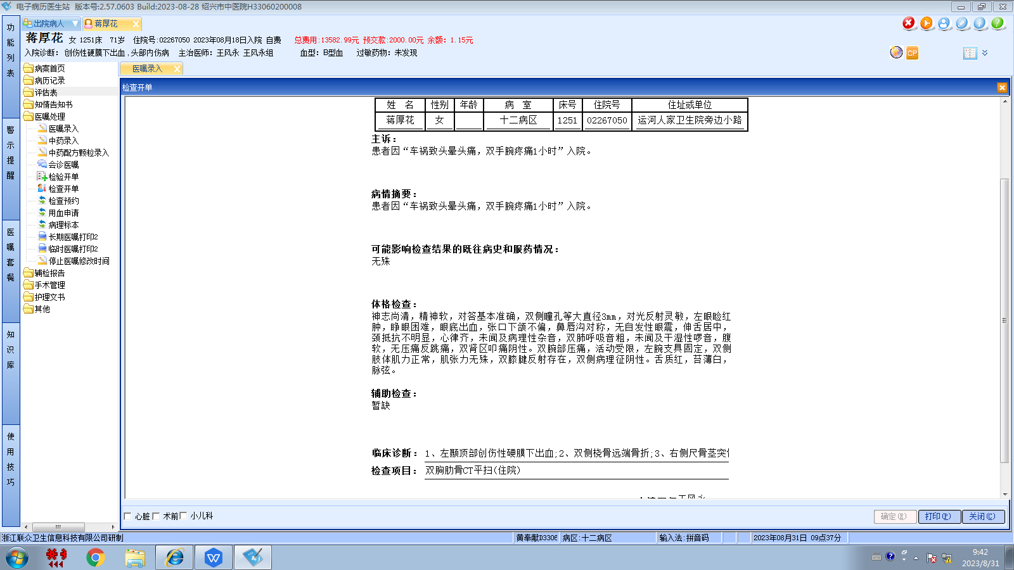王风永组
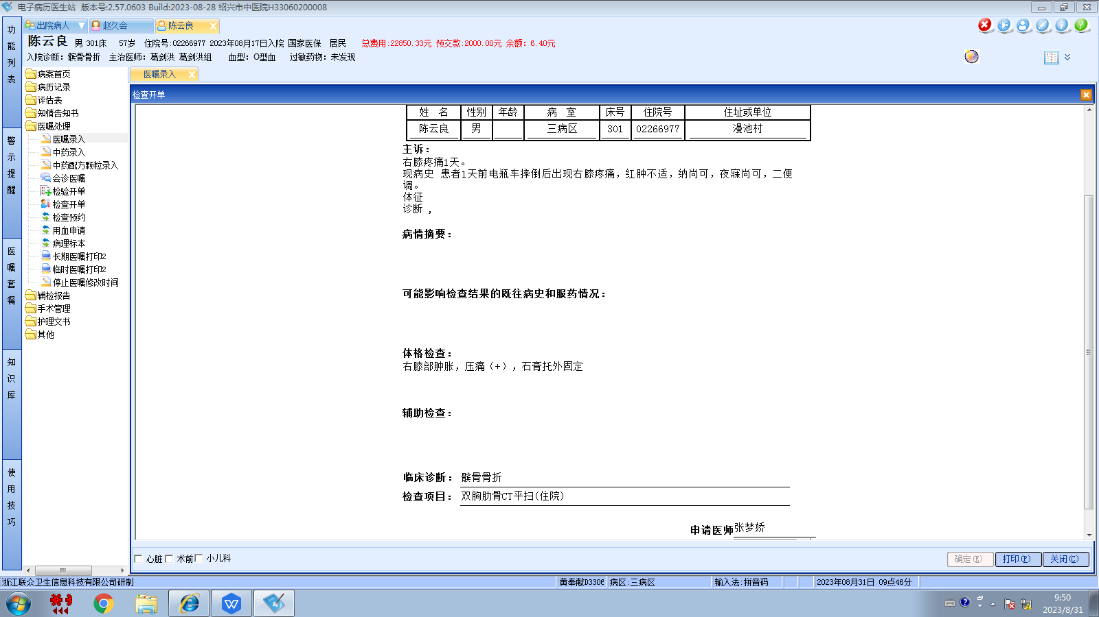葛剑洪组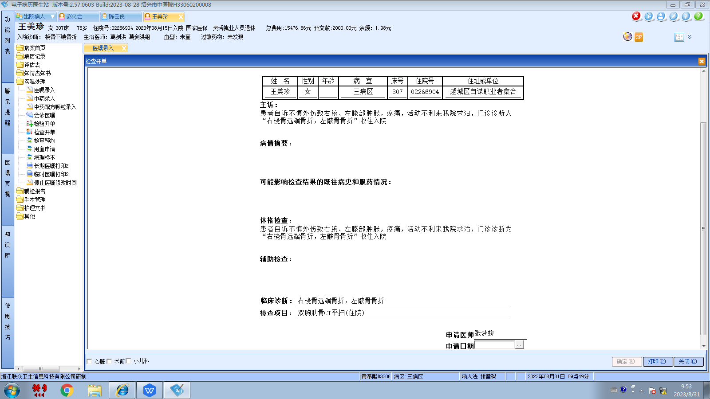葛剑洪组
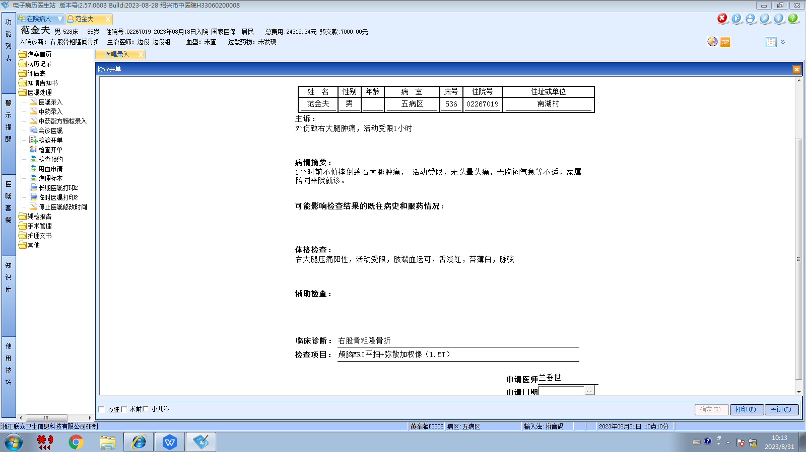边俊组

