9月检查申请单质控
住院号 | 检查单类型 | 开单日期 | 开单医师 |  |  | 检查项目
 |  |  |  | 主诉 | 病情摘要 |  | 既往史 | 体格检查 | 辅助检查 | 诊断 | 内容申请单不一致
01814750 | CT | 2023-9-1 | 柴绍军 | √ | √ |  | √ | √ | √ | √ | √
02267323 | MR | 2023-8-30 | 沈剑增 | √ | √ |  | √ | √ | √ | √ | √
01504017 | MR | 2023-8-31 | 吴明 | √ | √ |  | √ | √ | √ | √ | √
01301747 | MR | 2023-8-29 | 胡飞剑 | √ | √ |  | √ | √ | √ | √ | √
02267443 | MR | 2023-8-29 | 许杨 | √ | √ |  | √ | √ | √ | √ | √
02257133 | CT | 2023-8-30 | 谢超 | √ | √ |  | √ | √ | √ | √ | √
02267521 | MR | 2023-9-1 | 兰垂世 | √ | √ |  | √ | √ | √ | √ | √
02267359 | CT | 2023-9-2 | 王立波 | √ | √ |  | √ | √ | √ | √ | √
02267539 | MR | 2023-9-3 | 谢峰 | √ | √ |  | √ | √ | √ | √ | √
01308121 | CT | 2023-9-1 | 孙莉 | √ | √ |  | √ | √ | √ | √ | √
01916085 | CT | 2023-9-2 | 王冰清 | √ | √ |  | √ | √ | √ | √ | √
02267587 | CT | 2023-9-3 | 王洪灿 | √ | √ |  | √ | √ | √ | √ | √
01405686 | MR | 2023-9-1 | 王敏龙 | √ | √ |  | √ | √ | √ | √ | √
02102258 | MR | 2023-9-1 | 安星宇 | √ | √ |  | √ | √ | √ | √ | √
02102258 | MR | 2023-9-6 | 李国华 | √ | √ |  | √ | √ | √ | √ | √
02267374 | MR | 2023-9-2 | 王立波 | √ | √ |  | √ | √ | √ | √ | √
02267374 | MR | 2023-9-3 | 王立波 | √ | √ |  | √ | √ | √ | √ | √
02267356 | MR | 2023-9-2 | 孟闯闯 | √ | √ |  | √ | √ | √ | √ | √
02246491 | CT | 2023-9-4 | 张梦娇 | √ | √ |  | √ | √ | √ | √ | √
02267566 | MR | 2023-9-1 | 兰垂世 | √ | √ |  | √ | √ | √ | √ | √
02107811 | CT | 2023-9-4 | 刘浩飞 | √ | √ |  | √ | √ | √ | √ | √
20090659 | CT | 2023-9-4 | 陈剑磨 | √ | √ |  | √ | √ | √ | √ | √
02267452 | CT | 2023-9-6 | 张梦娇 | √ | √ |  | √ | √ | √ | √ | √
02267575 | MR | 2023-9-4 | 张梦娇 | √ | √ |  | √ | √ | √ | √ | √
02267685 | MR | 2023-9-5 | 王珊珊 | √ | √ |  | √ | √ | √ | √ | √
02107765 | MR | 2023-9-6 | 王珊珊 | √ | √ |  | √ | √ | √ | √ | √
02267033 | CT | 2023-9-5 | 张学思 | √ | √ |  | √ | √ | √ | √ | √
02267734 | MR | 2023-9-6 | 杨兴辉 | √ | √ |  | √ | √ | √ | √ | √
01806483 | MR | 2023-9-5 | 许杨 | √ | √ |  | √ | √ | √ | √ | √
02267462 | MR | 2023-9-5 | 王敏龙 | √ | √ |  | √ | √ | √ | √ | √
02267584 | MR | 2023-9-6 | 刘悦 | √ | √ |  | √ | √ | √ | √ | √
02267479 | MR | 2023-9-6 | 陆超锋 | √ | √ |  | √ | √ | √ | √ | √
02267798 | MR | 2023-9-7 | 魏平洋 | √ | √ |  | √ | √ | √ | √ | √
02267662 | MR | 2023-9-6 | 杨兴辉 | √ | √ |  | √ | √ | √ | √ | √
02267827 | MR | 2023-9-8 | 张梦娇 | √ | √ |  | √ | √ | √ | √ | √
02267796 | CT | 2023-9-8 | 吴旻键 | √ | √ |  | √ | √ | √ | √ | √
02267911 | MR | 2023-9-10 | 陈剑磨 | √ | √ |  | √ | √ | √ | √ | √
02267903 | CT/MR | 2023-9-12 | 何建明 | √ | √ |  | √ | √ | √ | √ | √
02267904 | CT | 2023-9-10 | 程爵富 | √ | √ |  | √ | √ | √ | √ | √
02267827 | MR | 2023-9-11 | 张梦娇 | √ | √ |  | √ | √ | √ | √ | √
02267960 | MR | 2023-9-11 | 冯梦雪 | √ | √ |  | √ | √ | √ | √ | √
02267835 | MR | 2023-9-8 | 孙玲玲 | √ | √ |  | √ | √ | √ | √ | √
02267976 | CT | 2023-9-13 | 吴智敏 | √ | √ |  | √ | √ | √ | √ | ×
01714169 | MR | 2023-9-12 | 杨兴辉 | √ | √ |  | √ | √ | √ | √ | √
02267638 | MR | 2023-9-12 | 刘悦 | √ | √ |  | √ | √ | √ | √ | √
02267810 | MR | 2023-9-12 | 朱大明 | √ | √ |  | √ | √ | √ | √ | √
02267810 | CT | 2023-9-14 | 朱大明 | √ | √ |  | √ | √ | √ | √ | √
02267928 | MR | 2023-9-12 | 苗超峰 | √ | √ |  | √ | √ | √ | √ | √
02245688 | CT | 2023-9-12 | 吴明 | √ | √ |  | √ | √ | √ | √ | √
02267781 | MR | 2023-9-14 | 俞梅 | √ | √ |  | √ | √ | √ | √ | √
02268047 | CT | 2023-9-13 | 许杨 | √ | √ |  | √ | √ | √ | √ | √
01511422 | CT | 2023-9-14 | 张梦娇 | √ | √ |  | √ | √ | √ | √ | √
02267876 | CT | 2023-9-15 | 支飞虎 | √ | √ |  | √ | √ | √ | √ | √
01916406 | CT | 2023-9-15 | 苗超峰 | √ | √ |  | √ | √ | √ | √ | √
01809646 | MR | 2023-9-15 | 苗超峰 | √ | √ |  | √ | √ | √ | √ | √
01809646 | MR | 2023-9-16 | 谢超 | √ | √ |  | √ | √ | √ | √ | √
02267796 | MR | 2023-9-14 | 李蓓珍 | √ | √ |  | √ | √ | √ | √ | √
02268109 | CT | 2023-9-15 | 胡少丹 | √ | √ |  | √ | √ | √ | √ | √
02268093 | CT | 2023-9-15 | 许杨 | √ | √ |  | √ | √ | √ | √ | ×
02268094 | MR | 2023-9-15 | 陶铁瑛 | √ | √ |  | √ | √ | √ | √ | ×
02267857 | MR | 2023-9-15 | 刘运海 | √ | √ |  | √ | √ | √ | √ | √
02268118 | MR | 2023-9-15 | 龚彬 | √ | √ |  | √ | √ | √ | √ | √
02267881 | MR | 2023-9-17 | 刘潇 | √ | √ |  | √ | √ | √ | √ | √
02268114 | MR | 2023-9-16 | 程爵富 | √ | √ |  | √ | √ | √ | √ | √
02268082 | CT/MR | 2023-9-17 | 王敏龙 | √ | √ |  | √ | √ | √ | √ | √
02268205 | CT | 2023-9-17 | 张春晓 | √ | √ |  | √ | √ | √ | √ | √
02268125 | MR | 2023-9-17 | 杜菲 | √ | √ |  | √ | √ | √ | √ | √
02268274 | CT/MR | 2023-9-19 | 陈剑磨 | √ | √ |  | √ | √ | √ | √ | √
02268040 | MR | 2023-9-19 | 杜菲 | √ | √ |  | √ | √ | √ | √ | √
02268262 | MR | 2023-9-19 | 谢思维 | √ | √ |  | √ | √ | √ | √ | √
02268200 | MR | 2023-9-18 | 钟承隽 | √ | √ |  | √ | √ | √ | √ | ×
02368314 | MR | 2023-9-20 | 杜菲 | √ | √ |  | √ | √ | √ | √ | √
02268258 | CT | 2023-9-21 | 肖功 | √ | √ |  | √ | √ | √ | √ | √
02268270 | MR | 2023-9-19 | 兰垂世 | √ | √ |  | √ | √ | √ | √ | √
02268191 | MR | 2023-9-20 | 吕宇航 | √ | √ |  | √ | √ | √ | √ | √
02240697 | CT | 2023-9-18 | 冯梦雪 | √ | √ |  | √ | √ | √ | √ | √
02268308 | CT | 2023-9-21 | 章银琪 | √ | √ |  | √ | √ | √ | √ | √
02368372 | MR | 2023-9-22 | 谢峰 | √ | √ |  | √ | √ | √ | √ | √
01902290 | MR | 2023-9-20 | 兰垂世 | √ | √ |  | √ | √ | √ | √ | √
01107869 | MR | 2023-9-20 | 兰垂世 | √ | √ |  | √ | √ | √ | √ | √
02268299 | MR | 2023-9-20 | 兰垂世 | √ | √ |  | √ | √ | √ | √ | √
02266547 | CT | 2023-9-23 | 何银银 | √ | √ |  | √ | √ | √ | √ | √
02368362 | MR | 2023-9-22 | 王家甜 | √ | √ |  | √ | √ | √ | √ | √
02368466 | MR | 2023-9-24 | 谢思维 | √ | √ |  | √ | √ | √ | √ | √
02368440 | CT | 2023-9-25 | 陶铁瑛 | √ | √ |  | √ | √ | √ | √ | √
02368485 | MR | 2023-9-24 | 王磊 | √ | √ |  | √ | √ | √ | √ | √
02368435 | CT | 2023-9-24 | 王家甜 | √ | √ |  | √ | √ | √ | √ | √
02368555 | CT | 2023-9-26 | 刘磊 | √ | √ |  | √ | √ | √ | √ | √
01703504 | MR | 2023-9-27 | 陆超锋 | √ | √ |  | √ | √ | √ | √ | √
02368531 | MR | 2023-9-26 | 王冰清 | √ | √ |  | √ | √ | √ | √ | √
01706212 | CT | 2023-9-26 | 凌一鸣 | √ | √ |  | √ | √ | √ | √ | √
02368532 | MR | 2023-9-26 | 王冰清 | √ | √ |  | √ | √ | √ | √ | √
02259944 | CT | 2023-9-27 | 王敏龙 | √ | √ |  | √ | √ | √ | √ | √
02368328 | CT | 2023-9-22 | 罗桢敏 | √ | √ |  | √ | √ | √ | √ | √
02368568 | MR | 2023-9-27 | 苗超峰 | √ | √ |  | √ | √ | √ | √ | √
01706490 | MR | 2023-9-27 | 杨兴辉 | √ | √ |  | √ | √ | √ | √ | √
02368633 | CT | 2023-9-28 | 陶铁瑛 | √ | √ |  | √ | √ | √ | √ | √
02108959 | MR | 2023-9-28 | 卢璐 | √ | √ |  | √ | √ | √ | √ | √
02368597 | MR | 2023-9-27 | 林武 | √ | √ |  | √ | √ | √ | √ | √
02368597 | MR | 2023-9-28 | 陶铁瑛 | √ | √ |  | √ | √ | √ | √ | √
02368487 | MR | 2023-9-27 | 陈剑磨 | √ | √ |  | √ | √ | √ | √ | ×
01804921 | MR | 2023-9-28 | 谢超 | √ | √ |  | √ | √ | √ | √ | √
02240537 | MR | 2023-9-29 | 张桢阳 | √ | √ |  | √ | √ | √ | √ | √
02368643 | MR | 2023-9-28 | 陶铁瑛 | √ | √ |  | √ | √ | √ | √ | √
02368681 | CT | 2023-9-29 | 程爵富 | √ | √ |  | √ | √ | √ | √ | ×
02267722 | MR | 2023-9-27 | 杨兴辉 | √ | √ |  | √ | √ | √ | √ | √
02368501 | CT | 2023-9-30 | 吕宇航 | √ | √ |  | √ | √ | √ | √ | √
注：对住院患者检查申请单进行专项检查，其中主诉、体格检查或诊断任缺一项者视为不合格申请单；非入院常规检查，如申请单内容与检查部位及要求不一致，亦视为不合格申请单。
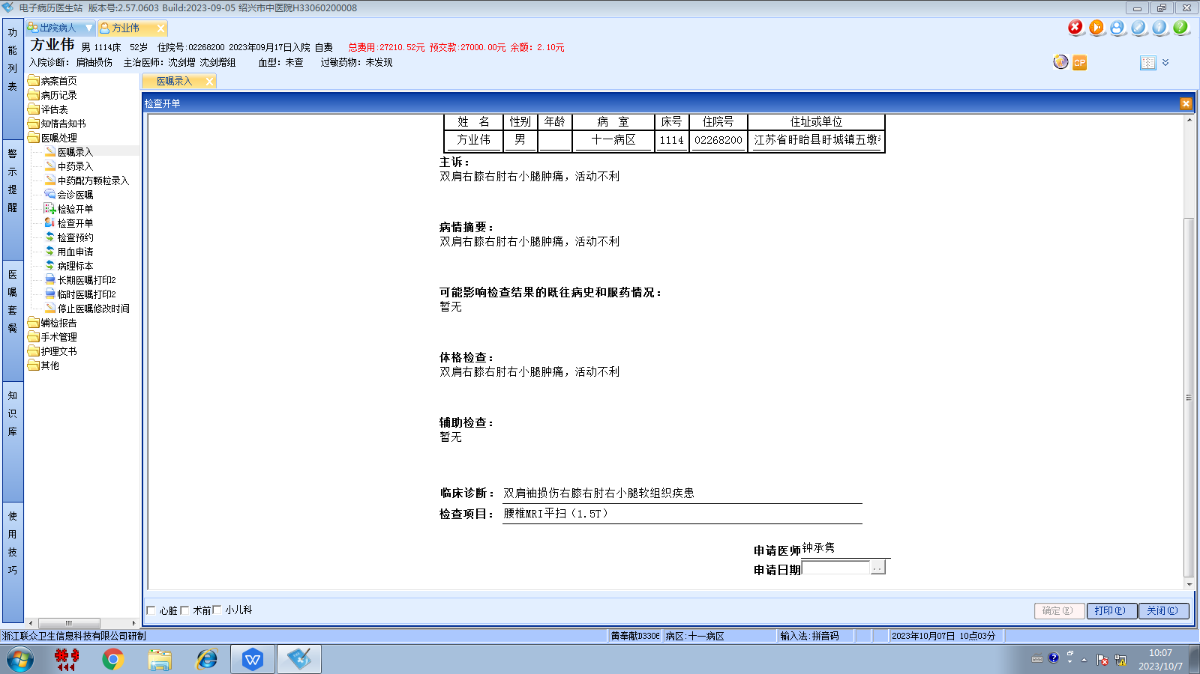
沈剑增组
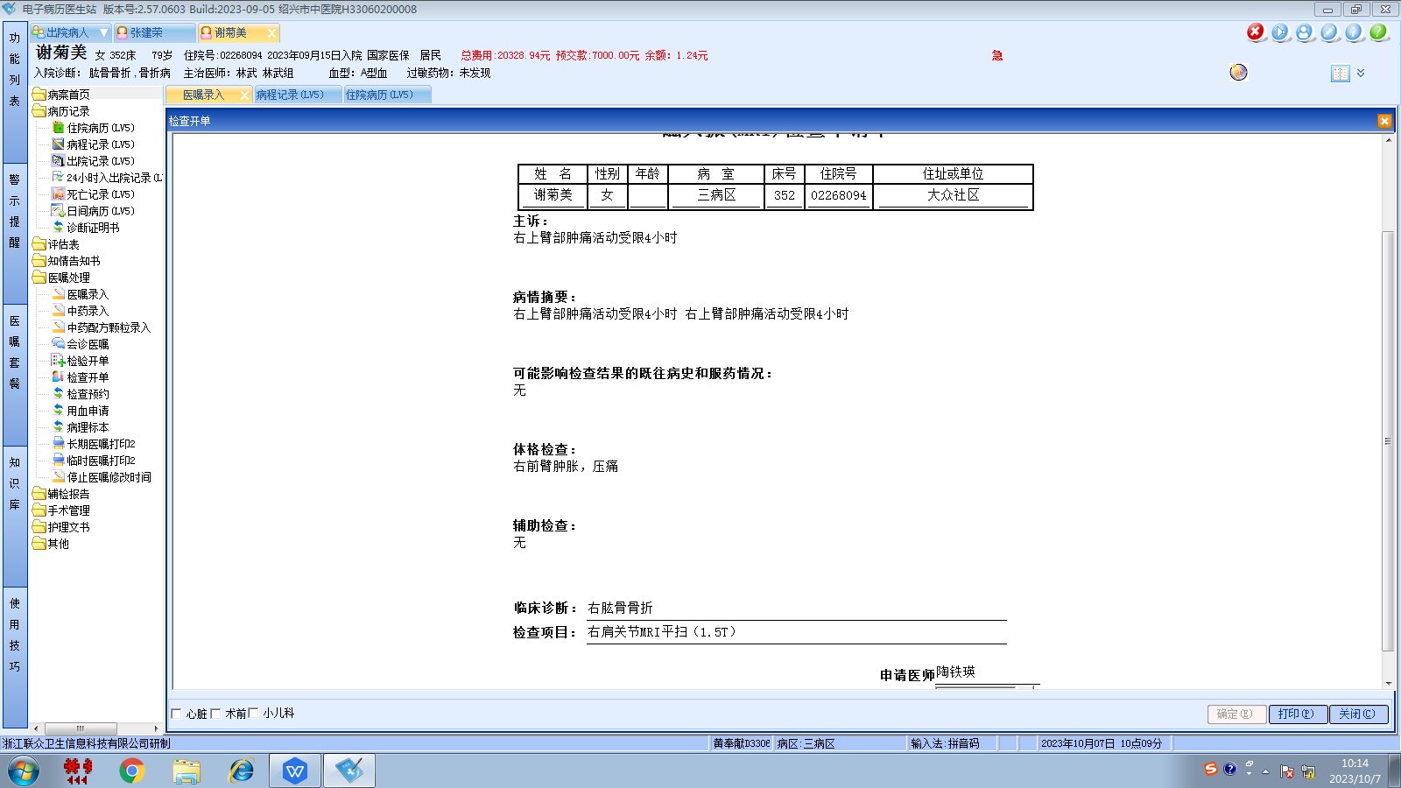林武组
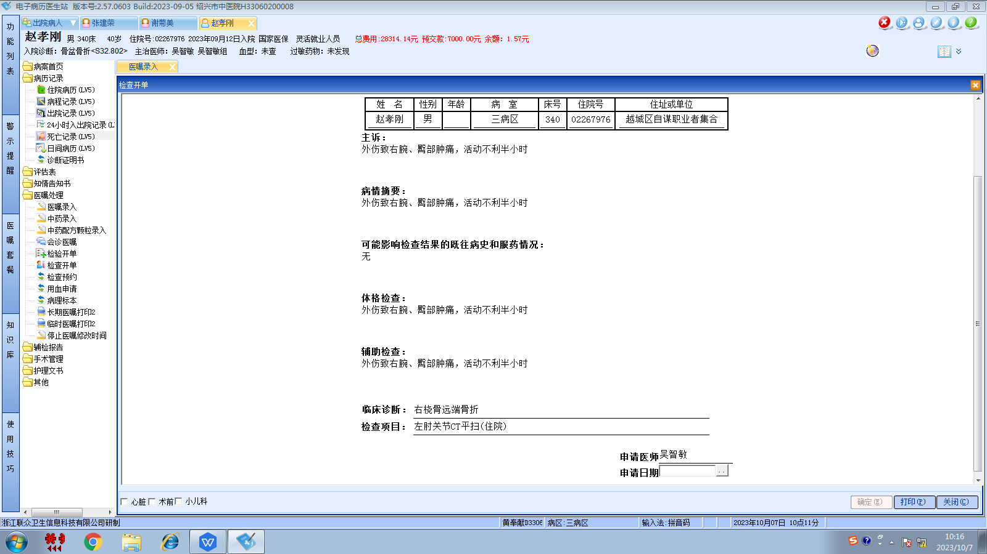吴智敏组
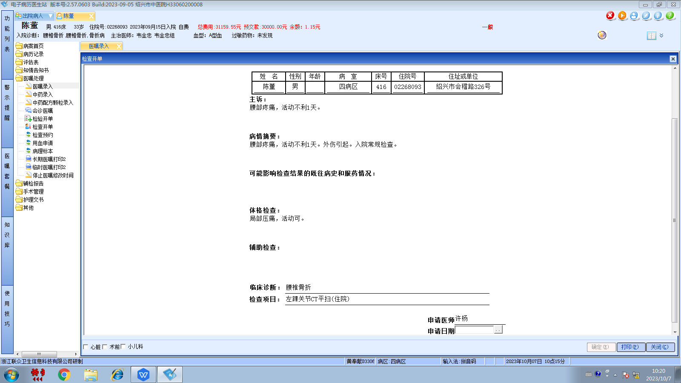韦金忠组
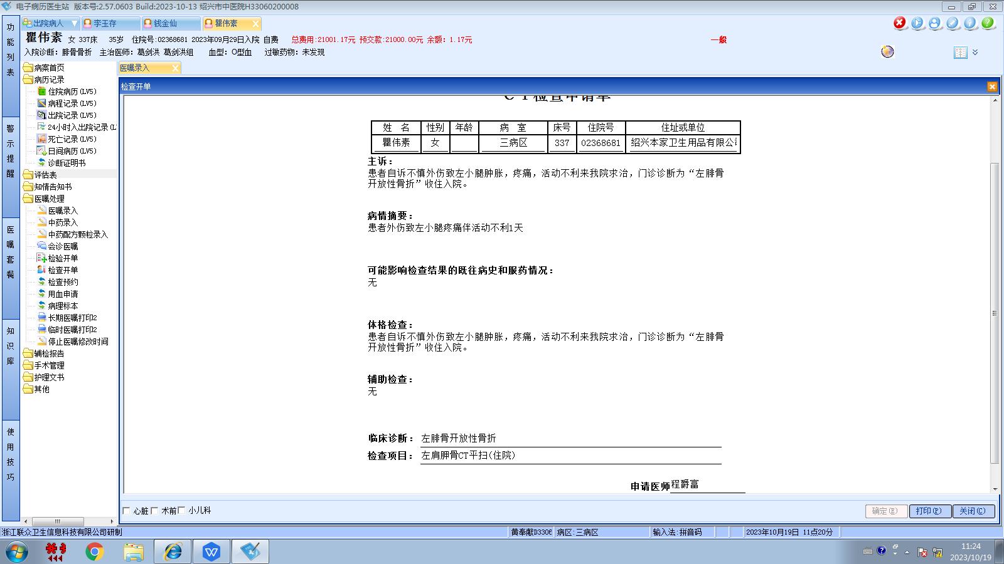葛剑洪组
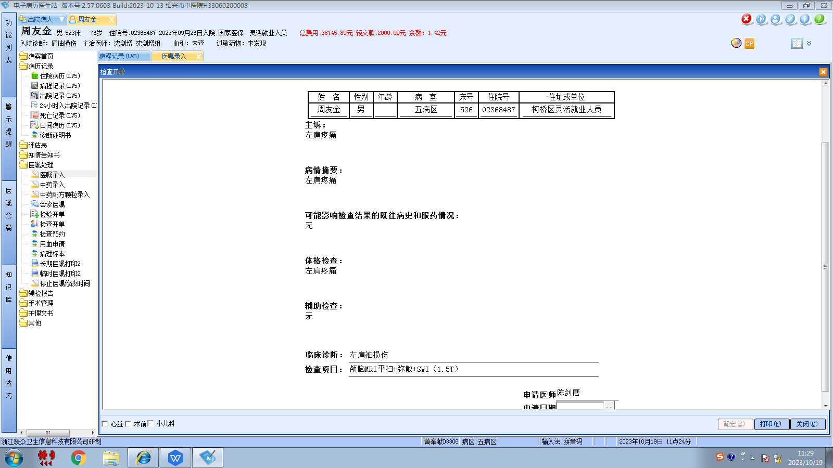沈剑增组

