10月检查申请单质控
住院号 | 检查单类型 | 开单日期 | 开单医师 |  |  | 检查项目
 |  |  |  | 主诉 | 病情摘要 |  | 既往史 | 体格检查 | 辅助检查 | 诊断 | 内容申请单不一致
01813768 | MR | 2023-9-30 | 谢超 | √ | √ |  | √ | √ | √ | √ | √
01813768 | MR | 2023-10-1 | 郑德财 | √ | √ |  | √ | √ | √ | √ | √
01803372 | MR | 2023-9-27 | 安星宇 | √ | √ |  | √ | √ | √ | √ | √
01903805 | MR | 2023-9-27 | 冯梦雪 | √ | √ |  | √ | √ | √ | √ | √
01917530 | CT | 2023-9-30 | 张梦娇 | √ | √ |  | √ | √ | √ | √ | √
02266547 | CT | 2023-10-2 | 支飞虎 | √ | √ |  | √ | √ | √ | √ | √
01804921 | MR | 2023-9-30 | 何薇 | √ | √ |  | √ | √ | √ | √ | √
01804921 | CT | 2023-10-3 | 周怡 | √ | √ |  | √ | √ | √ | √ | √
02368719 | MR | 2023-10-1 | 边俊 | √ | √ |  | √ | √ | √ | √ | √
02368712 | MR | 2023-9-29 | 张圣扬 | √ | √ |  | √ | √ | √ | √ | √
02368846 | CT | 2023-10-2 | 刘浩飞 | √ | √ |  | √ | √ | √ | √ | √
02368870 | CT | 2023-10-3 | 罗桢敏 | √ | √ |  | √ | √ | √ | √ | √
02268303 | MR | 2023-10-2 | 冯水娟 | √ | √ |  | √ | √ | √ | √ | √
02368531 | MR | 2023-10-2 | 王冰清 | √ | √ |  | √ | √ | √ | √ | √
02368634 | MR | 2023-10-1 | 王珊珊 | √ | √ |  | √ | √ | √ | √ | √
02368673 | MR | 2023-10-1 | 陈思忆 | √ | √ |  | √ | √ | √ | √ | √
02255564 | MR | 2023-10-1 | 卢璐 | √ | √ |  | √ | √ | √ | √ | √
02368775 | CT/MR | 2023-10-1 | 陶铁瑛 | √ | √ |  | √ | √ | √ | √ | √
02368921 | CT | 2023-10-4 | 魏平洋 | √ | √ |  | √ | √ | √ | √ | √
02368921 | CT | 2023-10-6 | 葛剑洪 | √ | √ |  | √ | √ | √ | √ | √
02108960 | MR | 2023-9-30 | 杨锋 | √ | √ |  | √ | √ | √ | √ | √
02105083 | MR | 2023-10-3 | 赵艳明 | √ | √ |  | √ | √ | √ | √ | √
02104738 | MR | 2023-10-2 | 王风永 | √ | √ |  | √ | √ | √ | √ | √
02264309 | CT | 2023-10-4 | 刘浩飞 | √ | √ |  | √ | √ | √ | √ | √
02108959 | MR | 2023-9-29 | 卢璐 | √ | √ |  | √ | √ | √ | √ | √
01907305 | MR | 2023-10-5 | 章联欢 | √ | √ |  | √ | √ | √ | √ | √
01915258 | CT | 2023-10-5 | 边佳萍 | √ | √ |  | √ | √ | √ | √ | √
02368910 | CT | 2023-10-5 | 刘运海 | √ | √ |  | √ | √ | √ | √ | ×
02368826 | MR | 2023-10-2 | 王磊 | √ | √ |  | √ | √ | √ | √ | ×
02369097 | CT | 2023-10-8 | 陶铁瑛 | √ | √ |  | √ | √ | √ | √ | √
02368766 | CT | 2023-10-8 | 陶铁瑛 | √ | √ |  | √ | √ | √ | √ | √
01806164 | MR | 2023-10-4 | 兰垂世 | √ | √ |  | × | √ | × | √ | ×
02265798 | MR | 2023-10-9 | 沈家峰 | √ | √ |  | √ | √ | √ | √ | √
02369076 | MR | 2023-10-8 | 胡飞剑 | √ | √ |  | √ | √ | √ | √ | √
02212528 | CT | 2023-10-7 | 裘鸿飞 | √ | √ |  | √ | √ | √ | √ | √
02369110 | MR | 2023-10-9 | 陶铁瑛 | √ | √ |  | √ | √ | √ | √ | ×
02369001 | MR | 2023-10-8 | 谢思维 | √ | √ |  | √ | √ | √ | √ | √
01809414 | CT | 2023-10-6 | 孙莉 | √ | √ |  | √ | √ | √ | √ | √
02369004 | MR | 2023-10-7 | 刘浩飞 | √ | √ |  | √ | √ | √ | √ | ×
02368991 | CT | 2023-10-6 | 郝飞 | √ | √ |  | √ | √ | √ | √ | √
02255384 | CT | 2023-10-9 | 周怡 | √ | √ |  | √ | √ | √ | √ | √
02369019 | MR | 2023-10-7 | 王珊珊 | √ | √ |  | √ | √ | √ | √ | √
02369087 | MR | 2023-10-9 | 苗超峰 | √ | √ |  | √ | √ | √ | √ | √
02369107 | MR | 2023-10-10 | 杜菲 | √ | √ |  | √ | √ | √ | √ | √
02369145 | MR | 2023-10-11 | 黄操 | √ | √ |  | √ | √ | √ | √ | √
02369127 | MR | 2023-10-10 | 陶铁瑛 | √ | √ |  | √ | √ | √ | √ | √
02261939 | MR | 2023-10-11 | 张梦娇 | √ | √ |  | √ | √ | √ | √ | √
02369036 | CT | 2023-10-10 | 俞梅 | √ | √ |  | √ | √ | √ | √ | √
02369247 | MR | 2023-10-11 | 陈剑磨 | √ | √ |  | √ | √ | √ | √ | √
01511247 | MR | 2023-10-10 | 兰垂世 | √ | √ |  | √ | √ | √ | √ | √
02246111 | MR | 2023-10-11 | 王依依 | √ | √ |  | √ | √ | √ | √ | √
02369229 | MR | 2023-10-12 | 何薇 | √ | √ |  | √ | √ | √ | √ | √
02369275 | MR | 2023-10-14 | 王冰清 | √ | √ |  | √ | √ | √ | √ | √
02369275 | MR | 2023-10-13 | 王冰清 | √ | √ |  | √ | √ | √ | √ | √
02101419 | MR | 2023-10-12 | 王珊珊 | √ | √ |  | √ | √ | √ | √ | √
01210377 | MR | 2023-10-13 | 陈剑磨 | √ | √ |  | √ | √ | √ | √ | √
02369338 | MR | 2023-10-14 | 何薇 | √ | √ |  | √ | √ | √ | √ | √
02369338 | MR | 2023-10-17 | 苗超峰 | √ | √ |  | √ | √ | √ | √ | √
01909066 | MR | 2023-10-14 | 胡飞剑 | √ | √ |  | √ | √ | √ | √ | √
02369303 | MR | 2023-10-14 | 杨锋 | √ | √ |  | √ | √ | √ | √ | √
02368921 | CT | 2023-10-15 | 程爵富 | √ | √ |  | √ | √ | √ | √ | √
01802590 | MR | 2023-10-14 | 王家甜 | √ | √ |  | √ | √ | √ | √ | √
01802590 | MR | 2023-10-15 | 裘鸿飞 | √ | √ |  | √ | √ | √ | √ | √
02369369 | CT/MR | 2023-10-15 | 程爵富 | √ | √ |  | √ | √ | √ | √ | √
02369355 | MR | 2023-10-14 | 何薇 | √ | √ |  | √ | √ | √ | √ | √
01912643 | MR | 2023-10-14 | 孙利荣 | √ | √ |  | √ | √ | √ | √ | √
02369394 | MR | 2023-10-16 | 许伟攀 | √ | √ |  | √ | √ | √ | √ | √
02369394 | MR | 2023-10-18 | 刘悦 | √ | √ |  | √ | √ | √ | √ | √
02369384 | MR | 2023-10-15 | 葛剑洪 | √ | √ |  | √ | √ | √ | √ | √
02369161 | MR | 2023-10-15 | 杜菲 | √ | √ |  | √ | √ | √ | √ | √
02369161 | MR | 2023-10-19 | 卢璐 | √ | √ |  | √ | √ | √ | √ | √
02369207 | MR | 2023-10-15 | 孙莉 | √ | √ |  | √ | √ | √ | √ | √
02369373 | MR | 2023-10-15 | 刘磊 | √ | √ |  | √ | √ | √ | √ | √
01901094 | MR | 2023-10-17 | 苗超峰 | √ | √ |  | √ | √ | √ | √ | √
01607041 | MR | 2023-10-17 | 刘悦 | √ | √ |  | √ | √ | √ | √ | √
02369447 | MR | 2023-10-17 | 边俊 | √ | √ |  | √ | √ | √ | √ | √
01708816 | MR | 2023-10-14 | 俞梅 | √ | √ |  | √ | √ | √ | √ | √
01301953 | MR | 2023-10-17 | 王珊珊 | √ | √ |  | √ | √ | √ | √ | √
01800446 | CT | 2023-10-17 | 边佳萍 | √ | √ |  | √ | √ | √ | √ | √
02369452 | MR | 2023-10-17 | 赵雄碧 | √ | √ |  | √ | √ | √ | √ | √
02368535 | CT | 2023-10-18 | 冯梦雪 | √ | √ |  | √ | √ | √ | √ | √
02369450 | MR | 2023-10-17 | 朱大明 | √ | √ |  | √ | √ | √ | √ | √
02369400 | CT/MR | 2023-10-17 | 王珊珊 | √ | √ |  | √ | √ | √ | √ | √
02369492 | MR | 2023-10-18 | 兰垂世 | √ | √ |  | × | √ | × | √ | ×
02369453 | CT | 2023-10-19 | 支飞虎 | √ | √ |  | √ | √ | √ | √ | √
02369475 | MR | 2023-10-17 | 陶铁瑛 | √ | √ |  | √ | √ | √ | √ | √
02369427 | CT | 2023-10-18 | 陈可为 | √ | √ |  | √ | √ | √ | √ | √
02369502 | MR | 2023-10-18 | 杜菲 | √ | √ |  | √ | √ | √ | √ | √
01603609 | MR | 2023-10-17 | 刘磊 | √ | √ |  | √ | √ | √ | √ | √
02369494 | MR | 2023-10-19 | 张建宇 | √ | √ |  | √ | √ | √ | √ | √
02369371 | MR | 2023-10-20 | 吕宇航 | √ | √ |  | √ | √ | √ | √ | √
02369543 | CT | 2023-10-19 | 龙平 | √ | √ |  | √ | √ | √ | √ | √
02369555 | MR | 2023-10-19 | 胡烨琛 | √ | √ |  | √ | √ | √ | √ | √
02369419 | CT | 2023-10-18 | 罗桢敏 | √ | √ |  | √ | √ | √ | √ | √
02369580 | MR | 2023-10-20 | 赵弘铭 | √ | √ |  | √ | √ | √ | √ | √
02369547 | MR | 2023-10-20 | 张新凡 | √ | √ |  | √ | √ | √ | √ | √
02369544 | MR | 2023-10-20 | 卢璐 | √ | √ |  | √ | √ | √ | √ | √
02369427 | MR | 2023-10-18 | 陈可为 | √ | √ |  | √ | √ | √ | √ | √
02369578 | MR | 2023-10-20 | 沈家峰 | √ | √ |  | √ | √ | √ | √ | √
02369394 | MR | 2023-10-21 | 许伟攀 | √ | √ |  | √ | √ | √ | √ | √
02369592 | MR | 2023-10-20 | 张梦娇 | √ | √ |  | √ | √ | √ | √ | √
02369568 | MR | 2023-10-20 | 张梦娇 | √ | √ |  | √ | √ | √ | √ | √
02369579 | MR | 2023-10-20 | 沈家峰 | √ | √ |  | √ | √ | √ | √ | √
02369556 | MR | 2023-10-20 | 盛苏红 | √ | √ |  | √ | √ | √ | √ | √
02369589 | CT | 2023-10-21 | 王风永 | √ | √ |  | √ | √ | √ | √ | √
02369453 | MR | 2023-10-23 | 陶铁瑛 | √ | √ |  | √ | √ | √ | √ | √
01713996 | MR | 2023-10-23 | 谢睿 | √ | √ |  | √ | √ | √ | √ | √
02369373 | MR | 2023-10-19 | 冯梦雪 | √ | √ |  | √ | √ | √ | √ | √
01907009 | MR | 2023-10-23 | 谢超 | √ | √ |  | √ | √ | √ | √ | √
02369625 | CT | 2023-10-23 | 吴旻键 | √ | √ |  | √ | √ | √ | √ | √
02369703 | CT | 2023-10-25 | 赵弘铭 | √ | √ |  | √ | √ | √ | √ | √
02369744 | MR | 2023-10-24 | 谢思维 | √ | √ |  | √ | √ | √ | √ | √
01411521 | MR | 2023-10-24 | 何薇 | √ | √ |  | √ | √ | √ | √ | √
01908298 | MR | 2023-10-23 | 苗超峰 | √ | √ |  | √ | √ | √ | √ | √
02001287 | CT | 2023-10-26 | 严雪港 | √ | √ |  | √ | √ | √ | √ | √
02369697 | MR | 2023-10-23 | 张梦娇 | √ | √ |  | √ | √ | √ | √ | √
02369772 | MR | 2023-10-25 | 杜菲 | √ | √ |  | √ | √ | √ | √ | √
02105816 | MR | 2023-10-25 | 黄操 | √ | √ |  | √ | √ | √ | √ | √
01705973 | MR | 2023-10-25 | 杜菲 | √ | √ |  | √ | √ | √ | √ | √
02369410 | CT | 2023-10-27 | 王冰清 | √ | √ |  | √ | √ | √ | √ | √
02369623 | MR | 2023-10-26 | 王风永 | √ | √ |  | √ | √ | √ | √ | √
01607618 | CT | 2023-10-25 | 樊晓琦 | √ | √ |  | √ | √ | √ | √ | √
01905009 | MR | 2023-10-27 | 沈家峰 | √ | √ |  | √ | √ | √ | √ | √
02369717 | MR | 2023-10-27 | 陆超锋 | √ | √ |  | √ | √ | √ | √ | √
02369823 | CT | 2023-10-27 | 周怡 | √ | √ |  | √ | √ | √ | √ | √
02369809 | MR | 2023-10-25 | 何建明 | √ | √ |  | √ | √ | √ | √ | √
02369849 | MR | 2023-10-27 | 谢立江 | √ | √ |  | √ | √ | √ | √ | √
01612659 | MR | 2023-10-27 | 王立波 | √ | √ |  | √ | √ | √ | √ | √
02267989 | CT | 2023-10-28 | 张春晓 | √ | √ |  | √ | √ | √ | √ | √
01602007 | MR | 2023-10-29 | 陶铁瑛 | √ | √ |  | √ | √ | √ | √ | √
02369911 | MR | 2023-10-29 | 朱海波 | √ | √ |  | √ | √ | √ | √ | √
02369999 | MR | 2023-10-30 | 张梦娇 | √ | √ |  | √ | √ | √ | √ | √
02369766 | CT | 2023-10-30 | 罗桢敏 | √ | √ |  | √ | √ | √ | √ | √
02369701 | CT | 2023-10-28 | 孙莉 | √ | √ |  | √ | √ | √ | √ | √
02369994 | MR | 2023-10-30 | 张梦娇 | √ | √ |  | √ | √ | √ | √ | √
02370020 | CT | 2023-10-31 | 任园伟 | √ | √ |  | √ | √ | √ | √ | √
02238954 | CT | 2023-10-31 | 杨锋 | √ | √ |  | √ | √ | √ | √ | √
01602589 | MR | 2023-10-30 | 郑德财 | √ | √ |  | √ | √ | √ | √ | √
02369888 | MR | 2023-10-29 | 龙平 | √ | √ |  | √ | √ | √ | √ | √
02369845 | CT | 2023-10-31 | 王风永 | √ | √ |  | √ | √ | √ | √ | √
注：对住院患者检查申请单进行专项检查，其中主诉、体格检查或诊断任缺一项者视为不合格申请单；非入院常规检查，如申请单内容与检查部位及要求不一致，亦视为不合格申请单。
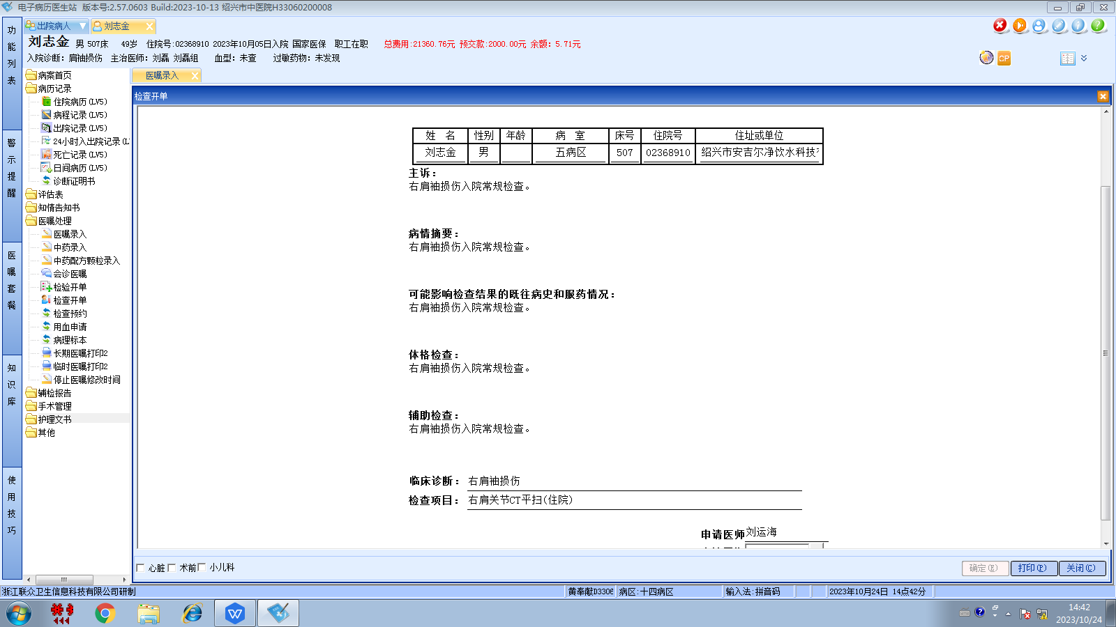刘磊组
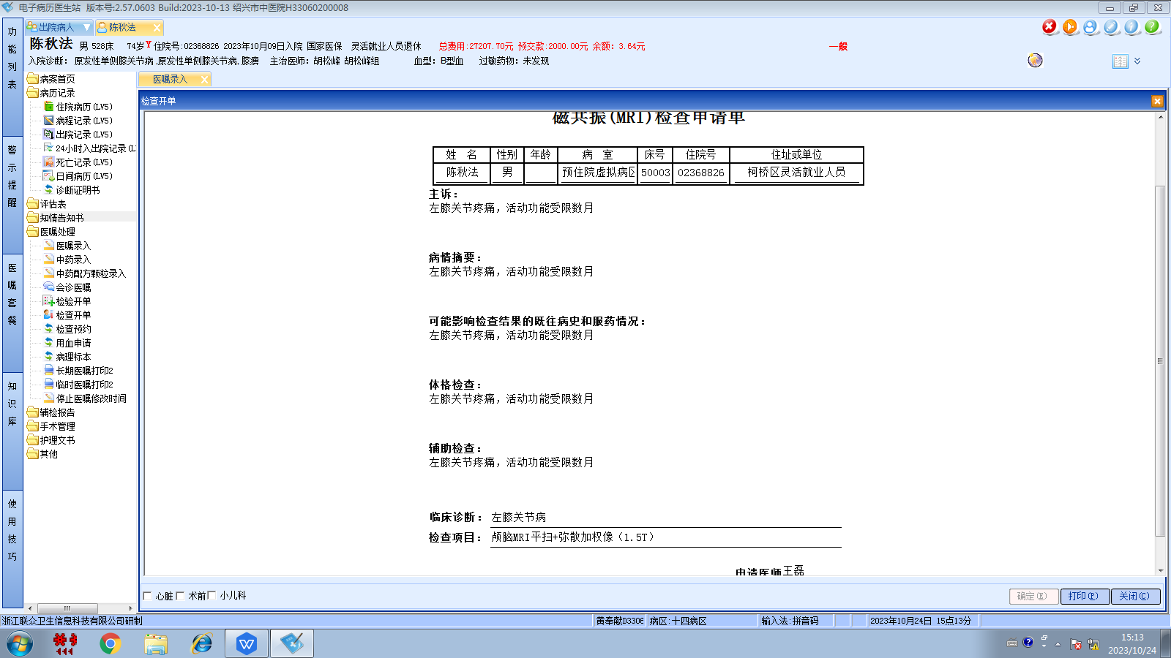胡松峰组
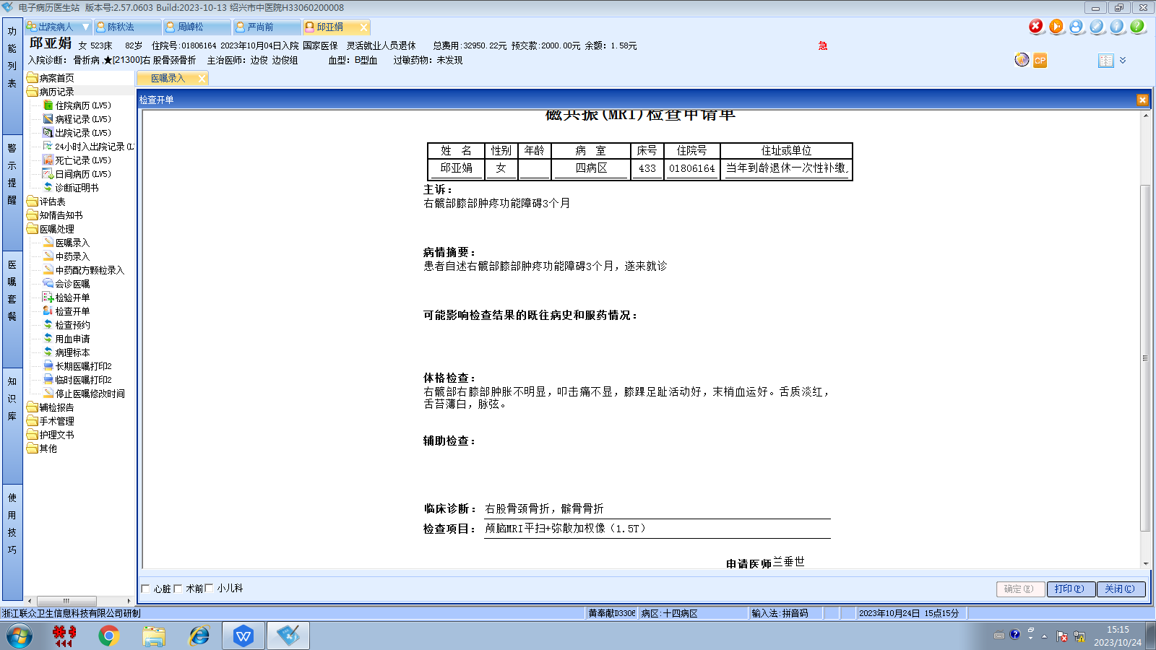边俊组
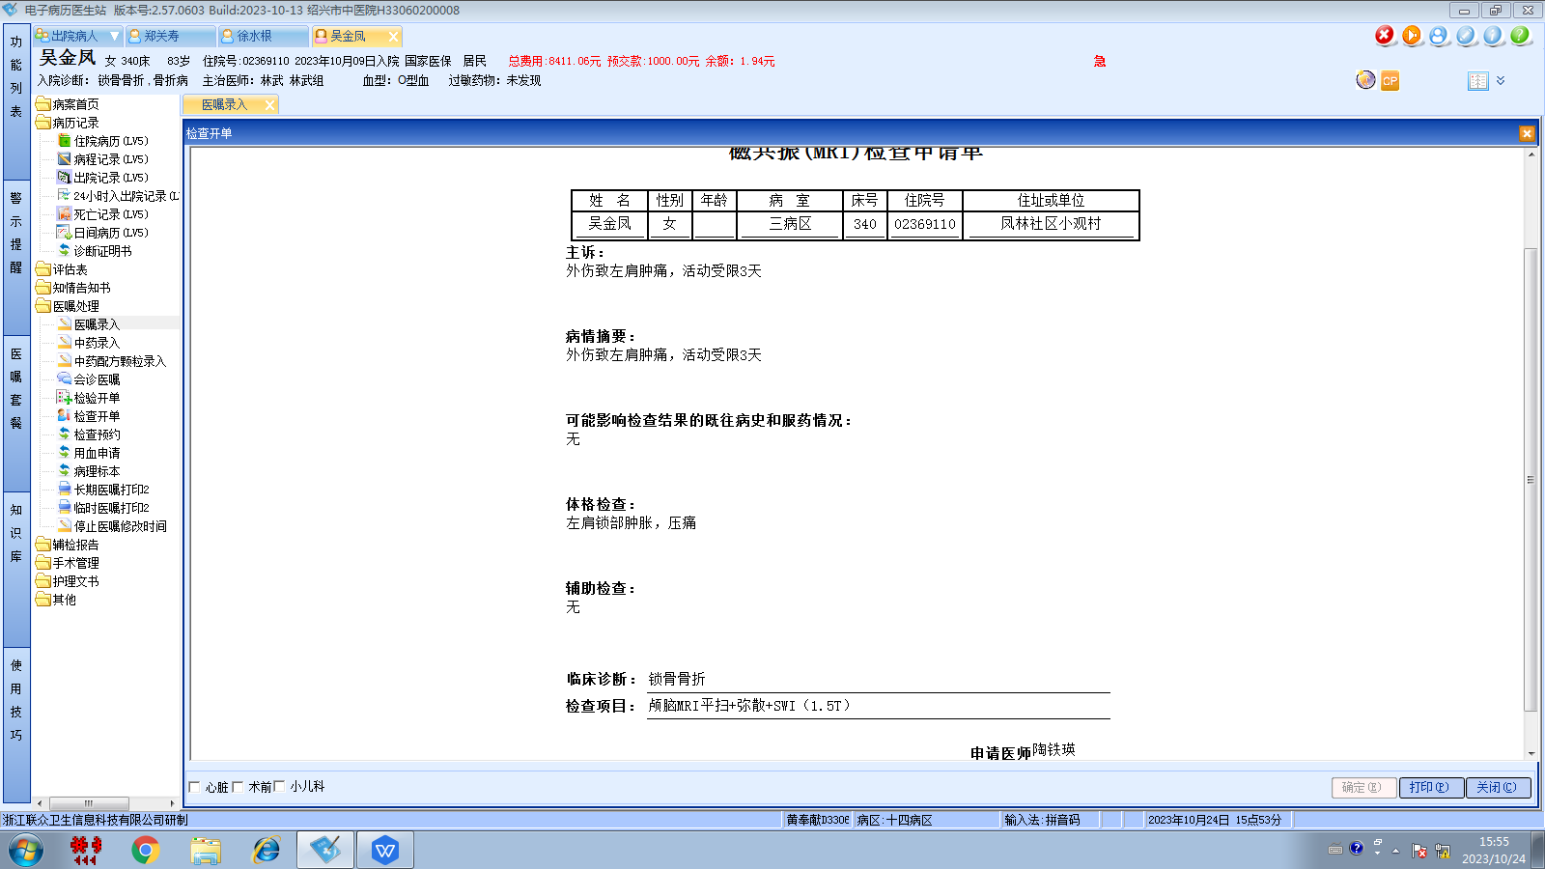林武组
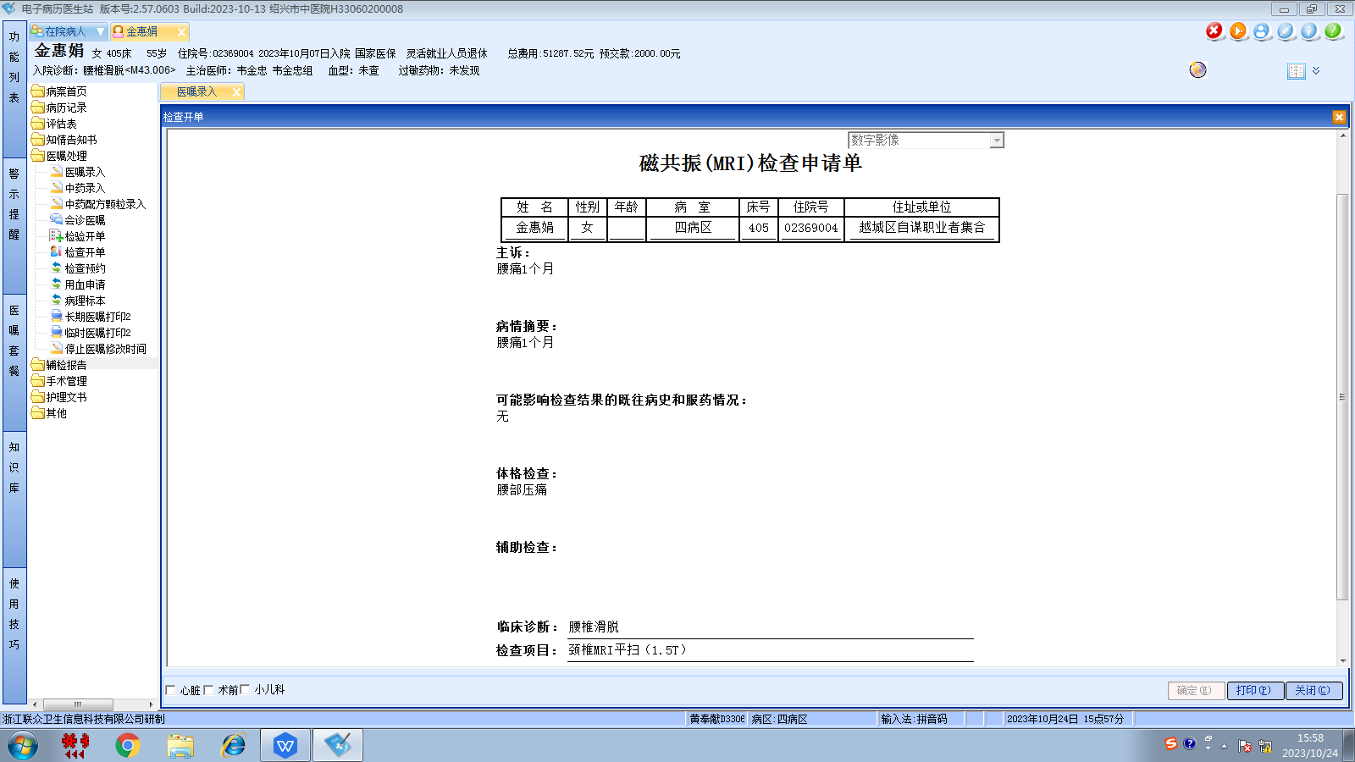韦金忠组
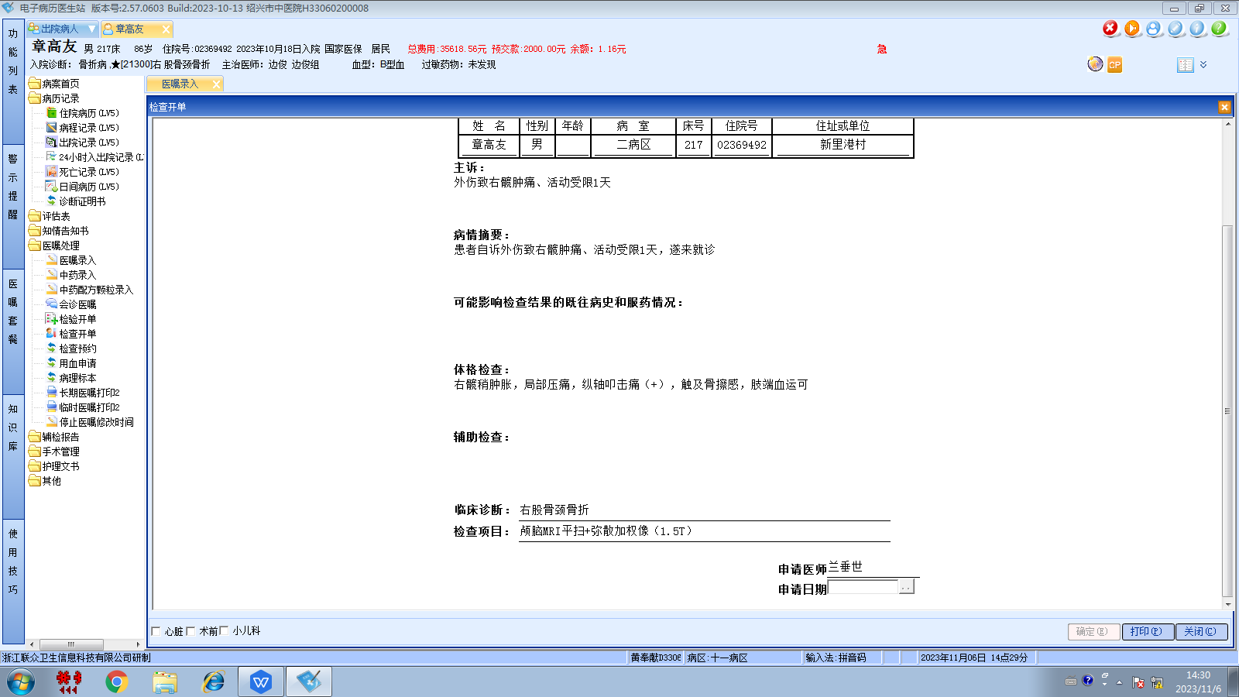边俊组

