11月检查申请单质控
住院号 | 检查单类型 | 开单日期 | 开单医师 |  |  | 检查项目
 |  |  |  | 主诉 | 病情摘要 |  | 既往史 | 体格检查 | 辅助检查 | 诊断 | 内容申请单不一致
01610289 | MR | 2023-10-31 | 兰垂世 | √ | √ |  | √ | √ | √ | √ | √
01900950 | CT | 2023-11-1 | 张建宇 | √ | √ |  | √ | √ | √ | √ | √
02370014 | MR | 2023-10-31 | 程爵富 | √ | √ |  | √ | √ | √ | √ | √
02369813 | CT | 2023-10-31 | 郝飞 | √ | √ |  | √ | √ | √ | √ | √
02370026 | CT | 2023-11-1 | 卢璐 | √ | √ |  | √ | √ | √ | √ | √
02369955 | CT | 2023-11-2 | 朱大明 | √ | √ |  | √ | √ | √ | √ | √
02246053 | MR | 2023-10-31 | 郑德财 | √ | √ |  | √ | √ | √ | √ | √
01602694 | CT | 2023-11-2 | 黄仕尧 | √ | √ |  | √ | √ | √ | √ | √
01602753 | CT | 2023-11-1 | 罗桢敏 | √ | √ |  | √ | √ | √ | √ | √
01602589 | MR | 2023-11-1 | 苗超峰 | √ | √ |  | √ | √ | √ | √ | √
02369888 | MR | 2023-11-1 | 边佳萍 | √ | √ |  | √ | √ | √ | √ | √
01812020 | MR | 2023-11-2 | 胡飞剑 | √ | √ |  | √ | √ | √ | √ | √
01812020 | CT | 2023-11-10 | 谢峰 | √ | √ |  | √ | √ | √ | √ | √
02370028 | CT | 2023-11-2 | 王立波 | √ | √ |  | √ | √ | √ | √ | √
01209497 | CT | 2023-11-3 | 罗桢敏 | √ | √ |  | √ | √ | √ | √ | √
02370052 | MR | 2023-11-2 | 龚彬 | √ | √ |  | √ | √ | √ | √ | √
02369718 | MR | 2023-11-4 | 周怡 | √ | √ |  | √ | √ | √ | √ | √
02370119 | MR | 2023-11-4 | 胡烨琛 | √ | √ |  | √ | √ | √ | √ | √
02369881 | MR | 2023-11-6 | 陶铁瑛 | √ | √ |  | √ | √ | √ | √ | √
02370056 | CT | 2023-11-5 | 朱涵杰 | √ | √ |  | √ | √ | √ | √ | √
01410074 | CT | 2023-11-8 | 陈可为 | √ | √ |  | √ | √ | √ | √ | √
02370237 | MR | 2023-11-4 | 程爵富 | √ | √ |  | √ | √ | √ | √ | √
02370158 | MR | 2023-11-6 | 沈波 | √ | √ |  | √ | √ | √ | √ | √
02370239 | MR | 2023-11-6 | 赵弘铭 | √ | √ |  | √ | √ | √ | √ | √
02370306 | CT | 2023-11-7 | 王风永 | √ | √ |  | √ | √ | √ | √ | √
02370241 | MR | 2023-11-5 | 陈金堂 | √ | √ |  | √ | √ | √ | √ | √
01204008 | CT | 2023-11-8 | 王洪灿 | √ | √ |  | √ | √ | √ | √ | √
02370266 | MR | 2023-11-5 | 谢峰 | √ | √ |  | √ | √ | √ | √ | √
01202643 | MR | 2023-11-8 | 朱大明 | √ | √ |  | √ | √ | √ | √ | √
02370327 | MR | 2023-11-7 | 胡飞剑 | √ | √ |  | √ | √ | √ | √ | √
02262776 | MR | 2023-11-6 | 肖功 | √ | √ |  | √ | √ | √ | √ | √
02262776 | MR | 2023-11-7 | 肖功 | √ | √ |  | √ | √ | √ | √ | √
20100437 | CT/MR | 2023-11-9 | 朱大明 | √ | √ |  | √ | √ | √ | √ | √
02370163 | MR | 2023-11-8 | 冯梦雪 | √ | √ |  | √ | √ | √ | √ | √
02370353 | CT | 2023-11-9 | 肖功 | √ | √ |  | √ | √ | √ | √ | √
02369540 | CT | 2023-11-8 | 王风永 | √ | √ |  | √ | √ | √ | √ | √
01702846 | MR | 2023-11-10 | 郑德财 | √ | √ |  | √ | √ | √ | √ | √
01900238 | MR | 2023-11-9 | 刘潇 | √ | √ |  | √ | √ | √ | √ | √
02370370 | CT | 2023-11-9 | 凌一鸣 | √ | √ |  | √ | √ | √ | √ | √
01609803 | MR | 2023-11-8 | 冯梦雪 | √ | √ |  | √ | √ | √ | √ | √
02370372 | MR | 2023-11-10 | 冯水娟 | √ | √ |  | √ | √ | √ | √ | √
02370262 | MR | 2023-11-12 | 陈剑磨 | √ | √ |  | √ | √ | √ | √ | √
01203958 | MR | 2023-11-11 | 盛苏红 | √ | √ |  | √ | √ | √ | √ | √
02370146 | MR | 2023-11-13 | 冯梦雪 | √ | √ |  | √ | √ | √ | √ | √
01702846 | CT | 2023-11-12 | 谢超 | √ | √ |  | √ | √ | √ | √ | √
02007500 | CT | 2023-11-13 | 张梦娇 | √ | √ |  | √ | √ | √ | √ | √
02370505 | MR | 2023-11-12 | 陆超锋 | √ | √ |  | √ | √ | √ | √ | √
02370598 | MR | 2023-11-14 | 边俊 | √ | √ |  | √ | √ | √ | √ | √
02370352 | CT | 2023-11-13 | 柴绍军 | √ | √ |  | √ | √ | √ | √ | √
02370490 | CT | 2023-11-14 | 吴明 | √ | √ |  | √ | √ | √ | √ | √
02108270 | CT | 2023-11-14 | 周怡 | √ | √ |  | √ | √ | √ | √ | √
02370410 | MR | 2023-11-13 | 谢超 | √ | √ |  | √ | √ | √ | √ | √
02370365 | CT | 2023-11-10 | 陆超锋 | √ | √ |  | √ | √ | √ | √ | √
02370619 | MR | 2023-11-14 | 陈思忆 | √ | √ |  | √ | √ | √ | √ | √
02370628 | MR | 2023-11-15 | 许杨 | √ | √ |  | √ | √ | √ | √ | √
02370316 | CT | 2023-11-13 | 罗桢敏 | √ | √ |  | √ | √ | √ | √ | √
02255027 | MR | 2023-11-14 | 周怡 | √ | √ |  | √ | √ | √ | √ | √
02370637 | CT | 2023-11-15 | 张学思 | √ | √ |  | √ | √ | √ | √ | √
01911771 | MR | 2023-11-16 | 谢超 | √ | √ |  | √ | √ | √ | √ | √
02370482 | MR | 2023-11-13 | 施俊峰 | √ | √ |  | √ | √ | √ | √ | √
02370661 | MR | 2023-11-15 | 苗超峰 | √ | √ |  | √ | √ | √ | √ | √
02370690 | CT | 2023-11-16 | 陶铁瑛 | √ | √ |  | √ | √ | √ | √ | √
02105427 | MR | 2023-11-16 | 王风永 | √ | √ |  | √ | √ | √ | √ | √
02105427 | MR | 2023-11-19 | 王风永 | √ | √ |  | √ | √ | √ | √ | √
02370658 | CT | 2023-11-15 | 肖功 | √ | √ |  | √ | √ | √ | √ | √
02370237 | CT | 2023-11-16 | 陶铁瑛 | √ | √ |  | √ | √ | √ | √ | √
01903490 | CT | 2023-11-17 | 王春春 | √ | √ |  | √ | √ | √ | √ | √
01607045 | MR | 2023-11-15 | 陈金堂 | √ | √ |  | √ | √ | √ | √ | √
02370686 | CT | 2023-11-16 | 王风永 | √ | √ |  | √ | √ | √ | √ | √
02370656 | CT | 2023-11-17 | 王春春 | √ | √ |  | √ | √ | √ | √ | √
02370711 | MR | 2023-11-16 | 陈剑磨 | √ | √ |  | √ | √ | √ | √ | √
02244486 | MR | 2023-11-15 | 卢璐 | √ | √ |  | √ | √ | √ | √ | √
02370720 | MR | 2023-11-17 | 刘浩飞 | √ | √ |  | √ | √ | √ | √ | √
02370612 | MR | 2023-11-17 | 沈家峰 | √ | √ |  | √ | √ | √ | √ | √
02370640 | CT | 2023-11-17 | 刘潇 | √ | √ |  | √ | √ | √ | √ | √
02370798 | CT | 2023-11-19 | 刘浩飞 | √ | √ |  | √ | √ | √ | √ | √
02370618 | MR | 2023-11-18 | 朱海波 | √ | √ |  | √ | √ | √ | √ | √
02370669 | MR | 2023-11-19 | 刘悦 | √ | √ |  | √ | √ | √ | √ | √
01808113 | MR | 2023-11-18 | 王风永 | √ | √ |  | √ | √ | √ | √ | √
02256759 | CT | 2023-11-19 | 郑德财 | √ | √ |  | √ | √ | √ | √ | √
02256759 | MR | 2023-11-19 | 许杨 | √ | √ |  | √ | √ | √ | √ | √
20107096 | MR | 2023-11-18 | 兰垂世 | √ | √ |  | √ | √ | √ | √ | ×
02370681 | MR | 2023-11-17 | 王冰清 | √ | √ |  | √ | √ | √ | √ | √
02370729 | MR | 2023-11-19 | 沈家峰 | √ | √ |  | √ | √ | √ | √ | √
02261568 | CT | 2023-11-19 | 夏炳江 | √ | √ |  | √ | √ | √ | √ | √
01803846 | MR | 2023-11-19 | 边俊 | √ | √ |  | √ | √ | √ | √ | ×
02100365 | MR | 2023-11-19 | 边俊 | √ | √ |  | √ | √ | √ | √ | √
02370795 | CT | 2023-11-19 | 王风永 | √ | √ |  | √ | √ | √ | √ | √
注:对住院患者检查申请单进行专项检查，其中主诉、体格检查或诊断任缺一项者视为不合格申请单；非入院常规检查，如申请单内容与检查部位及要求不一致，亦视为不合格申请单。
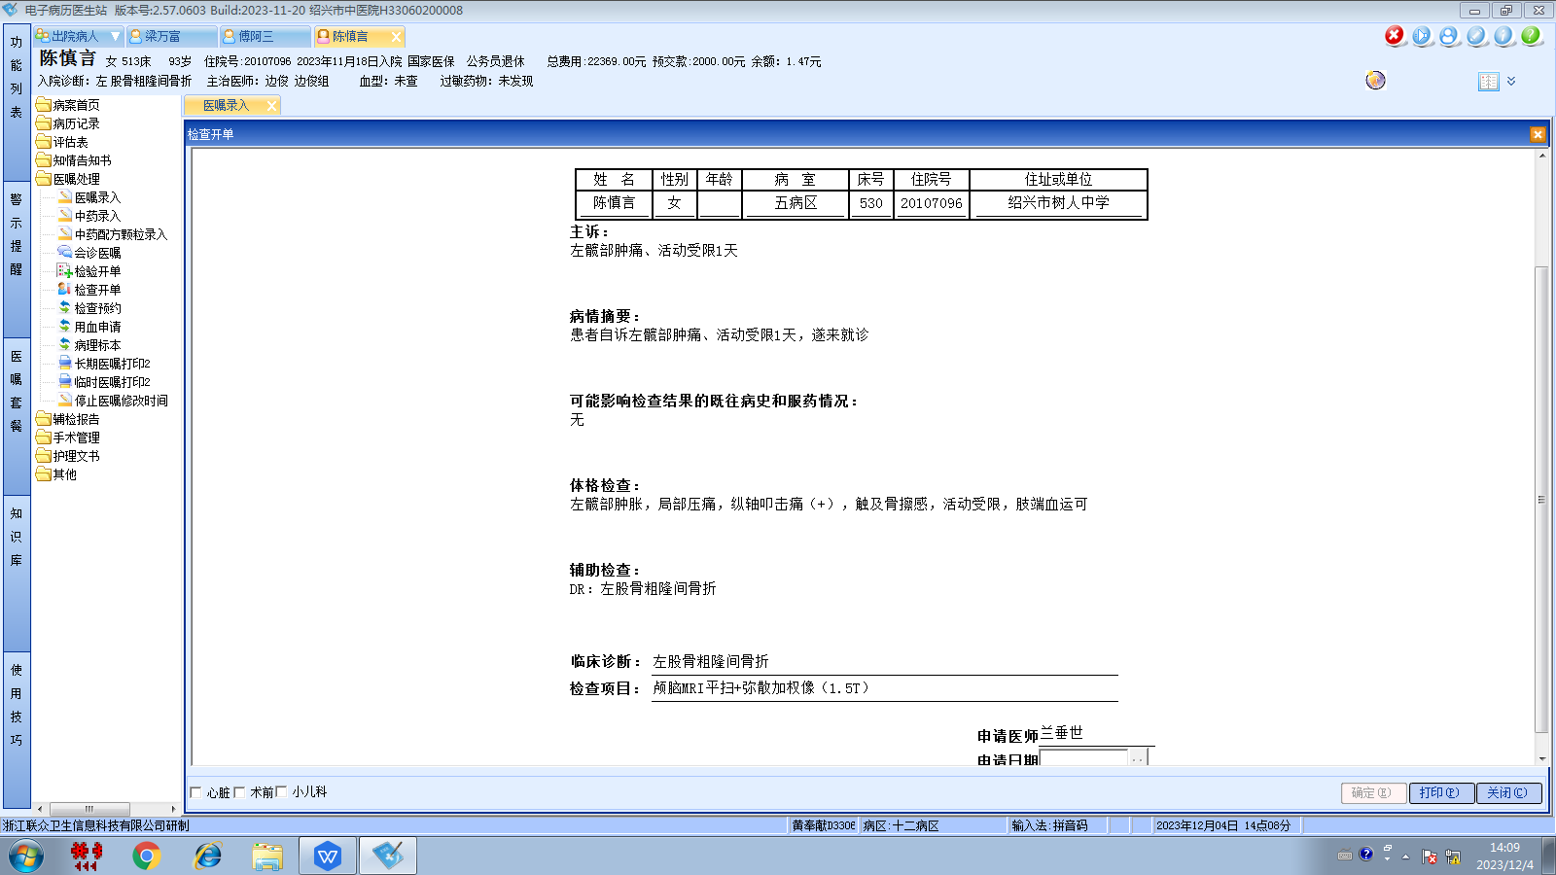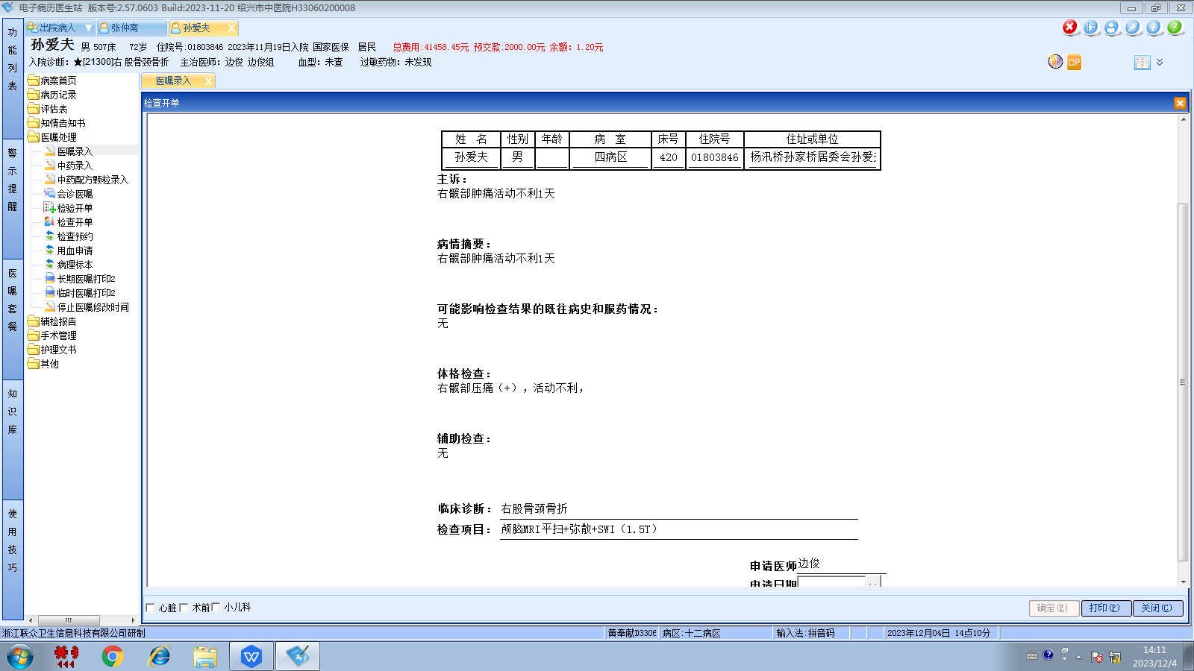边俊组

