12月检查申请单质控
住院号 | 检查单类型 | 开单日期 | 开单医师 |  |  | 检查项目
 |  |  |  | 主诉 | 病情摘要 |  | 既往史 | 体格检查 | 辅助检查 | 诊断 | 内容申请单不一致
01800160 | CT | 2023-11-30 | 朱大明 | √ | √ |  | √ | √ | √ | √ | √
02109072 | MR | 2023-11-30 | 刘浩飞 | √ | √ |  | √ | √ | √ | √ | √
02371130 | MR | 2023-12-1 | 谢峰 | √ | √ |  | √ | √ | √ | √ | √
02371267 | CT | 2023-11-30 | 刘运海 | √ | √ |  | √ | √ | √ | √ | √
02371267 | MR | 2023-11-30 | 刘运海 | √ | √ |  | √ | √ | √ | √ | √
02371183 | MR | 2023-12-1 | 陆超锋 | √ | √ |  | √ | √ | √ | √ | √
01908814 | MR | 2023-12-2 | 夏建宇 | √ | √ |  | √ | √ | √ | √ | ×
02369577 | MR | 2023-12-1 | 刘运海 | √ | √ |  | √ | √ | √ | √ | √
02371343 | MR | 2023-12-1 | 谢峰 | √ | √ |  | √ | √ | √ | √ | √
20091358 | CT | 2023-11-30 | 张梦娇 | √ | √ |  | √ | √ | √ | √ | √
02371227 | CT | 2023-12-4 | 张梦娇 | √ | √ |  | √ | √ | √ | √ | √
02371304 | MR | 2023-12-2 | 张梦娇 | √ | √ |  | √ | √ | √ | √ | √
02264122 | MR | 2023-12-1 | 程爵富 | √ | √ |  | √ | √ | √ | √ | √
02371333 | MR | 2023-12-1 | 谢峰 | √ | √ |  | √ | √ | √ | √ | √
01510562 | MR | 2023-12-2 | 尤志新 | √ | √ |  | √ | √ | √ | √ | √
02008462 | CT | 2023-12-4 | 谢铭 | √ | √ |  | √ | √ | √ | √ | √
02371324 | MR | 2023-12-4 | 许海锋 | √ | √ |  | √ | √ | √ | √ | √
02371321 | CT | 2023-12-3 | 石娟 | √ | √ |  | √ | √ | √ | √ | √
02371461 | CT | 2023-12-6 | 谢睿 | √ | √ |  | √ | √ | √ | √ | √
02371456 | MR | 2023-12-5 | 许杨 | √ | √ |  | √ | √ | √ | √ | √
02371456 | MR | 2023-12-7 | 许杨 | √ | √ |  | √ | √ | √ | √ | √
02103050 | CT | 2023-12-6 | 赵弘铭 | √ | √ |  | √ | √ | √ | √ | √
02103050 | MR | 2023-12-7 | 赵弘铭 | √ | √ |  | √ | √ | √ | √ | √
02371572 | CT | 2023-12-7 | 刘运海 | √ | √ |  | √ | √ | √ | √ | √
01911966 | MR | 2023-12-6 | 夏建宇 | √ | √ |  | √ | √ | √ | √ | √
02244039 | MR | 2023-12-5 | 张梦娇 | √ | √ |  | √ | √ | √ | √ | √
01705556 | MR | 2023-12-5 | 沈沉 | √ | √ |  | √ | √ | √ | √ | √
01705556 | MR | 2023-12-6 | 杨锋 | √ | √ |  | √ | √ | √ | √ | √
02371419 | CT | 2023-12-7 | 肖功 | √ | √ |  | √ | √ | √ | √ | √
02257697 | CT | 2023-12-6 | 张梦娇 | √ | √ |  | √ | √ | √ | √ | √
02371449 | MR | 2023-12-8 | 刘运海 | √ | √ |  | √ | √ | √ | √ | √
02104409 | MR | 2023-12-7 | 陈剑磨 | √ | √ |  | √ | √ | √ | √ | √
02371579 | MR | 2023-12-7 | 胡飞剑 | √ | √ |  | √ | √ | √ | √ | √
02371484 | CT | 2023-12-7 | 孙利荣 | √ | √ |  | √ | √ | √ | √ | √
02371623 | MR | 2023-12-9 | 钟承隽 | √ | √ |  | √ | √ | √ | √ | ×
02238436 | CT | 2023-12-10 | 马黎丽 | √ | √ |  | √ | √ | √ | √ | √
01807131 | MR | 2023-12-11 | 冯梦雪 | √ | √ |  | √ | √ | √ | √ | √
02005129 | MR | 2023-12-10 | 孙利荣 | √ | √ |  | √ | √ | √ | √ | √
02371668 | MR | 2023-12-10 | 沈家峰 | √ | √ |  | √ | √ | √ | √ | √
02371690 | MR | 2023-12-12 | 苗超峰 | √ | √ |  | √ | √ | √ | √ | √
02371496 | MR | 2023-12-11 | 王珊珊 | √ | √ |  | √ | √ | √ | √ | √
02371603 | MR | 2023-12-13 | 王冰清 | √ | √ |  | √ | √ | √ | √ | √
02371519 | MR | 2023-12-11 | 卢璐 | √ | √ |  | √ | √ | √ | √ | √
02243321 | MR | 2023-12-13 | 赵艳明 | √ | √ |  | √ | √ | √ | √ | √
02371777 | MR | 2023-12-13 | 刘浩飞 | √ | √ |  | √ | √ | √ | √ | √
02371518 | MR | 2023-12-11 | 王珊珊 | √ | √ |  | √ | √ | √ | √ | √
01805977 | MR | 2023-12-12 | 沈剑增 | √ | √ |  | √ | √ | √ | √ | √
02371713 | CT | 2023-12-11 | 谢睿 | √ | √ |  | √ | √ | √ | √ | √
01906938 | CT | 2023-12-13 | 张春晓 | √ | √ |  | √ | √ | √ | √ | √
02371814 | MR | 2023-12-14 | 许伟攀 | √ | √ |  | √ | √ | √ | √ | √
02371814 | CT | 2023-12-14 | 许伟攀 | √ | √ |  | √ | √ | √ | √ | √
02371814 | CT | 2023-12-19 | 赵弘铭 | √ | √ |  | √ | √ | √ | √ | √
02371790 | MR | 2023-12-13 | 卢璐 | √ | √ |  | √ | √ | √ | √ | √
02371765 | MR | 2023-12-13 | 王洪灿 | √ | √ |  | √ | √ | √ | √ | √
02371748 | MR | 2023-12-15 | 刘运海 | √ | √ |  | √ | √ | √ | √ | √
01604888 | MR | 2023-12-15 | 刘浩飞 | √ | √ |  | √ | √ | √ | √ | ×
02371676 | MR | 2023-12-15 | 刘运海 | √ | √ |  | √ | √ | √ | √ | √
02371822 | MR | 2023-12-14 | 刘浩飞 | √ | √ |  | √ | √ | √ | √ | √
02371438 | MR | 2023-12-17 | 张学思 | √ | √ |  | √ | √ | √ | √ | √
02371769 | CT | 2023-12-16 | 罗桢敏 | √ | √ |  | √ | √ | √ | √ | √
02371904 | MR | 2023-12-16 | 许伟攀 | √ | √ |  | √ | √ | √ | √ | √
02371845 | MR | 2023-12-18 | 王轶辉 | √ | √ |  | √ | √ | √ | √ | √
02103359 | MR | 2023-12-18 | 王轶辉 | √ | √ |  | √ | √ | √ | √ | √
02371943 | MR | 2023-12-17 | 马军华 | √ | √ |  | √ | √ | √ | √ | √
01303964 | CT | 2023-12-19 | 赵弘铭 | √ | √ |  | √ | √ | √ | √ | √
02371998 | CT | 2023-12-18 | 谢睿 | √ | √ |  | √ | √ | √ | √ | √
02371910 | MR | 2023-12-19 | 王春春 | √ | √ |  | √ | √ | √ | √ | √
02106029 | MR | 2023-12-19 | 王依依 | √ | √ |  | √ | √ | √ | √ | √
02371658 | CT | 2023-12-19 | 何银银 | √ | √ |  | √ | √ | √ | √ | √
02371901 | MR | 2023-12-20 | 谢立江 | √ | √ |  | √ | √ | √ | √ | √
02372071 | CT | 2023-12-20 | 陈剑磨 | √ | √ |  | √ | √ | √ | √ | √
01402535 | MR | 2023-12-20 | 王珊珊 | √ | √ |  | √ | √ | √ | √ | √
02371658 | CT | 2023-12-21 | 蒋琪 | √ | √ |  | √ | √ | √ | √ | √
02372053 | MR | 2023-12-19 | 张学思 | √ | √ |  | √ | √ | √ | √ | √
02371973 | MR | 2023-12-21 | 刘悦 | √ | √ |  | √ | √ | √ | √ | √
02372092 | MR | 2023-12-20 | 胡飞剑 | √ | √ |  | √ | √ | √ | √ | √
02372095 | MR | 2023-12-20 | 刘悦 | √ | √ |  | √ | √ | √ | √ | √
02264978 | MR | 2023-12-22 | 兰垂世 | √ | √ |  | √ | √ | √ | √ | √
02372066 | MR | 2023-12-20 | 张学思 | √ | √ |  | √ | √ | √ | √ | √
02371963 | MR | 2023-12-22 | 陶铁瑛 | √ | √ |  | √ | √ | √ | √ | √
01701166 | MR | 2023-12-22 | 沈家峰 | √ | √ |  | √ | √ | √ | √ | √
02371977 | MR | 2023-12-22 | 鲁剑梅 | √ | √ |  | √ | √ | √ | √ | √
02267819 | MR | 2023-12-21 | 冯梦雪 | √ | √ |  | √ | √ | √ | √ | √
02372154 | MR | 2023-12-22 | 陶铁瑛 | √ | √ |  | √ | √ | √ | √ | √
02371921 | MR | 2023-12-17 | 冯梦雪 | √ | √ |  | √ | √ | √ | √ | √
01801736 | MR | 2023-12-23 | 朱海波 | √ | √ |  | √ | √ | √ | √ | √
02372108 | MR | 2023-12-21 | 张梦娇 | √ | √ |  | √ | √ | √ | √ | √
02371985 | MR | 2023-12-21 | 卢璐 | √ | √ |  | √ | √ | √ | √ | √
02265319 | CT | 2023-12-24 | 周怡 | √ | √ |  | √ | √ | √ | √ | √
02372141 | MR | 2023-12-24 | 苗超峰 | √ | √ |  | √ | √ | √ | √ | √
02372141 | MR | 2023-12-27 | 郑德财 | √ | √ |  | √ | √ | √ | √ | √
02371864 | CT | 2023-12-23 | 张建宇 | √ | √ |  | √ | √ | √ | √ | √
20081583 | CT | 2023-12-23 | 张桢阳 | √ | √ |  | √ | √ | √ | √ | √
02372229 | MR | 2023-12-25 | 卢璐 | √ | √ |  | √ | √ | √ | √ | √
02371821 | MR | 2023-12-24 | 孙莉 | √ | √ |  | √ | √ | √ | √ | √
02372226 | MR | 2023-12-25 | 刘浩飞 | √ | √ |  | √ | √ | √ | √ | √
02103544 | MR | 2023-12-25 | 许海锋 | √ | √ |  | √ | √ | √ | √ | √
02005969 | MR | 2023-12-24 | 周怡 | √ | √ |  | √ | √ | √ | √ | √
02372179 | MR | 2023-12-26 | 许杨 | √ | √ |  | √ | √ | √ | √ | √
01811881 | MR | 2023-12-25 | 安艳军 | √ | √ |  | √ | √ | √ | √ | √
02372115 | CT | 2023-12-26 | 何薇 | √ | √ |  | √ | √ | √ | √ | √
02372270 | MR | 2023-12-26 | 张学思 | √ | √ |  | √ | √ | √ | √ | √
02372278 | MR | 2023-12-26 | 张圣扬 | √ | √ |  | √ | √ | √ | √ | √
02372277 | MR | 2023-12-26 | 王珊珊 | √ | √ |  | √ | √ | √ | √ | √
02372119 | MR | 2023-12-26 | 卢璐 | √ | √ |  | √ | √ | √ | √ | √
02372241 | CT | 2023-12-26 | 周怡 | √ | √ |  | √ | √ | √ | √ | √
01914255 | CT | 2023-12-25 | 赵艳明 | √ | √ |  | √ | √ | √ | √ | √
02111824 | MR | 2023-12-26 | 王珊珊 | √ | √ |  | √ | √ | √ | √ | √
02111824 | MR | 2023-12-27 | 杨锋 | √ | √ |  | √ | √ | √ | √ | √
02372205 | MR | 2023-12-29 | 刘运海 | √ | √ |  | √ | √ | √ | √ | √
02372276 | MR | 2023-12-27 | 王珊珊 | √ | √ |  | √ | √ | √ | √ | √
02372390 | MR | 2023-12-29 | 边俊 | √ | √ |  | √ | √ | √ | √ | √
02372446 | MR | 2023-12-30 | 许伟攀 | √ | √ |  | √ | √ | √ | √ | √
注：对住院患者检查申请单进行专项检查，其中主诉、体格检查或诊断任缺一项者视为不合格申请单；非入院常规检查，如申请单内容与检查部位及要求不一致，亦视为不合格申请单。
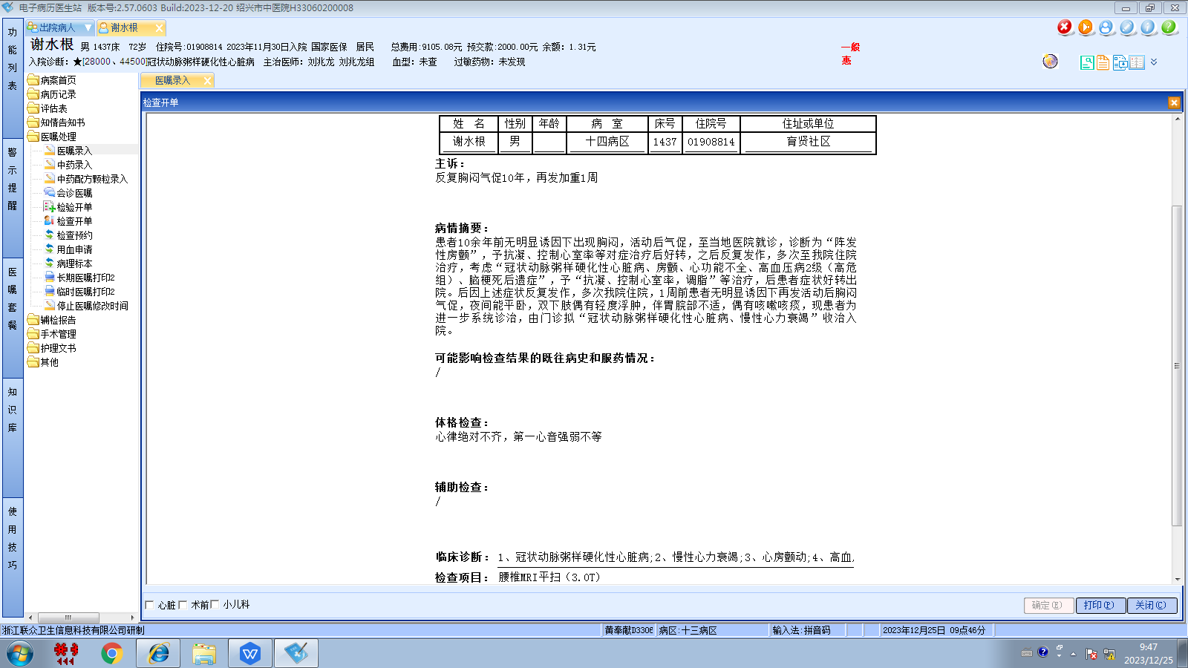刘兆龙组
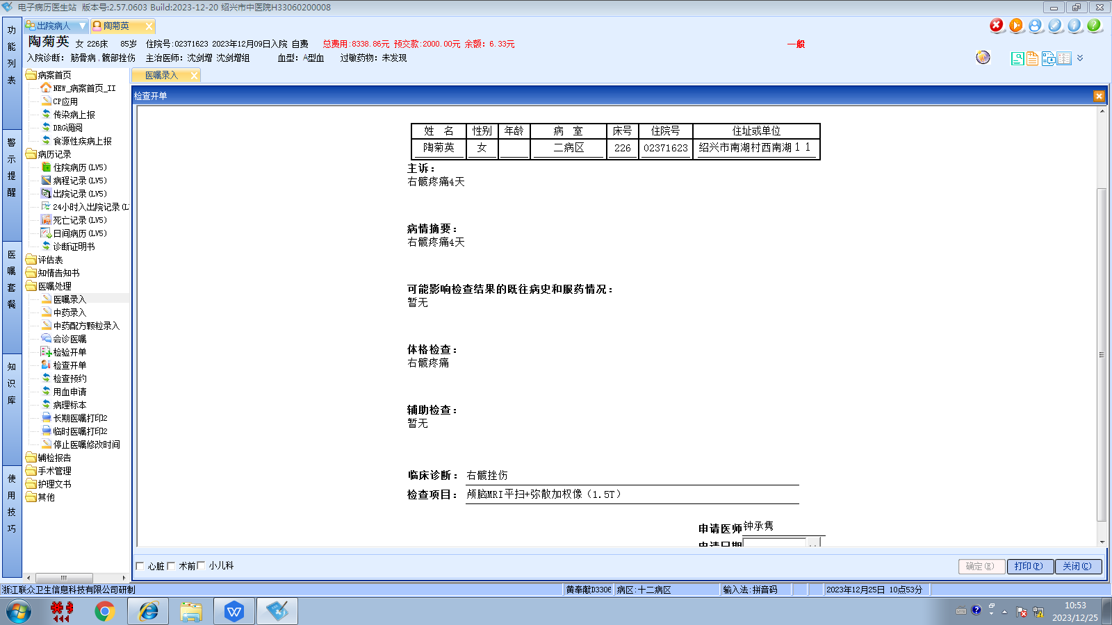沈剑增组
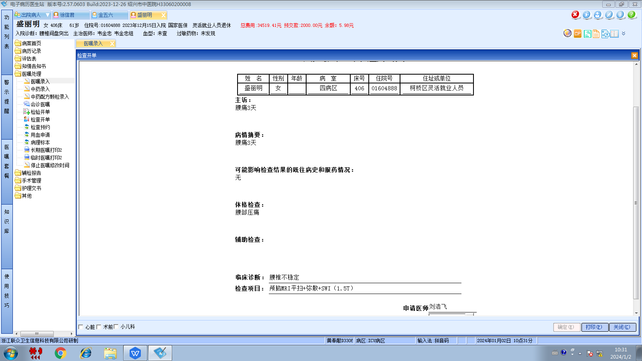韦金忠组

