1月检查申请单质控
住院号 | 检查单类型 | 开单日期 | 开单医师 |  |  | 检查项目
 |  |  |  | 主诉 | 病情摘要 |  | 既往史 | 体格检查 | 辅助检查 | 诊断 | 内容申请单不一致
02372265 | CT | 2023-12-30 | 程爵富 | √ | √ |  | √ | √ | √ | √ | √
02372265 | CT | 2024-1-10 | 任园伟 | √ | √ |  | √ | √ | √ | √ | √
01412988 | MR | 2024-1-2 | 沈沉 | √ | √ |  | √ | √ | √ | √ | √
02372449 | MR | 2024-1-2 | 刘悦 | √ | √ |  | √ | √ | √ | √ | √
02255393 | MR | 2024-1-1 | 张圣扬 | √ | √ |  | √ | √ | √ | √ | √
02372484 | MR | 2024-1-1 | 陈剑磨 | √ | √ |  | √ | √ | √ | √ | √
02372512 | CT | 2024-1-3 | 周怡 | √ | √ |  | √ | √ | √ | √ | √
02372521 | MR | 2024-1-2 | 张梦娇 | √ | √ |  | √ | √ | √ | √ | √
01908298 | MR | 2024-1-2 | 郑德财 | √ | √ |  | √ | √ | √ | √ | √
01908298 | MR | 2024-1-4 | 苗超峰 | √ | √ |  | √ | √ | √ | √ | √
01611107 | MR | 2024-1-2 | 谢峰 | √ | √ |  | √ | √ | √ | √ | √
02372379 | MR | 2024-1-3 | 王春春 | √ | √ |  | √ | √ | √ | √ | √
02260767 | MR | 2024-1-3 | 马军华 | √ | √ |  | √ | √ | √ | √ | √
01607006 | MR | 2024-1-4 | 支飞虎 | √ | √ |  | √ | √ | √ | √ | √
02372534 | MR | 2024-1-4 | 王风永 | √ | √ |  | √ | √ | √ | √ | ×
01714137 | MR | 2024-1-4 | 苗超峰 | √ | √ |  | √ | √ | √ | √ | √
02400097 | MR | 2024-1-5 | 张梦娇 | √ | √ |  | √ | √ | √ | √ | √
01906179 | MR | 2024-1-5 | 刘运海 | √ | √ |  | √ | √ | √ | √ | √
02400071 | CT | 2024-1-4 | 王风永 | √ | √ |  | √ | √ | √ | √ | ×
02371651 | CT | 2024-1-5 | 刘潇 | √ | √ |  | √ | √ | √ | √ | √
02400096 | MR | 2024-1-5 | 程爵富 | √ | √ |  | √ | √ | √ | √ | √
02400032 | CT | 2024-1-6 | 田悦越 | √ | √ |  | √ | √ | √ | √ | √
02372506 | MR | 2024-1-6 | 张学思 | √ | √ |  | √ | √ | √ | √ | √
02400279 | CT | 2024-1-10 | 刘运海 | √ | √ |  | √ | √ | √ | √ | √
02400290 | CT | 2024-1-10 | 朱江 | √ | √ |  | √ | √ | √ | √ | √
01508274 | CT | 2024-1-10 | 刘浩飞 | √ | √ |  | √ | √ | √ | √ | √
01305502 | MR | 2024-1-10 | 张春晓 | √ | √ |  | √ | √ | √ | √ | √
02400236 | CT | 2024-1-9 | 谢睿 | √ | √ |  | √ | √ | √ | √ | √
02400315 | CT | 2024-1-10 | 王风永 | √ | √ |  | √ | √ | √ | √ | √
02400249 | MR | 2024-1-10 | 刘浩飞 | √ | √ |  | √ | √ | √ | √ | √
02008382 | CT | 2024-1-12 | 谢睿 | √ | √ |  | √ | √ | √ | √ | √
02255871 | MR | 2024-1-11 | 周怡 | √ | √ |  | √ | √ | √ | √ | √
02400083 | CT | 2024-1-11 | 程爵富 | √ | √ |  | √ | √ | √ | √ | √
02400206 | MR | 2024-1-12 | 沈学香 | √ | √ |  | √ | √ | √ | √ | √
02400314 | MR | 2024-1-10 | 陶铁瑛 | √ | √ |  | √ | √ | √ | √ | √
01311812 | MR | 2024-1-12 | 兰垂世 | √ | √ |  | √ | √ | √ | √ | √
02400418 | CT | 2024-1-13 | 程爵富 | √ | √ |  | √ | √ | √ | √ | √
02400418 | MR | 2024-1-13 | 程爵富 | √ | √ |  | √ | √ | √ | √ | √
02400337 | MR | 2024-1-12 | 胡飞剑 | √ | √ |  | √ | √ | √ | √ | √
02241962 | MR | 2024-1-13 | 谢峰 | √ | √ |  | √ | √ | √ | √ | √
02263863 | MR | 2024-1-12 | 刘浩飞 | √ | √ |  | √ | √ | √ | √ | √
02400473 | MR | 2024-1-15 | 陈剑磨 | √ | √ |  | √ | √ | √ | √ | √
02400368 | CT | 2024-1-14 | 赵雄碧 | √ | √ |  | √ | √ | √ | √ | √
02400474 | MR | 2024-1-15 | 陶铁瑛 | √ | √ |  | √ | √ | √ | √ | √
01707883 | MR | 2024-1-15 | 冯水娟 | √ | √ |  | √ | √ | √ | √ | √
02400438 | MR | 2024-1-14 | 边俊 | √ | √ |  | √ | √ | √ | √ | √
02400566 | CT | 2024-1-16 | 王风永 | √ | √ |  | √ | √ | √ | √ | √
02400591 | CT | 2024-1-17 | 王晋钟 | √ | √ |  | √ | √ | √ | √ | √
02400417 | MR | 2024-1-17 | 苗超峰 | √ | √ |  | √ | √ | √ | √ | √
02400557 | MR | 2024-1-16 | 胡飞剑 | √ | √ |  | √ | √ | √ | √ | √
02371410 | MR | 2024-1-16 | 边俊 | √ | √ |  | √ | √ | √ | √ | √
01501846 | MR | 2024-1-16 | 胡飞剑 | √ | √ |  | √ | √ | √ | √ | √
02400552 | MR | 2024-1-16 | 沈钱理 | √ | √ |  | √ | √ | √ | √ | √
02400573 | MR | 2024-1-17 | 沈钱理 | √ | √ |  | √ | √ | √ | √ | √
02400575 | MR | 2024-1-18 | 陈剑磨 | √ | √ |  | √ | √ | √ | √ | √
02400505 | MR | 2024-1-15 | 胡飞剑 | √ | √ |  | √ | √ | √ | √ | √
01909940 | MR | 2024-1-19 | 罗桢敏 | √ | √ |  | √ | √ | √ | √ | √
02400537 | MR | 2024-1-18 | 王风永 | √ | √ |  | √ | √ | √ | √ | √
02400715 | CT | 2024-1-20 | 刘运海 | √ | √ |  | √ | √ | √ | √ | √
02400715 | MR | 2024-1-20 | 刘运海 | √ | √ |  | √ | √ | √ | √ | √
02400417 | MR | 2024-1-20 | 尤志新 | √ | √ |  | √ | √ | √ | √ | √
02400668 | MR | 2024-1-19 | 沈波 | √ | √ |  | √ | √ | √ | √ | √
02400764 | CT | 2024-1-22 | 谢睿 | √ | √ |  | √ | √ | √ | √ | √
01413320 | CT | 2024-1-22 | 王风永 | √ | √ |  | √ | √ | √ | √ | √
02400725 | MR | 2024-1-20 | 张梦娇 | √ | √ |  | √ | √ | √ | √ | √
02400725 | CT | 2024-1-20 | 张梦娇 | √ | √ |  | √ | √ | √ | √ | √
01512122 | MR | 2024-1-22 | 柴绍军 | √ | √ |  | √ | √ | √ | √ | √
01914853 | MR | 2024-1-22 | 俞梅 | √ | √ |  | √ | √ | √ | √ | √
02000515 | MR | 2024-1-24 | 王珊珊 | √ | √ |  | √ | √ | √ | √ | √
02400647 | CT | 2024-1-23 | 凌一鸣 | √ | √ |  | √ | √ | √ | √ | √
02400770 | MR | 2024-1-22 | 何建明 | √ | √ |  | √ | √ | √ | √ | √
01913565 | MR | 2024-1-24 | 苗超峰 | √ | √ |  | √ | √ | √ | √ | √
01801446 | CT | 2024-1-25 | 冯水娟 | √ | √ |  | √ | √ | √ | √ | √
02400862 | MR | 2024-1-24 | 赵弘铭 | √ | √ |  | √ | √ | √ | √ | √
02257193 | CT | 2024-1-26 | 安艳军 | √ | √ |  | √ | √ | √ | √ | √
02400751 | CT | 2024-1-22 | 陶铁瑛 | √ | √ |  | √ | √ | √ | √ | √
01703034 | CT | 2024-1-26 | 安艳军 | √ | √ |  | √ | √ | √ | √ | √
01903469 | MR | 2024-1-26 | 陈剑磨 | √ | √ |  | √ | √ | √ | √ | √
02400909 | MR | 2024-1-26 | 张梦娇 | √ | √ |  | √ | √ | √ | √ | √
02400909 | MR | 2024-1-28 | 程爵富 | √ | √ |  | √ | √ | √ | √ | √
02400841 | MR | 2024-1-26 | 董珍 | √ | √ |  | √ | √ | √ | √ | √
02400905 | CT | 2024-1-26 | 刘浩飞 | √ | √ |  | √ | √ | √ | √ | √
02400880 | MR | 2024-1-26 | 肖功 | √ | √ |  | √ | √ | √ | √ | √
02400899 | MR | 2024-1-25 | 凌一鸣 | √ | √ |  | √ | √ | √ | √ | √
02400961 | MR | 2024-1-27 | 沈波 | √ | √ |  | √ | √ | √ | √ | √
02372172 | MR | 2024-1-28 | 朱涵杰 | √ | √ |  | √ | √ | √ | √ | √
02400566 | CT | 2024-1-29 | 王风永 | √ | √ |  | √ | √ | √ | √ | √
02400928 | CT | 2024-1-26 | 谢超 | √ | √ |  | √ | √ | √ | √ | √
02401018 | CT | 2024-1-28 | 程爵富 | √ | √ |  | √ | √ | √ | √ | √
02401018 | MR | 2024-1-28 | 程爵富 | √ | √ |  | √ | √ | √ | √ | √
02401018 | MR | 2024-1-31 | 张梦娇 | √ | √ |  | √ | √ | √ | √ | √
02002670 | MR | 2024-1-29 | 王春春 | √ | √ |  | √ | √ | √ | √ | √
02256571 | CT | 2024-1-29 | 张梦娇 | √ | √ |  | √ | √ | √ | √ | √
02400768 | CT | 2024-1-29 | 许伟攀 | √ | √ |  | √ | √ | √ | √ | √
02258189 | CT | 2024-1-29 | 谢超 | √ | √ |  | √ | √ | √ | √ | √
02258595 | MR | 2024-1-30 | 郑德财 | √ | √ |  | √ | √ | √ | √ | √
注：对住院患者检查申请单进行专项检查，其中主诉、体格检查或诊断任缺一项者视为不合格申请单；非入院常规检查，如申请单内容与检查部位及要求不一致，亦视为不合格申请单。
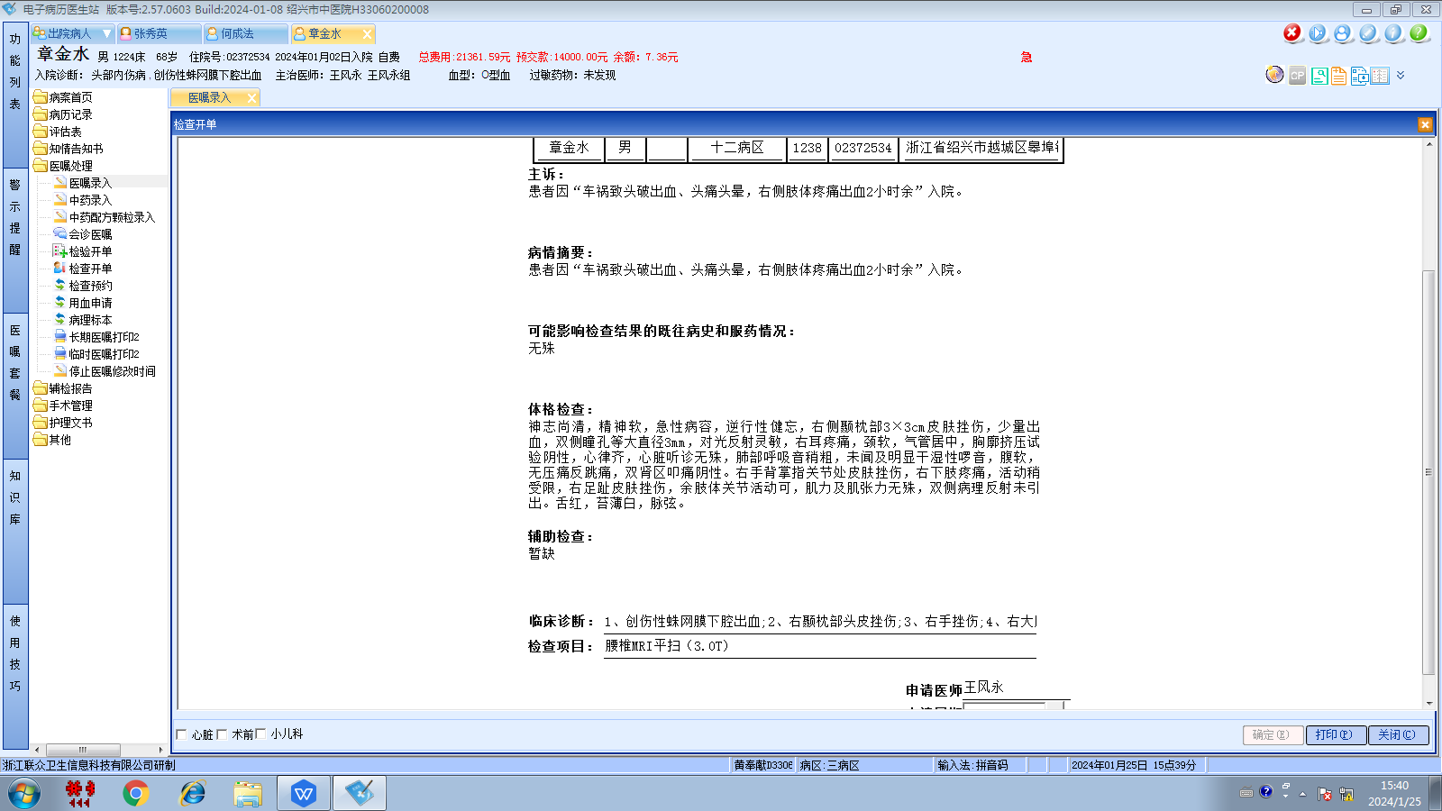王风永组
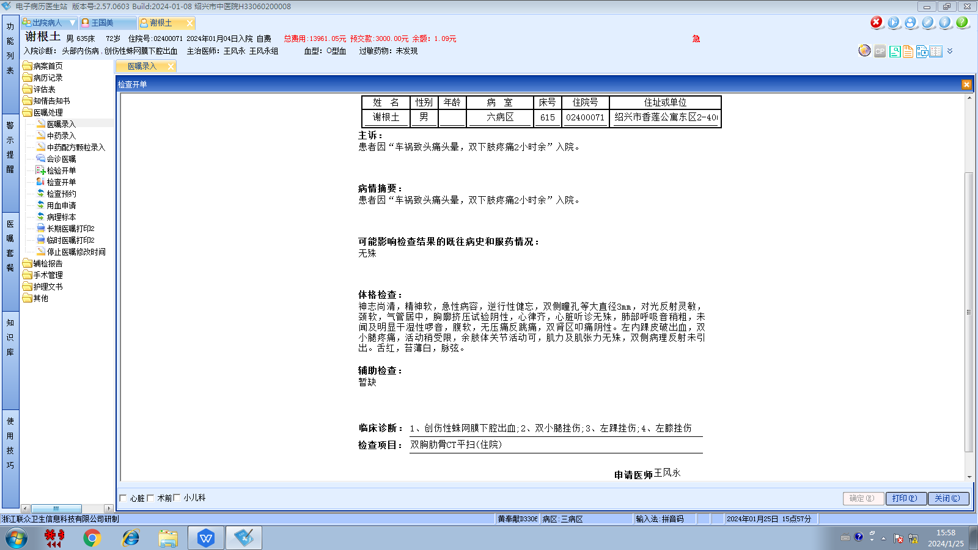
王风永组

