2月检查申请单质控
住院号 | 检查单类型 | 开单日期 | 开单医师 |  |  | 检查项目
 |  |  |  | 主诉 | 病情摘要 |  | 既往史 | 体格检查 | 辅助检查 | 诊断 | 内容申请单不一致
02401100 | MR | 2024-1-30 | 陶铁瑛 | √ | √ |  | √ | √ | √ | √ | √
02401045 | MR | 2024-1-29 | 冯梦雪 | √ | √ |  | √ | √ | √ | √ | √
02401115 | CT | 2024-2-1 | 安艳军 | √ | √ |  | √ | √ | √ | √ | √
02401091 | CT | 2024-2-1 | 王春春 | √ | √ |  | √ | √ | √ | √ | √
01101385 | MR | 2024-1-31 | 周怡 | √ | √ |  | √ | √ | √ | √ | √
02265195 | MR | 2024-2-1 | 陈剑磨 | √ | √ |  | √ | √ | √ | √ | √
02401164 | CT | 2024-2-1 | 苗超峰 | √ | √ |  | √ | √ | √ | √ | √
02401202 | CT | 2024-2-2 | 刘运海 | √ | √ |  | √ | √ | √ | √ | √
02401202 | MR | 2024-2-2 | 刘运海 | √ | √ |  | √ | √ | √ | √ | √
01709566 | MR | 2024-2-2 | 赵艳明 | √ | √ |  | √ | √ | √ | √ | √
02401219 | CT | 2024-2-3 | 夏建宇 | √ | √ |  | √ | √ | √ | √ | √
02401148 | CT | 2024-2-7 | 王风永 | √ | √ |  | √ | √ | √ | √ | √
02401380 | CT | 2024-2-8 | 许杨 | √ | √ |  | √ | √ | √ | √ | √
02401380 | MR | 2024-2-7 | 王风永 | √ | √ |  | √ | √ | √ | √ | √
02401397 | CT | 2024-2-12 | 苗超峰 | √ | √ |  | √ | √ | √ | √ | √
02401412 | MR | 2024-2-11 | 吴智敏 | √ | √ |  | √ | √ | √ | √ | √
02401472 | MR | 2024-2-13 | 王珊珊 | √ | √ |  | √ | √ | √ | √ | √
02259637 | MR | 2024-2-7 | 马军华 | √ | √ |  | √ | √ | √ | √ | √
02401403 | MR | 2024-2-13 | 沈沉 | √ | √ |  | √ | √ | √ | √ | √
02401408 | MR | 2024-2-13 | 沈钱理 | √ | √ |  | √ | √ | √ | √ | √
02401555 | CT | 2024-2-15 | 冯梦雪 | √ | √ |  | √ | √ | √ | √ | √
02401540 | MR | 2024-2-14 | 谢峰 | √ | √ |  | √ | √ | √ | √ | √
02102719 | CT | 2024-2-15 | 周怡 | √ | √ |  | √ | √ | √ | √ | √
02263789 | MR | 2024-2-14 | 陶铁瑛 | √ | √ |  | √ | √ | √ | √ | √
02401431 | CT | 2024-2-16 | 程爵富 | √ | √ |  | √ | √ | √ | √ | √
02401553 | MR | 2024-2-15 | 卢璐 | √ | √ |  | √ | √ | √ | √ | √
02401554 | MR | 2024-2-15 | 卢璐 | √ | √ |  | √ | √ | √ | √ | √
02401450 | MR | 2024-2-14 | 叶玲玲 | √ | √ |  | √ | √ | √ | √ | √
02401593 | MR | 2024-2-15 | 沈丽娜 | √ | √ |  | √ | √ | √ | √ | √
02401593 | MR | 2024-2-17 | 王一萍 | √ | √ |  | √ | √ | √ | √ | √
02401366 | MR | 2024-2-16 | 刘运海 | √ | √ |  | √ | √ | √ | √ | √
02401506 | MR | 2024-2-16 | 陈剑磨 | √ | √ |  | √ | √ | √ | √ | √
02008353 | MR | 2024-2-16 | 王一萍 | √ | √ |  | √ | √ | √ | √ | √
02241602 | MR | 2024-2-16 | 金建淼 | √ | √ |  | √ | √ | √ | √ | √
02401666 | MR | 2024-2-16 | 程爵富 | √ | √ |  | √ | √ | √ | √ | √
02108320 | MR | 2024-2-16 | 程爵富 | √ | √ |  | √ | √ | √ | √ | √
02401667 | MR | 2024-2-16 | 程爵富 | √ | √ |  | √ | √ | √ | √ | √
02401652 | MR | 2024-2-16 | 张学思 | √ | √ |  | √ | √ | √ | √ | √
02401731 | MR | 2024-2-18 | 何薇 | √ | √ |  | √ | √ | √ | √ | √
02401754 | CT | 2024-2-18 | 夏炳江 | √ | √ |  | √ | √ | √ | √ | √
02401754 | MR | 2024-2-18 | 夏炳江 | √ | √ |  | √ | √ | √ | √ | √
01612462 | CT | 2024-2-18 | 肖功 | √ | √ |  | √ | √ | √ | √ | √
01612462 | MR | 2024-2-18 | 肖功 | √ | √ |  | √ | √ | √ | √ | √
02401598 | CT | 2024-2-18 | 肖功 | √ | √ |  | √ | √ | √ | √ | √
01911244 | CT | 2024-2-20 | 朱大明 | √ | √ |  | √ | √ | √ | √ | √
02401575 | MR | 2024-2-19 | 杨兴辉 | √ | √ |  | √ | √ | √ | √ | √
02401701 | MR | 2024-2-19 | 赵雄碧 | √ | √ |  | √ | √ | √ | √ | ×
02401694 | MR | 2024-2-17 | 施俊峰 | √ | √ |  | √ | √ | √ | √ | √
02401632 | MR | 2024-2-19 | 冯梦雪 | √ | √ |  | √ | √ | √ | √ | √
02401755 | MR | 2024-2-20 | 钟承隽 | √ | √ |  | √ | √ | √ | √ | ×
02262449 | CT | 2024-2-21 | 鲁剑梅 | √ | √ |  | √ | √ | √ | √ | √
02100426 | MR | 2024-2-18 | 刘悦 | √ | √ |  | √ | √ | √ | √ | √
02401843 | MR | 2024-2-20 | 张梦娇 | √ | √ |  | √ | √ | √ | √ | ×
02401356 | MR | 2024-2-21 | 黄操 | √ | √ |  | √ | √ | √ | √ | √
02401327 | MR | 2024-2-21 | 卢璐 | √ | √ |  | √ | √ | √ | √ | √
02401890 | CT | 2024-2-22 | 冯梦雪 | √ | √ |  | √ | √ | √ | √ | √
02401354 | CT | 2024-2-21 | 杨兴辉 | √ | √ |  | √ | √ | √ | √ | √
02401354 | MR | 2024-2-22 | 沈沉 | √ | √ |  | √ | √ | √ | √ | √
02401744 | MR | 2024-2-21 | 谢思维 | √ | √ |  | √ | √ | √ | √ | √
02401667 | CT | 2024-2-22 | 张梦娇 | √ | √ |  | √ | √ | √ | √ | ×
02401916 | MR | 2024-2-21 | 张学思 | √ | √ |  | √ | √ | √ | √ | √
02401355 | MR | 2024-2-22 | 黄操 | √ | √ |  | √ | √ | √ | √ | √
01500166 | MR | 2024-2-22 | 沈钱理 | √ | √ |  | √ | √ | √ | √ | √
02401824 | MR | 2024-2-23 | 王珊珊 | √ | √ |  | √ | √ | √ | √ | ×
02267529 | CT | 2024-2-26 | 刘运海 | √ | √ |  | √ | √ | √ | √ | √
02402063 | MR | 2024-2-25 | 边俊 | √ | √ |  | √ | √ | √ | √ | ×
02401873 | MR | 2024-2-23 | 兰垂世 | √ | √ |  | √ | √ | √ | √ | ×
02402120 | MR | 2024-2-26 | 边俊 | √ | √ |  | √ | √ | √ | √ | ×
02402022 | MR | 2024-2-26 | 卢璐 | √ | √ |  | √ | √ | √ | √ | √
02238400 | MR | 2024-2-28 | 刘浩飞 | √ | √ |  | √ | √ | √ | √ | ×
01910105 | MR | 2024-2-26 | 郑德财 | √ | √ |  | √ | √ | √ | √ | √
02402153 | MR | 2024-2-27 | 刘磊 | √ | √ |  | √ | √ | √ | √ | √
02402139 | MR | 2024-2-27 | 张梦娇 | √ | √ |  | √ | √ | √ | √ | ×
注：对住院患者检查申请单进行专项检查，其中主诉、体格检查或诊断任缺一项者视为不合格申请单；非入院常规检查，如申请单内容与检查部位及要求不一致，亦视为不合格申请单。
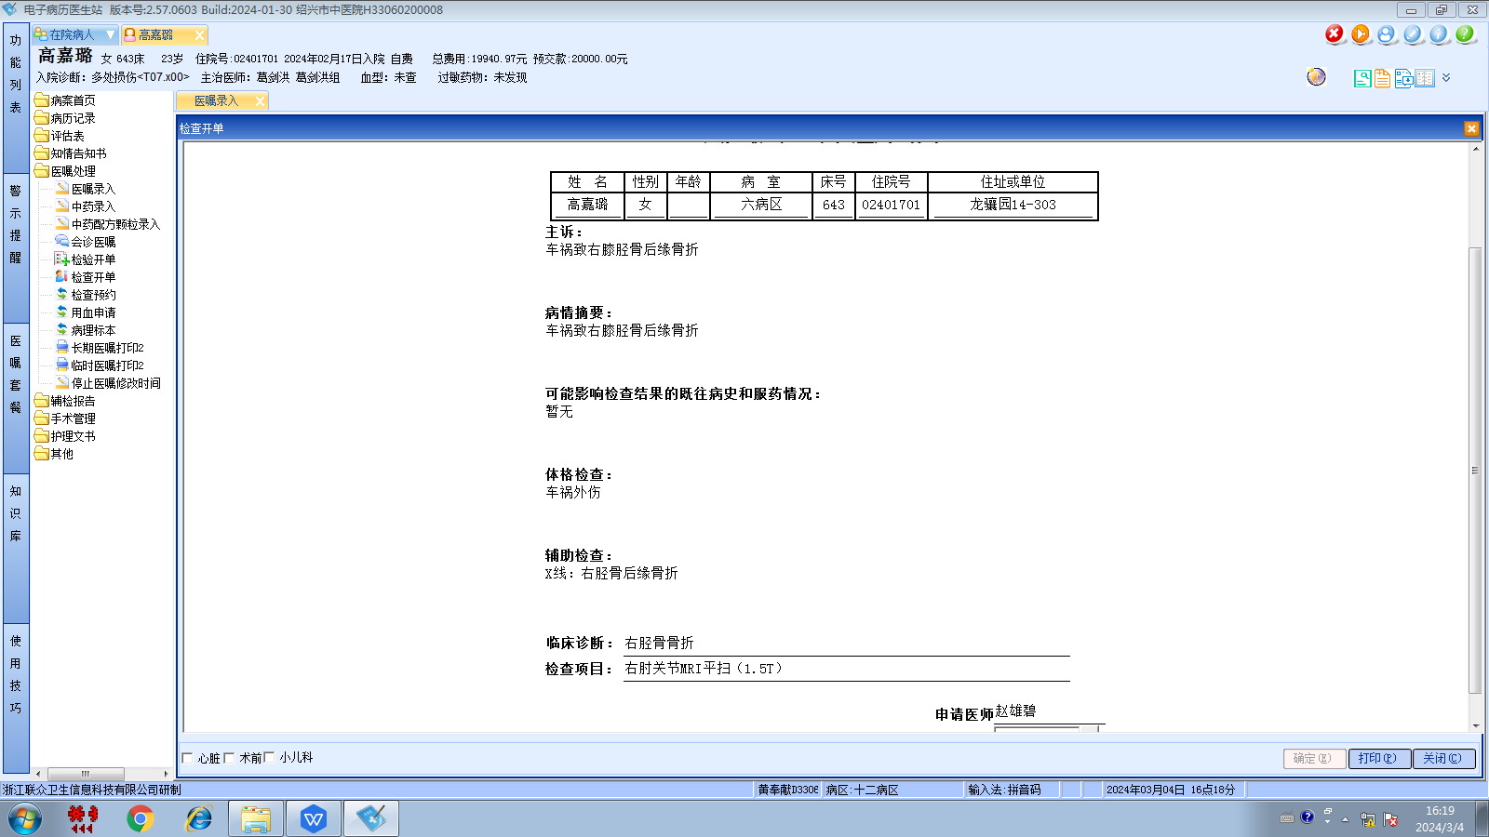张建宇组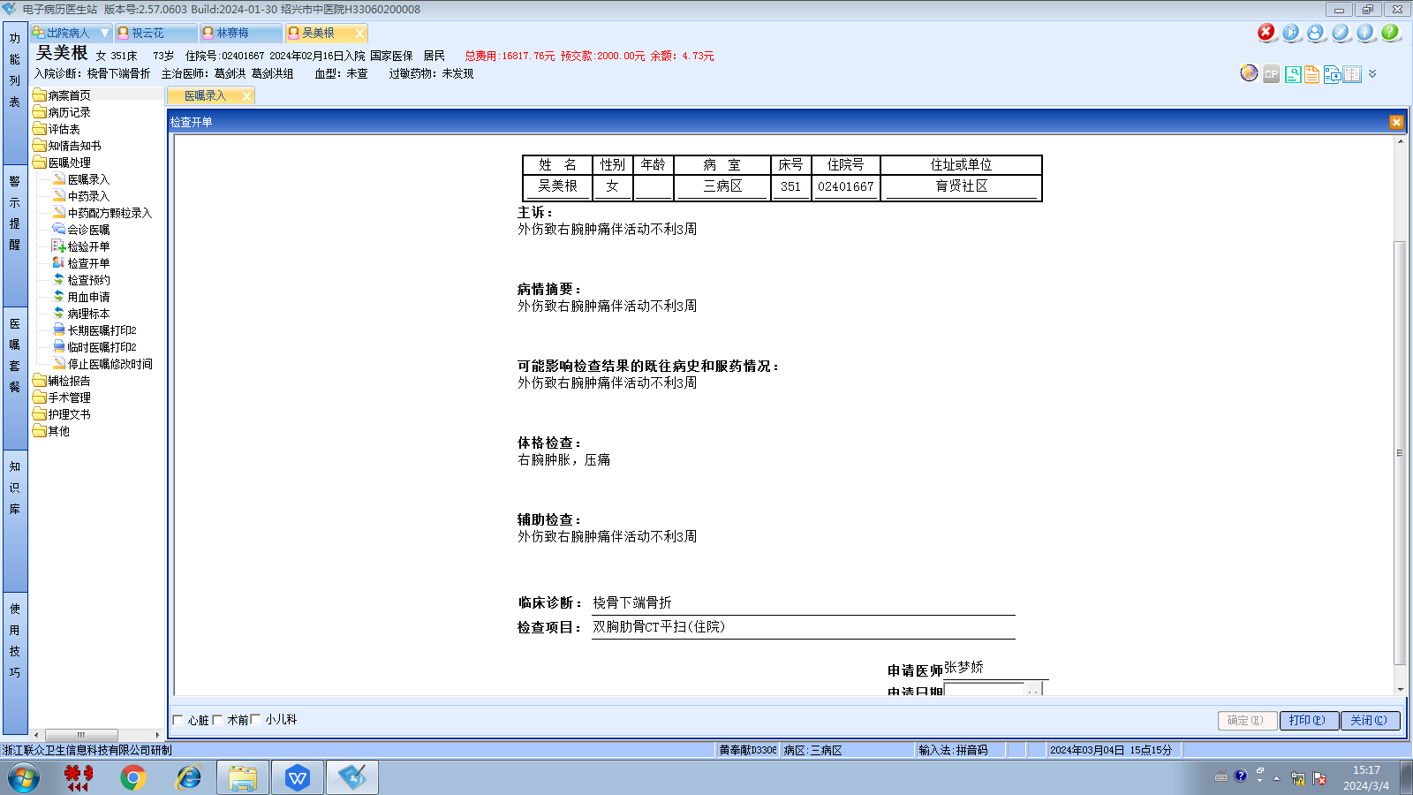葛剑洪组
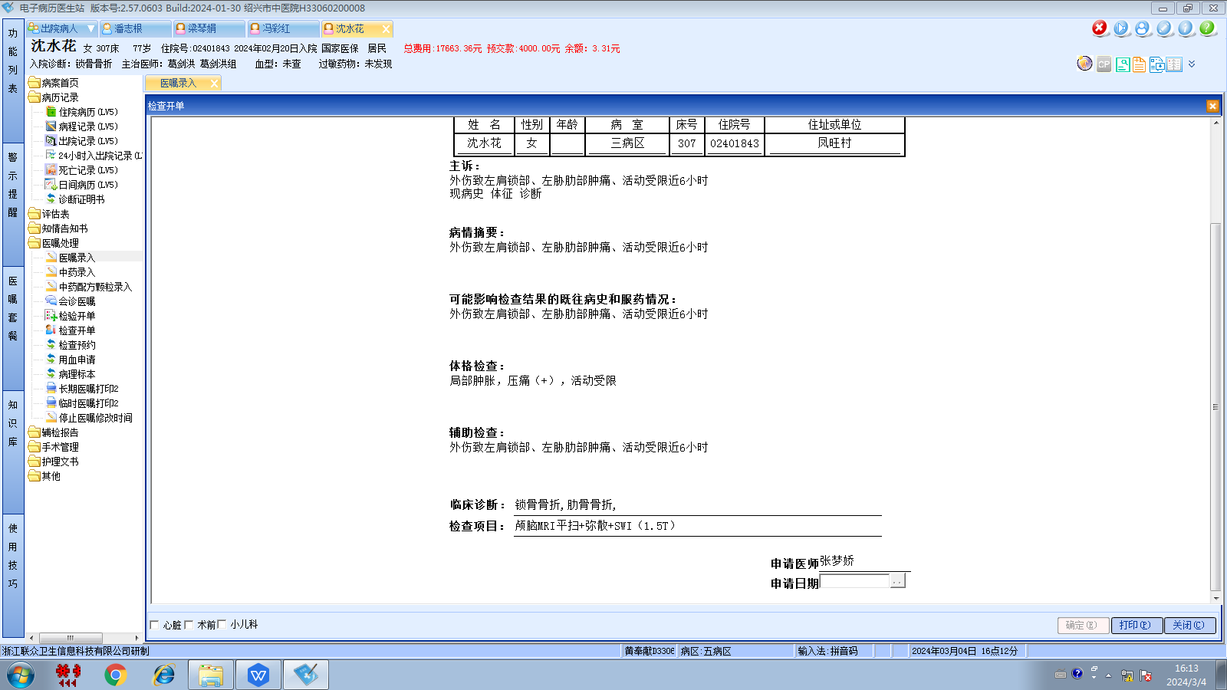葛剑洪组
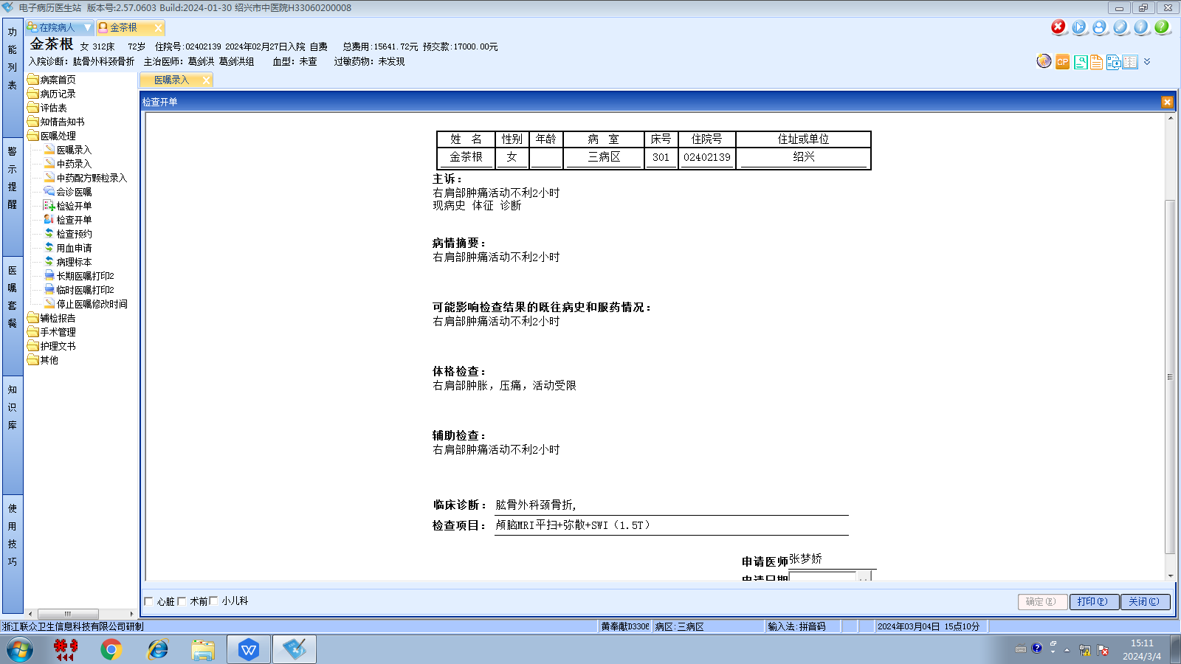葛剑洪组
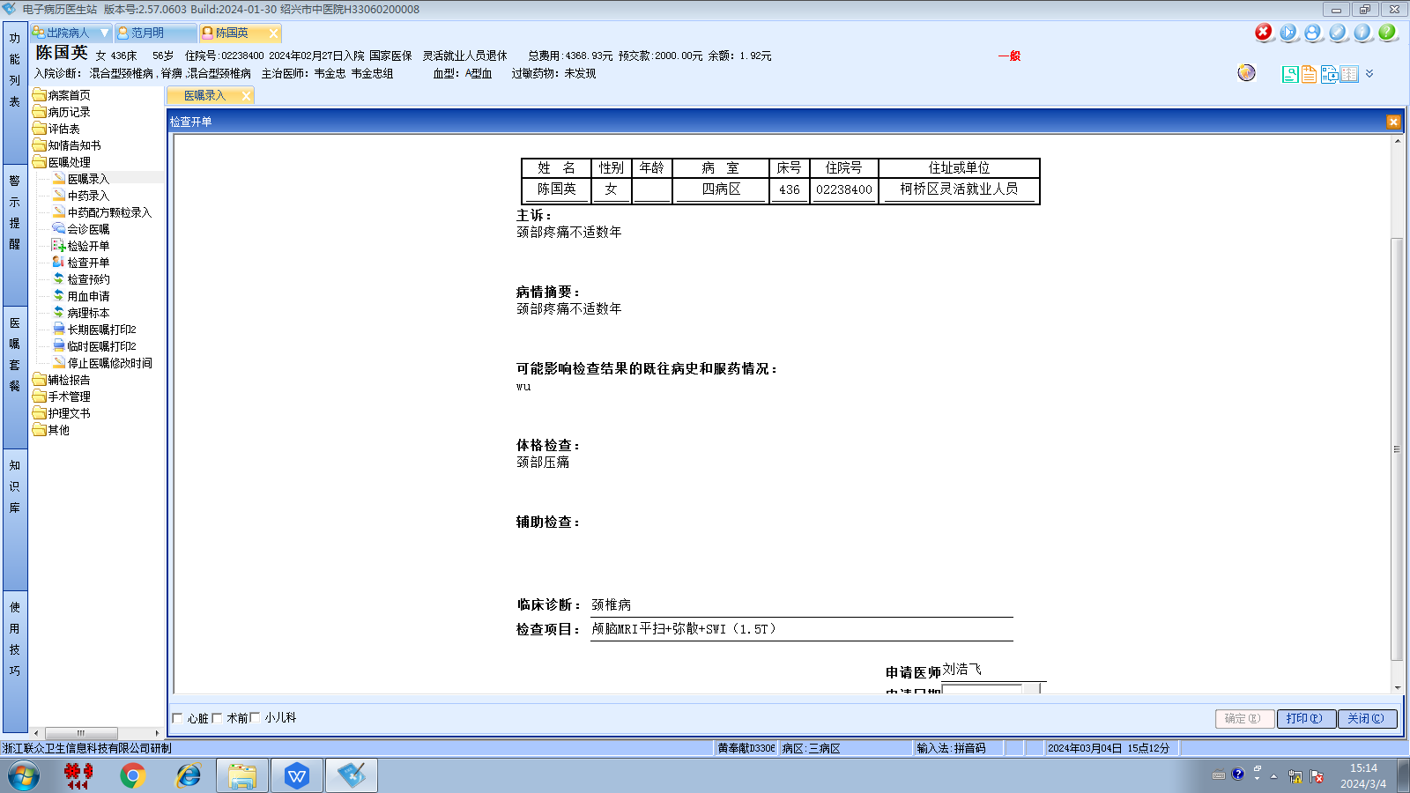韦金忠组
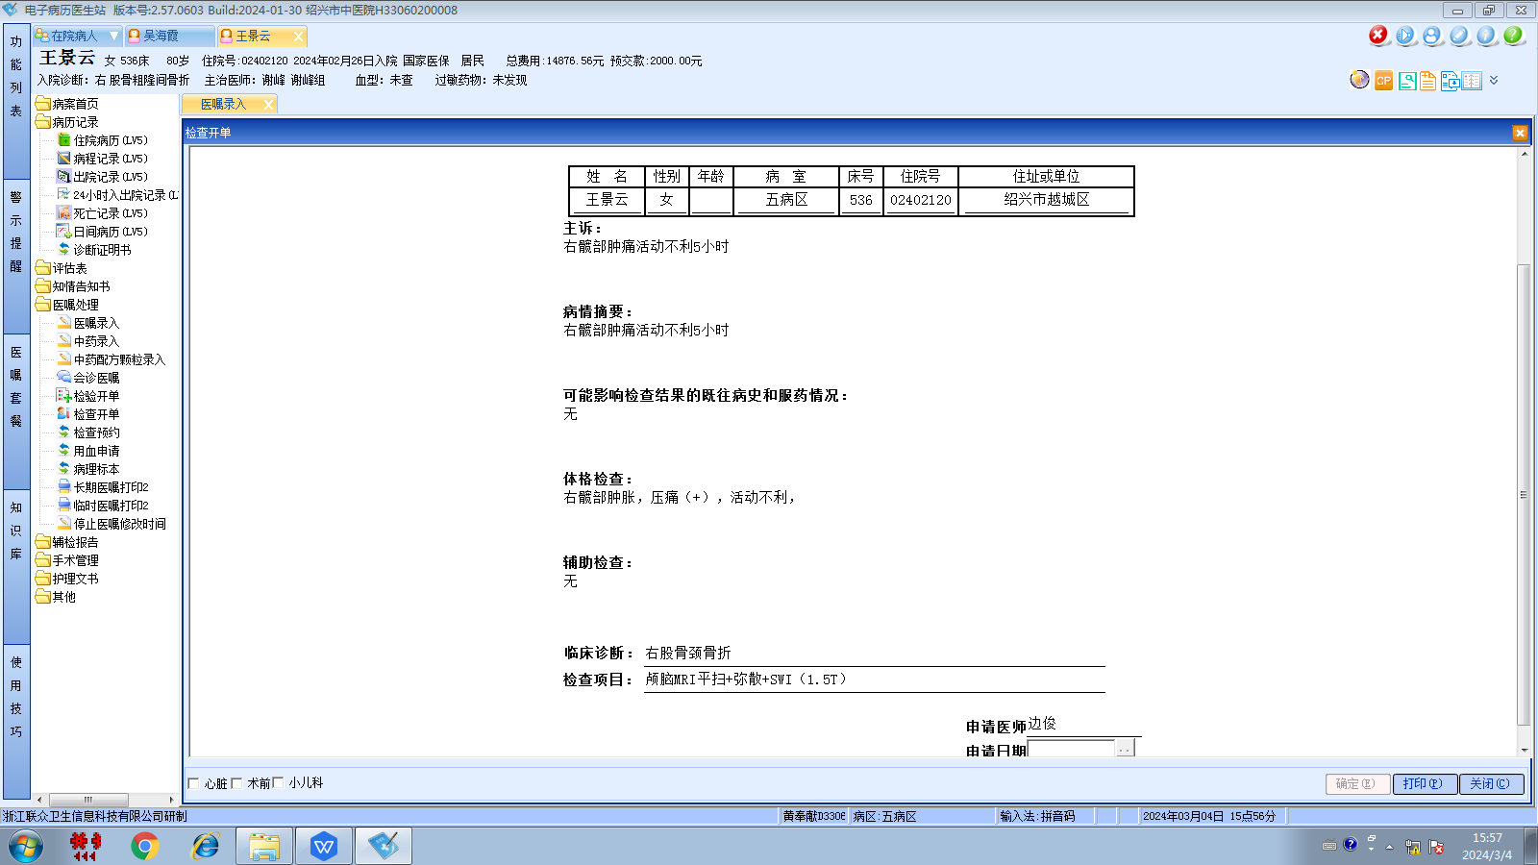谢峰组
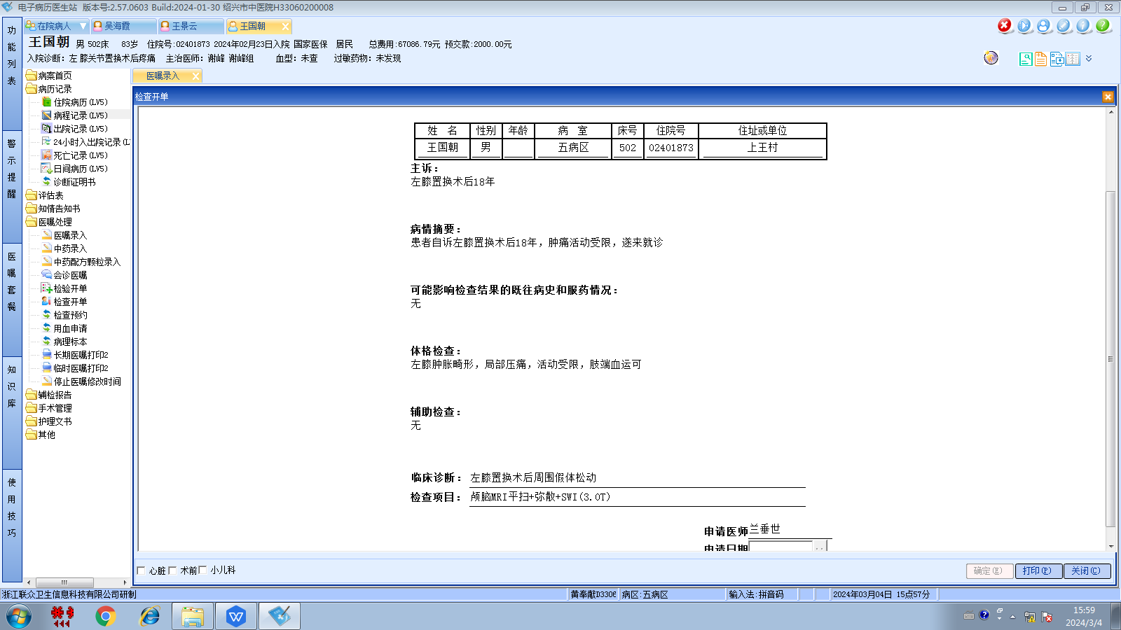谢峰组
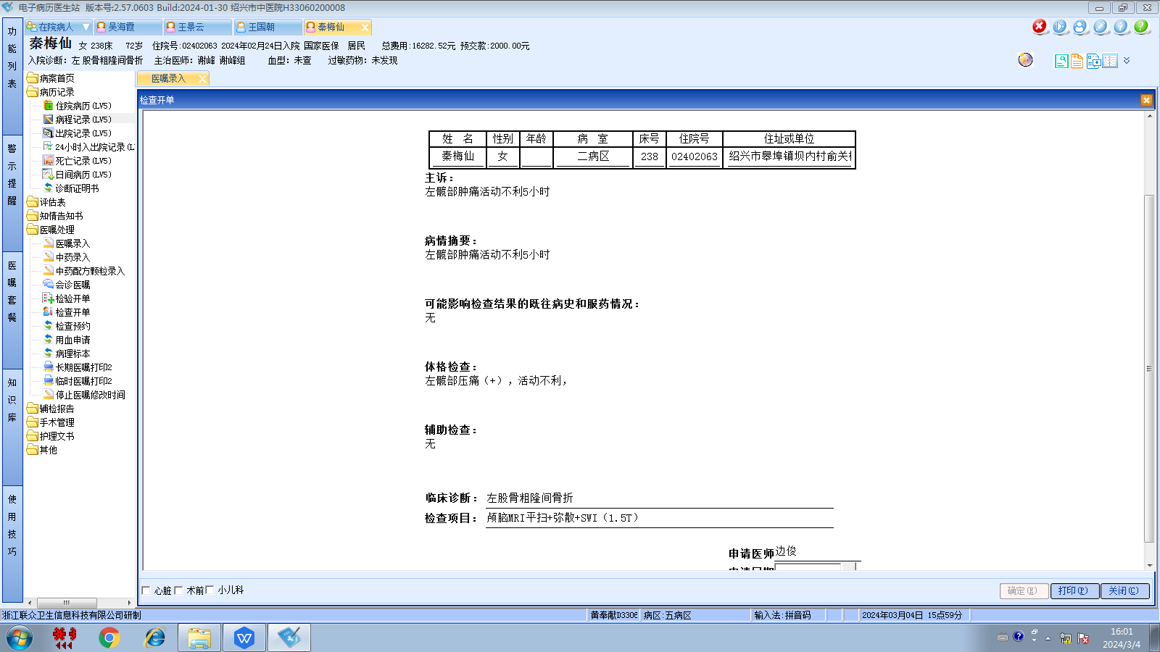谢峰组
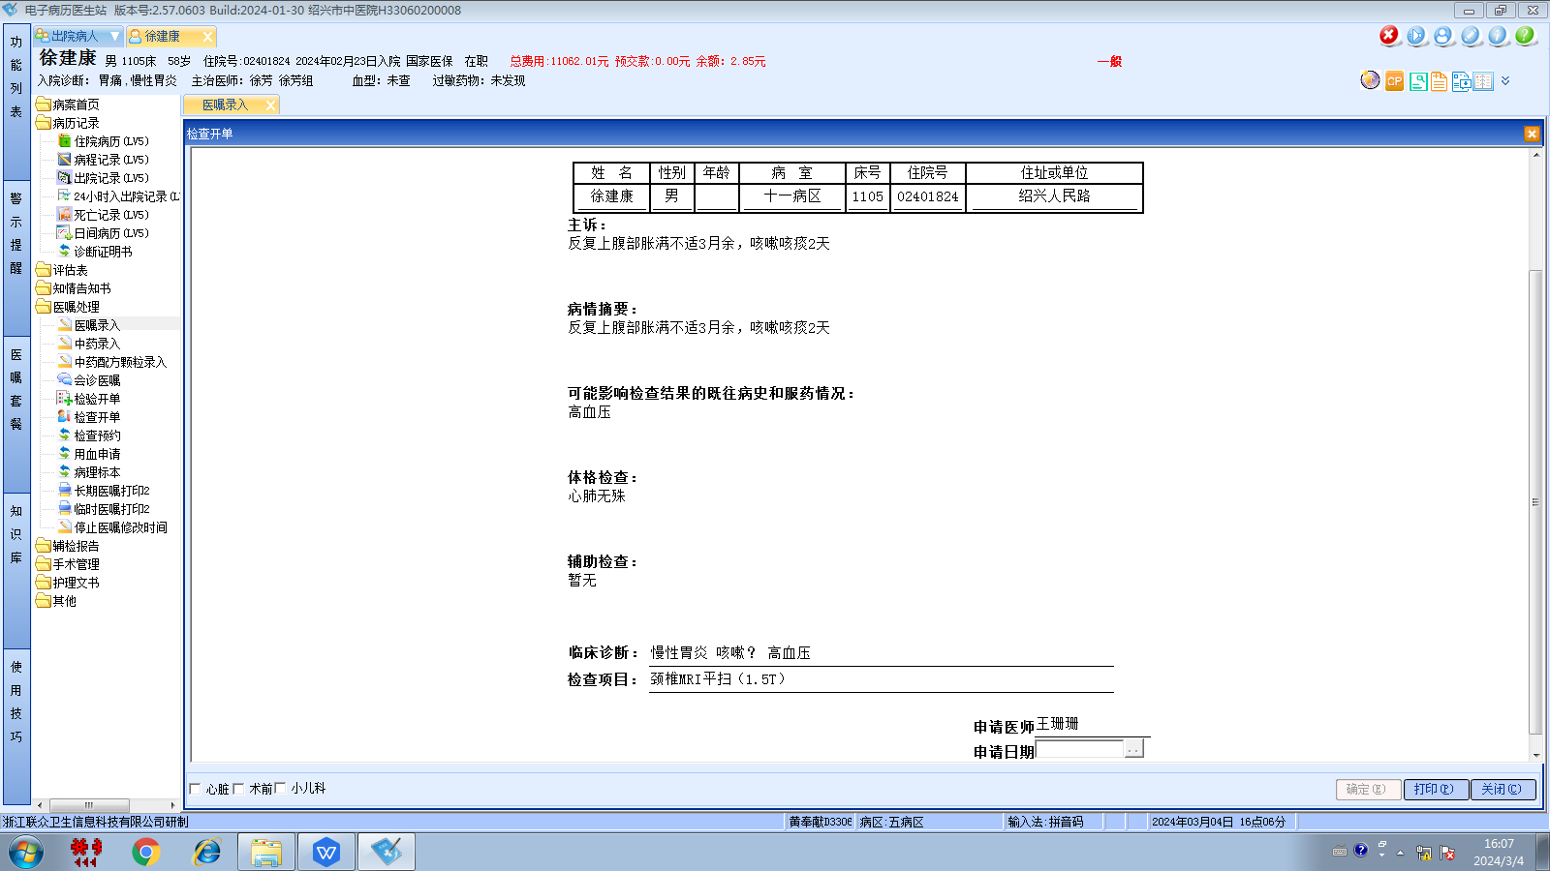徐芳组
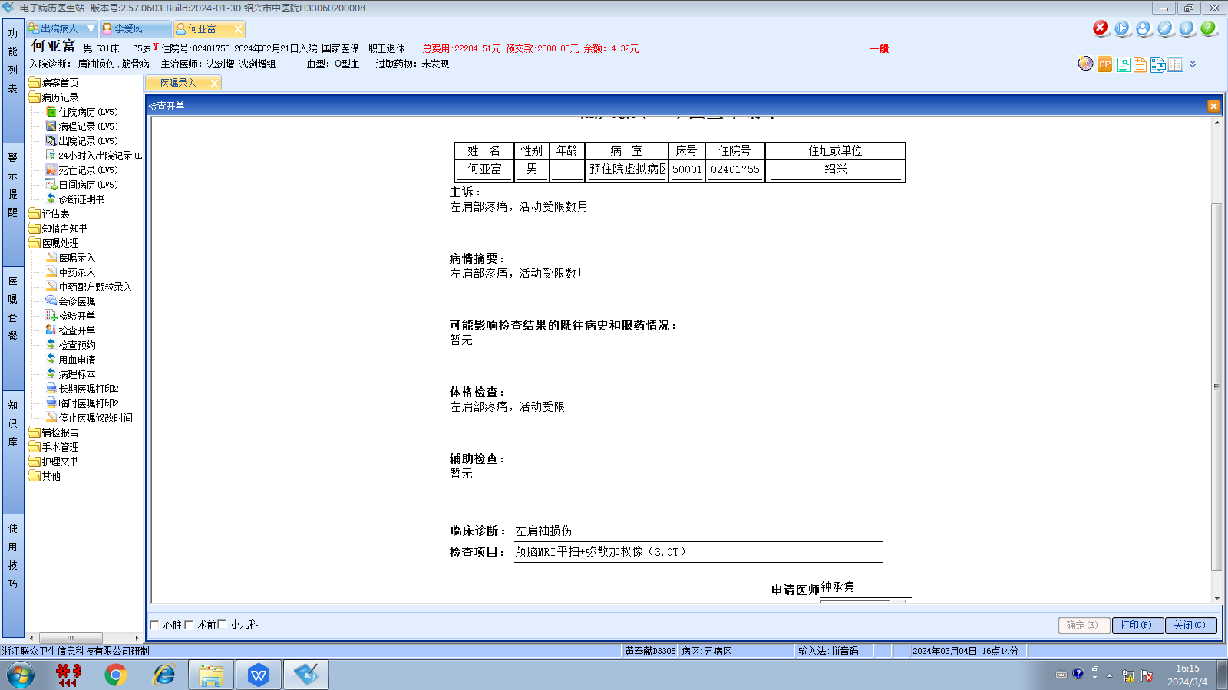沈剑增组

