5月检查申请单质控
住院号 | 检查单类型 | 开单日期 | 开单医师 |  |  | 检查项目
 |  |  |  | 主诉 | 病情摘要 |  | 既往史 | 体格检查 | 辅助检查 | 诊断 | 内容申请单不一致
02404827 | MR | 2024-5-1 | 赵雄碧 | √ | √ |  | √ | √ | √ | √ | √
02404827 | MR | 2024-5-2 | 赵雄碧 | √ | √ |  | √ | √ | √ | √ | √
02404903 | MR | 2024-5-1 | 苗超峰 | √ | √ |  | √ | √ | √ | √ | √
02404903 | MR | 2024-5-2 | 沈丽娜 | √ | √ |  | √ | √ | √ | √ | √
02110171 | MR | 2024-5-1 | 王风永 | √ | √ |  | √ | √ | √ | √ | √
02266278 | CT | 2024-5-1 | 胡飞剑 | √ | √ |  | √ | √ | √ | √ | √
02237986 | MR | 2024-5-1 | 尤志新 | √ | √ |  | √ | √ | √ | √ | √
02404898 | MR | 2024-5-1 | 陶铁瑛 | √ | √ |  | √ | √ | √ | √ | √
02404796 | MR | 2024-4-30 | 凌一鸣 | √ | √ |  | √ | √ | √ | √ | √
02404796 | CT | 2024-5-2 | 王立波 | √ | √ |  | √ | √ | √ | √ | √
01407384 | MR | 2024-5-2 | 黄操 | √ | √ |  | √ | √ | √ | √ | √
02404968 | CT | 2024-5-3 | 谢睿 | √ | √ |  | √ | √ | √ | √ | √
01915942 | MR | 2024-5-3 | 黄操 | √ | √ |  | √ | √ | √ | √ | √
01508719 | CT | 2024-5-2 | 张学思 | √ | √ |  | √ | √ | √ | √ | √
02404895 | CT | 2024-5-4 | 沈沉 | √ | √ |  | √ | √ | √ | √ | √
02404916 | MR | 2024-5-4 | 张圣扬 | √ | √ |  | √ | √ | √ | √ | √
01910173 | MR | 2024-5-4 | 边俊 | √ | √ |  | √ | √ | √ | √ | √
01908977 | CT | 2024-5-4 | 安艳军 | √ | √ |  | √ | √ | √ | √ | √
01908977 | CT | 2024-5-7 | 安艳军 | √ | √ |  | √ | √ | √ | √ | √
02404982 | MR | 2024-5-4 | 钟承隽 | √ | √ |  | √ | √ | √ | √ | √
02405069 | MR | 2024-5-5 | 谢超 | √ | √ |  | √ | √ | √ | √ | √
02264804 | CT | 2024-5-6 | 马军华 | √ | √ |  | √ | √ | √ | √ | √
01703805 | MR | 2024-5-3 | 边俊 | √ | √ |  | √ | √ | √ | √ | ×
01910619 | MR | 2024-5-3 | 罗桢敏 | √ | √ |  | √ | √ | √ | √ | √
02400816 | MR | 2024-5-5 | 陈剑磨 | √ | √ |  | √ | √ | √ | √ | √
02405046 | MR | 2024-5-6 | 杨锋 | √ | √ |  | √ | √ | √ | √ | √
02261332 | CT | 2024-5-7 | 安艳军 | √ | √ |  | √ | √ | √ | √ | √
02404983 | MR | 2024-5-5 | 俞梅 | √ | √ |  | √ | √ | √ | √ | √
02404782 | MR | 2024-5-7 | 王敏龙 | √ | √ |  | √ | √ | √ | √ | √
02264214 | CT | 2024-5-6 | 安艳军 | √ | √ |  | √ | √ | √ | √ | √
02404807 | CT | 2024-5-8 | 刘悦 | √ | √ |  | √ | √ | √ | √ | √
01808607 | MR | 2024-5-7 | 葛剑洪 | √ | √ |  | √ | √ | √ | √ | √
01307190 | MR | 2024-5-7 | 郑德财 | √ | √ |  | √ | √ | √ | √ | √
02405162 | CT | 2024-5-8 | 刘运海 | √ | √ |  | √ | √ | √ | √ | √
01502164 | MR | 2024-5-8 | 沈沉 | √ | √ |  | √ | √ | √ | √ | √
02405095 | MR | 2024-5-9 | 龙平 | √ | √ |  | √ | √ | √ | √ | √
02405238 | MR | 2024-5-10 | 黄操 | √ | √ |  | √ | √ | √ | √ | √
02405242 | CT | 2024-5-10 | 鲁剑梅 | √ | √ |  | √ | √ | √ | √ | √
02405167 | MR | 2024-5-8 | 周怡 | √ | √ |  | √ | √ | √ | √ | √
02405315 | MR | 2024-5-11 | 黄操 | √ | √ |  | √ | √ | √ | √ | √
02405315 | MR | 2024-5-12 | 王珊珊 | √ | √ |  | √ | √ | √ | √ | √
02405238 | CT | 2024-5-10 | 黄操 | √ | √ |  | √ | √ | √ | √ | √
02400617 | MR | 2024-5-11 | 苗超峰 | √ | √ |  | √ | √ | √ | √ | √
01902823 | MR | 2024-5-10 | 谢超 | √ | √ |  | √ | √ | √ | √ | √
02405314 | MR | 2024-5-11 | 许海锋 | √ | √ |  | √ | √ | √ | √ | √
02405314 | MR | 2024-5-12 | 王珊珊 | √ | √ |  | √ | √ | √ | √ | √
02405314 | MR | 2024-5-14 | 许海锋 | √ | √ |  | √ | √ | √ | √ | √
01811436 | MR | 2024-5-12 | 陈剑磨 | √ | √ |  | √ | √ | √ | √ | √
01400965 | MR | 2024-5-12 | 刘悦 | √ | √ |  | √ | √ | √ | √ | √
02405130 | MR | 2024-5-13 | 黄操 | √ | √ |  | √ | √ | √ | √ | √
01813111 | MR | 2024-5-12 | 王轶辉 | √ | √ |  | √ | √ | √ | √ | √
01801666 | MR | 2024-5-13 | 卢璐 | √ | √ |  | √ | √ | √ | √ | √
02405320 | MR | 2024-5-12 | 林武 | √ | √ |  | √ | √ | √ | √ | √
02405217 | MR | 2024-5-12 | 朱海波 | √ | √ |  | √ | √ | √ | √ | √
02404962 | MR | 2024-5-13 | 赵雄碧 | √ | √ |  | √ | √ | √ | √ | √
02404962 | MR | 2024-5-14 | 支飞虎 | √ | √ |  | √ | √ | √ | √ | √
01104702 | MR | 2024-5-12 | 陈剑磨 | √ | √ |  | √ | √ | √ | √ | √
02405207 | MR | 2024-5-13 | 罗桢敏 | √ | √ |  | √ | √ | √ | √ | √
02405393 | MR | 2024-5-13 | 张梦娇 | √ | √ |  | √ | √ | √ | √ | √
02405393 | CT | 2024-5-13 | 张梦娇 | √ | √ |  | √ | √ | √ | √ | √
02405129 | MR | 2024-5-13 | 杨兴辉 | √ | √ |  | √ | √ | √ | √ | √
02239001 | MR | 2024-5-13 | 程爵富 | √ | √ |  | √ | √ | √ | √ | √
02402967 | CT | 2024-5-13 | 王风永 | √ | √ |  | √ | √ | √ | √ | √
02405297 | MR | 2024-5-14 | 沈丽娜 | √ | √ |  | √ | √ | √ | √ | √
02405297 | MR | 2024-5-15 | 谢超 | √ | √ |  | √ | √ | √ | √ | √
02405297 | MR | 2024-5-18 | 王一萍 | √ | √ |  | √ | √ | √ | √ | √
02255053 | CT | 2024-5-14 | 杜菲 | √ | √ |  | √ | √ | √ | √ | √
02240569 | MR | 2024-5-14 | 谢峰 | √ | √ |  | √ | √ | √ | √ | √
01811955 | MR | 2024-5-13 | 钟承隽 | √ | √ |  | √ | √ | √ | √ | √
02259143 | MR | 2024-5-15 | 黄操 | √ | √ |  | √ | √ | √ | √ | √
02405399 | MR | 2024-5-14 | 沈钱理 | √ | √ |  | √ | √ | √ | √ | √
02405399 | MR | 2024-5-16 | 诸佳燕 | √ | √ |  | √ | √ | √ | √ | √
02405377 | MR | 2024-5-17 | 沈钱理 | √ | √ |  | √ | √ | √ | √ | √
02405372 | CT | 2024-5-16 | 金建淼 | √ | √ |  | √ | √ | √ | √ | √
02405587 | MR | 2024-5-17 | 沈钱理 | √ | √ |  | √ | √ | √ | √ | √
02405587 | CT | 2024-5-17 | 沈钱理 | √ | √ |  | √ | √ | √ | √ | √
01916745 | CT | 2024-5-18 | 刘浩飞 | √ | √ |  | √ | √ | √ | √ | √
02405502 | CT | 2024-5-16 | 赵艳明 | √ | √ |  | √ | √ | √ | √ | √
02405219 | MR | 2024-5-16 | 诸佳燕 | √ | √ |  | √ | √ | √ | √ | √
02405618 | MR | 2024-5-18 | 苗超峰 | √ | √ |  | √ | √ | √ | √ | √
02405151 | CT | 2024-5-15 | 张梦娇 | √ | √ |  | √ | √ | √ | √ | √
02405496 | MR | 2024-5-15 | 张梦娇 | √ | √ |  | √ | √ | √ | √ | √
02405624 | MR | 2024-5-18 | 凌一鸣 | √ | √ |  | √ | √ | √ | √ | √
02105043 | MR | 2024-5-18 | 卢璐 | √ | √ |  | √ | √ | √ | √ | √
01906956 | MR | 2024-5-19 | 胡飞剑 | √ | √ |  | √ | √ | √ | √ | √
01813881 | MR | 2024-5-20 | 祝笛 | √ | √ |  | √ | √ | √ | √ | ×
02405565 | CT | 2024-5-21 | 安艳军 | √ | √ |  | √ | √ | √ | √ | √
02405707 | MR | 2024-5-20 | 许杨 | √ | √ |  | √ | √ | √ | √ | √
02405570 | MR | 2024-5-22 | 黄操 | √ | √ |  | √ | √ | √ | √ | √
02405824 | MR | 2024-5-22 | 支飞虎 | √ | √ |  | √ | √ | √ | √ | √
02405765 | MR | 2024-5-22 | 胡飞剑 | √ | √ |  | √ | √ | √ | √ | √
02405847 | MR | 2024-5-22 | 程爵富 | √ | √ |  | √ | √ | √ | √ | √
02405622 | MR | 2024-5-22 | 王珊珊 | √ | √ |  | √ | √ | √ | √ | √
02405536 | MR | 2024-5-23 | 周怡 | √ | √ |  | √ | √ | √ | √ | √
02405842 | MR | 2024-5-22 | 许杨 | √ | √ |  | √ | √ | √ | √ | √
02110300 | MR | 2024-5-22 | 孟闯闯 | √ | √ |  | √ | √ | √ | √ | √
02405746 | MR | 2024-5-23 | 鲁剑梅 | √ | √ |  | √ | √ | √ | √ | √
02405786 | MR | 2024-5-21 | 龙平 | √ | √ |  | √ | √ | √ | √ | √
02405786 | MR | 2024-5-22 | 边佳萍 | √ | √ |  | √ | √ | √ | √ | √
02405901 | CT | 2024-5-24 | 陆超锋 | √ | √ |  | √ | √ | √ | √ | √
02405720 | CT | 2024-5-21 | 安艳军 | √ | √ |  | √ | √ | √ | √ | √
01713656 | MR | 2024-5-24 | 郑德财 | √ | √ |  | √ | √ | √ | √ | √
01205442 | CT | 2024-5-24 | 金建淼 | √ | √ |  | √ | √ | √ | √ | √
02262214 | MR | 2024-5-24 | 刘悦 | √ | √ |  | √ | √ | √ | √ | √
02262214 | MR | 2024-5-25 | 许伟攀 | √ | √ |  | √ | √ | √ | √ | √
02245296 | CT | 2024-5-25 | 许伟攀 | √ | √ |  | √ | √ | √ | √ | √
02405940 | CT | 2024-5-25 | 王磊 | √ | √ |  | √ | √ | √ | √ | √
02263508 | MR | 2024-5-25 | 安艳军 | √ | √ |  | √ | √ | √ | √ | √
01708877 | MR | 2024-5-27 | 兰垂世 | √ | √ |  | √ | √ | √ | √ | √
02405826 | MR | 2024-5-23 | 龙平 | √ | √ |  | √ | √ | √ | √ | √
02405963 | MR | 2024-5-26 | 胡飞剑 | √ | √ |  | √ | √ | √ | √ | √
02405869 | CT | 2024-5-24 | 刘磊 | √ | √ |  | √ | √ | √ | √ | √
02405869 | MR | 2024-5-27 | 刘磊 | √ | √ |  | √ | √ | √ | √ | √
02405816 | CT | 2024-5-25 | 陈剑磨 | √ | √ |  | √ | √ | √ | √ | √
02256690 | MR | 2024-5-27 | 鲁剑梅 | √ | √ |  | √ | √ | √ | √ | √
02256690 | MR | 2024-5-28 | 安艳军 | √ | √ |  | √ | √ | √ | √ | √
02256690 | CT | 2024-5-29 | 鲁剑梅 | √ | √ |  | √ | √ | √ | √ | √
02405979 | MR | 2024-5-27 | 谢超 | √ | √ |  | √ | √ | √ | √ | √
02405979 | MR | 2024-5-29 | 沈丽娜 | √ | √ |  | √ | √ | √ | √ | √
02406028 | MR | 2024-5-27 | 张梦娇 | √ | √ |  | √ | √ | √ | √ | √
02405701 | CT | 2024-5-29 | 张梦娇 | √ | √ |  | √ | √ | √ | √ | √
02406156 | MR | 2024-5-30 | 陶铁瑛 | √ | √ |  | √ | √ | √ | √ | √
02406027 | MR | 2024-5-29 | 朱涵杰 | √ | √ |  | √ | √ | √ | √ | √
02406088 | MR | 2024-5-29 | 兰垂世 | √ | √ |  | √ | √ | √ | √ | √
01312274 | CT | 2024-5-31 | 王敏龙 | √ | √ |  | √ | √ | √ | √ | √
02264883 | MR | 2024-5-28 | 葛剑洪 | √ | √ |  | √ | √ | √ | √ | √
02406024 | CT | 2024-5-31 | 安艳军 | √ | √ |  | √ | √ | √ | √ | √
01706269 | MR | 2024-5-30 | 苗超峰 | √ | √ |  | √ | √ | √ | √ | √
注：对住院患者检查申请单进行专项检查，其中主诉、体格检查或诊断任缺一项者视为不合格申请单；非入院常规检查，如申请单内容与检查部位及要求不一致，亦视为不合格申请单。
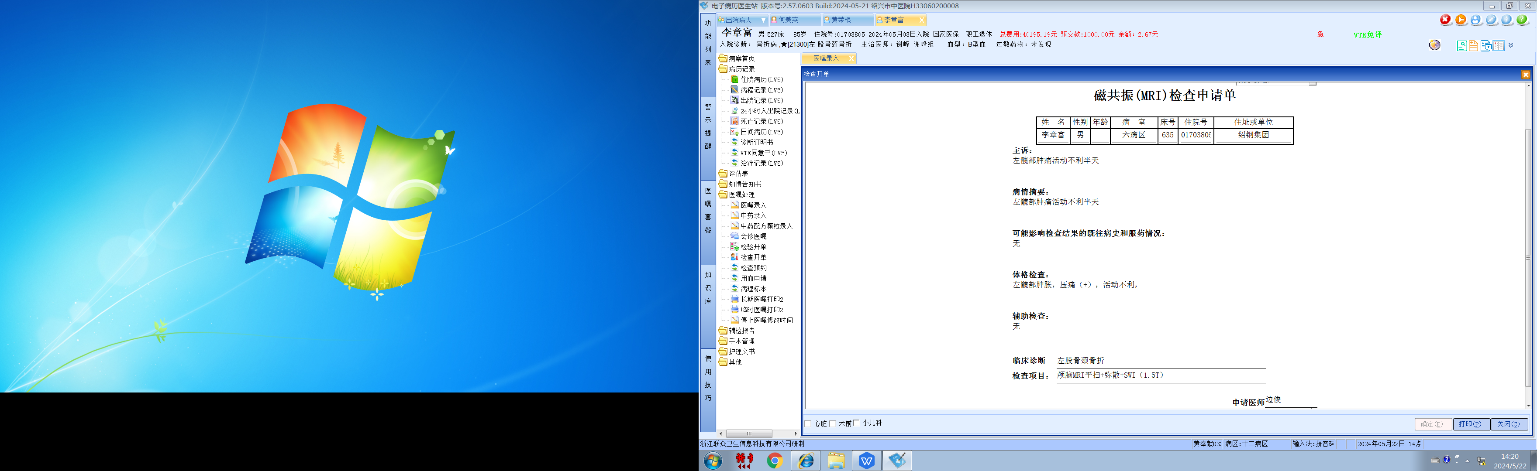谢峰组
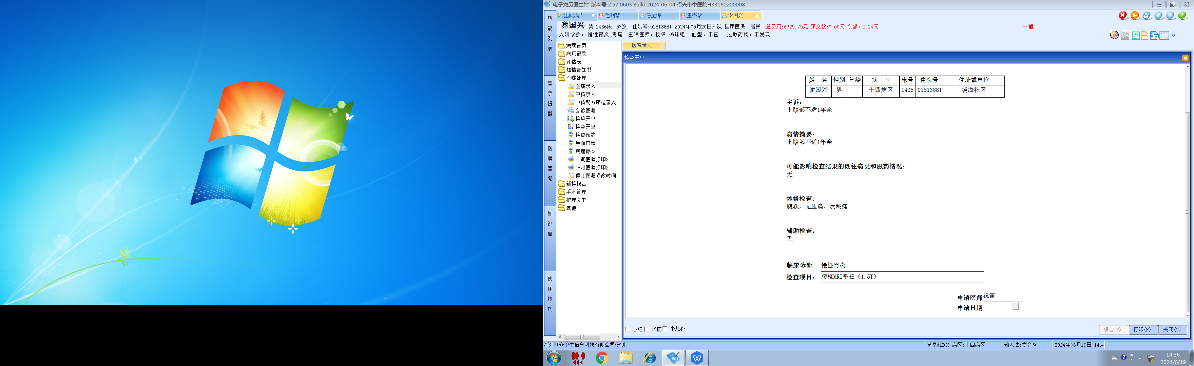杨锋组

