7月检查申请单质控
住院号 | 检查单类型 | 开单日期 | 开单医师 |  |  | 检查项目
 |  |  |  | 主诉 | 病情摘要 |  | 既往史 | 体格检查 | 辅助检查 | 诊断 | 内容申请单不一致
02407198 | CT | 2024-7-1 | 陆超锋 | √ | √ |  | √ | √ | √ | √ | √
02407242 | CT | 2024-7-1 | 安艳军 | √ | √ |  | √ | √ | √ | √ | √
02239855 | MR | 2024-6-30 | 胡飞剑 | √ | √ |  | √ | √ | √ | √ | √
01913801 | MR | 2024-7-1 | 陶铁瑛 | √ | √ |  | √ | √ | √ | √ | √
02407496 | MR | 2024-7-1 | 王冰清 | √ | √ |  | √ | √ | √ | √ | √
02407511 | CT | 2024-7-2 | 王冰清 | √ | √ |  | √ | √ | √ | √ | √
02407535 | MR | 2024-7-2 | 陆超锋 | √ | √ |  | √ | √ | √ | √ | √
02407475 | MR | 2024-7-2 | 卢璐 | √ | √ |  | √ | √ | √ | √ | √
02407504 | CT | 2024-7-2 | 王洪灿 | √ | √ |  | √ | √ | √ | √ | √
02403685 | MR | 2024-7-2 | 杜菲 | √ | √ |  | √ | √ | √ | √ | √
01809646 | MR | 2024-7-3 | 尤志新 | √ | √ |  | √ | √ | √ | √ | √
01809646 | MR | 2024-7-5 | 裘陈茹婷 | √ | √ |  | √ | √ | √ | √ | √
02102295 | MR | 2024-7-2 | 谢峰 | √ | √ |  | √ | √ | √ | √ | √
01704634 | MR | 2024-7-2 | 罗桢敏 | √ | √ |  | √ | √ | √ | √ | √
02407423 | MR | 2024-7-2 | 陈俊杰 | √ | √ |  | √ | √ | √ | √ | √
02239887 | CT | 2024-7-1 | 安艳军 | √ | √ |  | √ | √ | √ | √ | √
02407667 | MR | 2024-7-4 | 沈学香 | √ | √ |  | √ | √ | √ | √ | √
02407667 | MR | 2024-7-5 | 沈学香 | √ | √ |  | √ | √ | √ | √ | √
01805488 | MR | 2024-7-4 | 卢璐 | √ | √ |  | √ | √ | √ | √ | √
01913530 | CT | 2024-7-4 | 吴明 | √ | √ |  | √ | √ | √ | √ | √
02407727 | CT | 2024-7-6 | 程爵富 | √ | √ |  | √ | √ | √ | √ | √
01914965 | MR | 2024-7-6 | 杨锋 | √ | √ |  | √ | √ | √ | √ | √
02407524 | CT | 2024-7-5 | 裘陈茹婷 | √ | √ |  | √ | √ | √ | √ | √
02407533 | MR | 2024-7-4 | 边佳萍 | √ | √ |  | √ | √ | √ | √ | √
02002509 | MR | 2024-7-7 | 凌一鸣 | √ | √ |  | √ | √ | √ | √ | √
02407809 | MR | 2024-7-8 | 沈家峰 | √ | √ |  | √ | √ | √ | √ | √
01903240 | MR | 2024-7-8 | 张梦娇 | √ | √ |  | √ | √ | √ | √ | √
02407698 | CT | 2024-7-10 | 谢峰 | √ | √ |  | √ | √ | √ | √ | √
02407843 | MR | 2024-7-9 | 何建明 | √ | √ |  | √ | √ | √ | √ | √
01803221 | MR | 2024-7-9 | 朱海波 | √ | √ |  | √ | √ | √ | √ | √
01913416 | MR | 2024-7-9 | 沈丽娜 | √ | √ |  | √ | √ | √ | √ | √
02242412 | MR | 2024-7-10 | 谢峰 | √ | √ |  | √ | √ | √ | √ | √
02407910 | MR | 2024-7-10 | 赵艳明 | √ | √ |  | √ | √ | √ | √ | √
02255117 | MR | 2024-7-11 | 唐鋆超 | √ | √ |  | √ | √ | √ | √ | √
01911966 | MR | 2024-7-11 | 俞梅 | √ | √ |  | √ | √ | √ | √ | √
02407843 | MR | 2024-7-9 | 何建明 | √ | √ |  | √ | √ | √ | √ | √
02407874 | MR | 2024-7-10 | 苗超峰 | √ | √ |  | √ | √ | √ | √ | √
02407934 | MR | 2024-7-11 | 陆超锋 | √ | √ |  | √ | √ | √ | √ | √
02407824 | MR | 2024-7-10 | 王珊珊 | √ | √ |  | √ | √ | √ | √ | √
02407977 | MR | 2024-7-12 | 杜菲 | √ | √ |  | √ | √ | √ | √ | √
02406081 | CT | 2024-7-12 | 王立波 | √ | √ |  | √ | √ | √ | √ | √
02407888 | MR | 2024-7-12 | 苗超峰 | √ | √ |  | √ | √ | √ | √ | √
02108983 | MR | 2024-7-13 | 卢璐 | √ | √ |  | √ | √ | √ | √ | √
02006764 | MR | 2024-7-12 | 王珊珊 | √ | √ |  | √ | √ | √ | √ | √
02407226 | CT | 2024-7-13 | 蒋琪 | √ | √ |  | √ | √ | √ | √ | √
02407837 | CT | 2024-7-13 | 孙莉 | √ | √ |  | √ | √ | √ | √ | √
01906627 | CT | 2024-7-12 | 樊晓琦 | √ | √ |  | √ | √ | √ | √ | √
02408037 | CT | 2024-7-14 | 陆超锋 | √ | √ |  | √ | √ | √ | √ | √
02407734 | CT | 2024-7-14 | 赵弘铭 | √ | √ |  | √ | √ | √ | √ | √
02408075 | MR | 2024-7-15 | 陶铁瑛 | √ | √ |  | √ | √ | √ | √ | √
02407978 | MR | 2024-7-15 | 刘悦 | √ | √ |  | √ | √ | √ | √ | √
02408122 | MR | 2024-7-15 | 程爵富 | √ | √ |  | √ | √ | √ | √ | √
01915710 | MR | 2024-7-14 | 王一萍 | √ | √ |  | √ | √ | √ | √ | √
02369886 | MR | 2024-7-16 | 龙平 | √ | √ |  | √ | √ | √ | √ | √
02408067 | CT | 2024-7-15 | 兰垂世 | √ | √ |  | √ | √ | √ | √ | √
02408036 | MR | 2024-7-15 | 孟闯闯 | √ | √ |  | √ | √ | √ | √ | √
02408036 | MR | 2024-7-16 | 罗桢敏 | √ | √ |  | √ | √ | √ | √ | √
02408059 | MR | 2024-7-16 | 谢超 | √ | √ |  | √ | √ | √ | √ | √
02408059 | CT | 2024-7-18 | 苗超峰 | √ | × |  | × | × | × | √ | ×
02404510 | MR | 2024-7-17 | 张华良 | √ | √ |  | √ | √ | √ | √ | √
01304496 | MR | 2024-7-15 | 王立波 | √ | √ |  | √ | √ | √ | √ | √
02407986 | MR | 2024-7-17 | 黄操 | √ | √ |  | √ | √ | √ | √ | √
02407863 | MR | 2024-7-15 | 边佳萍 | √ | √ |  | √ | √ | √ | √ | √
02262876 | MR | 2024-7-17 | 赵艳明 | √ | √ |  | √ | √ | √ | √ | √
02262876 | CT | 2024-7-17 | 赵艳明 | √ | √ |  | √ | √ | √ | √ | √
02267735 | MR | 2024-7-16 | 陆超锋 | √ | √ |  | √ | √ | √ | √ | √
02265564 | MR | 2024-7-17 | 王敏龙 | √ | √ |  | √ | √ | √ | √ | √
02408064 | MR | 2024-7-17 | 杜菲 | √ | √ |  | √ | √ | √ | √ | √
02104016 | CT | 2024-7-18 | 赵弘铭 | √ | √ |  | √ | √ | √ | √ | √
02408249 | CT | 2024-7-18 | 柴绍军 | √ | √ |  | √ | √ | √ | √ | √
02408052 | CT | 2024-7-13 | 陶铁瑛 | √ | √ |  | √ | √ | √ | √ | √
02408240 | CT | 2024-7-18 | 葛剑洪 | √ | √ |  | √ | √ | √ | √ | √
02408255 | CT | 2024-7-18 | 王敏龙 | √ | √ |  | √ | √ | √ | √ | √
02408255 | MR | 2024-7-18 | 王敏龙 | √ | √ |  | √ | √ | √ | √ | √
02408090 | MR | 2024-7-18 | 黄操 | √ | √ |  | √ | √ | √ | √ | √
02407916 | MR | 2024-7-17 | 孙利荣 | √ | √ |  | √ | √ | √ | √ | √
02408250 | CT | 2024-7-18 | 张春晓 | √ | × |  | × | × | × | √ | √
01608528 | CT | 2024-7-18 | 张春晓 | √ | × |  | × | × | × | √ | √
01608528 | MR | 2024-7-18 | 张春晓 | √ | × |  | × | × | × | √ | √
01701340 | MR | 2024-7-19 | 沈英 | √ | √ |  | √ | √ | √ | √ | √
01916479 | MR | 2024-7-18 | 张梦娇 | √ | √ |  | √ | √ | √ | √ | √
02408263 | MR | 2024-7-18 | 许华强 | √ | √ |  | √ | √ | √ | √ | √
02408153 | MR | 2024-7-19 | 刘悦 | √ | √ |  | √ | √ | √ | √ | √
01605015 | MR | 2024-7-19 | 俞梅 | √ | √ |  | √ | √ | √ | √ | √
02266322 | MR | 2024-7-18 | 孙玲玲 | √ | √ |  | √ | √ | √ | √ | √
02408232 | MR | 2024-7-20 | 金建淼 | √ | √ |  | √ | √ | √ | √ | √
02407447 | CT | 2024-7-20 | 赵弘铭 | √ | √ |  | √ | √ | √ | √ | √
02242049 | CT | 2024-7-18 | 黄操 | √ | √ |  | √ | √ | √ | √ | √
02408152 | CT | 2024-7-18 | 周怡 | √ | √ |  | √ | √ | √ | √ | √
02408140 | MR | 2024-7-19 | 鲁剑梅 | √ | √ |  | √ | √ | √ | √ | √
02408337 | MR | 2024-7-20 | 许杨 | √ | √ |  | √ | √ | √ | √ | √
20105527 | MR | 2024-7-21 | 胡飞剑 | √ | √ |  | √ | √ | √ | √ | √
02408364 | CT | 2024-7-21 | 程爵富 | √ | √ |  | √ | √ | √ | √ | √
02408262 | CT | 2024-7-19 | 程爵富 | √ | √ |  | √ | √ | √ | √ | √
01901850 | MR | 2024-7-23 | 苗超峰 | √ | √ |  | √ | √ | √ | √ | √
02408524 | MR | 2024-7-25 | 林武 | √ | √ |  | √ | √ | √ | √ | √
02408525 | CT | 2024-7-25 | 赵艳明 | √ | √ |  | √ | √ | √ | √ | √
01607501 | MR | 2024-7-26 | 程爵富 | √ | √ |  | √ | √ | √ | √ | √
02408543 | MR | 2024-7-25 | 王一萍 | √ | √ |  | √ | √ | √ | √ | √
02408493 | CT | 2024-7-26 | 安艳军 | √ | √ |  | √ | √ | √ | √ | √
02408460 | MR | 2024-7-25 | 唐鋆超 | √ | √ |  | √ | √ | √ | √ | √
02408460 | MR | 2024-7-27 | 尤志新 | √ | √ |  | √ | √ | √ | √ | √
02408590 | CT | 2024-7-26 | 张梦娇 | √ | √ |  | √ | √ | √ | √ | √
02408590 | MR | 2024-7-26 | 张梦娇 | √ | √ |  | √ | √ | √ | √ | √
02242612 | MR | 2024-7-27 | 施俊峰 | √ | √ |  | √ | √ | √ | √ | √
02408517 | MR | 2024-7-27 | 苗超峰 | √ | √ |  | √ | √ | √ | √ | √
02408571 | CT | 2024-7-26 | 张春晓 | √ | √ |  | √ | √ | √ | √ | √
02408583 | CT | 2024-7-26 | 张梦娇 | √ | √ |  | √ | √ | √ | √ | √
02408652 | MR | 2024-7-28 | 沈丽娜 | √ | √ |  | √ | √ | √ | √ | √
02408089 | MR | 2024-7-28 | 谢超 | √ | √ |  | √ | √ | √ | √ | √
02408291 | MR | 2024-7-28 | 王珊珊 | √ | √ |  | √ | √ | √ | √ | √
01801726 | MR | 2024-7-28 | 兰垂世 | √ | √ |  | √ | √ | √ | √ | √
02408640 | MR | 2024-7-28 | 朱大明 | √ | √ |  | √ | √ | √ | √ | √
01607450 | MR | 2024-7-28 | 俞梅 | √ | √ |  | √ | √ | √ | √ | √
02408638 | CT | 2024-7-29 | 王立波 | √ | √ |  | √ | √ | √ | √ | √
02408652 | MR | 2024-7-29 | 沈丽娜 | √ | √ |  | √ | √ | √ | √ | √
02003759 | CT | 2024-7-29 | 董珍 | √ | √ |  | √ | √ | √ | √ | √
02408542 | CT | 2024-7-27 | 孙莉 | √ | √ |  | √ | √ | √ | √ | √
02408721 | CT | 2024-7-30 | 王敏龙 | √ | √ |  | √ | √ | √ | √ | √
02408260 | MR | 2024-7-30 | 苗超峰 | √ | √ |  | √ | √ | √ | √ | √
02408260 | MR | 2024-7-31 | 王一萍 | √ | √ |  | √ | √ | √ | √ | √
02408106 | MR | 2024-7-30 | 沈剑增 | √ | √ |  | √ | √ | √ | √ | √
02408737 | MR | 2024-7-31 | 鲁剑梅 | √ | √ |  | √ | √ | √ | √ | √
02408503 | CT | 2024-7-31 | 陈剑磨 | √ | √ |  | √ | √ | √ | √ | √
注：对住院患者检查申请单进行专项检查，其中主诉、体格检查或诊断任缺一项者视为不合格申请单；非入院常规检查，如申请单内容与检查部位及要求不一致，亦视为不合格申请单。
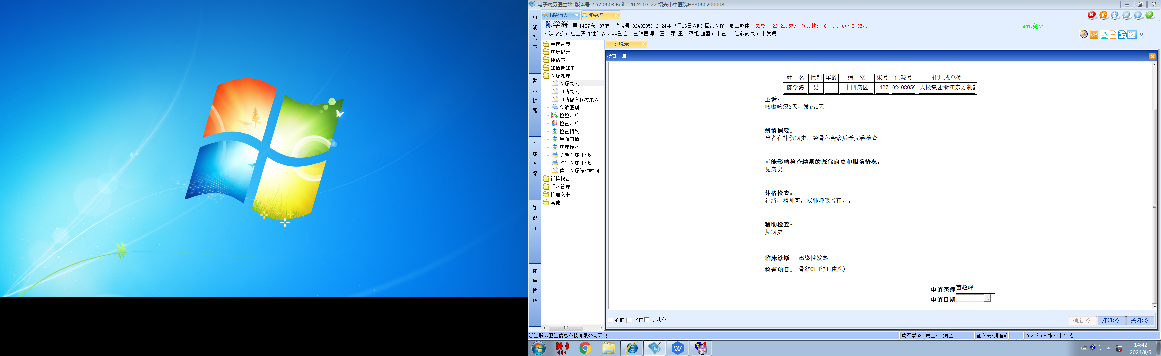王一萍组
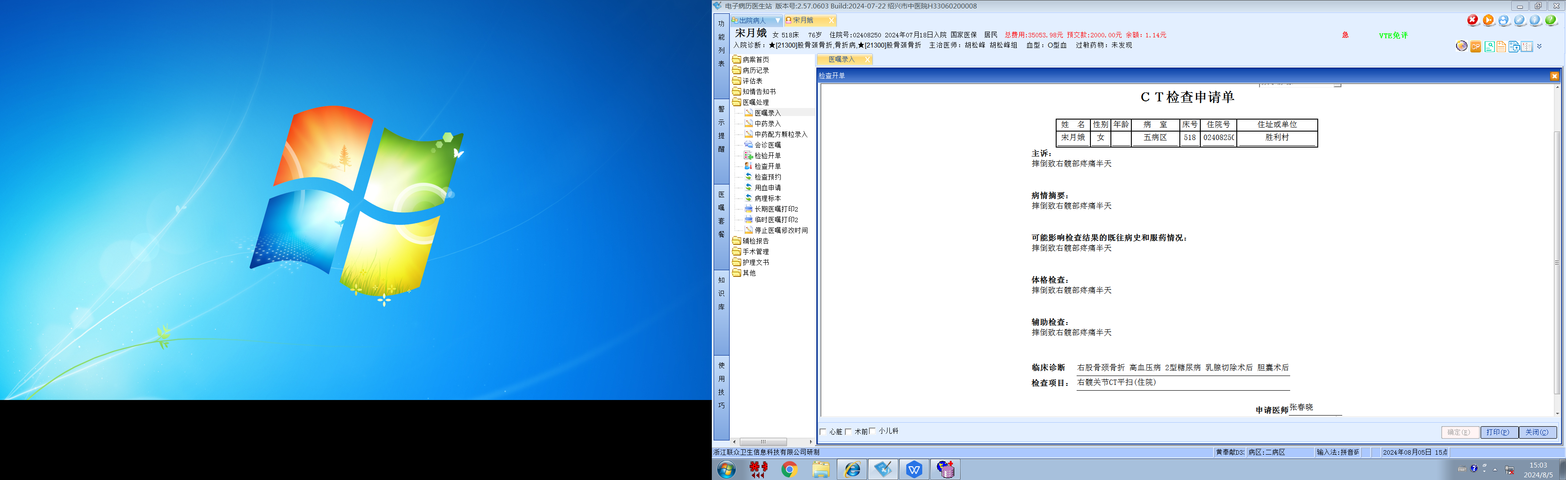
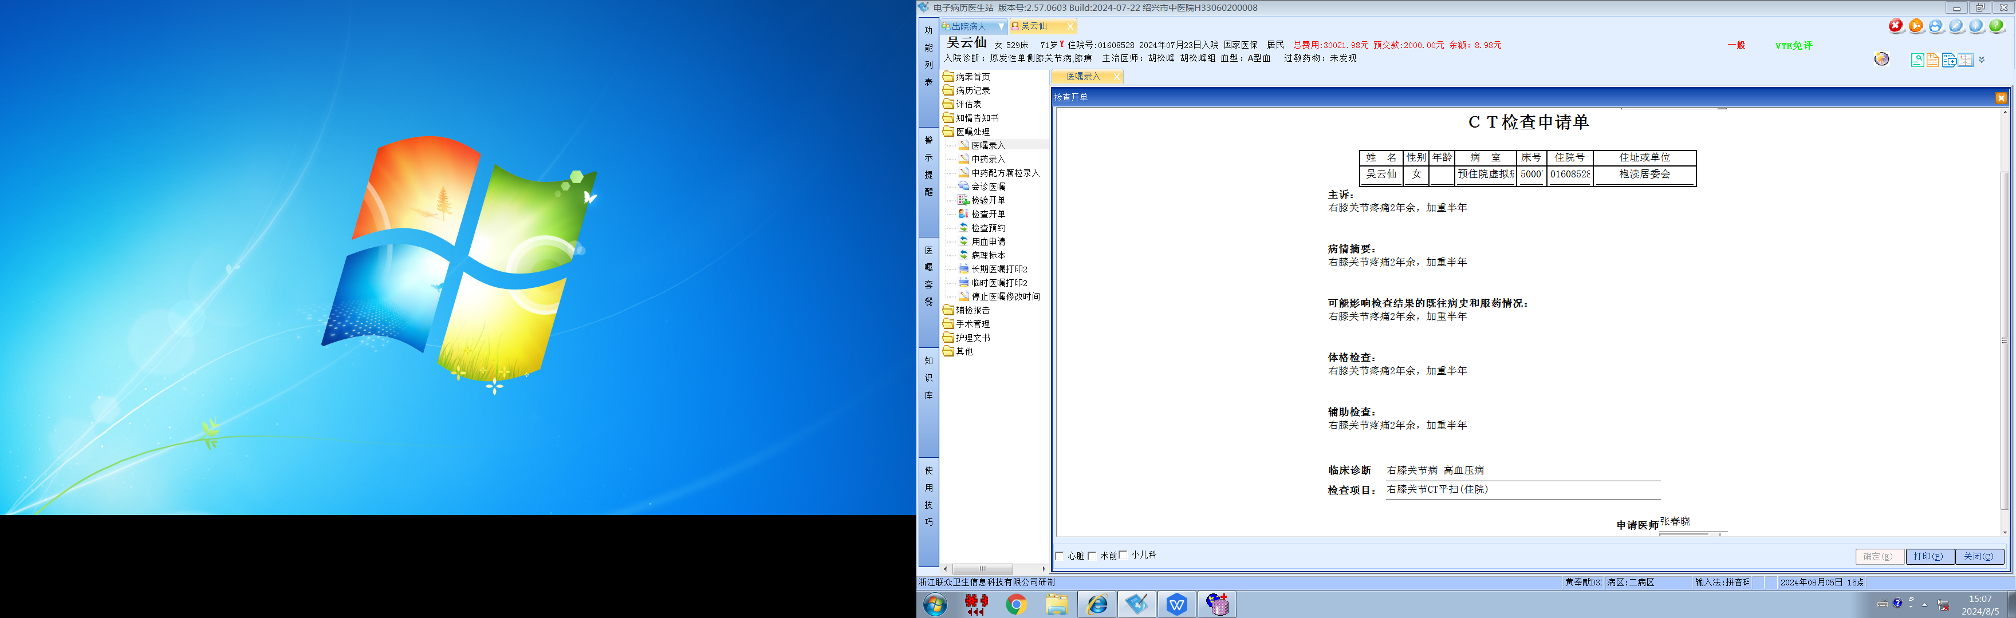

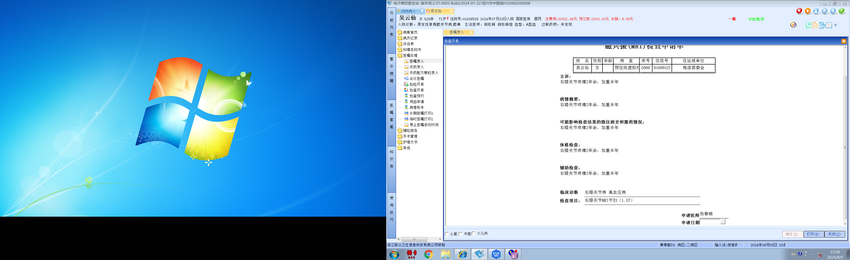
胡松峰组

