8月检查申请单质控
住院号 | 检查单类型 | 开单日期 | 开单医师 |  |  | 检查项目
 |  |  |  | 主诉 | 病情摘要 |  | 既往史 | 体格检查 | 辅助检查 | 诊断 | 内容申请单不一致
01902682 | CT | 2024-7-30 | 赵弘铭 | √ | √ |  | √ | √ | √ | √ | √
02408780 | CT | 2024-8-1 | 陈俊杰 | √ | √ |  | √ | √ | √ | √ | √
02408791 | MR | 2024-7-31 | 王磊 | √ | √ |  | √ | √ | √ | √ | √
02408768 | MR | 2024-7-31 | 张梦娇 | √ | √ |  | √ | √ | √ | √ | √
02408787 | MR | 2024-7-31 | 陶铁瑛 | √ | √ |  | √ | √ | √ | √ | √
02408653 | MR | 2024-8-2 | 王洪灿 | √ | √ |  | √ | √ | √ | √ | √
02408510 | MR | 2024-8-2 | 俞梅 | √ | √ |  | √ | √ | √ | √ | √
02104266 | MR | 2024-8-4 | 陈剑磨 | √ | √ |  | √ | √ | √ | √ | √
01413277 | MR | 2024-8-4 | 张桢阳 | √ | √ |  | √ | √ | √ | √ | √
01811912 | CT | 2024-8-3 | 王立波 | √ | √ |  | √ | √ | √ | √ | √
01811912 | MR | 2024-8-3 | 王立波 | √ | √ |  | √ | √ | √ | √ | √
02408558 | MR | 2024-8-4 | 张学思 | √ | √ |  | √ | √ | √ | √ | √
02408933 | MR | 2024-8-4 | 边俊 | √ | √ |  | √ | √ | √ | √ | √
02408919 | CT | 2024-8-5 | 吴明 | √ | √ |  | √ | √ | √ | √ | √
02409004 | MR | 2024-8-6 | 沈钱理 | √ | √ |  | √ | √ | √ | √ | √
02409003 | MR | 2024-8-6 | 沈钱理 | √ | √ |  | √ | √ | √ | √ | √
01311843 | CT | 2024-8-6 | 程爵富 | √ | √ |  | √ | √ | √ | √ | √
01808997 | MR | 2024-8-6 | 孙玲玲 | √ | √ |  | √ | √ | √ | √ | √
20101390 | MR | 2024-8-7 | 张梦娇 | √ | √ |  | √ | √ | √ | √ | √
02409036 | CT | 2024-8-6 | 赵艳明 | √ | √ |  | √ | √ | √ | √ | √
01917082 | MR | 2024-8-5 | 王冰清 | √ | √ |  | √ | √ | √ | √ | √
01708816 | MR | 2024-8-7 | 谢超 | √ | √ |  | √ | √ | √ | √ | √
01810927 | MR | 2024-8-7 | 孟闯闯 | √ | √ |  | √ | √ | √ | √ | √
02408941 | MR | 2024-8-6 | 王一萍 | √ | √ |  | √ | √ | √ | √ | √
02409098 | CT | 2024-8-8 | 陆超锋 | √ | √ |  | √ | √ | √ | √ | √
02409168 | CT | 2024-8-9 | 程爵富 | √ | √ |  | √ | √ | √ | √ | √
02409134 | MR | 2024-8-9 | 陶铁瑛 | √ | √ |  | √ | √ | √ | √ | √
01903779 | MR | 2024-8-10 | 施俊峰 | √ | √ |  | √ | √ | √ | √ | √
01208206 | MR | 2024-8-10 | 张梦娇 | √ | √ |  | √ | √ | √ | √ | √
02265947 | MR | 2024-8-9 | 刘浩飞 | √ | √ |  | √ | √ | √ | √ | √
02408977 | CT | 2024-8-10 | 严可风 | √ | √ |  | √ | √ | √ | √ | √
01805678 | MR | 2024-8-9 | 樊晓琦 | √ | √ |  | √ | √ | √ | √ | √
02409228 | CT | 2024-8-11 | 刘运海 | √ | √ |  | √ | √ | √ | √ | √
02409212 | MR | 2024-8-10 | 程爵富 | √ | √ |  | √ | √ | √ | √ | √
02104970 | CT | 2024-8-12 | 姜洪叶 | √ | √ |  | √ | √ | √ | √ | √
02409202 | MR | 2024-8-12 | 谢超 | √ | √ |  | √ | √ | √ | √ | √
02409239 | MR | 2024-8-11 | 孙莉 | √ | √ |  | √ | √ | √ | √ | √
02409317 | CT | 2024-8-13 | 王风永 | √ | √ |  | √ | √ | √ | √ | √
02409215 | MR | 2024-8-12 | 边佳萍 | √ | √ |  | √ | √ | √ | √ | √
02409215 | MR | 2024-8-13 | 刘兆龙 | √ | √ |  | √ | √ | √ | √ | √
01708573 | MR | 2024-8-13 | 苗超峰 | √ | √ |  | √ | √ | √ | √ | √
01708573 | MR | 2024-8-16 | 苗超峰 | √ | √ |  | √ | √ | √ | √ | √
02409129 | CT | 2024-8-14 | 张彬 | √ | √ |  | √ | √ | √ | √ | √
02409292 | MR | 2024-8-14 | 沈沉 | √ | √ |  | √ | √ | √ | √ | √
02409292 | MR | 2024-8-15 | 沈沉 | √ | √ |  | √ | √ | √ | √ | √
02409291 | MR | 2024-8-14 | 沈沉 | √ | √ |  | √ | √ | √ | √ | √
02409291 | MR | 2024-8-15 | 沈沉 | √ | √ |  | √ | √ | √ | √ | √
02408717 | MR | 2024-8-14 | 王风永 | √ | √ |  | √ | √ | √ | √ | ×
02000394 | MR | 2024-8-14 | 许杨 | √ | √ |  | √ | √ | √ | √ | √
20101390 | CT | 2024-8-14 | 张梦娇 | √ | √ |  | √ | √ | √ | √ | √
02239876 | MR | 2024-8-16 | 程爵富 | √ | √ |  | √ | √ | √ | √ | √
02409501 | MR | 2024-8-18 | 赵艳明 | √ | √ |  | √ | √ | √ | √ | √
02409521 | CT | 2024-8-19 | 刘悦 | √ | √ |  | √ | √ | √ | √ | √
02409521 | MR | 2024-8-19 | 许伟攀 | √ | √ |  | √ | √ | √ | √ | √
02267658 | MR | 2024-8-19 | 鲁剑梅 | √ | √ |  | √ | √ | √ | √ | √
02409161 | MR | 2024-8-20 | 张彬 | √ | √ |  | √ | √ | √ | √ | √
02409455 | CT | 2024-8-20 | 朱海波 | √ | √ |  | √ | √ | √ | √ | √
01312484 | MR | 2024-8-20 | 兰垂世 | √ | √ |  | √ | √ | √ | √ | ×
02409412 | CT | 2024-8-20 | 张彬 | √ | √ |  | √ | √ | √ | √ | √
01500748 | MR | 2024-8-21 | 张桢阳 | √ | √ |  | √ | √ | √ | √ | √
02409601 | MR | 2024-8-20 | 唐鋆超 | √ | √ |  | √ | √ | √ | √ | √
02409336 | MR | 2024-8-21 | 沈沉 | √ | √ |  | √ | √ | √ | √ | √
01512244 | MR | 2024-8-20 | 赵雄碧 | √ | √ |  | √ | √ | √ | √ | √
02409521 | MR | 2024-8-21 | 张彬 | √ | √ |  | √ | √ | √ | √ | √
02409620 | MR | 2024-8-22 | 黄操 | √ | √ |  | √ | √ | √ | √ | √
02409713 | MR | 2024-8-23 | 程爵富 | √ | √ |  | √ | √ | √ | √ | √
01801858 | MR | 2024-8-23 | 刘兆龙 | √ | √ |  | √ | √ | √ | √ | √
02409644 | CT | 2024-8-24 | 孙莉 | √ | √ |  | √ | √ | √ | √ | √
02408605 | CT | 2024-8-23 | 王立波 | √ | √ |  | √ | √ | √ | √ | √
01902085 | MR | 2024-8-24 | 郑德财 | √ | √ |  | √ | √ | √ | √ | √
02267905 | MR | 2024-8-24 | 张梦娇 | √ | √ |  | √ | √ | √ | √ | √
02409763 | CT | 2024-8-26 | 张梦娇 | √ | √ |  | √ | √ | √ | √ | √
02409763 | MR | 2024-8-26 | 张梦娇 | √ | √ |  | √ | √ | √ | √ | √
02409763 | MR | 2024-8-28 | 张梦娇 | √ | √ |  | √ | √ | √ | √ | √
02409695 | MR | 2024-8-23 | 王立波 | √ | √ |  | √ | √ | √ | √ | √
02409652 | MR | 2024-8-25 | 陈剑磨 | √ | √ |  | √ | √ | √ | √ | √
02409603 | MR | 2024-8-26 | 鲁剑梅 | √ | √ |  | √ | √ | √ | √ | √
02409613 | MR | 2024-8-26 | 沈钱理 | √ | √ |  | √ | √ | √ | √ | √
02409665 | MR | 2024-8-26 | 许杨 | √ | √ |  | √ | √ | √ | √ | √
02409665 | CT | 2024-8-27 | 许杨 | √ | √ |  | √ | √ | √ | √ | √
02409865 | MR | 2024-8-27 | 胡飞剑 | √ | √ |  | √ | √ | √ | √ | ×
02408717 | CT | 2024-8-28 | 王风永 | √ | √ |  | √ | √ | √ | √ | √
02371690 | CT | 2024-8-27 | 王冰清 | √ | √ |  | √ | √ | √ | √ | √
01804106 | CT | 2024-8-30 | 孙利荣 | √ | √ |  | √ | √ | √ | √ | ×
01204493 | CT | 2024-8-30 | 张彬 | √ | √ |  | √ | √ | √ | √ | √
01806372 | MR | 2024-8-30 | 谢超 | √ | √ |  | √ | √ | √ | √ | √
02409969 | MR | 2024-8-30 | 张梦娇 | √ | √ |  | √ | √ | √ | √ | √
01910193 | CT | 2024-8-30 | 王冰清 | √ | √ |  | √ | √ | √ | √ | √
02409586 | MR | 2024-8-30 | 赵海洋 | √ | √ |  | √ | √ | √ | √ | √
注：对住院患者检查申请单进行专项检查，其中主诉、体格检查或诊断任缺一项者视为不合格申请单；非入院常规检查，如申请单内容与检查部位及要求不一致，亦视为不合格申请单。
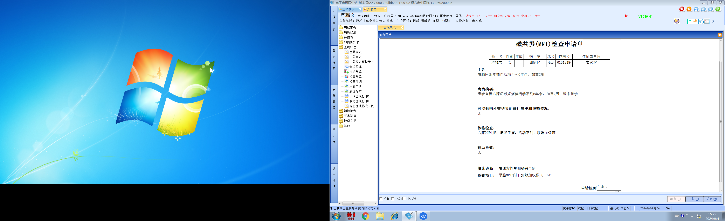
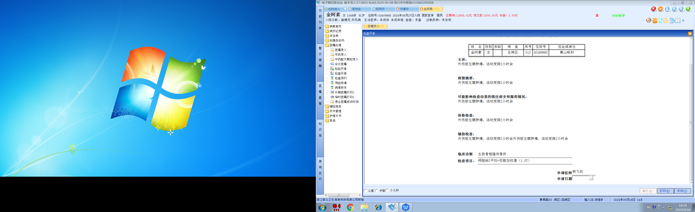谢峰组
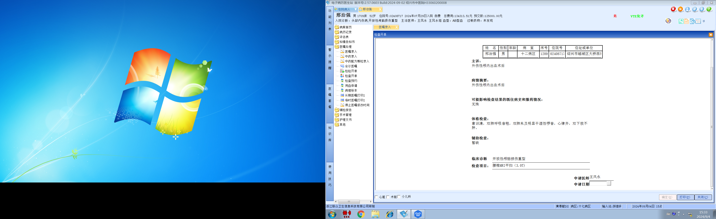王风永组
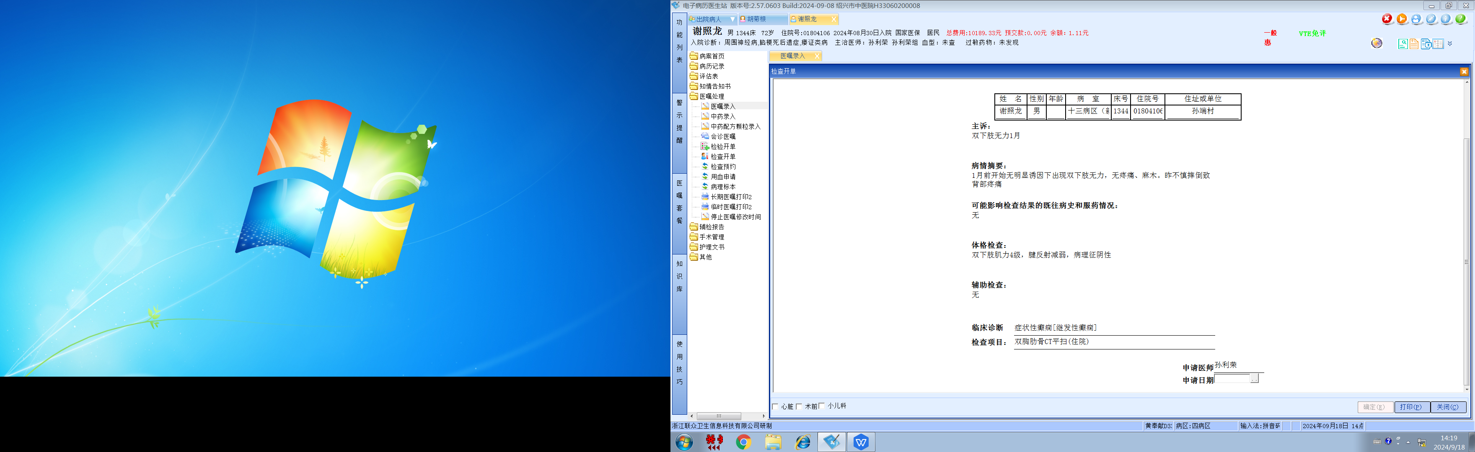

孙利荣组

