10月检查申请单质控
住院号 | 检查单类型 | 开单日期 | 开单医师 |  |  | 检查项目
 |  |  |  | 主诉 | 病情摘要 |  | 既往史 | 体格检查 | 辅助检查 | 诊断 | 内容申请单不一致
02411357 | MR | 2024-9-30 | 兰垂世 | √ | √ |  | √ | √ | √ | √ | √
02411285 | CT | 2024-9-29 | 王风永 | √ | √ |  | √ | √ | √ | √ | √
01602320 | MR | 2024-9-30 | 李新伟 | √ | √ |  | √ | √ | √ | √ | √
01907305 | MR | 2024-10-1 | 冯梦雪 | √ | √ |  | √ | √ | √ | √ | √
01806416 | MR | 2024-9-29 | 樊晓琦 | √ | √ |  | √ | √ | √ | √ | √
01708802 | MR | 2024-10-1 | 陈剑磨 | √ | √ |  | √ | √ | √ | √ | √
02411437 | CT | 2024-10-1 | 陈剑磨 | √ | √ |  | √ | √ | √ | √ | √
01917423 | MR | 2024-10-1 | 谢峰 | √ | √ |  | √ | √ | √ | √ | √
01913602 | MR | 2024-10-1 | 鲁剑梅 | √ | √ |  | √ | √ | √ | √ | √
02411221 | CT | 2024-10-2 | 裘鸿飞 | √ | √ |  | √ | √ | √ | √ | √
02411503 | MR | 2024-10-3 | 张学思 | √ | √ |  | √ | √ | √ | √ | √
02411483 | CT | 2024-10-2 | 钟承隽 | √ | √ |  | √ | √ | √ | √ | √
02411427 | MR | 2024-10-1 | 边俊 | √ | √ |  | √ | √ | √ | √ | √
02244163 | MR | 2024-10-2 | 边佳萍 | √ | √ |  | √ | √ | √ | √ | √
02411008 | MR | 2024-10-1 | 祝笛 | √ | √ |  | √ | √ | √ | √ | √
02111214 | MR | 2024-10-3 | 安艳军 | √ | √ |  | √ | √ | √ | √ | √
02411553 | CT | 2024-10-4 | 程爵富 | √ | √ |  | √ | √ | √ | √ | √
02411553 | MR | 2024-10-3 | 魏平洋 | √ | √ |  | √ | √ | √ | √ | √
02411500 | CT | 2024-10-3 | 孙玲玲 | √ | √ |  | √ | √ | √ | √ | √
02411327 | MR | 2024-10-4 | 刘悦 | √ | √ |  | √ | √ | √ | √ | √
02002012 | CT | 2024-10-6 | 朱海波 | √ | √ |  | √ | √ | √ | √ | √
02406903 | MR | 2024-10-4 | 詹晨阳 | √ | √ |  | √ | √ | √ | √ | √
02411661 | CT | 2024-10-6 | 冯梦雪 | √ | √ |  | √ | √ | √ | √ | √
02260248 | CT | 2024-10-7 | 王敏龙 | √ | √ |  | √ | √ | √ | √ | √
02411656 | MR | 2024-10-6 | 杜菲 | √ | √ |  | √ | √ | √ | √ | √
02003960 | MR | 2024-10-7 | 许海锋 | √ | √ |  | √ | √ | √ | √ | √
01904845 | MR | 2024-10-6 | 刘悦 | √ | √ |  | √ | √ | √ | √ | √
02411368 | MR | 2024-10-7 | 王风永 | √ | √ |  | √ | √ | √ | √ | √
01809195 | MR | 2024-10-6 | 孙利荣 | √ | √ |  | √ | √ | √ | √ | √
02411592 | MR | 2024-10-5 | 程爵富 | √ | √ |  | √ | √ | √ | √ | √
02411769 | MR | 2024-10-8 | 沈家峰 | √ | √ |  | √ | √ | √ | √ | √
02411457 | CT | 2024-10-8 | 谢立江 | √ | √ |  | √ | √ | √ | √ | √
02105146 | MR | 2024-10-8 | 鲁剑梅 | √ | √ |  | √ | √ | √ | √ | √
02411732 | CT | 2024-10-9 | 钟承隽 | √ | √ |  | √ | √ | √ | √ | √
02411810 | MR | 2024-10-9 | 黄操 | √ | √ |  | √ | √ | √ | √ | √
02411750 | CT | 2024-10-9 | 王风永 | √ | √ |  | √ | √ | √ | √ | √
02411856 | MR | 2024-10-10 | 兰垂世 | √ | √ |  | √ | √ | √ | √ | √
01308561 | MR | 2024-10-9 | 黄操 | √ | √ |  | √ | √ | √ | √ | √
02411845 | MR | 2024-10-10 | 孟闯闯 | √ | √ |  | √ | √ | √ | √ | √
02411933 | CT | 2024-10-12 | 陶铁瑛 | √ | √ |  | √ | √ | √ | √ | √
02411933 | MR | 2024-10-12 | 陶铁瑛 | √ | √ |  | √ | √ | √ | √ | √
02411587 | MR | 2024-10-11 | 卢璐 | √ | √ |  | √ | √ | √ | √ | √
01309819 | MR | 2024-10-11 | 王立波 | √ | √ |  | √ | √ | √ | √ | √
02411929 | CT | 2024-10-13 | 朱海波 | √ | √ |  | √ | √ | √ | √ | √
02411973 | CT | 2024-10-12 | 张建宇 | √ | √ |  | × | √ | × | √ | ×
02400751 | CT | 2024-10-13 | 林武 | √ | √ |  | √ | √ | √ | √ | √
02411902 | MR | 2024-10-11 | 许杨 | √ | √ |  | √ | √ | √ | √ | √
02411667 | CT | 2024-10-11 | 孙莉 | √ | √ |  | √ | √ | √ | √ | √
01511766 | CT | 2024-10-14 | 吴明 | √ | √ |  | √ | √ | √ | √ | √
02412133 | CT | 2024-10-15 | 陆超锋 | √ | √ |  | √ | √ | √ | √ | √
02412133 | MR | 2024-10-15 | 陆超锋 | √ | √ |  | √ | √ | √ | √ | √
01712452 | CT | 2024-10-14 | 张春晓 | √ | √ |  | √ | √ | √ | √ | ×
02412021 | MR | 2024-10-13 | 陈金堂 | √ | √ |  | √ | √ | √ | √ | √
02001678 | MR | 2024-10-14 | 唐鋆超 | √ | √ |  | √ | √ | √ | √ | √
02412007 | MR | 2024-10-14 | 沈波 | √ | √ |  | √ | √ | √ | √ | √
02412081 | MR | 2024-10-15 | 杜菲 | √ | √ |  | √ | √ | √ | √ | √
01900383 | MR | 2024-10-14 | 鲁剑梅 | √ | √ |  | √ | √ | √ | √ | √
02412168 | MR | 2024-10-16 | 尤志新 | √ | √ |  | √ | √ | √ | √ | √
02412123 | MR | 2024-10-15 | 支飞虎 | √ | √ |  | √ | √ | √ | √ | √
02406186 | CT | 2024-10-17 | 孙莉 | √ | √ |  | √ | √ | √ | √ | √
02412083 | MR | 2024-10-16 | 沈沉 | √ | √ |  | √ | √ | √ | √ | √
02412082 | MR | 2024-10-15 | 杜菲 | √ | √ |  | √ | √ | √ | √ | √
01803656 | MR | 2024-10-16 | 兰垂世 | √ | √ |  | √ | √ | √ | √ | √
01904443 | CT | 2024-10-18 | 冯梦雪 | √ | √ |  | √ | √ | √ | √ | √
02412194 | MR | 2024-10-17 | 胡飞剑 | √ | √ |  | √ | √ | √ | √ | ×
02243112 | CT | 2024-10-17 | 何薇 | √ | √ |  | √ | √ | √ | √ | √
02412250 | MR | 2024-10-18 | 赵雄碧 | √ | √ |  | √ | √ | √ | √ | √
01709390 | MR | 2024-10-18 | 赵艳明 | √ | √ |  | √ | √ | √ | √ | √
02403115 | CT | 2024-10-18 | 何薇 | √ | √ |  | √ | √ | √ | √ | √
01712391 | MR | 2024-10-19 | 谢峰 | √ | √ |  | √ | √ | √ | √ | ×
02412119 | MR | 2024-10-15 | 陈剑磨 | √ | √ |  | √ | √ | √ | √ | √
02412171 | MR | 2024-10-19 | 赵艳明 | √ | √ |  | √ | √ | √ | √ | √
01915282 | MR | 2024-10-20 | 王洪灿 | √ | √ |  | √ | √ | √ | √ | √
01700070 | MR | 2024-10-19 | 周怡 | √ | √ |  | √ | √ | √ | √ | √
01410383 | MR | 2024-10-20 | 苗超峰 | √ | √ |  | √ | √ | √ | √ | √
02412256 | MR | 2024-10-20 | 施俊峰 | √ | √ |  | √ | √ | √ | √ | √
01203958 | MR | 2024-10-21 | 孟闯闯 | √ | √ |  | √ | √ | √ | √ | √
02370812 | MR | 2024-10-20 | 王风永 | √ | √ |  | √ | √ | √ | √ | √
02412436 | CT | 2024-10-22 | 张春晓 | √ | √ |  | √ | √ | √ | √ | √
02412436 | MR | 2024-10-22 | 张春晓 | √ | √ |  | √ | √ | √ | √ | √
01910533 | CT | 2024-10-22 | 冯梦雪 | √ | √ |  | √ | √ | √ | √ | √
02006727 | MR | 2024-10-21 | 王轶辉 | √ | √ |  | √ | √ | √ | √ | √
02412356 | MR | 2024-10-22 | 谢思维 | √ | √ |  | √ | √ | √ | √ | √
02412379 | MR | 2024-10-21 | 张春晓 | √ | √ |  | √ | √ | √ | √ | √
02412423 | MR | 2024-10-22 | 刘浩飞 | √ | √ |  | √ | √ | √ | √ | √
02412501 | CT | 2024-10-24 | 张梦娇 | √ | √ |  | √ | √ | √ | √ | √
02411935 | MR | 2024-10-21 | 张建宇 | √ | √ |  | √ | √ | √ | √ | √
02412398 | MR | 2024-10-23 | 黄操 | √ | √ |  | √ | √ | √ | √ | √
02412456 | CT | 2024-10-24 | 吕宇航 | √ | √ |  | √ | √ | √ | √ | √
02412422 | MR | 2024-10-22 | 兰垂世 | √ | √ |  | √ | √ | √ | √ | √
02412552 | MR | 2024-10-24 | 兰垂世 | √ | √ |  | √ | √ | √ | √ | √
02412579 | CT | 2024-10-25 | 杜菲 | √ | √ |  | √ | √ | √ | √ | √
02412485 | MR | 2024-10-23 | 许杨 | √ | √ |  | √ | √ | √ | √ | √
02412471 | MR | 2024-10-22 | 张建宇 | √ | √ |  | √ | √ | √ | √ | √
02412471 | MR | 2024-10-23 | 支飞虎 | √ | √ |  | √ | √ | √ | √ | √
02412601 | MR | 2024-10-25 | 张梦娇 | √ | √ |  | √ | √ | √ | √ | √
02412588 | MR | 2024-10-25 | 谢峰 | √ | √ |  | √ | √ | √ | √ | √
02006885 | MR | 2024-10-26 | 龙平 | √ | √ |  | √ | √ | √ | √ | √
02412499 | MR | 2024-10-26 | 刘浩飞 | √ | √ |  | √ | √ | √ | √ | √
02412673 | CT | 2024-10-26 | 王风永 | √ | √ |  | √ | √ | √ | √ | √
02411973 | CT | 2024-10-27 | 张建宇 | √ | √ |  | √ | √ | √ | √ | √
02400345 | CT | 2024-10-27 | 刘潇 | √ | √ |  | √ | √ | √ | √ | √
02412523 | MR | 2024-10-26 | 苗超峰 | √ | √ |  | √ | √ | √ | √ | √
02412523 | MR | 2024-10-29 | 沈丽娜 | √ | √ |  | √ | √ | √ | √ | √
02412538 | CT | 2024-10-28 | 冯梦雪 | √ | √ |  | √ | √ | √ | √ | √
02412805 | CT | 2024-10-29 | 张华良 | √ | √ |  | √ | √ | √ | √ | √
02412704 | MR | 2024-10-27 | 沈沉 | √ | √ |  | √ | √ | √ | √ | √
01600452 | MR | 2024-10-29 | 姜洪叶 | √ | √ |  | √ | √ | √ | √ | √
02412862 | CT | 2024-10-31 | 谢峰 | √ | √ |  | √ | √ | √ | √ | √
02412628 | CT | 2024-10-30 | 刘悦 | √ | √ |  | √ | √ | √ | √ | √
01910048 | MR | 2024-10-29 | 王风永 | √ | √ |  | √ | √ | √ | √ | √
注：对住院患者检查申请单进行专项检查，其中主诉、体格检查或诊断任缺一项者视为不合格申请单；非入院常规检查，如申请单内容与检查部位及要求不一致，亦视为不合格申请单。

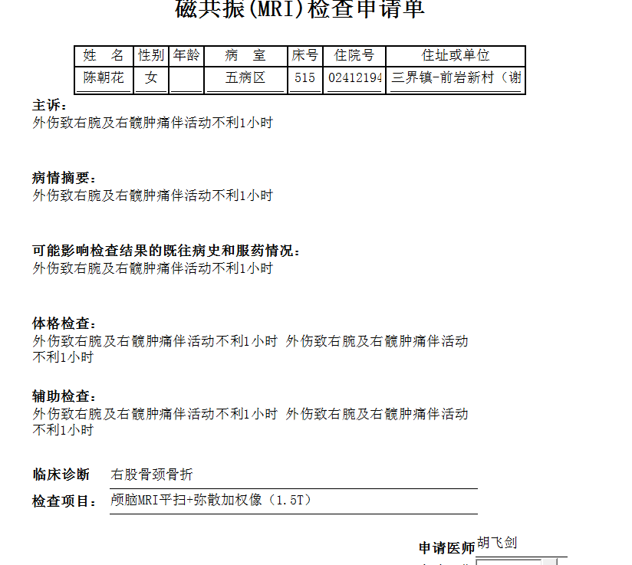

谢峰组

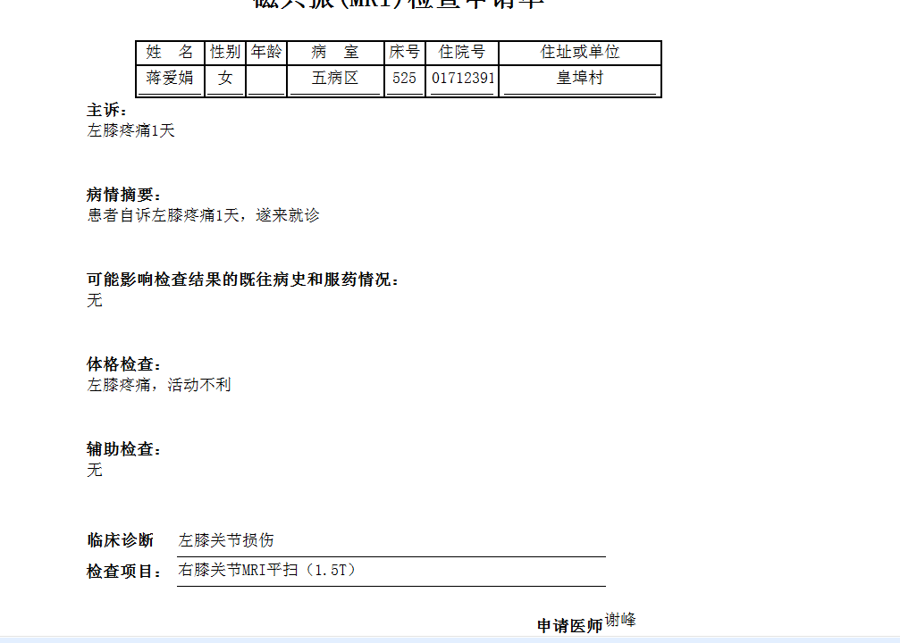
谢峰组
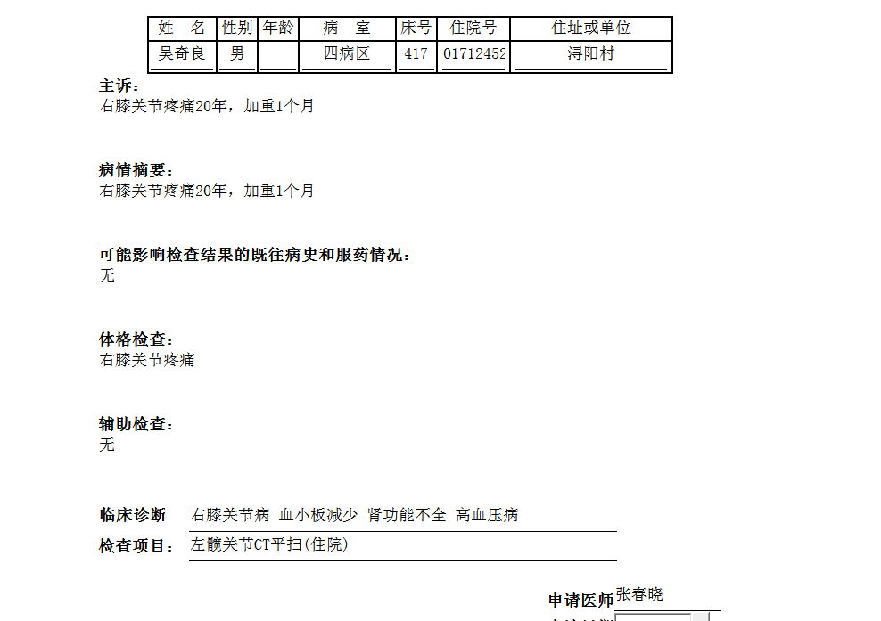
胡松峰组

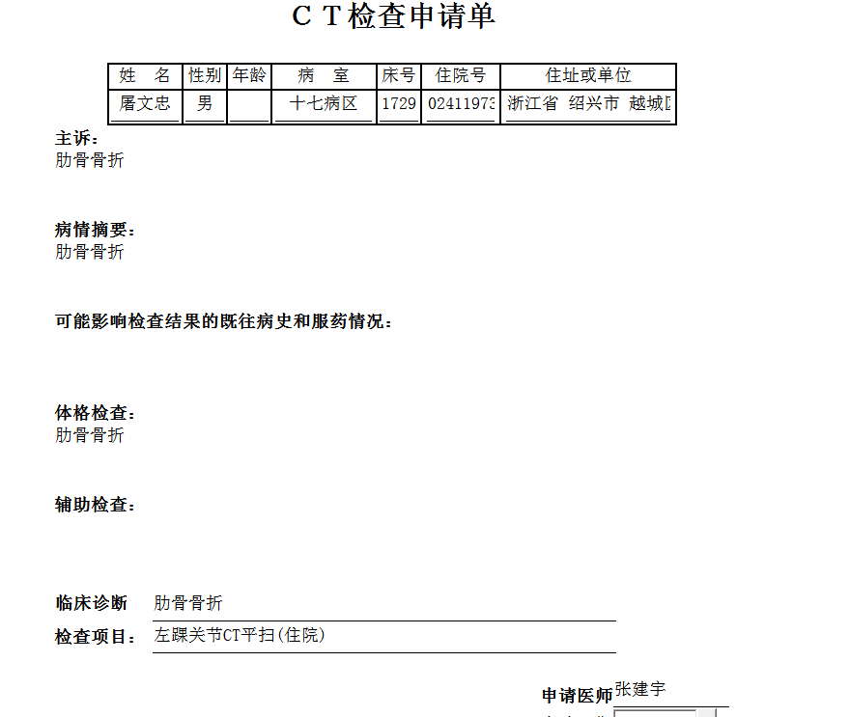
张建宇组

