3月检查申请单质控
住院号 | 检查单类型 | 开单日期 | 开单医师 |  |  | 检查项目
 |  |  |  | 主诉 | 病情摘要 |  | 既往史 | 体格检查 | 辅助检查 | 诊断 | 内容申请单不一致
01102382 | MR | 2025-2-28 | 王风永 | √ | √ |  | √ | √ | √ | √ | ×
02239836 | MR | 2025-2-28 | 尤志新 | √ | √ |  | √ | √ | √ | √ | ×
02502226 | CT | 2025-2-28 | 王洪灿 | √ | × |  | × | √ | × | √ | ×
02502526 | MR | 2025-3-2 | 杨兴辉 | √ | √ |  | √ | √ | √ | √ | ×
02502410 | CT | 2025-3-2 | 蒋琪 | √ | √ |  | √ | × | √ | √ | ×
02502628 | MR | 2025-3-3 | 程爵富 | √ | √ |  | √ | × | √ | √ | ×
02502692 | MR | 2025-3-5 | 叶玲玲 | √ | √ |  | × | √ | × | √ | ×
02502447 | MR | 2025-3-3 | 刘浩飞 | √ | √ |  | × | √ | × | √ | ×
01713887 | CT | 2025-3-4 | 张春晓 | √ | √ |  | √ | √ | √ | √ | ×
02412988 | CT | 2025-3-6 | 钟承隽 | √ | √ |  | √ | √ | √ | √ | ×
01913653 | MR | 2025-3-3 | 孙玲玲 | √ | √ |  | √ | √ | √ | √ | ×
02502823 | MR | 2025-3-6 | 兰垂世 | √ | √ |  | √ | √ | √ | √ | ×
02372408 | MR | 2025-3-8 | 沈波 | √ | √ |  | √ | √ | √ | √ | ×
02502402 | MR | 2025-3-8 | 张彬 | √ | √ |  | × | √ | × | √ | ×
02502578 | CT | 2025-3-5 | 张建宇 | √ | √ |  | × | √ | × | √ | ×
02244923 | MR | 2025-3-8 | 张梦娇 | √ | √ |  | × | √ | × | √ | ×
02502881 | MR | 2025-3-10 | 付玉芳 | √ | √ |  | √ | √ | √ | √ | ×
02257285 | MR | 2025-3-11 | 王立波 | √ | √ |  | √ | √ | √ | √ | ×
01911922 | MR | 2025-3-12 | 边佳萍 | √ | √ |  | √ | √ | √ | √ | ×
02266034 | MR | 2025-3-13 | 祝笛 | √ | √ |  | √ | √ | √ | √ | ×
02104895 | MR | 2025-3-15 | 郑德财 | √ | √ |  | × | √ | × | √ | ×
02503271 | MR | 2025-3-16 | 边俊 | √ | √ |  | √ | √ | √ | √ | ×
02503309 | MR | 2025-3-17 | 刘运海 | √ | √ |  | √ | √ | √ | √ | ×
02007804 | CT | 2025-3-17 | 路文杰 | √ | √ |  | √ | √ | × | √ | ×
01803245 | MR | 2025-3-18 | 沈沉 | √ | √ |  | √ | √ | √ | √ | ×
02503255 | MR | 2025-3-16 | 沈兴潮 | √ | √ |  | × | √ | × | √ | ×
02503375 | MR | 2025-3-18 | 宋雪 | √ | √ |  | √ | √ | √ | √ | ×
02503519 | MR | 2025-3-21 | 沈家峰 | √ | √ |  | √ | √ | √ | √ | ×
02503627 | MR | 2025-3-24 | 苗超峰 | √ | √ |  | × | √ | × | √ | ×
02110614 | MR | 2025-3-24 | 沈钱理 | √ | √ |  | √ | √ | √ | √ | ×
01506258 | MR | 2025-3-27 | 谢思维 | √ | √ |  | √ | √ | √ | √ | ×
02002689 | CT | 2025-3-27 | 柴绍军 | √ | √ |  | √ | √ | √ | √ | ×
02503934 | MR | 2025-3-30 | 陈剑磨 | √ | √ |  | √ | √ | √ | √ | ×
02503799 | MR | 2025-3-28 | 支飞虎 | √ | √ |  | √ | √ | √ | √ | ×
02503865 | CT | 2025-3-29 | 诸佳燕 | √ | √ |  | × | √ | × | √ | ×
02503971 | MR | 2025-3-31 | 陶铁瑛 | √ | √ |  | √ | √ | √ | √ | ×
注：对住院患者检查申请单进行专项检查，其中主诉、体格检查或诊断任缺一项者视为不合格申请单；非入院常规检查，如申请单内容与检查部位及要求不一致，亦视为不合格申请单。

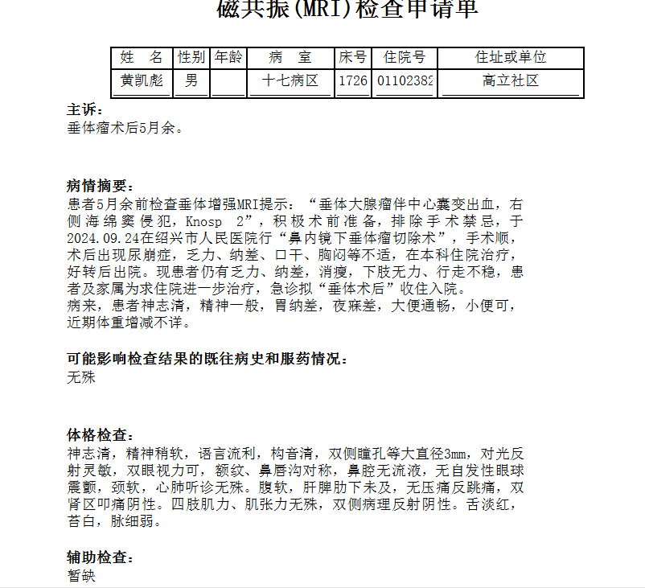

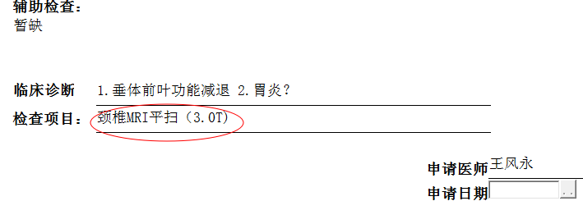
王风永组

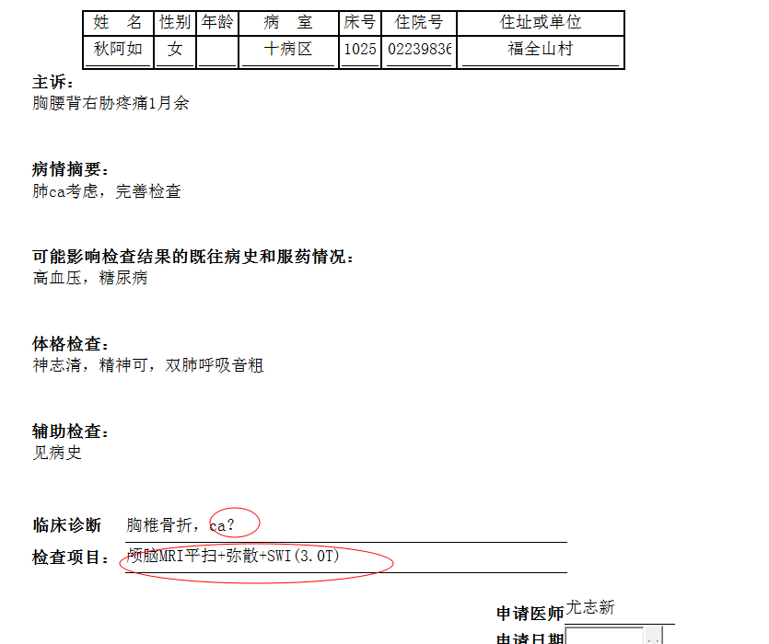
何薇组

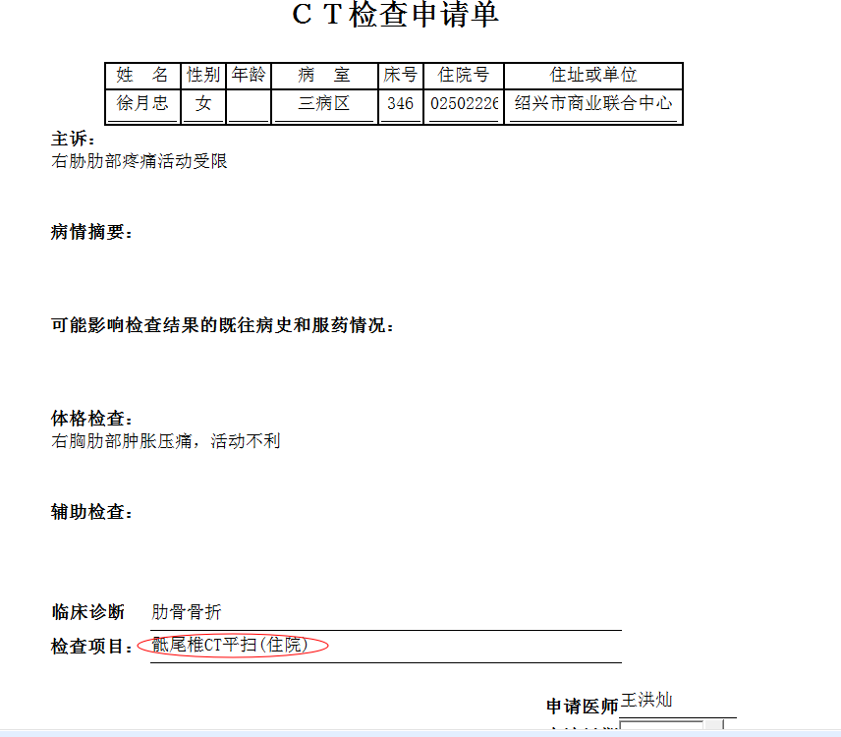
林武组

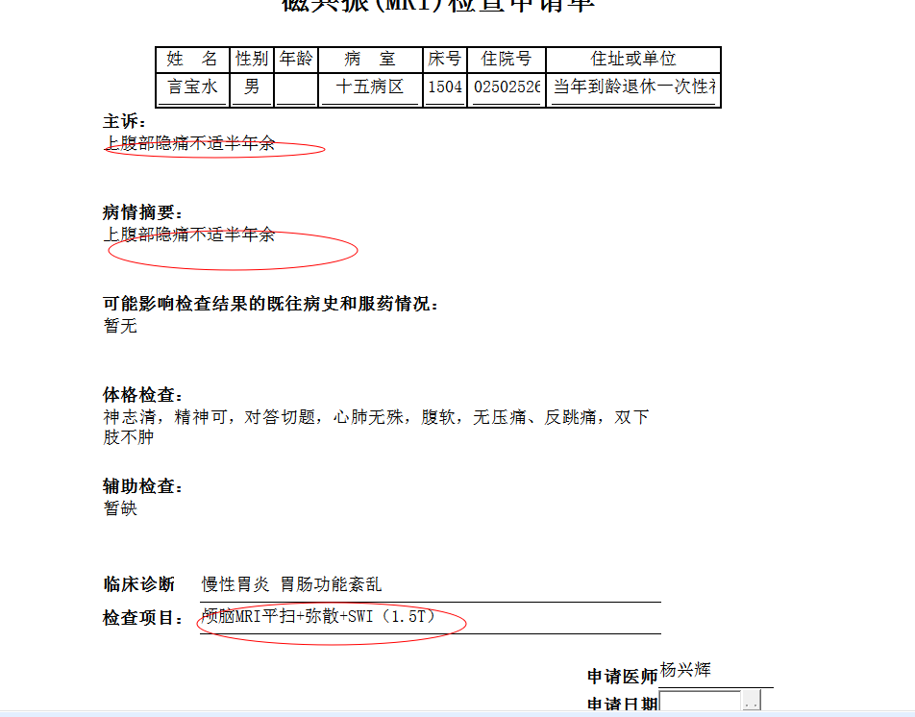
徐芳组
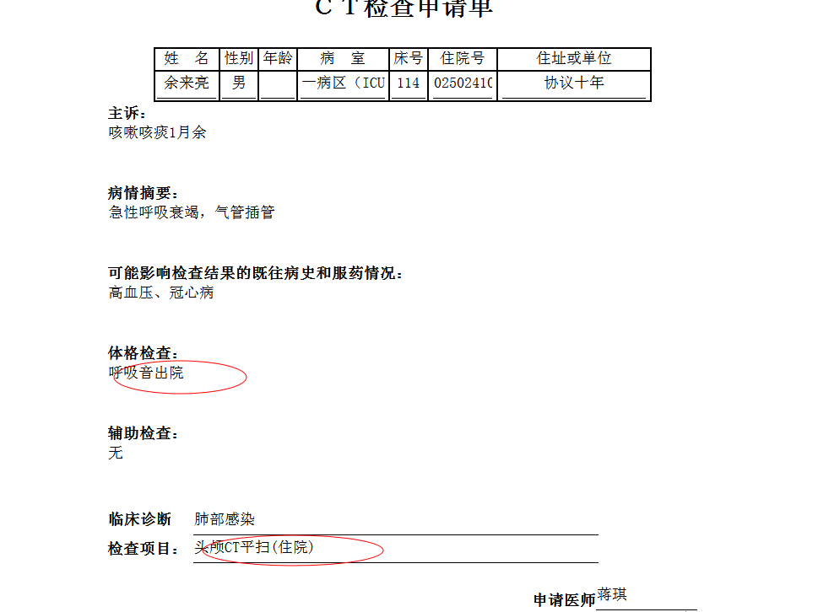
严可风组

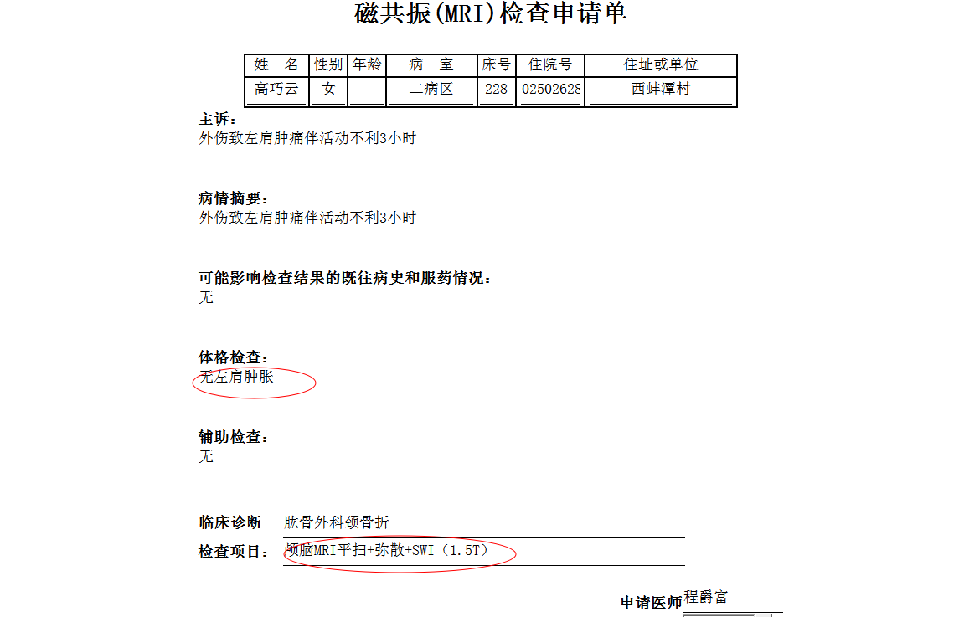
葛剑洪组
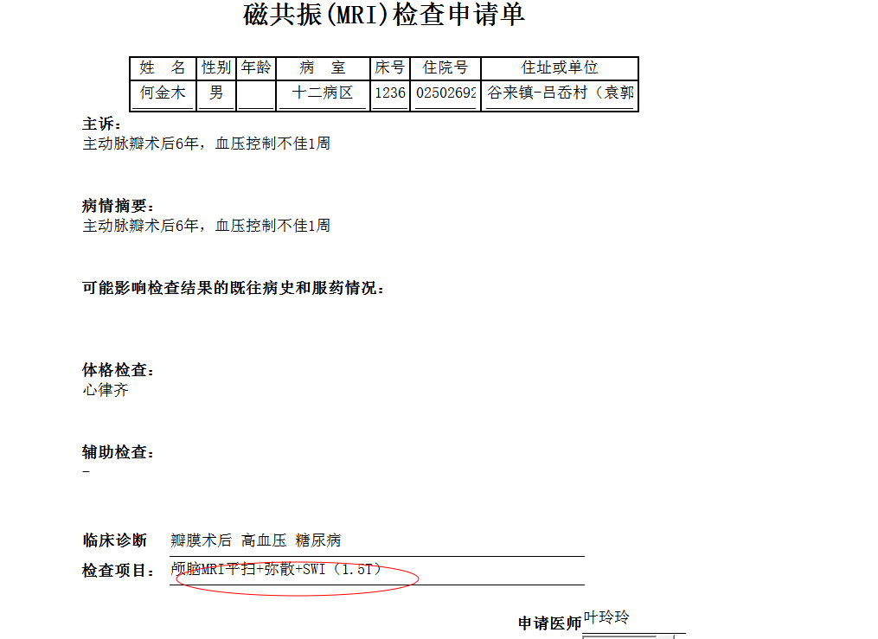
叶玲玲组

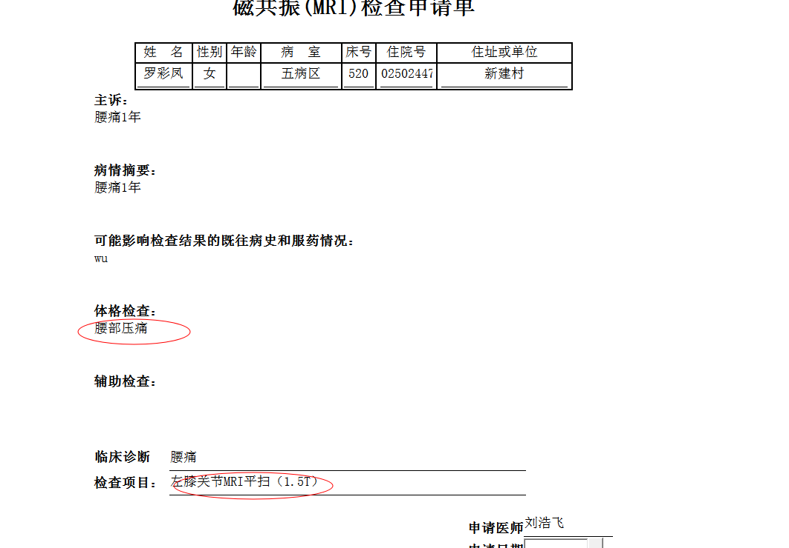
韦金忠组

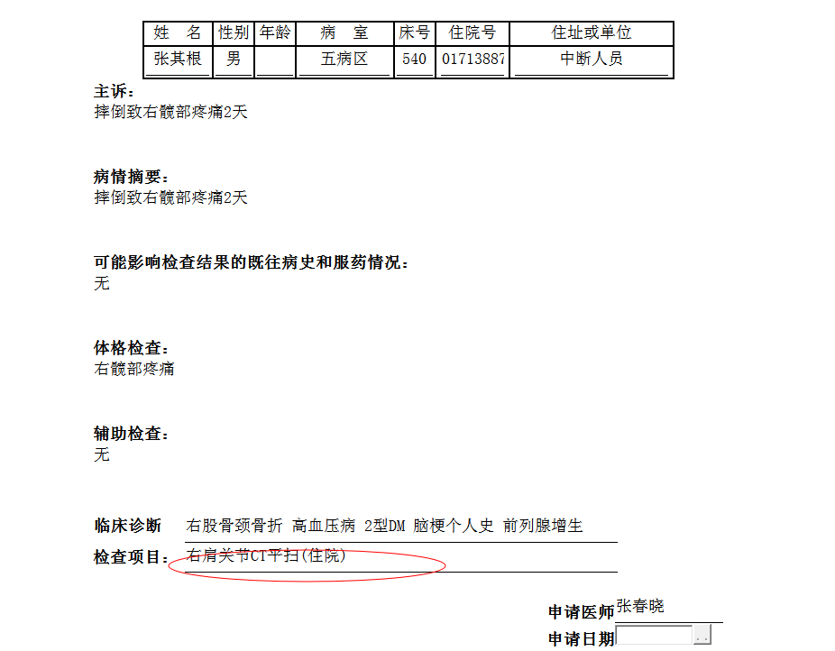
胡松峰组

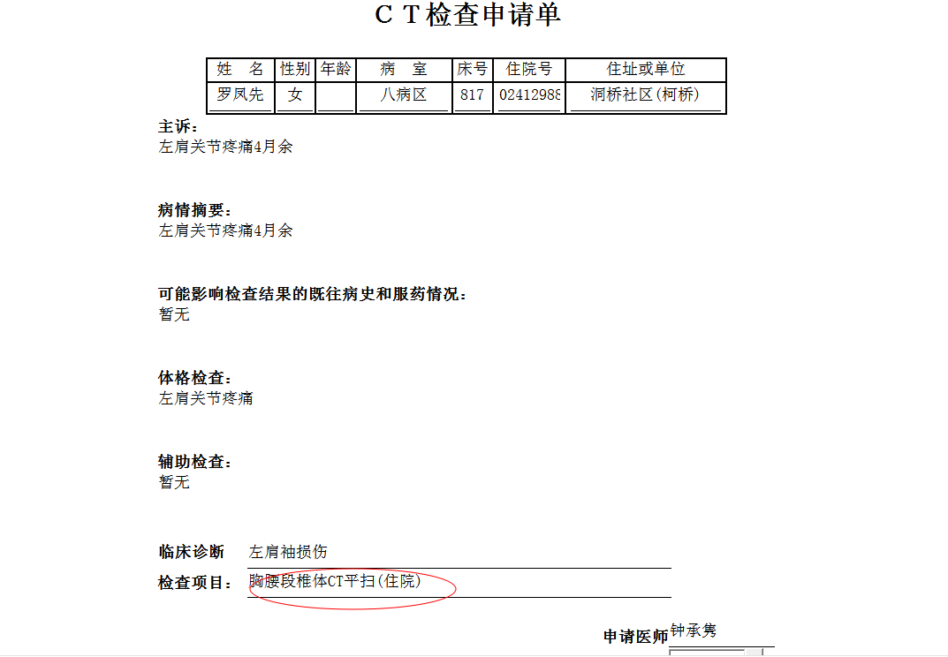
沈剑增组
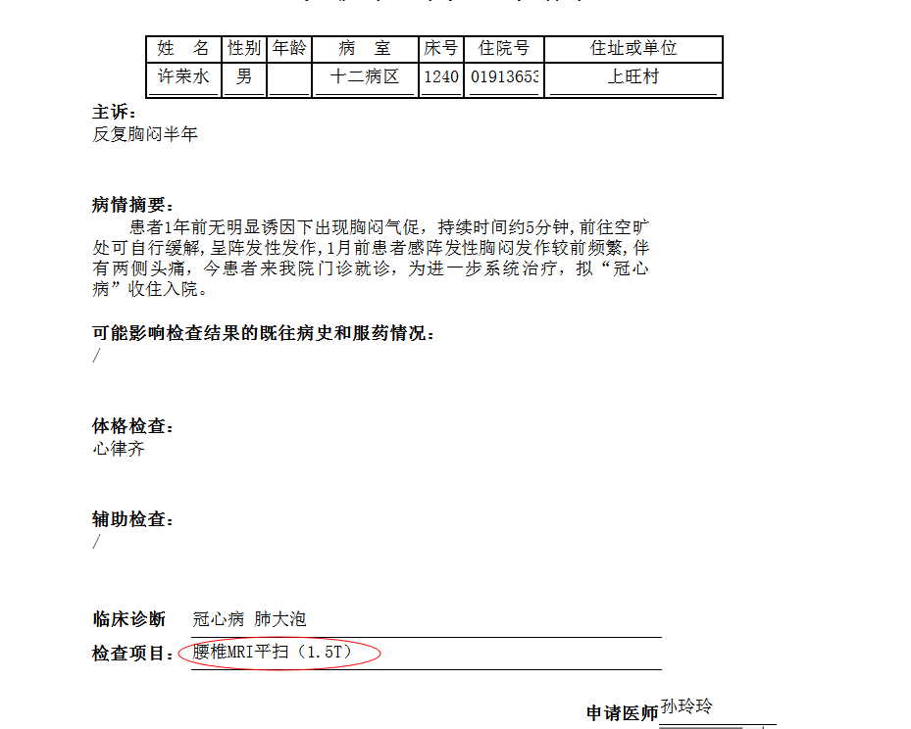
叶玲玲组
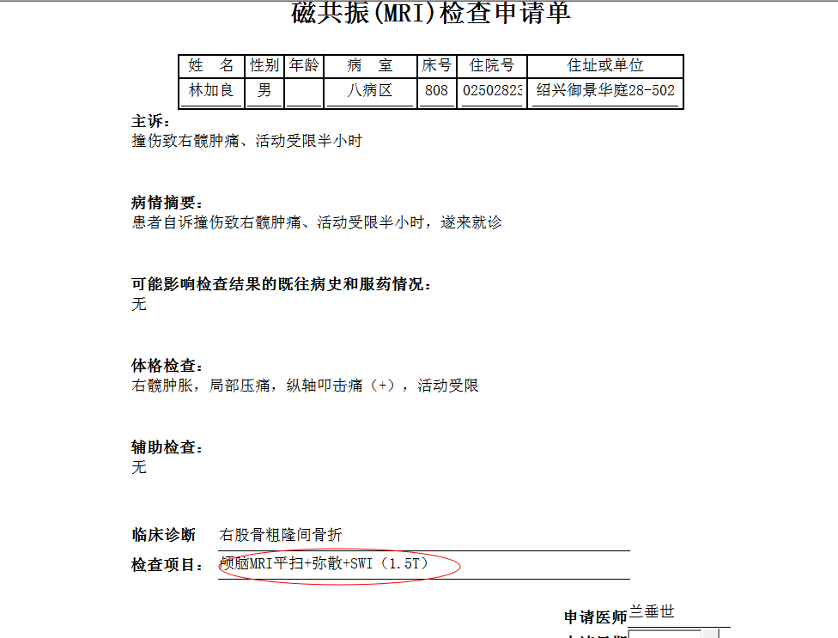
谢峰组

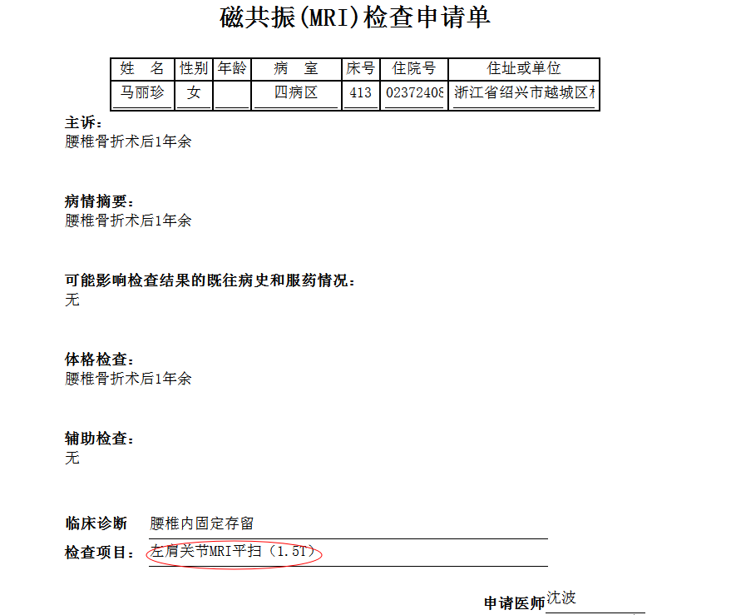
陈建德组
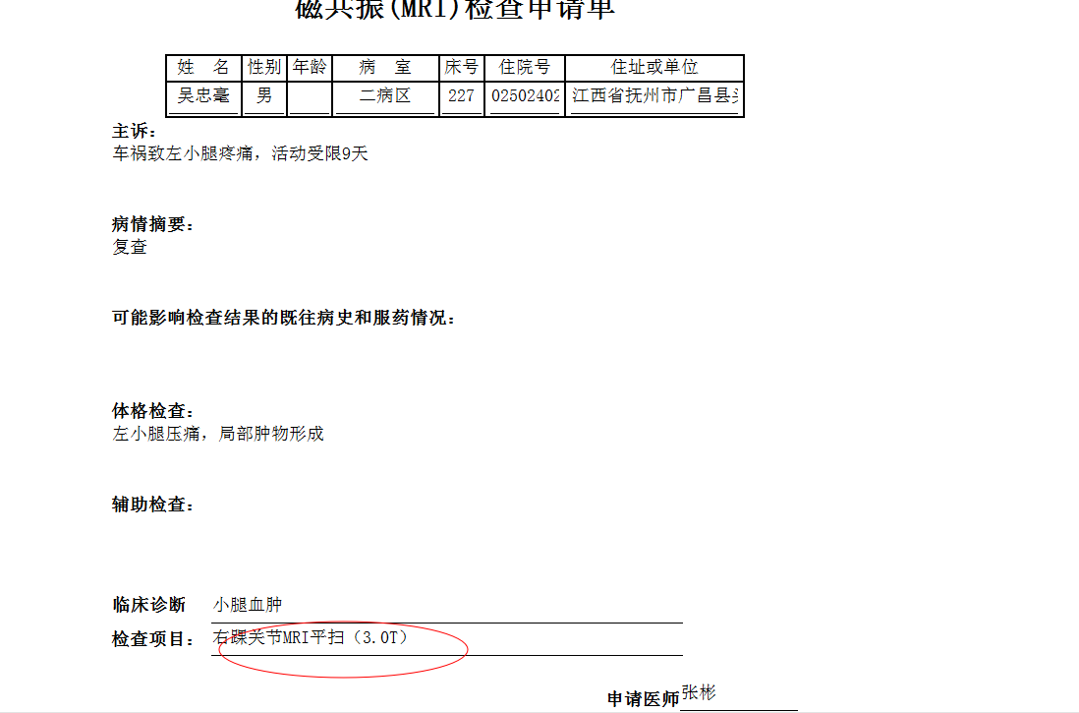
马军华组
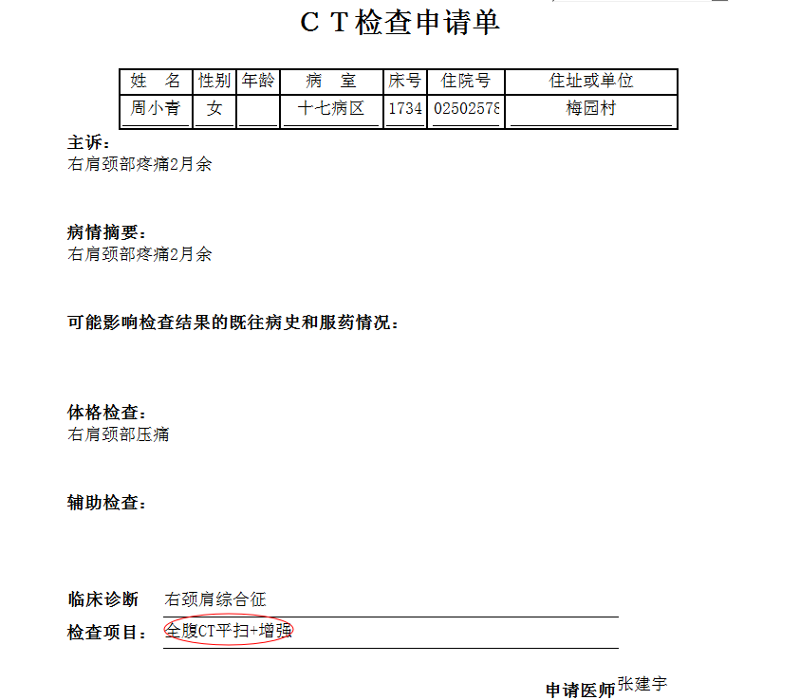
张建宇组
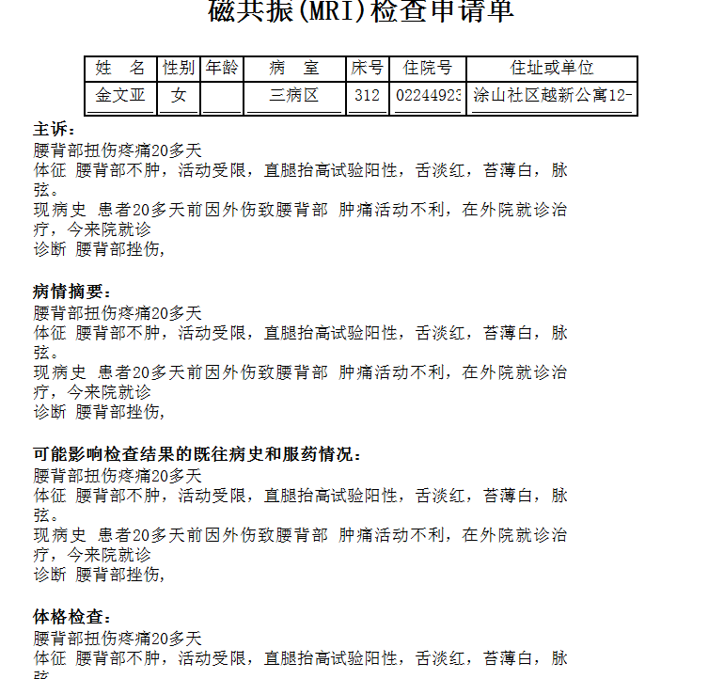
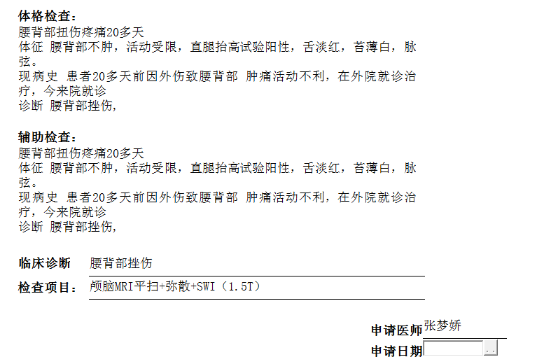
葛剑洪组

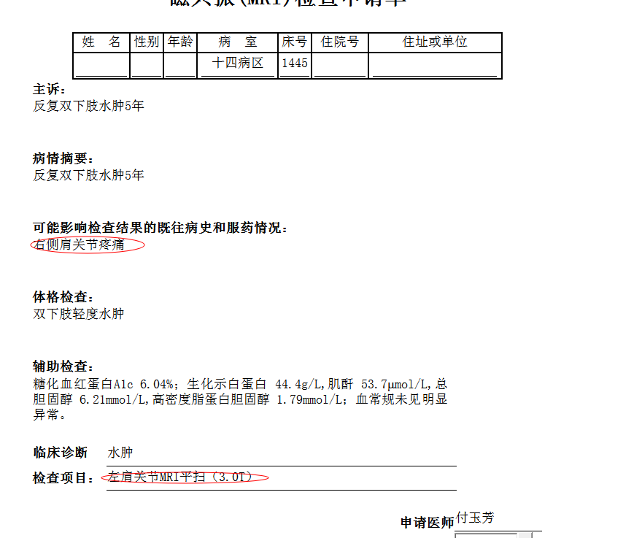
王亚平组

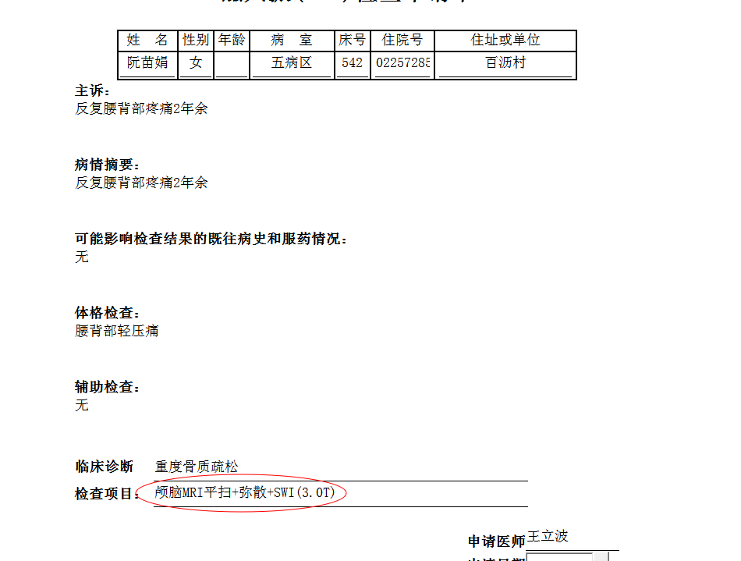
夏炳江组

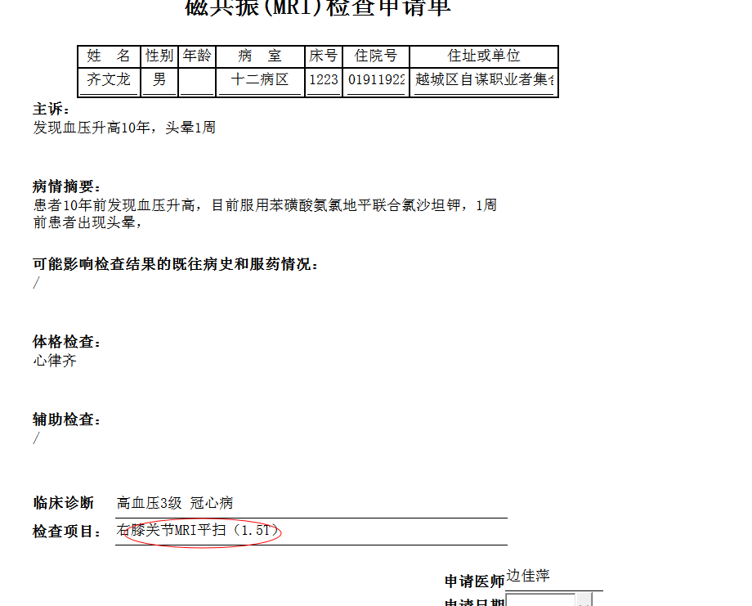
边佳萍组
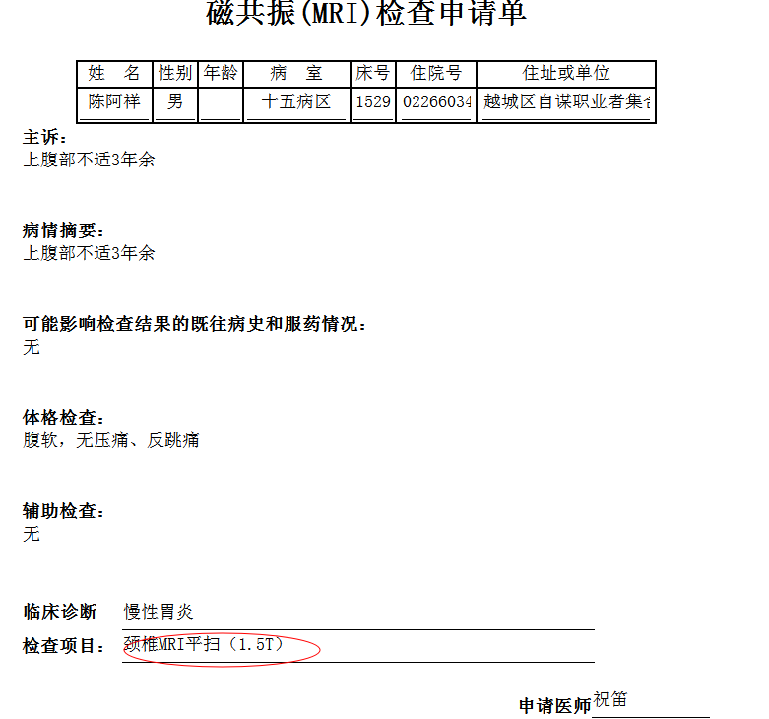
徐芳组
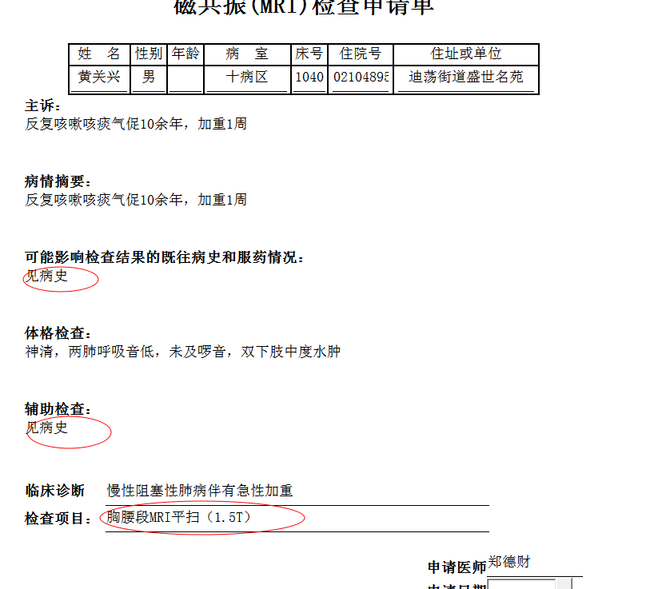
何薇组
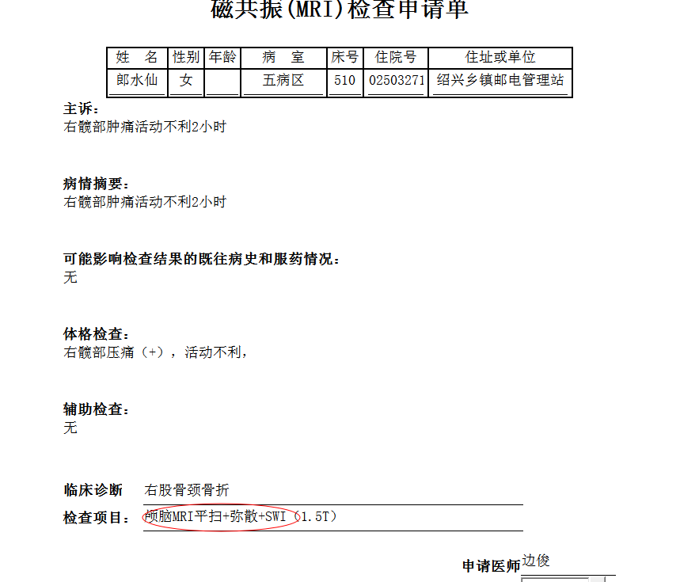
谢峰组

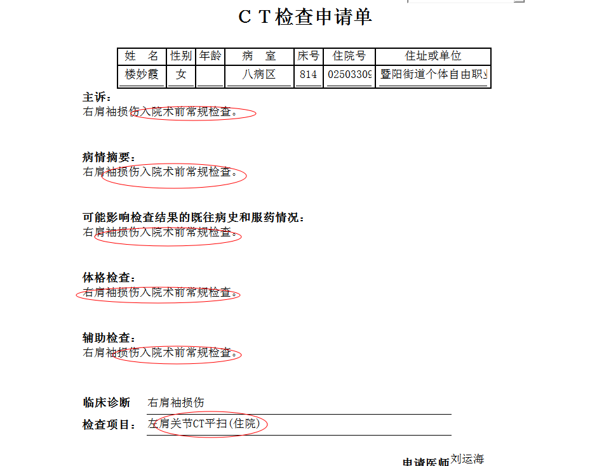
刘磊组

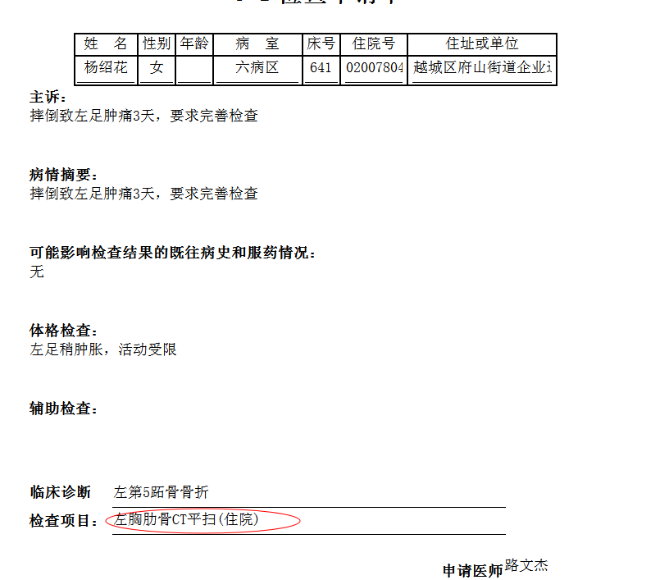
章宁杰组
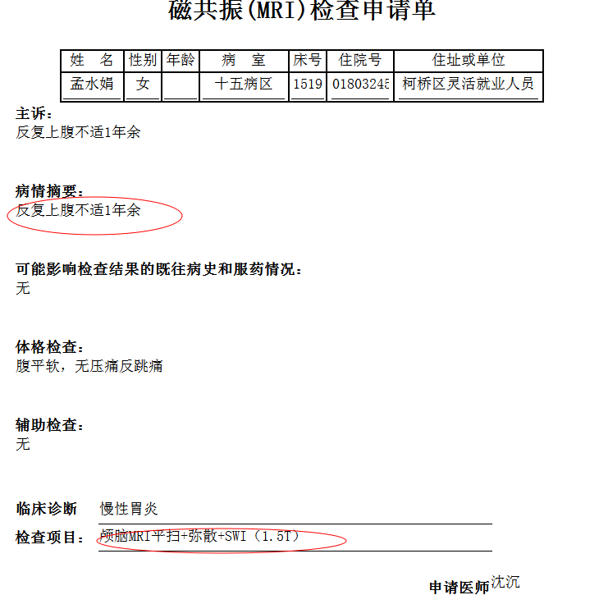
杨锋组

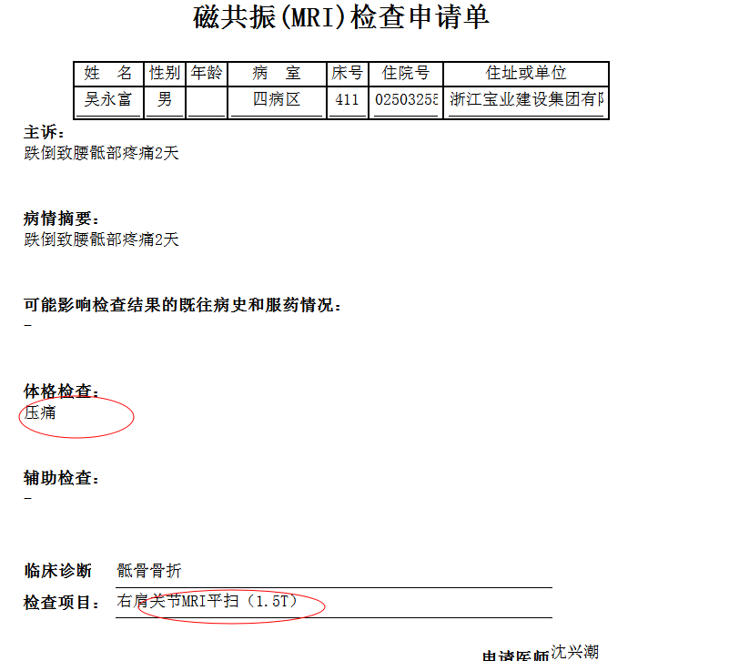
韦金忠组
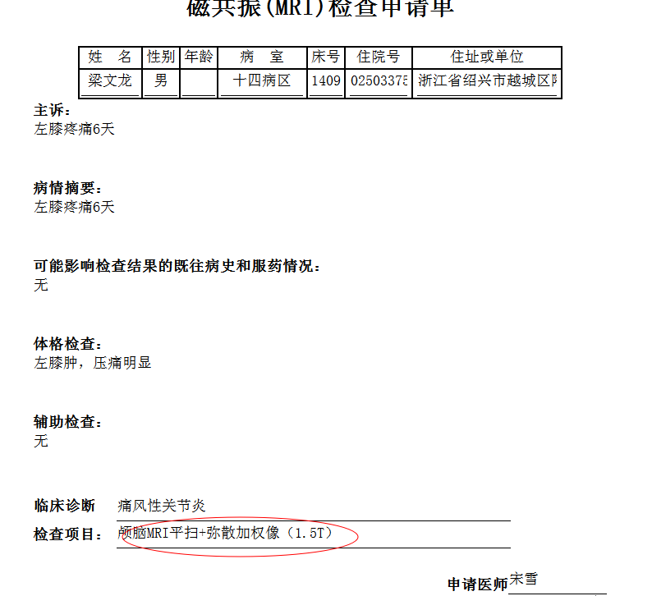
陈丹组
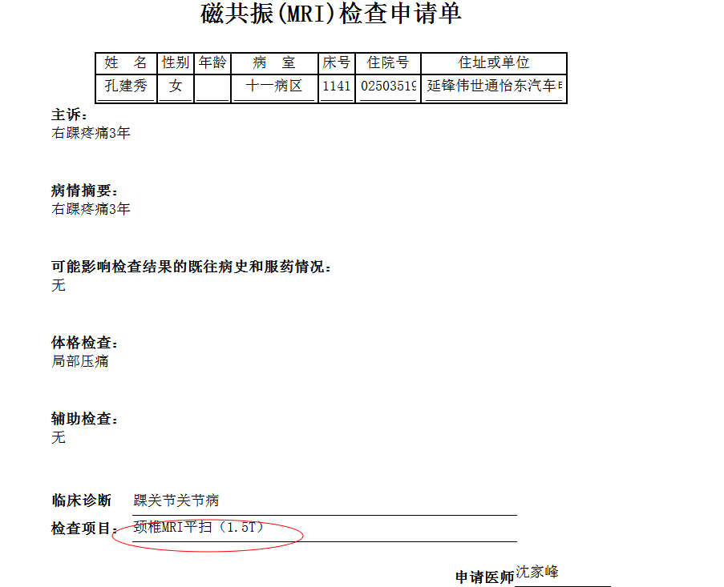
朱国文组

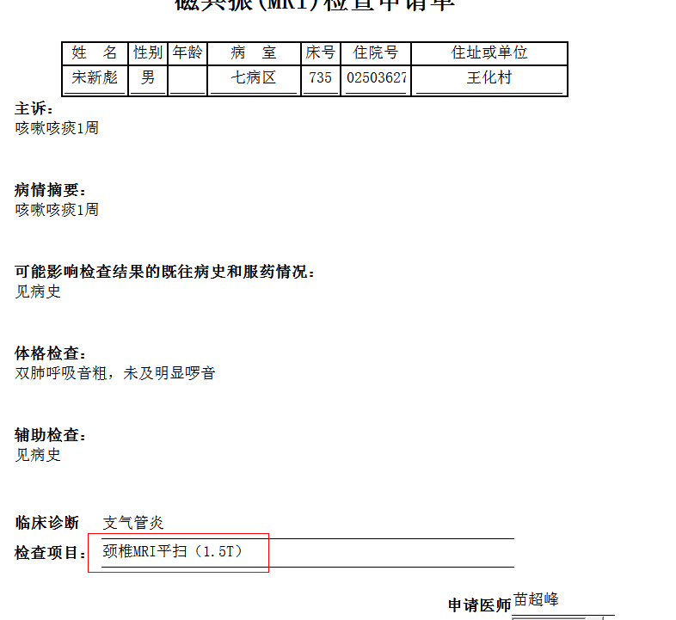
王一萍组
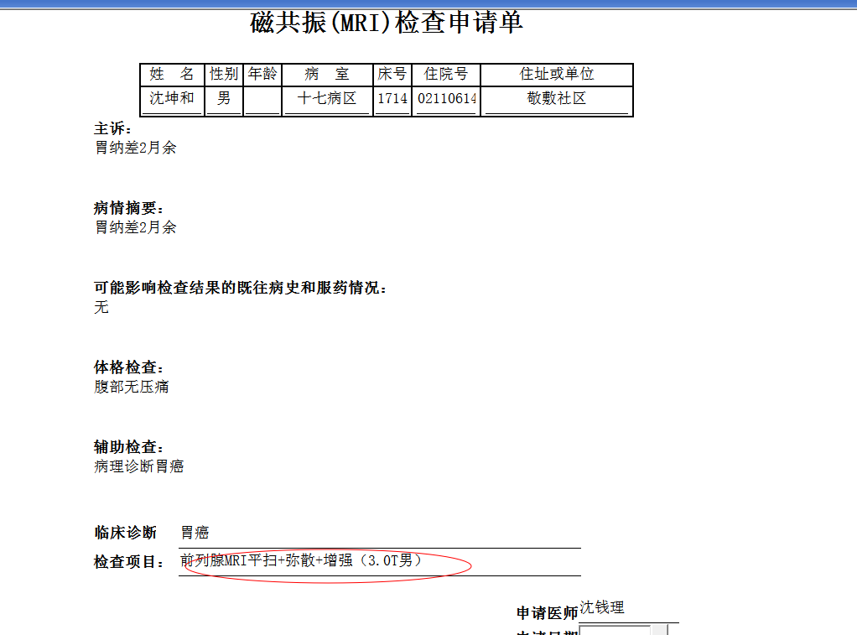
谢立江组
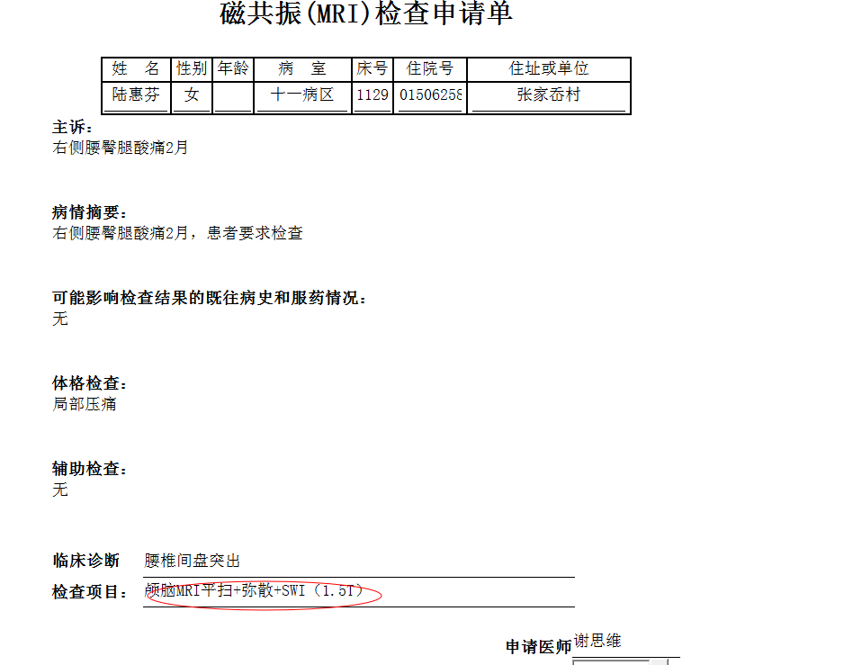
朱国文组
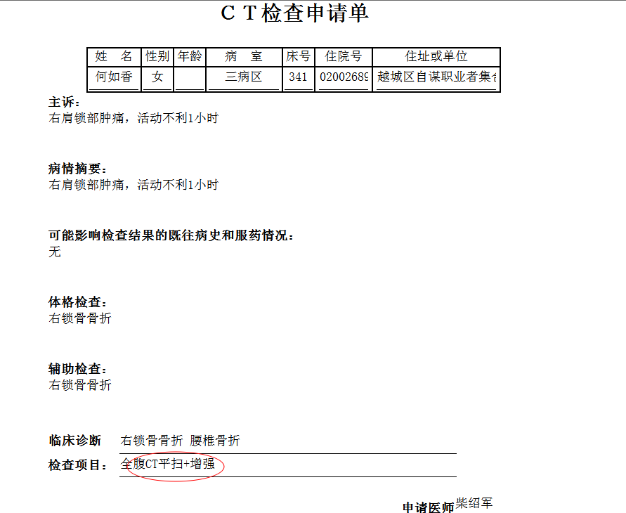
吴智敏组

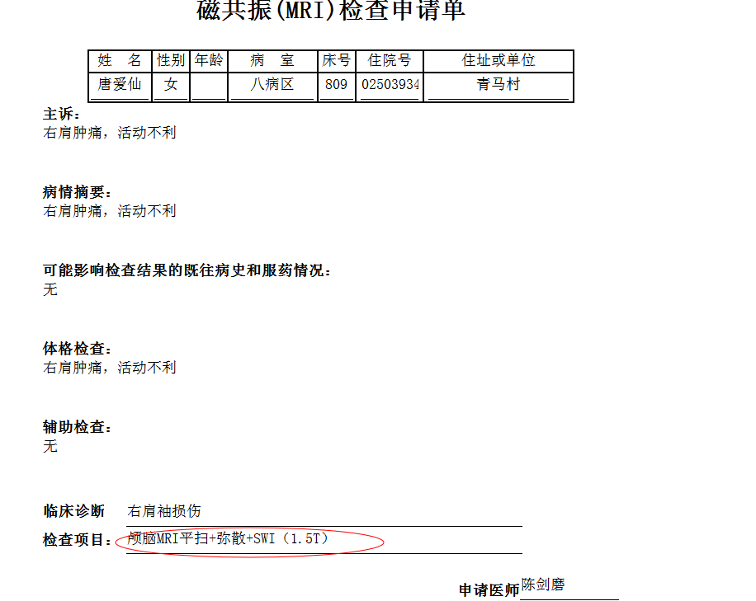
沈剑增组
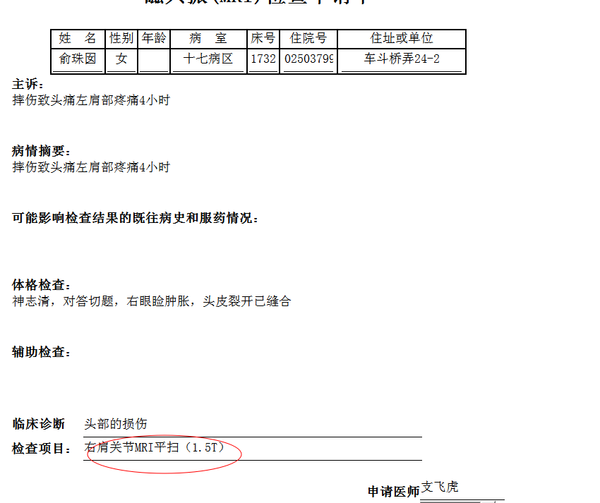
张建宇组
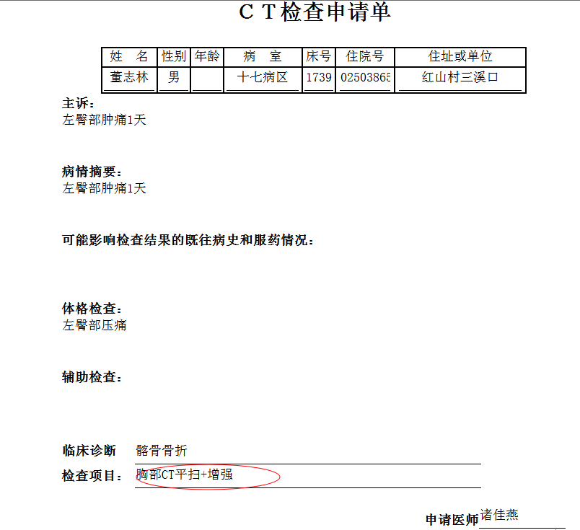
谢立江组

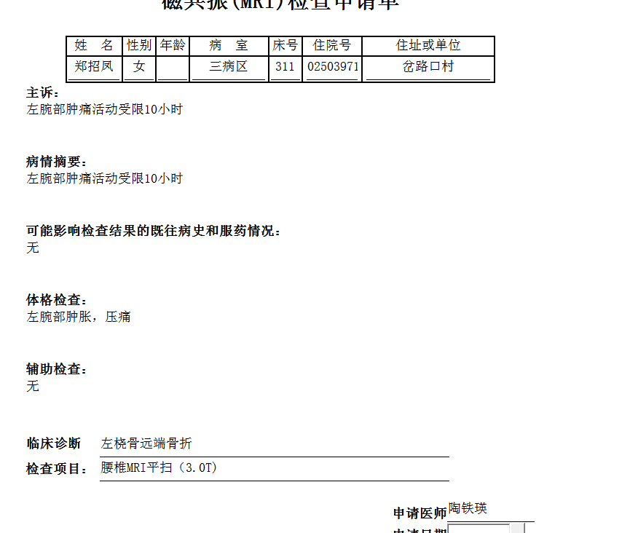
林武组

